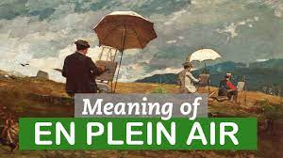

Have you ever taken your crayons or paints outside to create a picture
start to finish?
If you have, then you have painted or drawn it
“En Plein Air”
(Pronounced: On – plane – air)
That’s French for:
“In the open air.”
Not only is it fun, but you get to enjoy fresh air while getting ideas from nature.

The best way to capture what the clouds look like where you live is to go outside and draw them ‘En plein air’
What you will need:
- The cloud paper on the next page.
- A book or something strong that is larger than the piece of paper to make it easy to draw.
- Crayons or paints.
- A blanket or bath towel.
- Your cloud headband – artists often wear things they made

Step out into the open air and observe (Pronounced: ub-zerv. It means to look at closely, to study it) the clouds.
What do you see?

