This document was created to help you, as the supervisor, have conversations with your new employees that will facilitate employee engagement, increase and accelerate time-to-productivity, encourage communications, and help employees connect to the mission. Onboarding is a critical component in improving employee engagement and satisfaction. Cover the following top ten areas to jump start your new employee.
- Understand your New Employee’s Expectations and Help Them Understand Yours
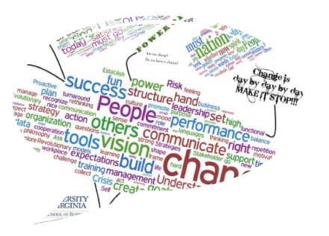
Conversation Point: Why did they take the job? What motivates them? What are their future plans?

Success Tip: Validate and clarify the employee’s expectations as needed, providing a safe space to connect and have a conversation about the personal aspects of what the job means to them.

- Share your Expectations with your New Employee
Conversation Point: What are your expectations? How does this relate to the employee’s position description and performance plan? How will the new employee be measured? What are the key metrics and timelines? What objectives take priority? What training and opportunities are you willing to provide? What training or opportunities should be included on the employees IDP? When will they be scheduled to take Fundamentals?

Success Tip: Share with them their performance standards and work plan. Explain how their performance helps meet the mission of the NPS. Align individual development plans with performance objectives. Ensure that required training and prerequisites for Fundamentals are included.

- Organizational Vision & Strategy
Conversation Point: What is organizational success? Where is NPS headed (i.e., GPRA goals, Call to Action, Directors 4 emphasis areas, and safety responsibilities)? (Ideally provide link to Insidenps).

Success Tip: Provide your employee with an honest manager’s perspective on the challenges, successes, and realities of your unit and NPS as an organization.

- Employee’s Work Group
Conversation Point: What is the larger group your new employee is now a part of? What is the group’s structure and goals? Who are the key team members? What is the group culture?

Success Tip: Have your new employee spend some time with each key team member through short job shadowing experiences, allowing the employee to see the “moving pieces” of the team and to ask questions in order to better understand their individual role and responsibilities.

- Employee’s Job Importance
Conversation Point: What does the new employee’s job mean to the unit and the organization? How does it contribute to the mission of the unit and the organization? Who are the new employee’s internal and external customers?

Success Tip: Employees who see how their tasks, no matter how small, contribute to and are valued by both the unit and organization mission are more likely to feel engaged, motivated, and satisfied with their jobs.

- Employee’s Job Responsibilities
Conversation Point: What are the employee’s main responsibilities, tasks, and outcomes? Who else is involved in this work? How do the employee’s responsibilities depend on others?

Success Tip: Clearly lay out the employee’s responsibilities by reviewing their Position Description and workplan, with them, the importance of being flexible with responsibilities, and potential for expanding responsibilities.

- Provide Meaningful Work Immediately
Conversation Point: What assignments and responsibilities would make the employee feel like they are contributing substantively, early on? How does the employee prefer to be given feedback to learn and feel empowered?

Success Tip: Early success predicts long-term career success and good performance leads to engagement. Leverage strengths and build on momentum. Monitor performance and provide feedback.

- Make a Personal Connection
Conversation Point: What does the mission of your unit and NPS mean to you, as a manager? How can the new employee maintain a connection with you? (i.e., regularly scheduled check-ins, “open-door” policy, etc.).

Success Tip: Don’t be a stranger to your new employee. Be visible and willing to help the new employee throughout their orientation. Communicate early and often.

- Relationships with Co-Workers
Conversation Point: Who is the best resource for what? What is the best way to get to know others?

Success Tip: Assign a PAL to assist your employee in answering basic questions related to your park, getting around the area, and tips for getting settled.

- Necessary Supplies, Tools, and Resources
Conversation Point: Does your new employee have what they need to do their job? Do they know how to navigate the organization and find the resources they need? Do they have the training and knowledge they need?

Success Tip: Schedule essential and mandatory trainings, including NPS Fundamentals.

