Draw a Nēnē!  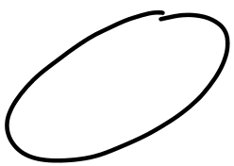  Start by drawing an oval. Use a pencil or draw lightly so you can erase later. | 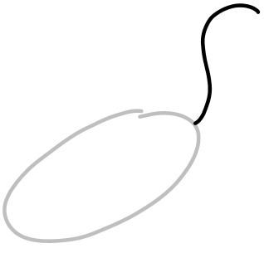  2.  Add an S shape for the head. | 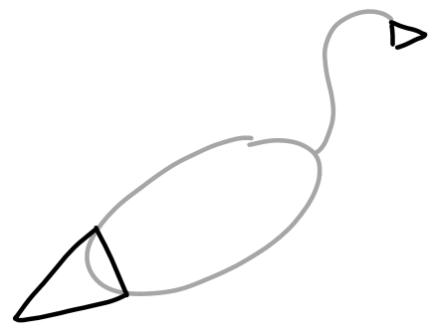  3.  Draw triangles for the beak and tail.
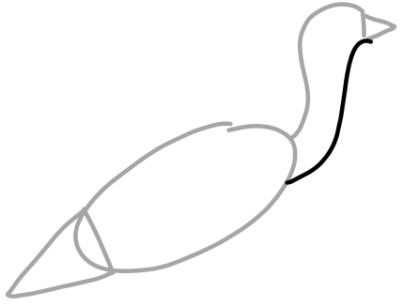  4.  Add another S shape to finish the neck. | 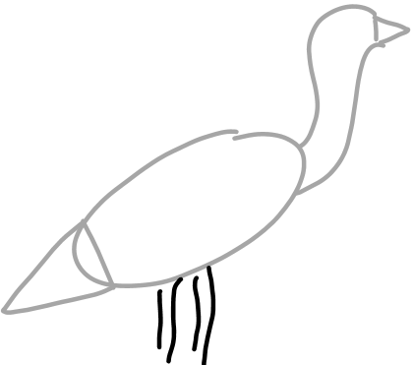  5.  Put four lines to make legs | 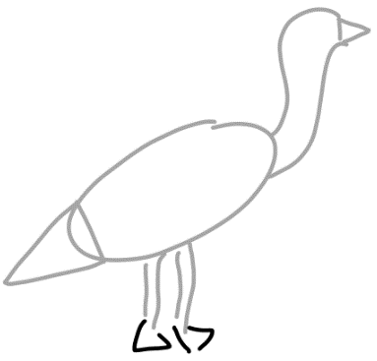  6.  Use two triangles to make some feet.
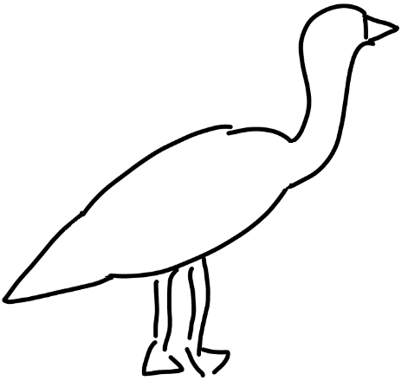  7.  Erase the lines inside the body. | 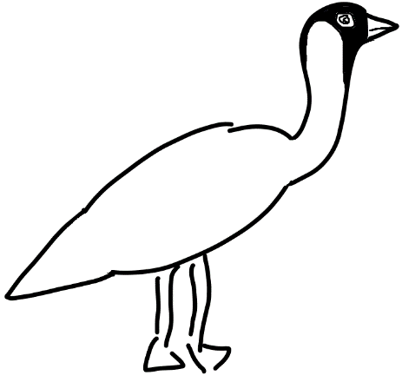  8.  Draw an eye and mouth! Add some color to the head | 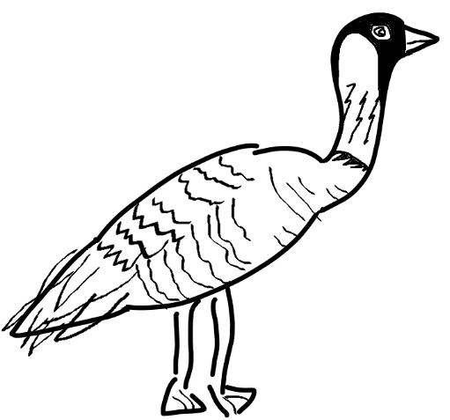  9.  Put the final touches on your nēnē! Draw feathers and markings or add color.

