Spring
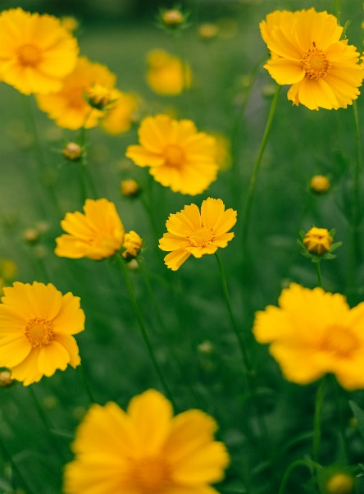
Spring is the time of year when the Earth wakes up from a long winter nap.
Flowers begin to bloom, trees grow new leaves, grass turns greener and the temperature gets warmer.
Spring begins in late March and lasts until late June.
Small, yellow flowers
Have you heard the saying:
“April showers bring May flowers”?
- The saying was used in a book of poems written almost 500 years ago.
- It became popular in 1886, when it was included in a book of over 3,000 sayings, some of them almost a thousand years old!
- Listen to a short story on the history of “April showers bring May flowers” here:
https://www.youtube.com/watch?app=desktop&v=m80zKHtz7SE
What are some of your favorite things to do in the Spring? Write down three in the space below:

_____________________________________________________________________________________

_____________________________________________________________________________________

_____________________________________________________________________________________

