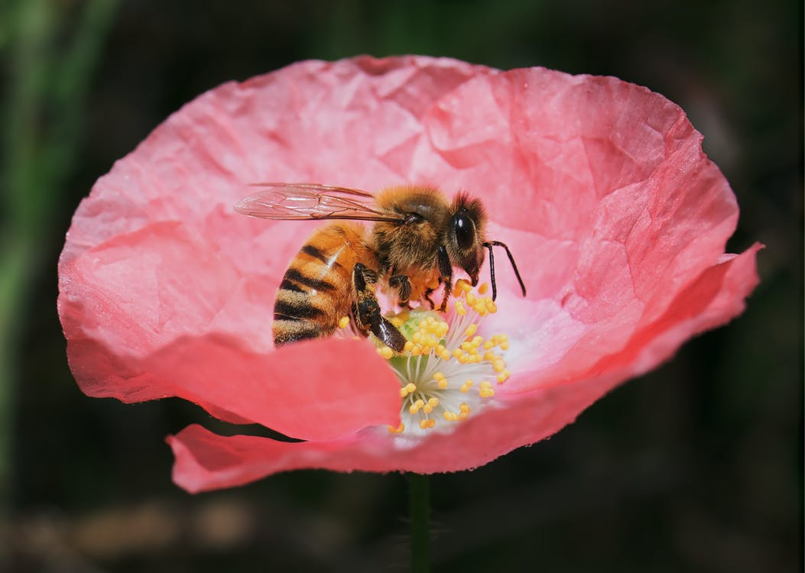
Make a Bee
and
Pollinate
Your Own
Flower!
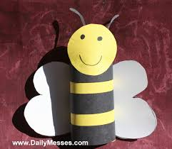
Close-Up Photo of Bumblebee On Flower by: C. Charlie

Materials Needed for the Bee:
sponge
1 toilet paper roll tube
1 Black Marker
1 Piece of Black, White and Yellow Paper (or a yellow marker or crayon)
1 bottle of glue – if using yellow paper
1 pair of scissors
1 small piece of a sponge

Directions:
1. Cut the toilet paper roll tube in half.
2. Cut the yellow paper to be the same size as the toilet paper roll tube.
3. Glue the yellow paper to the toilet paper roll tube, or color the tube yellow.
4. Cut out black strips of paper and glue them around the lower half of the toilet paper tube to make bumble bee stripes.
5. Draw two eyes at the top for bumble bee eyes.
6. Cut two small bumble bee wings from the white piece of paper and glue them to the back of the tube.
7. Cut two small strips of black paper for antennas and glue them inside the top of the toilet paper tube
8. Glue the small piece of sponge to the middle of the toilet paper tube (on the Front)

Materials Needed for this Pollination Activity: 1 Crayons, Talc Powder or Baking Powder or Dry Ginger Spice and a small dish of water.
- Draw a flower on the X.
- Shake a bit of powder (pretend pollen) in the middle of the picture of the flower.
- Lightly tap the sponge glued to your tube in the dish of water (the pretend nectar).
- Land your bee on the middle of the pictured flower with the powder.
- Have the bee follow the dotted line to the flower you drew.
- Make sure your bee lands in the middle of your flower to ‘pollinate’ it.
X
