The National Park Service Presents:

An Online Interactive Program
for the
Pre-School – Kindergarten Set

For the Adults of Ranger Time participants:
Ranger Time is an on-line interactive themed program offering sensitively explained age-appropriate lessons to help adults introduce: civics, American history and Martin Van Buren to the pre-school and kindergarten child/children in their lives.
Each program includes lessons with multi-generational activities to engage both the child and adult; and always with a connection to America’s eighth president, Martin Van Buren.
All programs require a minimal amount of time to complete, and step-by-step instructions are included for easy following.
The National Park Service Presents:

2021 Theme: The Making of America

This year’s Ranger Time builds upon the theme for 2020: Democracy and how Americans choose a president.

The focus for 2021 is on America; how it was formed and the idea of citizenship.

- You can find, “I Voted! – Ranger Time Election” under Ranger Time 2020.

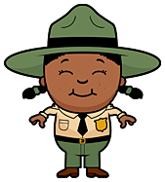

The United States Constitution:

1.Read:
‘Have you ever visited Lindenwald?’
2. Read:
“No. 2: Introduction”

3. Do:
“We the People Activity”
4. Read:
“The 3 Parts of The United States Constitution”
5. Play:
“Constitution Parts Match Game”
6. Read:
“Martin Connection:”

7. Make:
“Your Own Constitution”

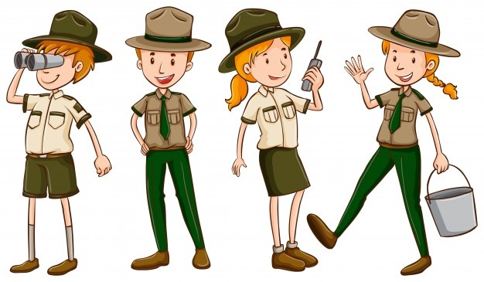

Have you ever visited the Martin Van Buren National Historic Site named Lindenwald?
It’s a beautiful place to walk around and enjoy nature.
Do you know the name of the person who once lived there and was the eighth President of the United States?
It’s Martin Van Buren, of course!
If you visit Lindenwald make sure to stop and talk to the Park Rangers.
They are always happy to meet visitors and answer any questions you may have.

No. 2 for 2021 Introduction:

The United States Constitution

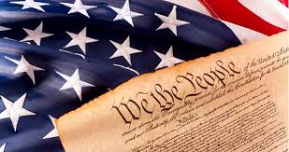

Welcome back to Ranger Time!
Now that you’ve learned about the American Revolution
and how the first thirteen colonies became the United States, it’s time to find out
how leaders organized the country.
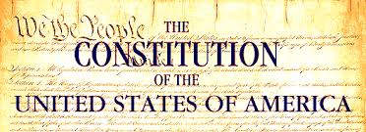
After the American Revolution, the United States was in a disorganized mess.

The thirteen colonies came together, but each state worked alone. Each of the thirteen states even had their own rules.
Can you imagine having the citizens of each states having to learn the laws belonging to each of the other twelve just to avoid trouble?

Some states had their own Navy and threatened to take ships belonging to other states. They were from the same country but behaving like they weren’t.

Craziness, don’t you think?
You can imagine the problems this caused for the people of the United States.

To straighten out the mess, state leaders gathered in Philadelphia, Pennsylvania.
It took a lot of arguing but they finally came to a compromise (an agreement) and created a document to make the United States of America one strong, organized nation.
This document is called The United States Constitution.
The United States Constitution is the guide people in charge of running America must follow, including the President of the United States.

It also explains the rights and protections for all Americans throughout the country.

For this reason, the United States Constitution is considered one of America’s most important documents and the law of the land.

The first three words in the United States Constitution are:

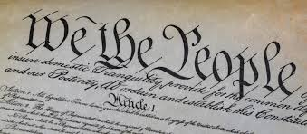

The words mean that we come from different places, and we look different and are different but together ‘We the People’ are all Americans.
Have you ever made a paper chain?
Well, this activity has you making a type of paper chain- of hands.
Trace the hands of a few friends or family members and glue them together, making a circle of hands.
Think about the hands that make up your circle.
Together they are,
“We the people.”

Supplies needed: Crayon, Scissors, Tape or glue and pieces of paper.

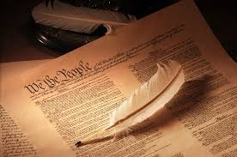

The United States Constitution explains the laws protecting every American.
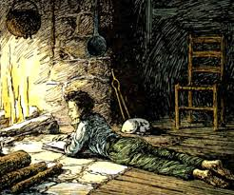

It helps to think of it as one long paper with three different parts.

Part 1: The Preamble
This first part is called the Preamble.
(Pre- am – bull)
The Preamble explains what the Constitution means and why it was written in the first place – except the leaders left out what a mess America was in at the time.

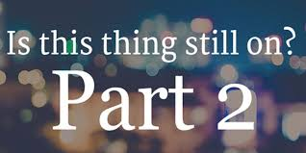

The 7 Articles

People read articles every day in newspapers, on the internet and in magazines but the 7 Articles of the United States Constitution are not the same.

They are seven different sets of rules explaining exactly how the United States of America will operate as a country.

At the time the Articles were written, Americans were afraid of being ruled again by a king, so the leaders wrote Articles to make them feel safe about those in charge of the country.

State leaders and the president must follow the rules in the Articles.
The Articles also have rules for the courts and for its judges, so they don’t overuse their power.

One Article even tells Americans when they can vote for state leaders and the President of the United States.

Other Articles are rules to make sure the states work together.
All in all, the 7 Articles make sure America runs as one united country.

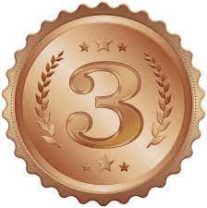

The
Amendments :
Part 3
Sounds like the name of a singing group, doesn’t it?
“Next up folks, it’s the Amendments!”
Woo hoo!
You can almost hear the people clapping and cheering.
Well, you should clap for the Amendments (additions and changes) to the United States Constitution. They are an amazing group … of rights.

What rights? Well, yours! That’s correct, rights for every American- including children.

The first 10 are even called the ‘Bill of Rights.’ Remember how Americans were afraid of a King ruling them? Well, the Bill of Rights explains exactly what rights Americans have and what they should expect from the people running the country.

The next 17 Amendments make extra sure no American is left without certain rights, because long ago it did happen to some people.

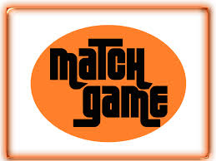

The United States Constitution is one of America’s
most important documents,
but trying to understand it can be confusing.

Sometimes it is easier to learn about something if it is put into a game.
To help you learn the three parts of the
United States Constitution
we have created for you the:
Constitution Parts Match- Up Game.

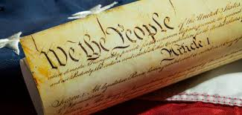
Supplies Needed: Crayons: Red, Blue and Green. Scissors. Bowl or hat.
Constitution Parts Match-Up
1. Cut out each of the 9 squares with clues.

2. Fold the squares into small pieces and put them in a bowl or hat.

3. Pull the squares out of the bowl or hat one-by-one.

4. Read each clue and try to figure out what part of the Constitution the clue falls under.

* Adults who are reading the clue: The answers are on the top left side of each.

5. When you have decided on the answer to the clue, color the box the same color as the answer.

Example: color the box red under ‘The Preamble’ if that’s your answer.

Color Key: Red – Preamble Green – The Articles Blue – The Amendments
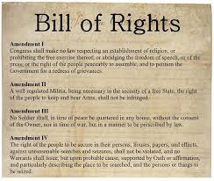

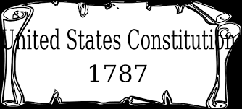

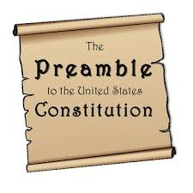
1: Preamble
Explains
the
Constitution and why it was written.

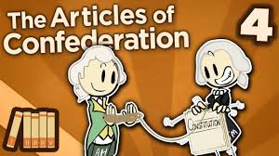
2: Articles
7 sets of rules
to make sure America runs
as one united country.

3: Amendments
Lists the rights for all Americans.

Constitution Parts Match-Up Game

Part 1
Preamble

Part 2
Articles
Part 3
Amendments

Did you guess the correct answers from the clues? If you have more than 3 colors for each column go over the clues to find the oops.
Part 1:
This part
explains why
the Constitution
was written.

Part 1:
This part explains
what the
Constitution
is all about.

Part 1:

This part begins with:
“We the people”

Part 2:
This part is a set of
7 rules
for those in charge
of America.

Part 2:
This part includes rules
even the
President of the United States must follow.

Part 2:
This part was written
to make sure
every state in
America works together
as one united country.
Part 3:

This part made
sure, all Americans
have the same rights.

Part 3:
‘The Bill of Rights’ are
the first
part of this section.

Part 3:
This part lists
17 changes
made to the Constitution.

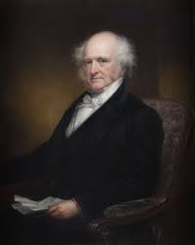

Martin Connection:
Martin Van Buren
and
The U.S. and
New York State
Constitutions

Huntington

Have you ever thought how things happening today while you are young will become an important part of your life as a grown-up?
We don’t know what Martin Van Buren thought about as a little boy growing up in Kinderhook. Still, we do know what was going on in America throughout his life.
Martin Van Buren was only five years old when state leaders gathered in Philadelphia to discuss and create the United States Constitution.
Any person studying to become a lawyer in America must learn the Constitution and its other two parts: The Bill of Rights and Amendments, as well as the Constitution for their state. Martin Van Buren had to do the same.
He admired Thomas Jefferson very much and wanted to be just like him. Martin thought the best way to serve the people of New York was to become a lawyer.
Back then, there were few universities to attend. To become a lawyer most studied the law for seven years with another lawyer who took responsibility for their learning. It was called an apprenticeship, and this is how Martin became a lawyer.
In 1821 he attended a meeting to make changes to New York’s State Constitution. During this conference Martin Van Buren helped change voting laws to make sure all free men could vote, but it took nearly 100 years before all American women were allowed to vote.

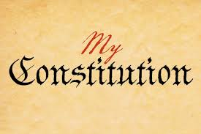
It’s time to sign your own Constitution!
Band a feather (real or make one) to a pencil. Sign it just as our founding fathers did when they signed the United States Constitution. Roll up the paper and tie it with a ribbon.

