The best way to start a learning adventure is through a story.
It’s even better when a grown-up is reading it to you!

Check this one out at your local library!

Or, listen to a grown-up read it at:
https://www.youtube.com/watch?v=_05LmSF5fEI

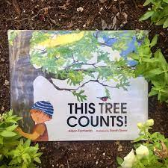
This Tree Counts!

Written by:
Alison Formento

Illustrated by:
Sarah Snow

When you think of trees do you think of them only out in nature?
What about in pictures or on wall paper?
Martin Van Buren was the 8th President of the United States.
Almost 180 years ago he bought
a home he named Lindenwald, you will learn more about it later.

He wanted a special dining room in the house to have supper with his friends.

To decorate, he picked a wallpaper that looks like an outdoor country scene with many trees.

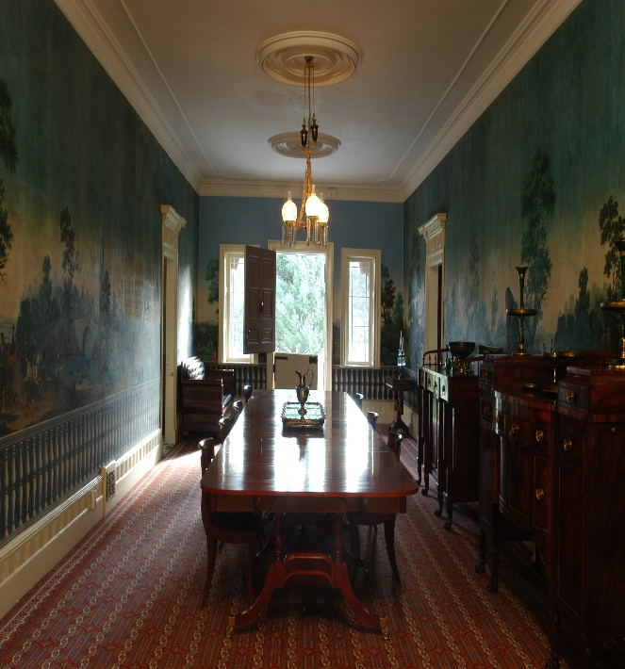

Take a virtual tour of Lindenwald and see his fancy dining room with the beautiful wallpaper:
https://artsandculture.google.com/exhibit/virtual-tour-of-martin-van-buren-national-historic-site/lQJC2ny6sCnoIQ

