The American Sycamore
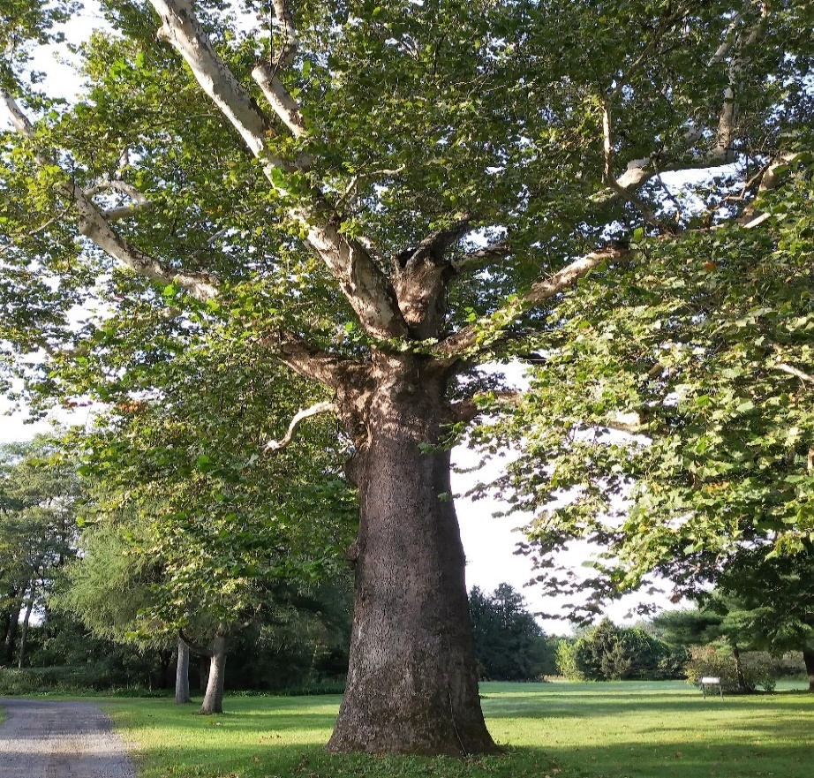

Autumn, or Fall, is a favourite time up North. It is when the leaves of trees around Lindenwald begin turning beautiful shades of brown, gold and yellow – including this American Sycamore.

Since the leaves turn colour and fall off it is a deciduous (Pronounced: De-sid-you-us) tree.
Trees, such as Pine trees, that have needles and stay green all year long are evergreen trees.

The American Sycamore grows incredibly tall. You can recognize it by its coloured bark around the lower branches and trunk and a lighter grey colouring toward the top.
As the American Sycamore grows it sheds its bark giving the wood underneath a chance to live.
This large American Sycamore tree at Lindenwald dates sometime before President Van Buren bought the house and farm in 1839.
All Bark, No Bite
Bark is more than just what a dog does.
Bark is the hard, outer shell of a tree. Bark can be rough and bumpy or even as smooth as paper!
Did you know a tree’s bark is like your fingerprints?
No single tree has the exact same bark pattern! Just like no one has the same fingerprints as you. How cool is that?
Visit 3 tree friends and at each one use the space below to make a bark rubbing. When finished getting all 3 tree rubbings compare their “tree-prints” (bark).
How to:
Place the page over the bark and rub a crayon over the page.
You will end up with a tracing or what is called a rubbing of the bark.

Use your tree chart to help decide of each tree friend you chose
is either a Deciduous or Evergreen.

Tree Number 1 chosen is a: _____________________________________
(Circle one) It is an: Evergreen tree Deciduous tree

All Bark, No Bite
Tree number 2 chosen is a : ______________
(Circle one) It is an: Evergreen tree Deciduous tree

All Bark, No Bite
Tree number 3 chosen is a : ___________________
(Circle one) It is an: Evergreen tree Deciduous tree

