National Park Service
U.S. Department of the Interior
Brown v. Board of Education National Historical Park

Superintendent’s Compendium

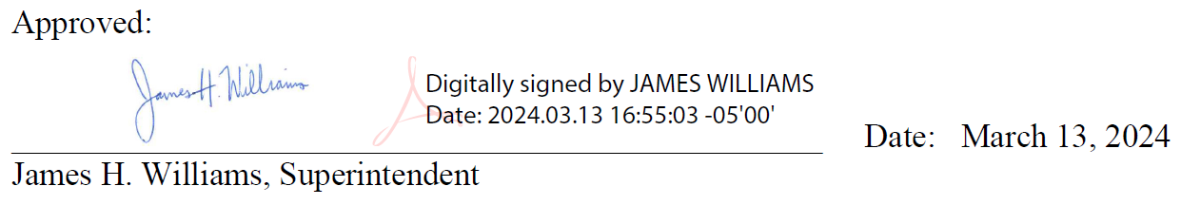

In accordance with applicable law and policy, and pursuant to the delegated authorities provided in Title 36, Code of Federal Regulations, Chapter 1 (“36 CFR”), the following compendium actions apply to all lands and waters administered by the National Park Service (NPS) within the boundaries of Brown v. Board of Education National Historical Park. This document is the written compilation of designations, closures, permit requirements, and other restrictions imposed under the discretionary authority of the Superintendent, as required by 36 CFR 1.7(b). Violating any provision in this compendium may result in criminal penalties under 36 CFR 1.3.

The compendium actions in this document apply in addition to all other laws that apply to lands and waters administered by the NPS within the boundaries of Brown v. Board of Education National Historical Park. These include:

- Regulations in 36 CFR and other CFR titles such as Title 43, which contains regulations that apply on public lands administered by the Department of the Interior. The current version of the CFR may be found at www.ecfr.gov. Click on “Title 36” and then “Chapter 1” to access 36 CFR.
- Statutes codified in U.S. Code, in particular provisions in Titles 16 and 54.

Please contact Superintendent James H. Williams if you have any questions or comments about the Superintendent’s Compendium:

James H. Williams, PhD
(785) 817-1843
james_williams@nps.gov

Brown v. Board of Education National Historical Park
1515 SE Monroe Street
Topeka KS 66612

NPS regulations in 36 CFR 1.4 define certain terms that are used in 36 CFR. Other sections in 36 CFR may define certain terms that are used in those sections. To the extent any terms defined in the CFR are used in this compendium, those definitions apply. In addition to terms defined in the CFR, the following terms used in this compendium are defined as follows:

Day Use Area: Any area consisting of or adjacent to paved parking lots, buildings, or toilet facilities that are open to the general public.

Uncrewed Aircraft: A device that is used or intended to be used for flight without the possibility of direct human intervention from within or on the device, and the associated operational elements and components that are required for the pilot or system operator in command to operate or control the device (such as cameras, sensors, communication links). This term includes all types of devices that meet this definition (e.g., model airplanes, quadcopters, and drones) that are used for any purpose, including for recreation or commerce.

Walkway: Sidewalks, paths, trails, or hard-surfaced areas that are closed to the use of bicycles and motorized vehicles.

36 CFR 1.5 – CLOSURES AND PUBLIC USE LIMITS

36 CFR 1.5(a)(1)—Visiting hours, public use limits, and closures

Visitor Center Hours

Brown v. Board of Education National Historical Park is open from 9:00 a.m. to 5:00 p.m., five days a week (Tuesday-Saturday), except January 1, Thanksgiving Day, and December 25. Severe winter and summer storms may cause the park to close until such time as it is safe for visitation.

The above schedule is in place to provide maximum visitor and resource protection consistent with current staffing levels. These hours of operation meet the needs of current visitation trends for the park. Activities may occur throughout the year outside of these times and will be advertised as such.

Monroe School, Exhibit Galleries

Food and drink are not allowed within the two exhibit galleries on the first floor of the Monroe School building, except for closable water bottles and foods that are essential for medical purposes.

The prohibition of consumable items in the galleries guards against inadvertent spills, litter, or the potential to attract pests that may be attracted to or damage the exhibits.

Passenger Carrying Buses – Engines must be shut down when not underway.

The idling of bus engines adds unnecessary exhaust fumes to the air and diminishes the enjoyment by visitors of the peace and tranquility of the park.

36 CFR 1.5(a)(2)—Designated areas, conditions, or restrictions on a use or activity

Conditions or Restrictions on a Use or Activity

Launching, landing, or operating an unmanned aircraft from or on lands and waters administered by the National Park Service within the boundaries of Brown v. Board of Education National Historical Park is prohibited except as approved in writing by the Superintendent.

Unauthorized unmanned aircraft within the site may pose a safety hazard to participants and/or visitors, damage cultural resources, interfere with interpretive programming, and harass local wildlife. This determination has been made based on the need to maintain public health and safety, to protect park resources and values, and to avoid conflict among visitor use activities. This restriction is required by NPS Policy Memorandum 14-05 dated June 19, 2014.

36 CFR 1.6 – ACTIVITIES THAT REQUIRE A PERMIT

36 CFR 1.6(f)—Activities that require a permit

- Launching or landing uncrewed aircraft. 36 CFR 1.5
- Carrying or possessing a weapon (excluding firearms in compliance with applicable Kansas state and Federal firearms laws), trap, or net. 2.4(d-e)
- Collecting specimens for research purposes. 36 CFR 2.5
- Creating audio disturbances, such as operating a power saw; operating any type of portable motor or engine, or device powered by a portable motor or engine in non-developed areas; and Operation of a public address system in connection with a public gathering or special event. 36 CFR 2.12(a)(2-4)
- Soliciting or demanding gifts, money, goods, or services. 36 CFR 2.37
- Using, possessing, storing, or transporting explosives; using or possessing fireworks or firecrackers. 36 CFR 2.38
- Conducting a special event. 36 CRF 2.50
- Conducting a demonstration by groups of more than 25 people. 36 CFR 2.51
(b1) Demonstrations involving 25 persons or less do not require a permit unless the event presents a clear and present danger to public health and safety; the event takes place outside a designated area; structures, stages, platforms, sound systems are used; or the event unreasonably interferes with other permitted demonstrations and special events, or park program activities.
(c2) All demonstrations will be held in the rectangular designated area defined as the lawn and sidewalk area north of Monroe School, south of 15th Street, west of Monroe Street, and east of the alley on the park’s western boundary.
- Selling or distributing printed matter and other message-bearing items by groups of more than 25 people. 36 CFR 2.52
- Scattering of human ashes from cremation. 36 CFR 2.62
- Displaying, posting, or distributing commercial notices or advertisements. 36 CFR 5.1
- Engaging in or soliciting any business. 36 CFR 5.3
- Examining ruins, excavating archeological sites, and gathering of objects of antiquity. 43 CFR part 3
- Commercial filming. 43 CFR 5.2
- Some still photography (if conditions are met). 43 CFR 5.2
- Excavating or removing archeological resources. 43 CFR part 7
- Collecting paleontological resources. 43 CFR part 49

36 CFR 2—PRESERVATION OF NATURAL, CULTURAL, AND ARCHEOLOGICAL RESOURCES

36 CFR 2(a)(5)—Walking on, climbing, entering, ascending, descending, or traversing a cultural resource, monument, or statue, except in designated areas and under conditions established by the superintendent, is prohibited.

The park contains cultural resources that may be irrevocably damaged or cause a public safety concern. Designated areas for pedestrian use include sidewalks, pathways, and other established walkways. Prohibition includes but is not limited to climbing buildings, park signs, and exhibits.

36 CFR 2(a)(6)—Possessing, destroying, injuring, defacing, removing, digging, or disturbing a structure or its furnishing or fixtures, or other cultural or archeological resources is prohibited.

36 CFR 2(a)(7)—Possessing or using a mineral or metal detector, magnetometer, side scan sonar, other metal detecting device, or subbottom profiler is prohibited.

The grounds of Brown v. Board of Education National Historical Park are a cultural landscape, where the use of such devices and the digging associated with them will adversely affect the park resource.

36 CFR 2.10—CAMPING AND FOOD STORAGE

Camping within the boundaries of Brown v. Board of Education National Historical Park (grounds or parking lot) is prohibited.

There are no camping facilities in the park. These restrictions are intended protect natural and cultural resources, and for public safety concerns. In consideration of the increased potential for resource damage and the health and safety of visitors these activities are prohibited.

36 CFR 2.11—PICNICKING

Picnicking is allowed at the picnic tables on the south lawn of the Monroe School and on the grassy areas of the Brown v. Board of Education National Historical Park landscape.

Conditions for picnicking: Individual and family picnicking is limited to picnic baskets, brown bagging, lunch boxes, and the like and is permitted on public park grounds unless otherwise prohibited in the compendium; trash should be contained and disposed of in trash receptacles located around the grounds.

Food and other waste are unsanitary and attracts pests and is at odds with the historic appearance of the grounds.

36 CFR 2.13—FIRES

The lighting or maintaining of fires is generally prohibited. No lantern, open flame stove, candle, or other open flame source may be used inside the historic Monroe School building.

Numerous cultural resources exist throughout the historic Monroe School that may be irrevocably damaged. The smell of smoke or flames may cause a public safety concern and interfere with fire detection systems.

36 CFR 2.15—PETS

The Monroe School building is closed to pets (service animals excepted).

Consistent with public health and safety, the protection of natural and cultural resources, and avoidance of conflict among visitor use activities, pets must be restricted. Pets are not considered compatible with the broad park goal of minimal visitor impact nor are they inherently suitable for adapting quickly to a strange environment often involving close association with strange persons or other animals. It is recognized that many park visitors have pets, and they are permitted where they do not jeopardize basic park values. This does not apply to animals assisting people with disabilities.

Pets shall be attended and under control while owners are in the park. Pets will not be left in areas where food, water, shade, ventilation, and other basic needs are inadequate. Pets will be controlled and on a leash, if not contained within a vehicle or in a pet carrier. Leashes will not exceed six feet in length. Animals running at-large and not claimed by the owner within a reasonable period will be impounded by City of Topeka animal control officers.

These requirements protect visitors, natural resources, park structures, and the cultural landscape and ensure pets are properly cared for while in the park.

Pet excrement shall be removed immediately from the park or deposited in a refuse container by the person(s) controlling the pet(s).

The grounds are a cultural and natural resource within an urban area where concentrations of people gather. School groups often visit and traverse the grounds. This restriction is intended to reduce any possible conflict between users and to provide for a healthy, sanitary, and safe environment.

36 CFR 2.20—SKATING, SKATEBOARDS, AND SIMILAR DEVICES

Using roller skates, skateboards, roller skis, coasting vehicles, or similar devices is prohibited. All types of bicycles are prohibited on sidewalks and pedestrian areas around Monroe School.

These restrictions are intended to reduce any possible conflict between park users, and protect natural and cultural resources, and for public safety concerns. In consideration of the increased potential for resource damage and the health and safety of visitors these activities are prohibited.

36 CFR 2.21—SMOKING

The following portions of the park, or all or portions of buildings, structures or facilities are closed to smoking as noted:
- Within 25 feet of the exterior of the historic Monroe School building.
- Within all government buildings, facilities, and vehicles.

These restrictions are intended to reduce any possible conflict between users and to ensure a healthy workplace for employees and visitors. Further, smoke and gases from cigarettes, cigars, and pipes adversely affect museum exhibits and artifacts.

36 CFR 2.22—PROPERTY

The following are prohibited:
(1) Abandoning property.
(2) Leaving property unattended for longer than 24 hours, except in locations where longer time periods have been designated or in accordance with conditions established by the superintendent.
(3) Failing to turn in found property to the superintendent as soon as practicable.

To ensure the security of park visitors, employees, and resources, no item(s) may be left unattended for any length of time in the Visitor Center.

Geocaching, letterboxing, or like GPS activities, or the placement of a physical cache on park property, are prohibited. Geocaching is defined as the placement of a concealed cache within the park boundaries and then disseminating the coordinates/location, or clues to the coordinates/location, for the purpose of enticing third parties to search for the cache at a later date.

Unattended property is inconsistent with the orderly management of park areas and may present a security or other threat to park resources. Property may not be left unattended in the park for security, health, and safety reasons, and it is not compatible with the cultural landscape or interpretive value of the park.

36 CFR 2.32—INTERFERING WITH AGENCY FUNCTIONS

As defined in this section, interference, violations of lawful orders, false information, and false reports are prohibited.

36 CFR 2.35—ALCOHOLIC BEVERAGES AND CONTROLLED SUBSTANCES

The use, possession, or consumption of alcoholic beverages is prohibited on federally owned lands within Brown v. Board of Education National Historical Park, except under the conditions of a special use permit issued by the office of the superintendent. Presence in a park area when under the influence of alcohol or a controlled substance to a degree that may endanger oneself or another person, or damage property or park resources, is prohibited.

The use of alcoholic beverages within a historic school may be perceived as incompatible with its historic nature as a place for education of children. Additionally, the facility is sometimes viewed as a place of pilgrimage by participants in the Civil Rights Movement.

36 CFR 2.51—DEMONSTRATIONS AND DESIGNATED AVAILABLE PARK AREAS
36 CFR 2.51(c)(2)—Designated location
The location outlined in orange in the photo below, to the north of the visitor center, is designated as available for demonstrations. A permit is not required for a demonstration in the designated location if it involves 25 persons or fewer and does not involve structures.
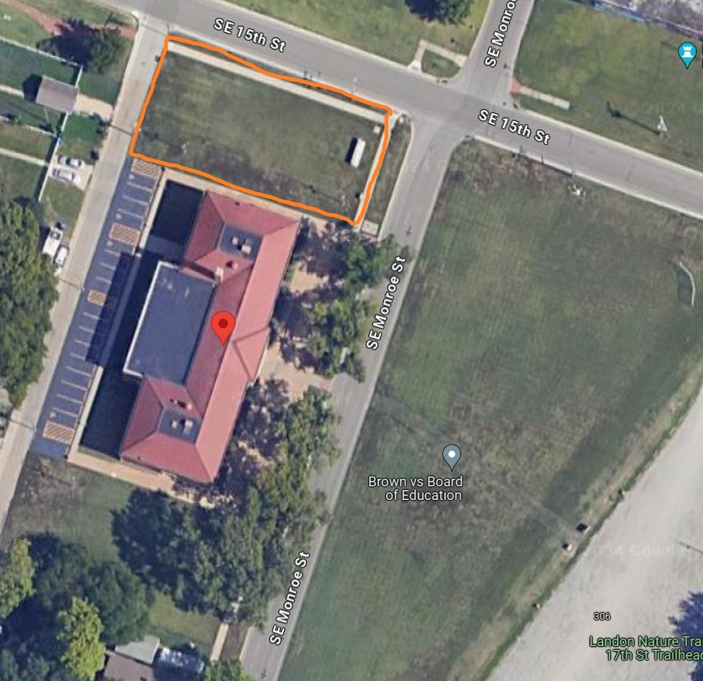
The designated location is in a prominent location near the visitor center that will allow individuals and groups to conduct demonstrations in a manner that will allow for effective communication of speech and other protected activities. At the same time, the designated location leaves ample space for visitors to enter and leave the visitor center safely and for the NPS to conduct administrative activities such as interpretive events.
36 CFR 2.52—SALE OF PRINTED MATTER AND THE DISTRIBUTION OF PRINTED MATTER AND OTHER MESSAGE-BEARING ITEMS
The location outlined in orange in the photo below, to the north of the visitor center, is designated as available for the sale or distribution of printed matter, and the free distribution of other message-bearing items. A permit is not required for these activities in the designated location if they involve 25 persons or fewer and do not involve structures.
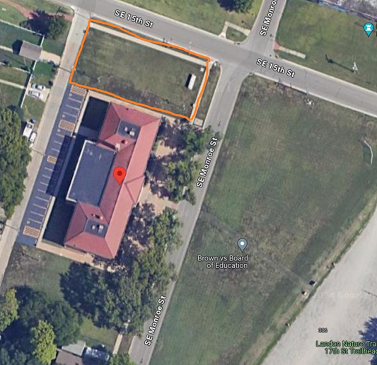
The designated location is in a prominent location near the visitor center that will allow individuals and groups to conduct demonstrations in a manner that will allow for effective communication of speech and other protected activities. At the same time, the designated location leaves ample space for visitors to enter and leave the visitor center safely and for the NPS to conduct administrative activities such as interpretive events.

36 CFR 4.30--BICYCLES
36 CFR 4.30(i)—Electric Bicycles

Class 1 and Class 2 electric bicycles are allowed in locations where traditional bicycles are also allowed, namely park roads and parking areas. Bicycles of all kinds are prohibited on sidewalks around the visitor center.

Allowing electric bicycles on roads and parking areas will not create new, adverse impacts to resources or visitors because those locations are already used by motor vehicles and traditional bicycles. Electric bicycles provide a recreational opportunity for visitors who want to ride a bicycle but might not otherwise because of physical fitness, age, or convenience. Class 3 electric bicycles, which allow the motor to assist pedaling up to 28 mph, would create unacceptable risks to visitor safety on roads and parking areas in the park due to potential conflicts with heavier and faster motor vehicles, and with other electric bicycles and traditional bicycles, which travel at slower speeds. Accidents that occur at higher speeds increase the risk of serious injury or death.

NOTICE OF THE USE OF CLOSED-CIRCUIT TELEVISION (CCTV)
In accordance with National Park Service (NPS) Law Enforcement Reference Manual 9 (RM-9), notice is hereby given that Brown v. Board of Education National Historical Park uses Closed-Circuit Television (CCTV) security camera monitoring.
NPS use of CCTV is for law enforcement and security purposes and will only be to visually monitor public park areas and public activities where no constitutionally protected reasonable expectation of privacy exists. Such CCTV use—which will have adequate privacy and First Amendment safeguards—will be to help ensure public safety and security; facilitate the detection, investigation, prevention, and deterrence of terrorist activity; help ensure the safety of citizens and officers; help assist in the proper allocation and deployment of law enforcement and public safety resources; and help facilitate the protection of the innocent and the apprehension and prosecution of criminals.
This policy does not restrict the official use of CCTV in government administrative areas, including administrative buildings, jail holding facilities, revenue collection sites, etc., where the government may record/monitor its facilities. For example, the government may perform unrestricted video/audio recording at revenue collection points (entrance stations, visitor center counters, etc.). This policy does not restrict the use of an Audio/Visual Recording Device (AVRD) in patrol vehicles or officer-worn recording devices used by commissioned rangers.
Operation of CCTV cameras will be in accordance with NPS and Department policy. No person will be targeted or monitored merely because of race, religion, gender, sex, disability, national origin, or political affiliation or views.
Nothing in this policy statement is intended to create any rights, privileges, or benefits not otherwise recognized by law.

