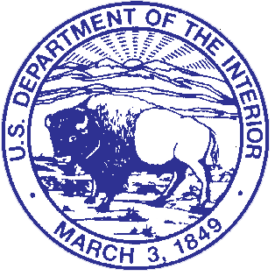
United States Department of the Interior

NATIONAL PARK SERVICE
National Capital Parks-East
National Capital Region
1900 Anacostia Drive, S.E.
Washington, D.C. 20020

July 8, 2024

In Reply Refer to:
10.B (NCR-NACE)

United States Department of the Interior

National Capital Parks-East
NATIONAL PARK SERVICE
National Capital Region
1900 Anacostia Drive, S.E.
Washington, D.C. 20020

April 3, 2024

NOTICE TO THE PUBLIC

The National Park Service is extending the temporary closure of the central turf panel of Lincoln Park to encourage the turf to take hold. The central turf panel was closed to the public at approximately 12:00 am on May 3, 2024, and was to remain closed through 11:59 pm on July 8, 2024, is now being extended until 11:59 pm on July 12, 2024

Violation is prohibited. A map illustrating the closed park areas is attached.

This temporary closure and public use limit is necessary for the protection of cultural and natural resources in Lincoln Park, as well as to ensure the greatest opportunity for the grass to become established. Persons using these park areas should remove themselves and any personal property from the closed park areas in accordance with the extension of this temporary closure.

The National Park Service appreciates the public’s cooperation in this matter.

Tara D. Morrison
Superintendent

Map of closed area:
