Chesapeake & Ohio National Historic Park Native & Non-Native Tree Guide
October 1, 2021
Chesapeake & Ohio National Historic Park
By: Intern Kelly Savannah

Definitions:
Simple: 1 leaf (blade) attached to a stem known as a petiole. Where the stem meets the twig is a lateral bud.
Compound: Many leaflets (Multiple blades). Leaflets do not have lateral buds.
*[See Boxelder for example].
Opposite: This is the arrangement of how the leaf sits on the twig (small branch). In this case the leaf is directly across from another leaf.
Alternate: The leaves zig-zag along the twig (small branch).
*[See Paw Paw picture for example]
Leaf Margin: Is the edge of a leaf. Some leaves will have smooth (entire) margins and others with have zig-zagged (toothed) margins.
Shape: The shape of a leaf is either lobed or not lobed. Therefore, if the leaf is lobed there are sections that are cut out whereas, if it is not lobed then the shape has a continuous leaf edge.
Base Shape: Refers to the shape of the base of a leaf. Some leaf bases are even, and some are uneven.
Diameter at Breast Height (DBH): Standard tree measurement that determines the thickness of a tree and is measured at the height of an adult's breast.
Native: Plant species that developed in its surrounding habitat & has adapted to living in that environment.
Non-Native: Plant species that was established in another location and has been introduced to the area it currently lives; most times outcompeting local (native) species.
Leaf petiole: the stalk that attaches the leaf blade to the stem.

Native Trees
Common and Scientific Name: Pawpaw (Asimina triloba)  Mature Size: Small, 20-40 feet (6-12 m) Tall  Native Range: Widely distributed throughout the Eastern, Southern, and Midwestern United States across southwestern Ontario, Canada.  Leaf shape/margins: Simple (1 leaf), alternate, long, pear-shaped with pointed tips, white hairs on top and rusty-colored hairs on the bottom.  Leaf Color: Green, turns yellow in Autumn.  Seed/Fruit: Light-to-dark green, soften when ripe, edible & tastes like banana or mango.  Flower: Small, purple petals, bloom in April to May.  Bark: Light gray, smooth, later becoming warty with blotches.  Interesting characteristics: When the leaves are crushed, they smell like green bell peppers & the Zebra Swallowtail butterfly larvae feed exclusively on Pawpaw leaves. |  | 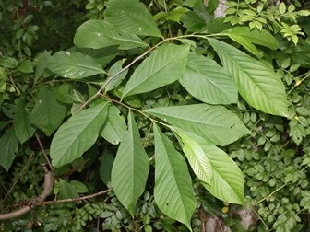  Paw Paw Tree & Leaves  NPS Photo  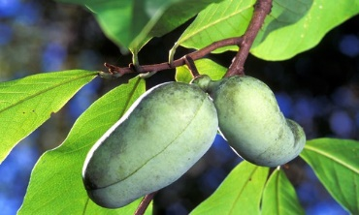  Paw Paw Fruit  NPS Photo

Common and Scientific Name:  Silver Maple (Acer saccharinum)  Mature Size: 90 to 120 feet (27-36 m)  Native Range: Eastern U.S., the Midwestern U.S., and Southern Canada (Southern Ontario and southwestern Quebec).  Leaf shape/margins: Simple (1 leaf), opposite, 5 deep-lobes with coarsely(rough) toothed edges.  Leaf Color: Yellow/Green with a silvery underside.  Seed/Fruit: Green & red samaras, (Winged in pairs, containing a single seed).  Bark: When young silver gray and smooth but as the tree is older; bark is gray and shaggy.  Interesting characteristics: Most abundant tree within the C&O Canal, due to its preference for moist soils; found in floodplains, near streams, and in low-lying forests. Silver Maple is also characterized as a fast-growing species. |  | 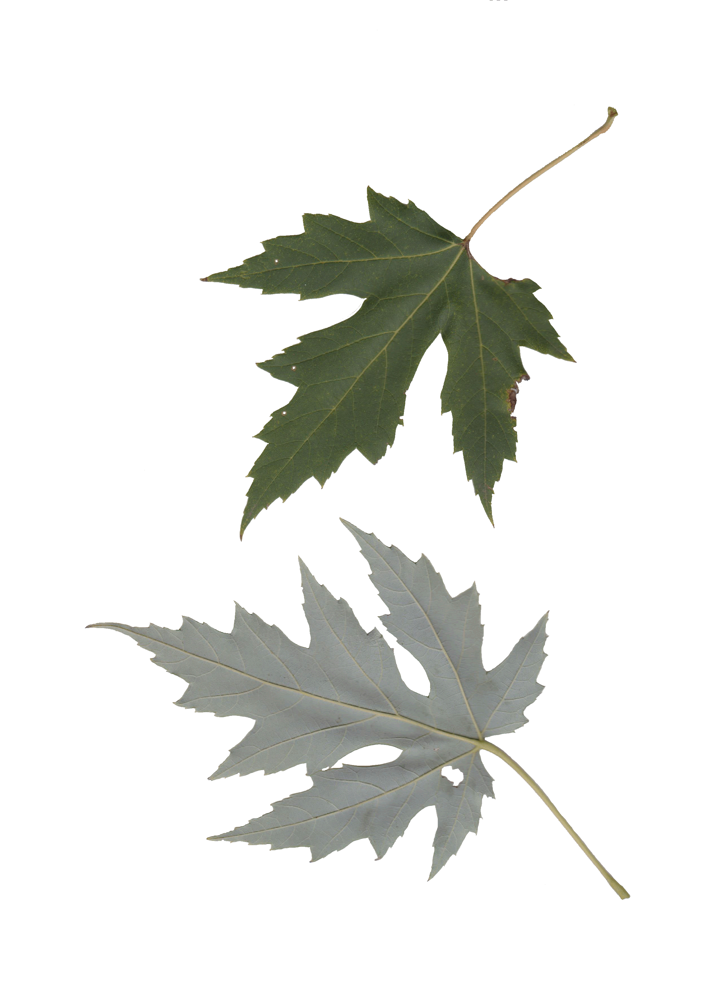  Silver Maple Leaves  Image Credit: MD DNR: Madeline Koenig &  Kerry Wixted  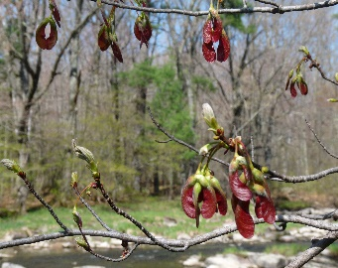  Silver Maple Samara Seeds  Helicopter.jpg. (2020, September 3). Wikimedia Commons, the free media repository
Common and Scientific Name:  Tulip Poplar (Liriodendron tulipifera)  Mature Size: 60 feet but can reach heights of 200 feet (61 m).  Native Range: Eastern North America from Vermont, west through southern Ontario and Michigan, south to Louisiana, and east to northern Florida.  Leaf shape/margins: Simple (1 leaf), alternate, smooth 5-pointed lobes that resemble a tulip-shaped leaf.  Leaf Color: Green; Yellow in Autumn  Seed/Fruit: Cone-shaped brown fruit with winged seeds (Samaras).  Flower: Tulip-shaped, yellowish-green marked with orange bands near base.  Bark: Brown, wrinkled, sweet fragrant and bitter.  Interesting characteristics: Leaves are shaped like tulips. |  | 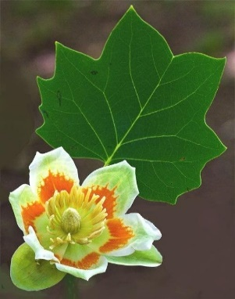  Tulip poplar flower. Wikimedia Commons
Common and Scientific Name:  Box Elder (Acer negundo)  Mature Size: 35 and 50 feet but may reach 70 feet (21 m) in height.  Native Range: Northeast and Central United States south to mountains of Mexico and Guatemala in Central America.  Leaf shape/margins: Compound, opposite, with 3 to 7 leaflets, toothed or lobed.  Leaf Color: Light green, turns yellow in autumn.  Seed/Fruit: Winged seeds (Samaras)  Flower: Small greenish yellow, no petals, drooping stalks.  Bark: Pale gray or light brown, deeply cleft into broad ridges, and scaly.  Interesting characteristics: Species of Maple. It is also known for its irregular form; trunk often divides near the ground into a few long, spreading, crooked limbs. |  | 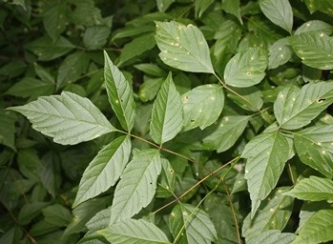  Box Elder leaflets  NPS Photo  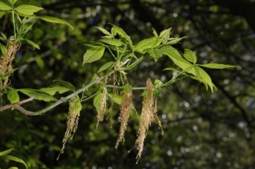  Box Elder leaflets and flowers Wikimedia Commons.
Common and Scientific Name: American Sycamore (Platanus occidentalis)  Mature Size: 60 to 120 feet (18-37 m)  Largest known Sycamore in the United States:  Tennessee tree 140 feet tall (42.67 m) and 65.9 inches (167.4 cm) DBH, with a circumference of 207 inches (525.8 cm).  Native Range: Extends from southwestern Maine to south-central Texas; east to northwestern Florida and southeastern Georgia.  Leaf shape/margins: Simple, alternate, large star-like & maple-like shape.  Leaf Color: Bright yellow green above, paler beneath; turn brown & wither (weaken) before falling in autumn.  Seed/Fruit: Brown-fruiting balls, densely packed with fluffy seeds called achenes.  Flower: Light-green & red round clusters.  Bark: Dark reddish brown, smooth & light gray when bark breaks off in patches.  Interesting characteristics: Mottling bark which flakes off in large irregular masses, leaving the surface blotchy, gray, greenish-white and brown. |  | 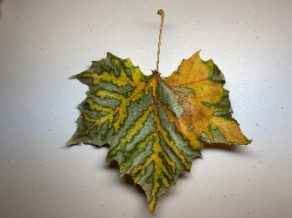  American Sycamore Leaf  Wikimedia commons  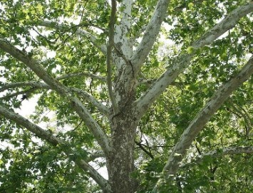  American Sycamore Tree with flakey bark  NPS Photo
Common and Scientific Name: White Ash (Fraxinus americana)  Mature Size: 60 to 70 feet (18-21 m)  Native Range: Extends from eastern North America such as Main to Central America, south to Texas and northern Florida.  Leaf shape/margins: Leaves are compound, 8 to 15 inches (20-38 cm) in length; seven oval, entire leaflets.  Leaf Color: Bright light green with a lighter almost white color on the underside, which is how the tree got its name. Leaves turn yellow or red in Autumn.  Seed/Fruit: single green narrow winged samara, 1 to 2 inches long, turn brown in Autumn.  Flower: Female and Male flowers are produced on separate individuals in clusters. Male flowers are yellow-green to purplish.  Bark: Ashy-gray to dark gray with corky scaly ridges & diamond shaped channels.  Interesting characteristics: Resprouts from the root crown after fire. The Ash species has also fallen victim to the Emerald Ash Borer (Agrilus planipennis) (EAB); a green beetle native to Asia. |  | 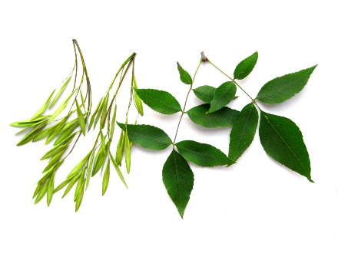  White Ash; Fraxinus americana; leaves and “samaras”.  NPS Photo  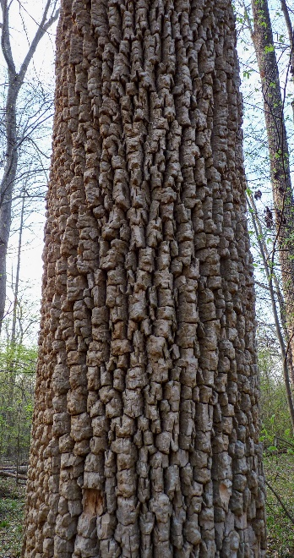  Corky bark of white ash.  NPS Photo, Photographer: Erin Lunsford Jones, courtesy of NatureServe

Common and Scientific Name: Eastern Redbud (Cercis canadensis) Alternate name: Judas tree.  Mature Size: 25 to 50 feet (7.6-15.2 m)  Native Range: Extends from New Jersey and Pennsylvania west to central American and south to Florida.  Leaf shape/margins: Alternately arranged leaves are about four inches long, four inches wide and heart shaped with prominent venation.  Leaf Color: Dark to yellow green.  Seed/Fruit: Produced in clusters of flat green pods (~3.5 inches long, ~0.5 inches wide) that change to brown when mature. Each pod contains four to ten small hard black or brown seeds.  Flower: Pink to reddish purple. Grow on old twigs, branches, and trunks. Appear before the leaves from as early as February-May.  Bark: Brownish black and scaly  Interesting characteristics: Deciduous, small tree. One of the first trees to bloom in spring. Fire tolerant and root sprouts after fire. |  | 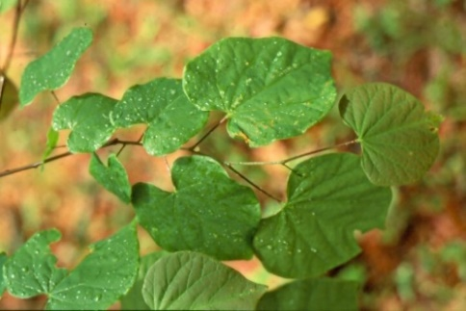  Eastern Redbud (Cercis canadensis) heart-shaped leaves.  NPS Photo.  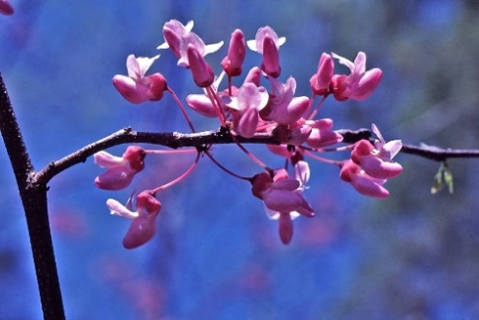  Eastern Redbud; Cercis canadensis; blooming in spring.  NPS Photo, Photographer: Gary Fleming.

Common and Scientific Name: White Oak (Quercus alba)  Mature Size: Medium to large, deciduous tree; 60 to 80 feet (18-24 m) in height.  Native Range: Southwest Maine to northern Florida.  Leaf shape/margins: Oval, seven-to nine round lobes, shallow pocket and grow alternately.  Leaf Color: Deep glossy green upper surface; turn red or brown in autumn.  Seed/Fruit: Light brown cup shaped acorns with dark brown top.  Flower: Yellow to reddish and hairy flowers that appear in May when leaves are one-third grown.  Bark: Light ash-gray and peels from the top.  Interesting characteristics: In craftmanship, the wood is known to be water-and rot-resistant. The acorns were an important food source for Native American tribes and the oils obtained from pressed acorns were used to alleviate pain in joins. |  | 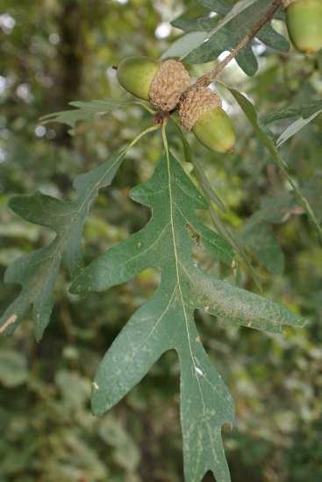  Green oak leaves with two acorns.  NPS Photo  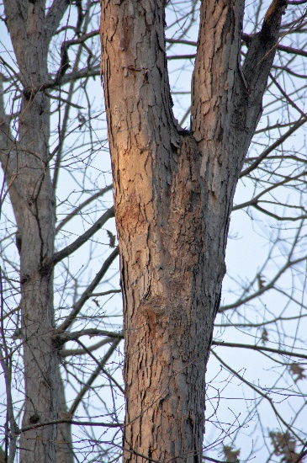  White Oak Tree and bark.  NPS Photo

Common and Scientific Name: Virginia Pine (Pinus virginiana) Alternate name: Possum pine.  Mature Size: 15 to 23 m (50 to 75 ft) at age  50 years of age.  Native Range: Generally, grows throughout the Piedmont and at lower elevations in the mountains from central Pennsylvania southwestward to northeastern Mississippi, Alabama, and northern Georgia.  Leaf shape/margins: Short, twisted needles that usually grow in bunches of two; typically, 2 inches (5 cm) long.  Leaf Color: Yellow-green  Seed/Fruit: Seed cones, are brown and almost the same color as the bark, larger than the pollen cones, 4–7 cm and spread throughout the tree.  Flower: Lacks flowers; produces pollen cones are circular, yellow with red accents; 10–20 millimeters in size.  Bark: Red and brown in color; young stems are smooth, whereas older bark tends to be rough with relatively flaky scales.  Interesting characteristics: Once considered a "forest weed" and called scrub pine, however it is now known as one of the most popular trees of commercial importance such as being the most preferred Christmas tree. |  | 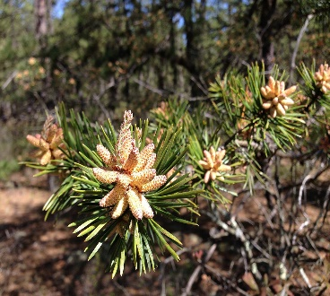  Pinus virginiana (Virginia Pine) new growth and pollen cones along the Mount Misery Trail in Brendan T. Byrne State Forest, New Jersey.  Wikimedia Commons, the free media repository.  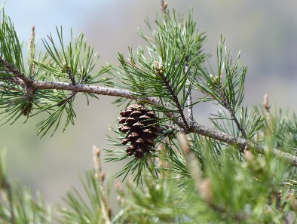  Virginia Pine Photographed by Milo Pyne, courtesy of NatureServe.  NPS Photo
Common and Scientific Name: Flowering Dogwood (Cornus florida) Alternate name: boxwood.  Mature Size: Multibranched shrub or small tree that commonly reaches 16 to 49 feet (5-15 m) in height.  Native Range: Southern-coastal Maine south to northern Florida.  Leaf shape/margins: Leaves grow opposite, are simple, egg-shaped, and entire (smooth).  Leaf Color: Dark green and turn red-brown in the fall.  Seed/Fruit: Cluster of 2-10 separate drupes (seeds with kernels inside) that ripen in late summer to early fall; yellow with a rosy blush to bright red.  Flower: White, pink, or red flowers that bloom in early spring. 4 rounded umbrella-shaped cluster petals grow with greenish-yellow centers.  Bark: Dark brown or gray with square patterns surrounded by deep ridges.  Interesting characteristics: Low-branching habit with a flattish crown. |  | 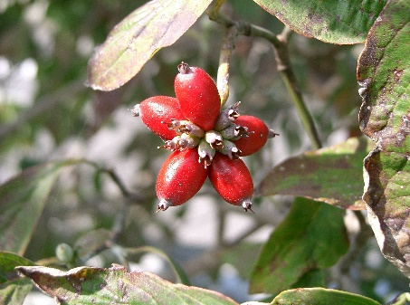  Flowering Dogwood tree fruit. Wikimedia Commons.  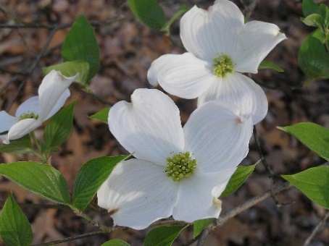  Flowering Dogwood tree in bloom.  NPS Photo

Non-Native Trees
Common and Scientific Name:  Tree-of-Heaven (Ailanthus altissima)  Mature Size: Up to 80 feet in height or more with a diameter of 6 feet.  Native Range: Northeast, central China, and Taiwan. Found anywhere in United States especially in arid and wet regions such as the great plains and southern Appalachian Mountains.  Leaf shape/margins: Compound, “lance” shaped leaflets, smooth and one leaf can range in length from 1 to 4 feet with anywhere from 10 to 40 leaflets.  Leaf Color: Develop bronze and grow into a medium dark green.  Seed/Fruit: Winged seeds (Samaras)  Flower: Small, 5 petals & yellowish green to reddish.  Bark: Smooth, light grey, becomes rougher with light tan cracks as the tree ages.  Interesting characteristics: When crushed, the leaves and all plant parts give off a strong, offensive odor (Burnt Peanut-butter). Often confused with native species that have compound leaves and numerous leaflets, such as: staghorn sumac, black walnut, and hickory. |  | 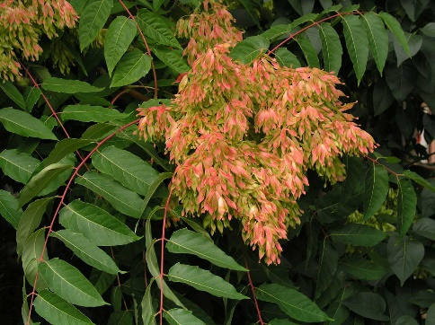  A female Tree of Heaven plant bearing a heavy load of seeds in Valladolid, Spain.  Photo courtesy of Wikipedia Commons.  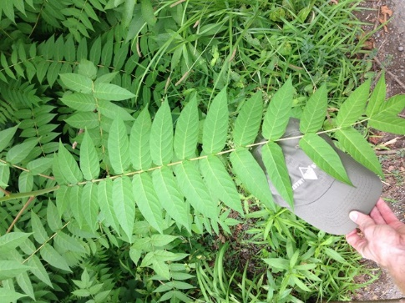  Close up of Tree of Heaven leaf - note the size of the leaf and the notches at the base of each leaflet.  NPS Photo

Common and Scientific Name:  Norway Maple (Acer platanoides)  Mature Size: 40 to 98 feet (12-30 m) in height.  Native Range: Continental Europe and western Asia; introduced to the United States in the mid- to late 1700s in eastern Pennsylvania. It can be found in southern New England south to Chesapeake Bay, the piedmont of southern Virginia and northern North Carolina, and the Appalachians of western North Carolina, South Carolina, and northern Georgia.  Leaf shape/margins: Leaves grow opposite and are palmately lobed (like the shape of a hand) with 5 pointy lobes; each lobe has 1 to 3 large side teeth.  Leaf Color: Dark green and turns yellow and sometimes orange-red in the fall. Unlike the Sugar maple that has a clear sap, the leaf petiole (Leafstalk) of the Norway maple, releases a milky sap when broken.  Seed/Fruit: 2-winged samaras (seeds) and each half of the fruit is typically 1.4 to 2.2 inches  (3.5-5.5 cm) long (Munger, 2003). The seeds are also flattened, while those of sugar maple are rounded.  Flower: Yellowish-green scented flowers that appear in the early spring.  Bark: Grey-brown with narrow grooves.  Interesting characteristics: Listed by the state of Vermont as a Category II plant: "Exotic plant species considered to have the potential to displace native plants either on a localized or widespread scale" (Munger, 2003). |  | 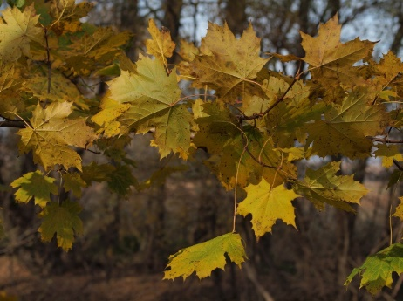  Leaves of a Norway maple tree; leaves turn a yellowish-brown color similar to sycamore leaves.  NPS Photo  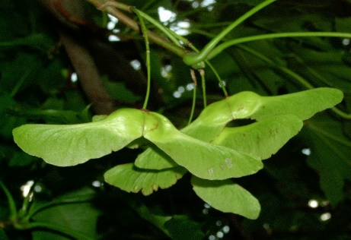  2-winged samaras (seeds) of a Norway maple tree.  Author: Krzysztof Ziarnek courtesy of Wikimedia Commons.  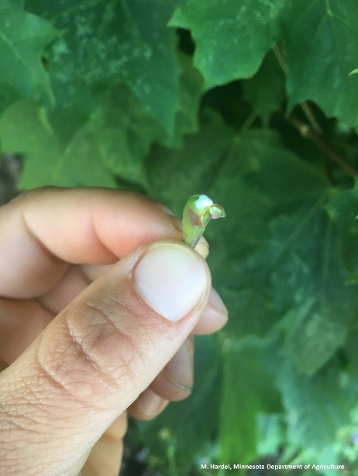  Broken petiole (Leafstalk) releases white sap from a Norway maple leaf. Courtesy of M. Hardel, Minnesota Department of Agriculture.
References:
Brakie, Melinda. 2010. Plant fact sheet for eastern redbud (Cercis canadensis). USDA-Natural Resources Conservation Service, East Texas Plant Materials Center. Nacogdoches, TX 75964
File: Acer platanoides fruit kz.jpg. (2020, September 12). Wikimedia Commons, the free media repository. Retrieved 18:53, September 28, 2021 from https://commons.wikimedia.org/w/index.php?title=File:Acer_platanoides_fruit_kz.jpg&oldid=455980829.
File: Ailanthus-altissima.jpg. (2020, September 18). Wikimedia Commons, the free media repository. Retrieved 20:48, September 13, 2021 from https://commons.wikimedia.org/w/index.php?title=File:Ailanthus-altissima.jpg&oldid=464157461.
File: Benthamidia florida8.jpg. (2020, September 13). Wikimedia Commons, the free media repository. Retrieved 15:58, September 8, 2021 from https://commons.wikimedia.org/w/index.php?title=File:Benthamidia_florida8.jpg&oldid=457628872.
File: image-20200320135749-1.jpeg (3024×4032), Norway maple. (2021). Retrieved from M. Hardel, Minnesota Department of Agriculture: image-20200320135749-1.jpeg (3024×4032) (state.mn.us)
File:2013-05-10 10 32 15 Virginia Pine new growth and pollen cones along the Mount Misery Trail in Brendan T. Byrne State Forest, New Jersey.jpg. (2021, January 14). Wikimedia Commons, the free media repository. Retrieved 20:29, August 30, 2021 from https://commons.wikimedia.org/w/index.php?title=File:2013-05-10_10_32_15_Virginia_Pine_new_growth_and_pollen_cones_along_the_Mount_Misery_Trail_in_Brendan_T._Byrne_State_Forest,_New_Jersey.jpg&oldid=525957263.
Griffith, Randy Scott. 1991. Fraxinus americana. In: Fire Effects Information System, [Online]. U.S. Department of Agriculture, Forest Service, Rocky Mountain Research Station, Fire Sciences Laboratory (Producer). Available: https://www.fs.fed.us/database/feis/plants/tree/fraame/all.html [2021, July 12].
Griffith, Randy Scott. 1991. Liriodendron tulipifera. In: Fire Effects Information System, [Online]. U.S. Department of Agriculture, Forest Service, Rocky Mountain Research Station, Fire Sciences Laboratory (Producer). Available: https://www.fs.fed.us/database/feis/plants/tree/lirtul/all.html [2021, July 12].
Gover, A. & Jackson, D. R. (2018, October 8). Tree-of-Heaven. PennState Extension. https://extension.psu.edu/tree-of-heaven
Katherine K. Carter and Albert G. Snow, J. (n.d.). Virginia Pine. Retrieved from USDA Forest Service Southern Research Station: https://www.srs.fs.usda.gov/pubs/misc/ag_654/volume_1/pinus/virginiana.htm
Munger, Gregory T. 2003. Acer platanoides. In: Fire Effects Information System, [Online]. U.S. Department of Agriculture, Forest Service, Rocky Mountain Research Station, Fire Sciences Laboratory (Producer). Available: https://www.fs.fed.us /database/feis/plants/tree/acepla/all.html [2021, September 8].
Native Trees & Shrubs. (2016, August 1). National Park Service, Chesapeake and Ohio Canal National Historical Park, Maryland. https://www.nps.gov/choh/learn/nature/native-trees-and-shrubs.htm
Non-native Plants. (2020, May 4). National Park Service, Chesapeake and Ohio Canal National Historical Park, Maryland. https://www.nps.gov/choh/learn/nature/nonnative-plants.htm
Rosario, Lynn C. 1988. Acer negundo. In: Fire Effects Information System, [Online]. U.S. Department of Agriculture, Forest Service, Rocky Mountain Research Station, Fire Sciences Laboratory (Producer). Available: https://www.fs.fed.us/database/feis/plants/tree/aceneg/all.html [2021, July 12].
Sullivan, Janet. 1994. Acer saccharinum. In: Fire Effects Information System, [Online]. U.S. Department of Agriculture, Forest Service, Rocky Mountain Research Station, Fire Sciences Laboratory (Producer). Available: https://www.fs.fed.us/database/feis/plants/tree/acesah/all.html [2021, July 12].
Sullivan, Janet. 1993. Asimina triloba. In: Fire Effects Information System, [Online]. U.S. Department of Agriculture, Forest Service, Rocky Mountain Research Station, Fire Sciences Laboratory (Producer). Available: https://www.fs.fed.us/database/feis/plants/tree/asitri/all.html [2021, July 12].
Sullivan, Janet. 1994. Cercis canadensis. In: Fire Effects Information System, [Online]. U.S. Department of Agriculture, Forest Service, Rocky Mountain Research Station, Fire Sciences Laboratory (Producer). Available: https://www.fs.fed.us/database/feis/plants/tree/cercan/all.html [2021, July 14].
Sullivan, Janet. 1993. Pinus virginiana. In: Fire Effects Information System, [Online]. U.S. Department of Agriculture, Forest Service, Rocky Mountain Research Station, Fire Sciences Laboratory (Producer). Available: https://www.fs.fed.us/database/feis/plants/tree/pinvir/all.html [2021, August 30].
Sullivan, Janet. 1994. Platanus occidentalis. In: Fire Effects Information System, [Online]. U.S. Department of Agriculture, Forest Service, Rocky Mountain Research Station, Fire Sciences Laboratory (Producer). Available: https://www.fs.fed.us/database/feis/plants/tree/plaocc/all.html [2021, July 12].
Tirmenstein, D. A. 1991. Cornus florida. In: Fire Effects Information System, [Online]. U.S. Department of Agriculture, Forest Service, Rocky Mountain Research Station, Fire Sciences Laboratory (Producer). Available: https://www.fs.fed.us/database/feis/plants/shrub/corflo/all.html [2021, September 7].
Tirmenstein, D. A. 1991. Quercus alba. In: Fire Effects Information System, [Online]. U.S. Department of Agriculture, Forest Service, Rocky Mountain Research Station, Fire Sciences Laboratory (Producer). Available: https://www.fs.fed.us/database/feis/plants/tree/quealb/all.html [2021, July 15].
The Nature Conservancy [Webpage]. (2020, July 06). Tree of Heaven. Retrieved from https://www.nature.org/en-us/about-us/where-we-work/united-states/indiana/stories-in-indiana/journey-with-nature--tree-of-heaven/#:~:text=The%20tree%20of%20heaven%20was,popular%20when%20planning%20urban%20landscaping.
Wikipedia contributors. (2021, September 4). Ailanthus altissima. In Wikipedia, The Free Encyclopedia. Retrieved 19:38, September 8, 2021, from https://en.wikipedia.org/w/index.php?title=Ailanthus_altissima&oldid=1042311944
Wikipedia contributors. (2021, September 8). Acer platanoides. In Wikipedia, The Free Encyclopedia. Retrieved 19:08, September 8, 2021, from https://en.wikipedia.org/w/index.php?title=Acer_platanoides&oldid=1043154623
Wikipedia contributors. (2021, September 7). Cornus florida. In Wikipedia, The Free Encyclopedia. Retrieved 21:23, September 7, 2021, from https://en.wikipedia.org/w/index.php?title=Cornus_florida&oldid=1042993389
Wikipedia contributors. (2021, May 7). Pinus virginiana. In Wikipedia, The Free Encyclopedia. Retrieved 19:35, August 30, 2021, from https://en.wikipedia.org/w/index.php?title=Pinus_virginiana&oldid=1021996252
Wikipedia contributors. (2021, June 18). Quercus alba. In Wikipedia, The Free Encyclopedia. Retrieved 14:42, July 15, 2021, from https://en.wikipedia.org/w/index.php?title=Quercus_alba&oldid=1029234810

