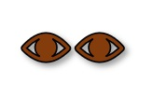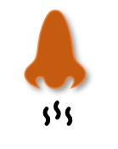
Using your eyes, Look for long, dark green (10 to 40) leaflets. | Using your hands, feel the bark of the tree. Does it feel smooth but at the same time does the bark seem to be flaking off? | Using your ears and eyes, listen for leaves moving in the wind on the tree or blowing on the ground. Are the leaves brown & withered?
Using your nose, smell the bark of this tree to see if it has a sweet & bitter fragrance. | Using your sense of touch and smell, rub your fingers back and forth over a leaflet to see if it smells of burnt peanut butter. | Using your eyes and hands, look to see if the fruit of the tree is brown? Is it shaped into a densely packed ball? Does it feel fluffy?
Using your ears, listen for fruit that is edible & tastes like banana or mango, falling to the ground because it is now ripe. | Using your eyes, look at the shape of the leaf. Does it look like a Tulip? | Using your hands, feel if the leaflets are toothed or lobed.
Using your eyes, look at the shape of this leaf. Does it look like a star? | Using your sense of touch and smell, rub your fingers back and forth over a leaf to see if it smells of green bell peppers. | Using your eyes, look to see if underneath the leaf is silver.
Using your hands, feel the bark of the tree. Does it feel like there are deep broad ridges? Does it feel scaly? | Using your ears, listen for these types of green & red winged seeds (Samaras) blowing in the wind. | Using your eyes, look for a leaf that is pear-shaped with pointed tips.

