ALSEK RIVER VISITOR USE MANAGEMENT PLAN

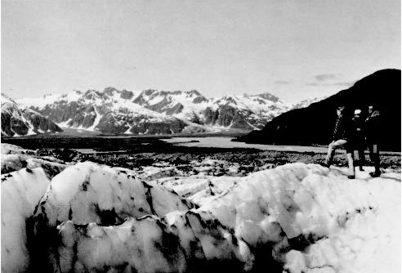

GLACIER BAY NATIONAL PARK & PRESERVE JULY 1989

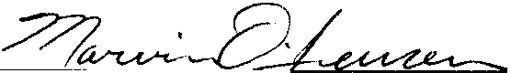
Approved by:

Superintendent

Date:
July 12, 1989

TABLE OF CONTENTS
- INTRODUCTION 1
  - PURPOSE AND SCOPE
  - RIVER MANAGEMENT OBJECTIVES 2
  - LEGAL CONSIDERATIONS 3
- RIVER MANAGEMENT 5
  - WILDERNESS ZONES 5
    - Resource Conditions 5
    - Social Conditions 5
    - Management Conditions 6
  - FACILITIES 6
  - ACCESS 6
  - VISITOR MANAGEMENT 6
    - Total Use Limits 6
    - Allocation of Trips 7
    - Scheduling of Trips 8
    - Group Size 9
    - Stay Limit 9
    - Orientation and Registration 10
    - Regulations and Closures 10
    - Prohibition on Motors 11
  - RESOURCE MANAGEMENT & RESEARCH 11
  - COORDINATION WITH CANADIAN GOVERNMENT 12
- FUTURE ACTIONS/ PLAN UPDATE 13
- APPENDIX 14
  - ANNUAL RIVER OPERATING PLAN 14

INTRODUCTION
- PURPOSE AND SCOPE
The most outstanding features that the Alsek and Tatshenshini rivers offer are uncommon environmental diversity, very impressive scenery, and an outstanding wilderness experience. All of these attributes contribute to an outstanding opportunity for wildlands based recreation. Even in Alaska and western Canada, where the term "wilderness' is an over-popularized cliché', the Alsek River offers an uncommonly pristine experience, free for the most part of evidence of man and his works (see insignificant Features.,, draft plan). Because a wilderness experience is one of the most outstanding attributes of the river, it is sensitive to the number and size of parties floating the river. This sensitivity to use is not shared by rivers which offer primarily a different experience, such as whitewater challenge, world class fishing, or other values.

The purpose of this plan is to establish policies and procedures to guide management of visitor use of the portion of the Alsek River watershed within Glacier Bay National Park and Preserve (see Figures 1 & 2). It pertains exclusively to float trips on the Alsek River and related side excursions from the river. Non-recreational issues and concerns affecting the Alsek River such as subsistence, commercial fishing, mining etc. are not within the scope of this plan, as they have particular legal contexts that are best described in separate documents.

In 1982, the park developed an interim Alsek River management plan designed to provide guidance for the early years of the National Park Service management. During this interim period, the park gathered information about the river, recreational use and environmental impacts. A major research contract between the National Park Service and the University of Washington's College of Forest Resources was conducted in 1984. It better defined river user's expectations and preferences for various management alternatives.

The draft version of the current Alsek River Visitor Use Management Plan, dated May 1988, was available for public comment from June 3 through August 31, 1988. Late comments were accepted until February 1989. Public meetings on the plan were held in Gustavus (6/27/88) and Juneau (6/28/88). Approximately 30 letters concerning the plan were received by the park and are available for review at Bartlett Cove.

The plan is consistent with, and subsidiary to, the park-wide general management plan which was approved in September 1984. It is also consistent with, and developed at the same time as, the Glacier Bay Wilderness Visitor Use Management Plan. The plan presents the general concepts which are expected to guide visitor

1

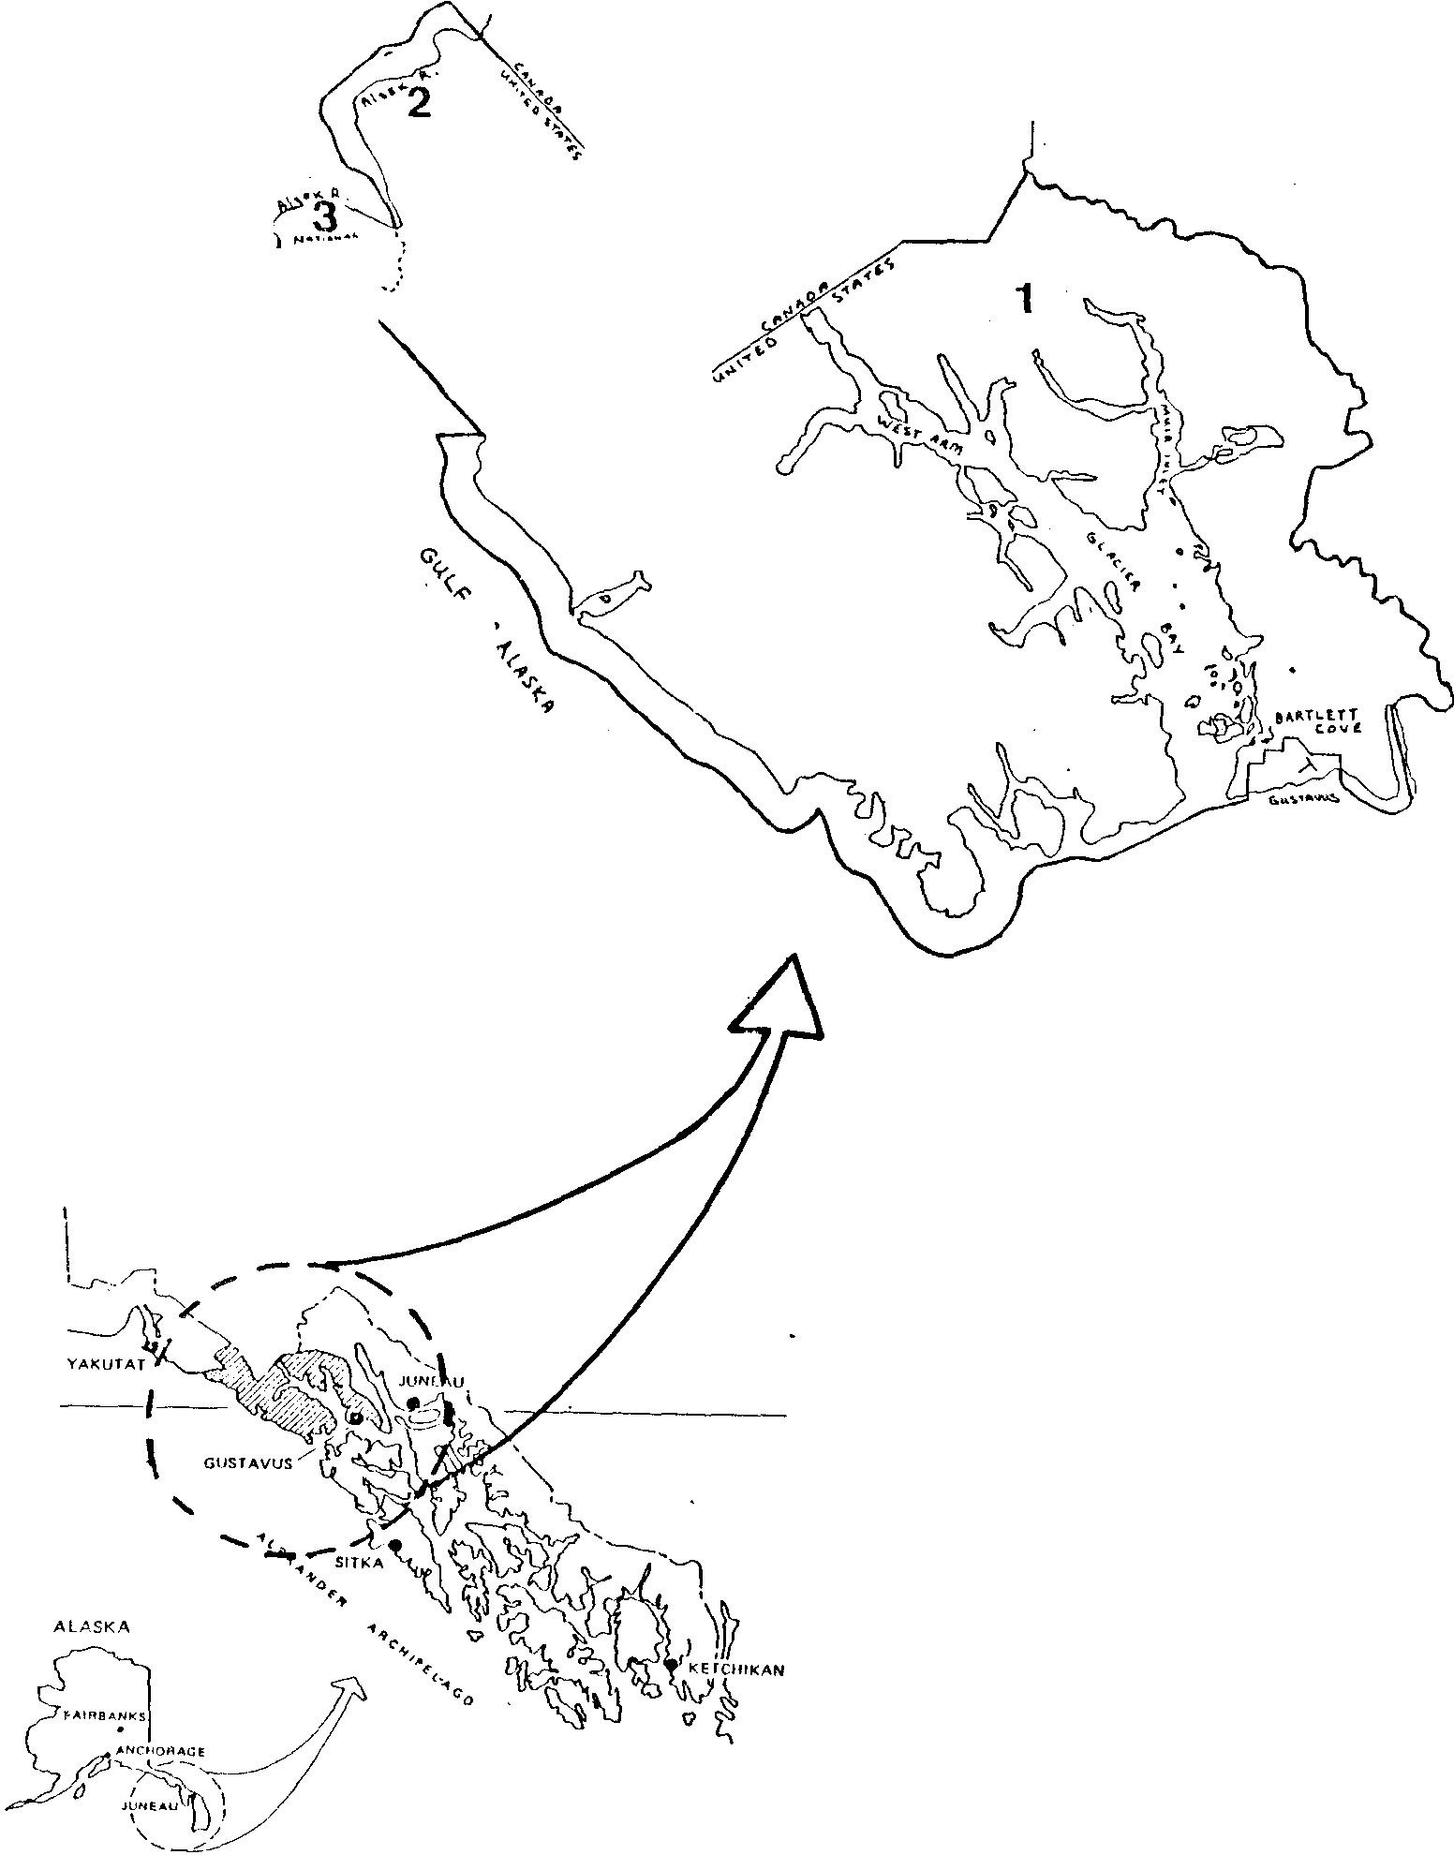THE REGION
GLACIER BAY NATIONAL PARK AND PRESERVE

p 1....
·
....

Glacier Bay
National Park

Figure l

l. Glacier Bay Wilderness

l. Alsek River Watershed

3. Glacier Bay National Preserve

!!,,Bo,,_ LAT ----j

Figure 2
(Dalton post
star;J/

0
(,.
1-
'
'( '' .,/ /
J \

' ' .', l'- \:''. 'i

'\-
0 ,._
'

: i
'.l
..
.
'---: .,
"(

. -1'
\ '

1n, .. ..\' '·,..

--

.,..: -

C I'

:)_,!

· .. ,:'' { ,._/

;' ,
..
' 0:
·J'
i ._
/, .. ,' : I
' Co I'"')
I
''
,.
(
'

' ...,..
',
.
\
o'v
·\s,,
' '

s

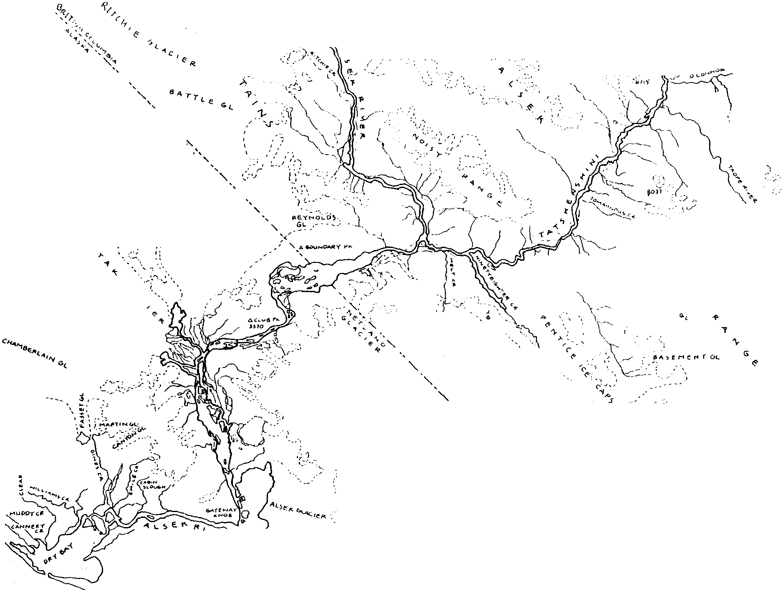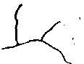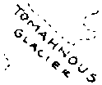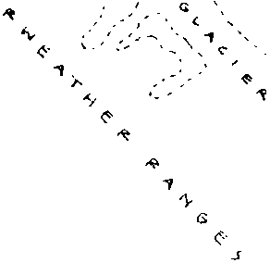

•'

) ..,, , ,..,
Dry Bay A. 9 ··..

-' /

.)
' ', ,
66'10, :1'(
'I
\
''\
\
'\
. ' ', . "'"'\,

/
:/
/

use of the Alsek River for the next 5 to 10 years. An annual operating plan in the appendix includes detailed information that is subject to change on a more frequent basis.

The plan meets the National Environmental Policy Act requirements for a categorical exclusion (516 DM 6, Appendix 7, sec. 7.4 B (1)) and no further environmental documentation has been prepared.

- RIVER MANAGEMENT OBJECTIVES
Glacier Bay National Park and Preserve is managed in accordance with existing legislative mandates (National Park Service Act of 8/25/16, Wilderness Act of 1964, ANILCA of 1980, etc.) and National Park Service Management Policies. Recreational use will be managed consistent with the overall management objectives of the park, preserve and designated wilderness. These objectives are listed in the Glacier Bay General Management Plan and are incorporated in this subsidiary plan by reference.

The objectives of this river management plan are to:
- Manage recreational use of the Alsek River consistent with the overall management objectives of the park, preserve and designated wilderness. These objectives are listed in the Glacier Bay general management plan and are incorporated in this subsidiary plan by reference.

- The following management objectives are consistent with the park wide objectives referenced above and relate specifically to recreational use of the Alsek River:

  - "....take such steps as are necessary to insure that overuse of the [Alsek] river does not occur." (ANILCA Legislation History, Congressional Record - House Vol. 126, p.H10529, November 12, 1980.)

  - "A quality wilderness river experience should be protected." (Ibid)

  - "The Secretary [of the Interior] is encouraged to seek cooperative agreements with Canada which serve to protect the entire watershed of the Alsek River, and provide for cooperative visitor use of the river and its environs." (Ibid, plus Congressional Record -Senate, Vol. 176, p. S1l 133, August 12, 1980).

  - Continue to monitor effects of human use on the resources and park values associated with river. Monitor visitor perceptions and opinions of river use and management. Adjust management policies as appropriate.

2

  - Ensure that other legitimate uses of the Alsek River, including commercial fishing and subsistence, are not detrimentally affected by recreational activities.

- LEGAL CONSIDERATIONS
On December 2, 1980 the Alaska National Interest Lands Conservation Act (ANILCA) expanded Glacier Bay National Monument by 550,000 acres and redesignated the area Glacier Bay National Park & Preserve. This addition included most of the Alsek River and its immediate environment within the United States. Previously, much of the river had been added to Glacier Bay National Monument on December 1, 1978 by Presidential Proclamation. Prior to 1978 the
U.S. portion of the river was entirely within the Tongass National Forest and managed by the U.S. Forest Service.

All federal park lands surrounding the Alsek River were also legally designated as wilderness by ANILCA, except Alsek Lake, small blocks of land bordering the outlet of the lake and lands within Glacier Bay National Preserve.

ANILCA provides the following guidance for park management of the Alsek River. "The Monument addition and preserve shall be managed for the following purposes, among others: to protect a segment of the Alsek River. fish and wildlife habitats and migration routes....'. The legislative history of ANILCA provides that "the National Park Service must take such steps as are necessary to insure that overuse of the river does not occur. A quality wilderness river experience should be protected." (Congressional Record - House, Vol. 126, page H10539, Nov. 12, 1980). "The Secretary is encouraged to seek cooperative agreements with Canada which serve to protect the entire watershed of the Alsek River, and provide for cooperative visitor use of the river and its environs., (Ibid and Congressional Record - Senate, Vol. 126, p. 511133, August 12, 1980).

3

RIVER MANAGEMENT
- WILDERNESS ZONES

The entire Alsek River watershed within Glacier Bay National Park is designated as zone 1 and a pristine zone in accord with the park-wide backcountry zoning plan. Glacier Bay National Preserve is not included in the zone plan. Zone 1 will be managed to maintain the following conditions:

  - Resource Conditions
Resource management will adhere to the following standard. Over the majority of the area resource effects from visitor use will not be apparent. Individual campsites will be used no more than 25% of the time during the July 1 to September 10 primary use season.
Disturbance to campsite vegetation and soils can be healed in one fallow year. Human effects on animal distribution, abundance, and behavior will be too slight to be biologically significant.

However, due to the linear nature of river use, which is quite different from the more random pattern of use within Glacier Bay, the three or four most popular campsites (Walker Glacier, Alsek spit, and Gateway Knob) along the river may be occupied almost 100% of the nights during the primary use season as use approaches one launch per day. Impacts at these popular campsites will include some loss of vegetation, soil compaction, and other evidence of use. Seasonal displacement of wildlife will occur at these three or four sites.

  - Social Conditions
The management plan is based on an average of one launch per day on the river. The standard will be for all groups to camp out of sight and sound of each other and to encounter no more than one different party along the river during the day for 90% of the groups (encountering the same group several times in one day will be treated as one encounter). As use increases and approaches one launch per day, more aggressive scheduling will be essential to maintain even spacing between groups.

At the three or four most popular campsites, inter-group contacts will be more frequent. Groups frequently spend two nights at these sites. The standard will be for groups to camp out of sight and sound of each other insofar as possible. Encounters with other groups should be held to two or less per day for 90% of the groups (encountering the same group several times in one day will be treated as one encounter).

4

  - Management Conditions
Over the majority of the area, management will seldom be evident. Off-site education, area closures and trip scheduling will be the primary modes of visitor management.

- FACILITIES
No facilities or improvements will be constructed or installed along that portion of the Alsek River within Glacier Bay National Park.

In the Preserve, some minor improvements have been constructed at the take-out. Dry Bay is not accessible by road. All river trip takeouts are by air, using the 4000' main airstrip adjacent to Sitka Sound Seafoods. This runway is accessible from the Alsek River via a side channel. A camping area for river rafters has been established 75 yards from the airstrip. It includes a pit toilet and well. In addition, a National Park Service ranger is stationed nearby. The ranger can assist with local information and radio to Yakutat if necessary. There is no public dump at Dry Bay and rafters are required to take their trash with them when flying out. No other facilities, such as a shelter, will be built.

Presently, three small concessions - a hunting lodge and two sport fish lodges, are authorized to provide overnight accommodations and food service at Dry Bay. Additional concessions for these services have not been requested by the river rafters, were not supported by the public comment on the draft plan, and therefore will not be authorized.

- ACCESS
Float trips on the Alsek River start in Canada. The most common put-in is Dalton Post, for trips on the Tatshenshini River. A small number of parties put-in at Haines Junction on the mainstem of the Alsek River. Both of these points are road accessible.

Dry Bay, Glacier say National Preserve, is the normal take-out. D. VISITOR MANAGEMENT
  - Total Use Limits
In order to preserve the wilderness character, minimize disturbance of wildlife and other river resources and provide the quality of visitor experience outlined in the management objectives, the National Park Service will limit the number of

5

float trips on the Alsek River within Glacier Bay National Park & Preserve to an average of one trip per day. During the primary use season, from July 1 - September 10 (72 days), the number of float trips arriving at Dry Bay will be limited to 72 trips.

The interim management plan for the river, in effect from 1979
-1988, limited the number of commercial trips to 84 for the entire season. During that time, over 90` of the commercial trips arrived at Dry Bay during the July 1 - September 10 period. The number of private trips was not limited. This pattern of primary use season developed from practical considerations of weather, water levels, access to the put-in points on the two rivers in Canada, the ice break up on Alsek Lake and access to the air strip at Dry Bay.
Therefore, the prime season for arrivals at Dry Bay will continue to be July 1 through September 10.
The prime season for rafting is a total of 72 days and the total number of trips allowed on the river is based on one trip per day or 72 trips. This limit of 72 trips pertains to arrivals at Dry Bay beginning on July 1 and ending on September 10.

Prior to July l and after September 10, the goal will be to limit the total number of private and commercial trips to an average of one trip per day.

The final plan allows for a very small increase in commercial use on the Alsek River during the prime season, while authorizing additional trips in the off-season and providing for a more efficient utilization of trips throughout the year (see below). The plan also puts a cap on the number of private trips for the first time, though at a level which will probably not be reached for many years because actual use is much less than the number of trips available.

  - Allocation of Trips
    - Commercial and Private
During the July l - September 10 prime season, half (36) of the total authorized trips will be allocated to commercial guide companies and half (36) to private river runners. During the
off-season, half of the trips will also be allocated to commercial guide companies and half to private river runners.

Half of the authorized commercial trips will be allocated to companies in the United States and half to companies in Canada, continuing the 50-50 split from the interim river management plan. During the July 1 - September 10 prime season, therefore, 18 commercial trips will be allocated to US companies and 18 to Canadian companies. This allocation of commercial trips recognizes that the majority of the Alsek and Tatshenshini river system is in Canada. By providing a fair allocation of

6

commercial opportunities for guides from both countries, the plan seeks to continue the mutual cooperation of US and Canadian authorities in cooperatively managing this international river.

Specific numbers of trips allocated to each of the companies is outlined in the appendix. Assignment of additional commercial trips to individual companies, beyond the number currently authorized in their individual concession permits, will not be made at this time. The NPS intends to offer for public comment regulations defining the legal rights to additional services of "historical operators" (those who operated in Alaska park units prior to 1/1/79) under section 1307 of ANILCA. Until this process is complete, a permanent assignment of additional trips would be premature.

    - Temporary Reallocation
The National Park Service will review the Alsek River schedule and reallocate unscheduled commercial or private trips for the upcoming summer season to those parties, either commercial or private, who can use them. Unused commercial trips will be pooled and temporarily reallocated by the Park Service in the spring for the upcoming summer season, and afterwards as unused trips are relinquished by the guides.

Until private river running use is at a level that all of the available trips would be taken, a portion of the excess will be temporarily reallocated to the commercial guides on a year by year basis. The number of private trips will be tallied in October each year, and 50i of the unused private trips will be reallocated to the guides for the next season. This method will allow for an increase in the number of private trips while giving the guides the early commitment they need to advertise and book clients. This temporary reallocation of unused private trips will be discontinued when private trip interest is sufficient to use all of their allocated trips.

For the past ten years, only the US guides have used all of the trips (17) allocated to them. Of the 17 trips allocated to Canadian guides, an average of fewer than 10 per year have been used. Unused commercial trips have been reallocated to commercial guides on a first-come first-served basis. The number of private trips peaked at 18 in 1984 and has since declined.

  - Scheduling of Trips
In order to meet the objective of the plan to provide and protect a quality wilderness river experience some type of scheduling is necessary. At current use levels, the Park Service spreads use of the river over the summer season by voluntary means. The commercial operators report their schedule in advance to the park. The park compiles all the commercial schedules and sends

7

the compiled schedule back to the commercial operators so that they are aware of multiple launches on a single day and, thereby, have an opportunity to voluntarily revise their schedules to achieve better spacing. Since the guides seek to offer the best possible wilderness experience for their clients, this system has worked well at current use levels. This arrangement was initiated prior to the 1985 season and has received unanimous endorsement by the commercial operators. Consistent with the voluntary nature of this system, the Park Service will routinely provide this schedule to any private boater who inquires about running a trip on the Alsek River. Private boaters would then be asked to voluntarily minimize their encounters with other groups and to report their put-in and take-out dates to the park so they could be added to the compiled schedule.

As the total number of trips on the river grows, the Park Service will work towards implementing a mandatory reservation system. As use increases, this will be necessary in order to spread use over the summer and achieve the management objectives listed in the plan. Since the number of commercial trips currently far surpasses the number of private trips, and is likely to continue to do so for some time, a mandatory reservation system will likely be required for commercial trips first. The park anticipates that a mandatory reservation system for private parties will not be necessary for many years. Should such a need arise in the future a reservation system would be developed and implemented.

  - Group Size
The maximum group size on the river will be limited to 15 people for commercial and private trips, except as noted below. On commercial trips this includes clients, boatmen, and trainees.

For the past 10 years, the interim river management plan limited group size to 25 people. Since the guides have come to rely on this, the maximum group size for the 34 commercial trips authorized in the interim river management plan will continue to be 25 people, including clients, boatmen, and trainees. This "grandfather privileges will be relinquished at the time a commercial permit or license is sold or there is a change in the controlling interest of an existing commercial operator, as defined by 36 CFR 51.7.

The limit of 15 will apply to all trips other than those noted above. The unused private trips temporarily reallocated for commercial use will have group sizes of no more than 15.

  - Stay Limit
No group or individual will remain longer than three consecutive nights in the same campsite, and shall make a substantial move to

8

a new campsite after that time. This mandatory restriction is intended to prevent long term occupancy of campsites other groups may wish to use, minimize campsite deterioration and disruption of wildlife use patterns. Exceptions may be granted where these adverse impact can be avoided.

  - Orientation and Registration
Orientation and registration for river users is strongly encouraged but will continue to be on a voluntary basis at this time. The park will continue to make a comprehensive effort to contact visitors before their river trip. The objectives of this orientation and registration are:

    - Provide an update on safety and camping closures, particularly related to bears and other wildlife, and record expected return dates and obtain information necessary if a search and rescue should become necessary.

    - Provide information on minimum impact camping practices.
    - Orient visitors. Help them plan a more enjoyable trip by providing a general orientation to the river.

    - Collect information about the number of river users and their activities necessary to properly manage the river .

The park will make a maximum effort to accomplish these objectives without requiring a mandatory permit for noncommercial river users. However, if the voluntary approach proves inadequate or the number of private parties approaches the limit authorized by this plan, a mandatory permit will be required .

  - Regulations and Closures
Varying degrees of protection will be needed to insure natural life processes prevail throughout the Alsek River watershed. In most areas, the instruction in minimum impact camping practices and low level dispersed visitor use should be sufficient. Some of the minimum impact camping practices, such as those currently pertaining to the preservation of natural and cultural resources, food storage, fires, sanitation and refuse, and pets are mandatory and legally enforceable by inclusion in the code of federal regulations or compendium.

Current regulations and closures specific to the Alsek River are described in the annual river operating plan (see Appendix A).

9

  - Prohibition on Motors
The Glacier Bay General Management Plan (September 1984) includes the following:

“To minimize conflicts between boaters, floaters, and fishermen, no motorized vessels will be permitted above Gateway Knob.” (GMP, p. 71 )

This policy has already been implemented for commercial river guides and will continue. For private parties, implementation would require new regulations.

- RESOURCE MANAGEMENT & RESEARCH
Research data and basic inventory information contribute to the understanding of park resources and the effects that visitor use activities may have on park values. The same resource inventory, monitoring, and research policies and programs applicable elsewhere in Glacier Bay National Park & Preserve will be applied to the Alsek River watershed.

Several years ago the National Park Service began to systematically monitor the condition of the most popular campsites along the Alsek River. The monitoring includes a description and photos taken from the same points on a periodic basis. This effort to monitor campsites will continue.

Recreational use of the Alsek River has led to some physical and biological impacts on the river environment, such as improper disposal of human waste, litter, loss of vegetation and development of trails, occasional fire rings, water pollution, and disturbance or displacement of wildlife. These impacts can be reduced if river users assume responsibility for lessening their impacts. On the whole, the vast majority of river users appear to make a concerted effort to minimize evidence of human use. Management direction will be to develop and communicate the minimum impact message.

Glacier Bay's Bear Management Plan will apply to the Alsek River watershed as well as the rest of the park & preserve. In the past, bear management has not been a major problem along the river.
However, the following key elements of the park bear management plan will apply to the river:

  - Education and enforcement
  - Reduction of unnatural food sources
  - Closures
  - Monitoring

10

See the bear management plan for details.
The Antiquities Act under which Glacier Bay National Monument was set aside, ANILCA, and the Biosphere Reserve designation all recognize the importance of science in Glacier Bay. Research conducted in park wilderness will generally comply with all wilderness requirements but case by case exceptions may be made to allow appropriate projects to proceed. Research proposals are routinely reviewed for their effects on wilderness and general park visitors as well as scientific merit.

- COORDINATION WITH CANADIAN GOVERNMENT
The legislative history of ANILCA provides The Secretary is encouraged to seek cooperative agreements with Canada which serve to protect the entire watershed of the Alsek River, and provide for cooperative visitor use of the river and its environs , (Congressional Record - House, Vol. 126, pg. H10539, Nov. 12, 1980;
- Senate, Vol. 126, pg. 511133, Aug. 12, 1980). Several Canadian authorities share jurisdiction of the Alsek and Tatshenshini rivers, including the Yukon Territory, Province of British Columbia, and the Federal government. Much of the mainstem of the Alsek River, but little of the Tatshenshini, flows through Kluane National Park, administered by Parks Canada.

Since 1979, numerous contacts between Glacier Bay National Park and Preserve and these Canadian authorities have been established. The interim Alsek River Management Plan and the draft of this plan were closely coordinated with Canadian authorities Though Canadian interest in the river has been high, a joint U.S.-Canadian river management plan has been premature. The Yukon portion of the Alsek River, within Kluane National Park, was nominated for inclusion in the Canadian Heritage Rivers system. The British Columbia portion cannot be nominated since the provincial government has, to date, declined to participate in the system. Designation would lead to a management plan. The Alsek and Tatshenshini rivers were approved in 1985 for study for inclusion in the British Columbia Provincial Recreation Corridors System. The U.S. National Park Service supports the Yukon, British Columbia and Canadian Federal governments in their efforts toward protective designations that would prevent consumptive uses from deteriorating the wilderness recreational qualities of this river system.

Currently, British Columbia regulates river rafting and requires permits for commercial operators under the Canada Shipping Act. Regulation concerns primarily river safety and the number of permits is not limited. U.S. National Park Service concession permits require commercial operators to comply with all Canadian requirements for operating on the river.

11

Glacier Bay National Park and Preserve will continue to coordinate planning and management for the Alsek River with appropriate Canadian authorities. A cooperative river management plan remains a long term goal.

12

FUTURE ACTIONS/ PLAN UPDATE
The UPS will review and analyze information from the ongoing monitoring program and other changes which may necessitate updating or modifying this plan. The plan was written so as to give park managers some flexibility in responding to changing conditions.
Some issues such as mandatory permits for private parties involve future actions which may be necessary if the current plan proves inadequate. These future actions are within the scope of the existing plan and may be adopted without revising the plan. The river visitor use management plan presents the general concepts which are expected to guide visitor use for 5 to 10 years. An annual operating plan in the appendix includes detailed information that is subject to change on a more frequent basis, such as current regulations. The method of assigning commercial trips to individual companies will also be included in the annual operating plan after these decisions are made.

If significant future changes are necessary, the plan will have to be modified. In this case plan modifications and the rationale for them will be made available for public comment.

13

APPENDIX A

ANNUAL RIVER OPERATING PLAN 1989
This document serves as a supplement to the Alsek River Visitor Use Management Plan. It includes detailed information that is subject to change on a more frequent basis than the parent plan.
ASSIGNMENT OF COMMERCIAL TRIPS
Following is the assignment of commercial trips. The number of trips assigned to individual US guides is the same as under the previous interim river management plan. This assignment shall be temporarily continued until regulations defining the legal rights to additional services of .,historical operators" (those who operated in Alaska park units prior to 1/1/79) under section 1307 of ANILCA are final.

US Guides # Authorized Trips
Alaska Discovery 3
Chilkat Guides | 1
Colorado River & Trail | 1
James Henry River Journeys | 1
Sobek | 7
Wilderness River Outfitters | 2
Gary Gray | 2

Unallocated
Total 18

Canadian Guides

Trips are not currently assigned to individual companies. A total of 18 trips for Canadian guides are available.

REGULATIONS AND CLOSURES
All parties, both commercial and private, will be required to use fire pans for all fires while on the river. The National Park Service believes the use of fire pans has had a significant positive effect in minimizing the evidence of recreational use of the river without imposing a hardship on river users. Major credit for this goes to the commercial guides, who have most consistently used fire pans and shown their use is good practice. The park's compendium to 36 CFR 2.13(a) currently reads:

Within 1/2 mile of the Alsek River - Except at Dry Bay, fires must be contained inside a fire pan.

