**LESSON PLAN**

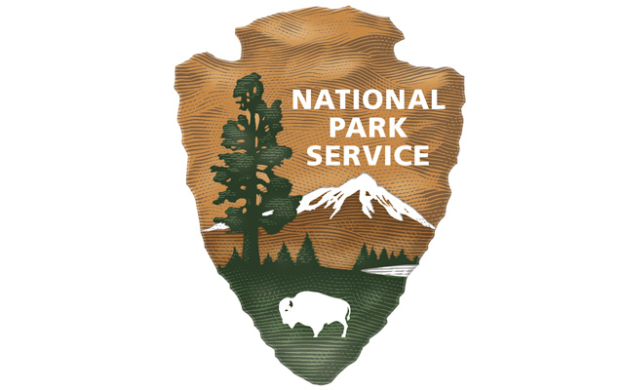The Arrowhead: Emblem of the National Park Service Elementary Lesson

Bottom of Form

**GRADE LEVEL:**

Elementary: Second Grade through Fifth Grade

**SUBJECT:**

Social Studies

**DURATION:**

90 Minutes

**COMMON CORE STANDARDS:**

4.RI.3, 4.RI.4, 4.RI.5

**CA STATE History-Social Science Content STANDARDS:**

2.3 Students explain governmental institutions and practices in the United States and other countries.

3.1 Students describe the physical and human geography and use maps, tables, graphs, photographs, and charts to organize information about people, places, and environments in a spatial context.

3.4 Students understand the role of rules and laws in our daily lives and the basic structure of the U.S. government.

4.1 Students demonstrate an understanding of the physical and human geographic features that define places and regions in California.

5.7 Students describe the people and events associated with the development of the U.S. Constitution and analyze the Constitution’s significance as the foundation of the American republic.

**THINKING SKILLS:**

Understanding: Understand the main idea of material heard, viewed, or read. Interpret or summarize the ideas in own words. Analyzing: Break down a concept or idea into parts and show the relationships among the parts. Creating: Bring together parts (elements, compounds) of knowledge to form a whole and build relationships for NEW situations. Evaluating: Make informed judgments about the value of ideas or materials. Use standards and criteria to support opinions and views.

Essential Question/Objective

In this lesson students will learn about the mission of the National Park Service and how it  
relates to Joshua Tree National Park through a guided exploration of the elements  
represented on the NPS Arrowhead emblem. By the end of the lesson, students will be able to answer the questions:   
  
*How do the five elements on the arrowhead emblem symbolize the NPS?   
*How can the five elements on the arrowhead emblem be observed at Joshua Tree National Park?

Background

There are two versions of this activity aimed at different age/ability levels. The version for elementary students involves viewing a PowerPoint about the arrowhead emblem and Joshua Tree National Park, then creating their own emblem. The version for middle school students involves reading a brief piece about the significance of the arrowhead, then visiting the park website to find out how the arrowhead relates to Joshua Tree National Park. Fourth and fifth grade teachers should examine both versions and decide which best matches the ability level of their students.

Although this lesson is intended as a pre-visit activity for field trip groups, it could also serve as an introduction to any NPS-related classroom activity such as research projects for older students.

Preparation

*Computer for PowerPoint presentation

*Arrowhead Intro PowerPoint

*One copy per student of the Arrowhead Worksheet and the Arrowhead Emblem Exit Ticket.

Materials

Worksheets and coloring supplies.

Lesson Hook/Preview

*Show students the logos available in this CNBC article: <http://www.cnbc.com/2015/05/01/13-famous-logos-that-require-a-double-take.html>

*Ask students to predict what the logo is representing. The students will most likely say it just represents the company.

*Explain to students that each company actually put significant thought into the logo and used it to represent more than just the company name. Explain that the NPS views the arrowhead emblem similarly. Today the students will learn the five elements of the arrowhead emblem and how those elements represent the National Park Service as a whole, as well as Joshua Tree National Park specifically.

Procedure

**Part 1: Investigation**

1. After distributing copies of the Arrowhead Worksheet to each student, present Arrowhead Intro PowerPoint to the class using a data projector or similar means.

2. After each slide is shown that explains a particular element of the emblem, brainstorm as a class how that element might relate to Joshua Tree National Park. *Note: Depending on your proximity to the park and whether or not students have visited previously, students may or may not be able to generate ideas. If they are having difficulty, leading questions or other hints may be helpful.*

3. For each element, after some ideas have been generated, proceed to the next slide, which will show some specific examples of how the element applies to Joshua Tree. Allow students time to list examples on the worksheet for each element as you work through the slide show. Before showing the “pop quiz” slide, have students turn their worksheets over so they will have to try to describe the elements from memory.

**Part 2: Creation**

4. Remind students that the NPS emblem was designed to represent ALL sites in the National Park system, and that many sites don’t actually have any of the examples represented on the emblem, such as bison and sequoia trees.

5. Tell students to imagine that they have been hired to design a custom emblem that’s just for Joshua Tree National Park. They will need to include each of the five elements, but use only examples that can be found at Joshua Tree National Park.

6. As they begin to plan, you may want to go back through the slides to help them visualize elements of their design. Have students draw their designs on the blank arrowhead provided on the back of the worksheet. Remind them that neatness counts, and that effective use of color can make a design more attractive.

**Part 3: Presentation and Assessment**

7. Using the PowerPoint, project the original arrowhead emblem.

8. Each student will stand up and share his or her new arrowhead emblem with the class. The rest of the class will connect each element of the Joshua Tree new emblems with the original.

9. To conclude, the students will use an exit ticket to vote for their favorite emblem, which can be selected from any of the new designs or the original NPS design. The students must justify their vote.

Vocabulary

*Emblem - a symbolic object used as a distinctive badge.

*Element - a part of something, especially one that is essential or characteristic.

*Culture - the arts and other manifestations of human intellectual achievement regarded collectively.

*Landform - a natural feature of the earth's surface.

*Wildlife - wild animals or native fauna of a region.

Assessment Materials

**Arrowhead Emblem Exit Ticket**

Students will complete this after emblem presentations to demonstrate understanding of the five elements of the arrowhead emblem.

Arrowhead Emblem Exit Ticket

Supports for Struggling Learners

*Students can design new emblems in heterogeneous pairs.

Enrichment Activities

*Research other emblems or symbols of US government agencies, such as the Federal Communications Commission or the Environmental Protection Agency.

**The Arrowhead**

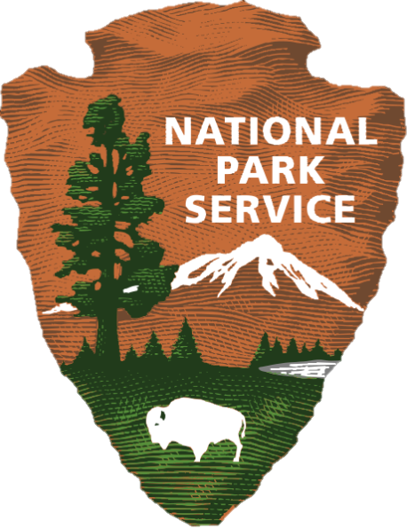Name:_______________________

This is the National Park Service arrowhead emblem. Each element of the arrowhead represents a feature protected within National Park Service sites. As you watch the PowerPoint, fill in the blanks below.

The sequoia tree represents________________________________________________

Examples from Joshua Tree: _______________________________________________ _______________________________________________________________________

The bison represents _____________________________________________________

Examples from Joshua Tree:_______________________________________________ _______________________________________________________________________

The mountain represents_________________________________________________

Examples from Joshua Tree: _______________________________________________ _______________________________________________________________________

The lake represents ______________________________________________________

Examples from Joshua Tree:_______________________________________________ _______________________________________________________________________

The arrowhead outline represents__________________________________________

Examples from Joshua Tree: _______________________________________________ _______________________________________________________________________

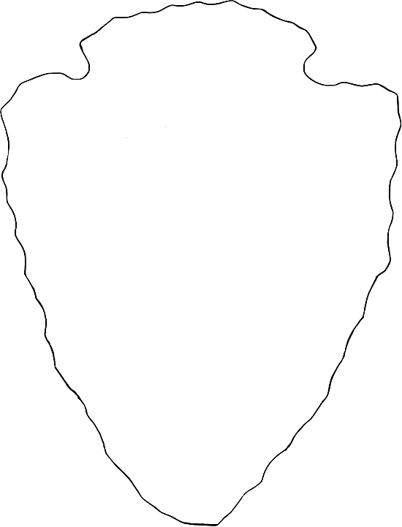 d

**ACTIVITY**

Pretend you’ve been hired to design a custom emblem just for Joshua Tree National Park. What things will you choose to represent each of the five elements? Use the blank arrowhead to create your design.

Arrowhead Emblem Exit Ticket

Name: ______________________________

I think the best National Park Service Arrowhead was designed by: ______________________

I believe this arrowhead emblem represents the park service and Joshua Tree National Park

because: __________________________________________________________________

__________________________________________________________________________

Arrowhead Emblem Exit Ticket

Name: ______________________________

I think the best National Park Service Arrowhead was designed by: ______________________

I believe this arrowhead emblem represents the park service and Joshua Tree National Park

because: __________________________________________________________________

__________________________________________________________________________

Arrowhead Emblem Exit Ticket

Name: ______________________________

I think the best National Park Service Arrowhead was designed by: ______________________

I believe this arrowhead emblem represents the park service and Joshua Tree National Park

because: __________________________________________________________________

__________________________________________________________________________

Arrowhead Emblem Exit Ticket

Name: ______________________________

I think the best National Park Service Arrowhead was designed by: ______________________

I believe this arrowhead emblem represents the park service and Joshua Tree National Park

because: __________________________________________________________________

__________________________________________________________________________