Africa
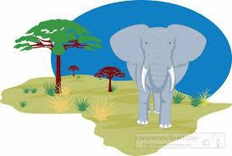
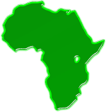

A drought (pronounced; dr-owt) happens when it hardly rains or doesn’t rain at
all for a very long time, causing a water shortage.

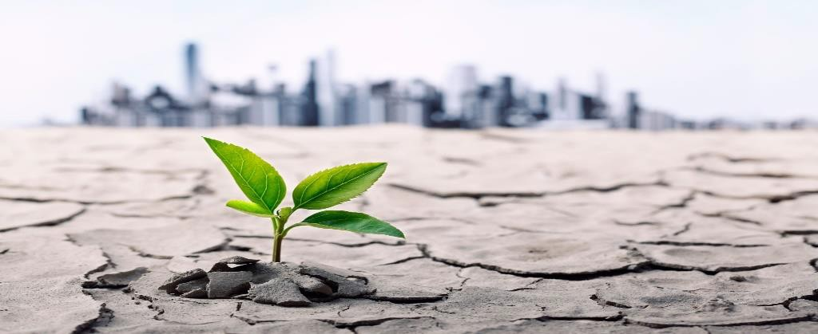

Africa
A terrible drought in East Africa has made it very hard for farmers to grow crops and feed their animals. It is also a problem for people who use a well for their drinking water.

Solutions:
African governments are building systems to pump water from deep within the ground,
and buy crop seeds that need little water for their farmers.
In Martin’s Time
One of the first serious droughts to hit the United States in
Martin Van Buren’s time lasted nearly ten years, from 1856 and 1865.
The middle part of the country was greatly affected, especially the bison.

The bison were forced to seek rivers in lower parts of the country where many people lived.
Sadly, there was not enough water for people and bison.
Bison are now protected in America.

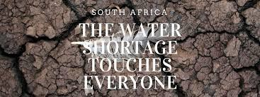
In Africa

In some communities in Africa, there is not enough water for everyone and everything. Here is an exercise to help understand the difficulty in Africa when it comes to water.
Supplies needed: 4 tall clear glasses and 1 pitcher filled less than halfway with water.

How would you issue the water in these containers to people in the community?

- Farmers
Needs water for crops to grow to provide food for everybody.

- School
Water is needed for the students to drink while at school.

- Households
Need water for cooking, cleaning, washing and bathing.

- Animals
Animals are used for transportation and to carry items, including buckets of water, for long distances.

Was it a difficult decision? Talk with an adult about how you went about deciding who or what should receive water and in what amount.

