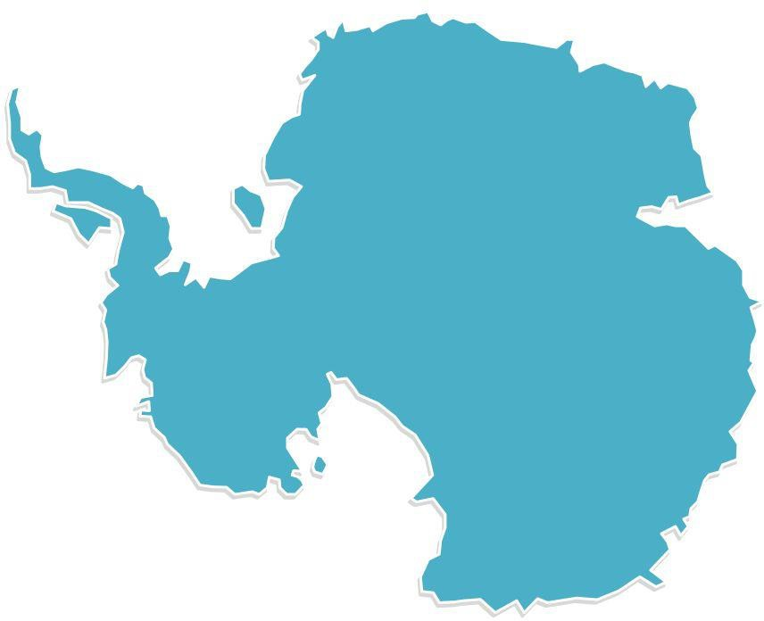
Antarctica

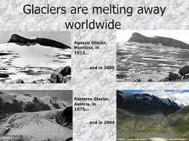
Glacial (pronounced: glay – shul) Melting occurs when glaciers melt faster than snow can fall and gather to create them.

Antarctica
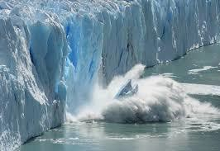
A glacier is snow built up over time, freezing into an enormous piece of ice.
The heat of the sun bounces off the glaciers and back into space, which helps keep the earth cool. Nearly 90% of the earth’s glaciers are in Antarctica.
The heat of the sun’s rays is getting trapped instead of being released, causing the glaciers to melt due to climate change. Everyone can help stop this by doing your best to prevent climate change.

In Martin’s Time
In 1816 an opposite problem occurred. Two volcanic eruptions in Asia, one after another, cooled the earth. 1816 is known as, ‘The Year
Without a Summer.’
During the year of 1816, a red fog, caused by the volcanic ash, prevented the sun from shining upon most parts of America. The ground throughout New York was so frozen, even in July nothing grew.
It took two years for the weather around the world to return to normal.

A family is one group made up of different members. Each family member has a different name.
Throughout the day, events create different experiences for each family member depending on their location.
For example, Smith had fun at school, Hannah was busy at work… get the picture?
Martin
Abe
Smith
Hannah
Angelica
Lizzy
John
The Van Buren Family

Throughout the day, events in the troposphere create different experiences all around the world depending on the temperature.
These events are called: Weather.
That’s why heavy water in the troposphere over Spain can cause rainy weather,
while ice crystals stuck together in the troposphere over Maine can cause snowy weather.
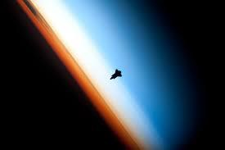

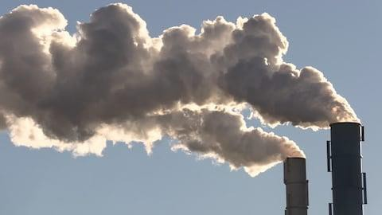
Lots of greenhouse gasses in the atmosphere trap the sun’s heat.

The trapped heat warms the earth, causing Glaciers to melt.

Over time the trapped heat changes the
earth’s climate.

Climate is what the weather is like over time.

So, Climate Change happens mainly because of things people depend on and use way too much. It also means:
We can all help to stop climate change!

Check your passport book to record some great ideas!

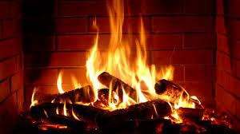

If a block of ice was placed in front of a fire like this, what would happen?
Why?

You can try the same at home. Take a piece of ice and put it on a small dish.
Set the dish on a sunny windowsill and check on it from time to time.
What happened?

It’s like glacial melting in Antarctica, isn’t it?

