Types of Trees
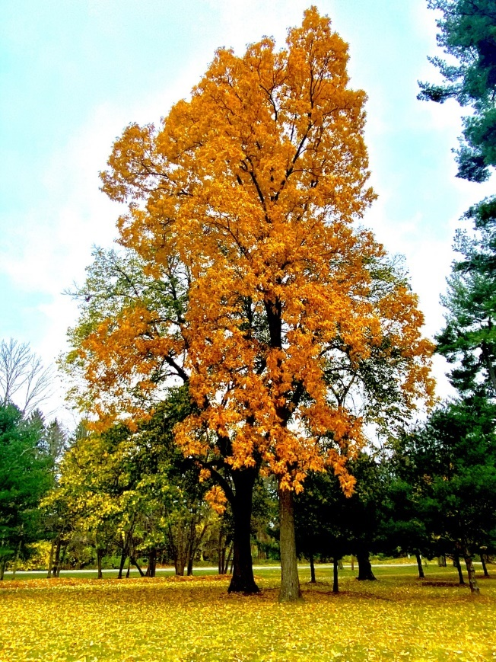 | Deciduous (DEE-SID-YOU-US) – A tree that drops its leaves every fall or when the weather gets cooler.  These trees are known for their fun fall colors that can be red, yellow or even orange!  Did you know there are people who travel across the country to see the different leaf colors? We call them ‘leaf peepers’!  What colors do you see in the trees around your home?

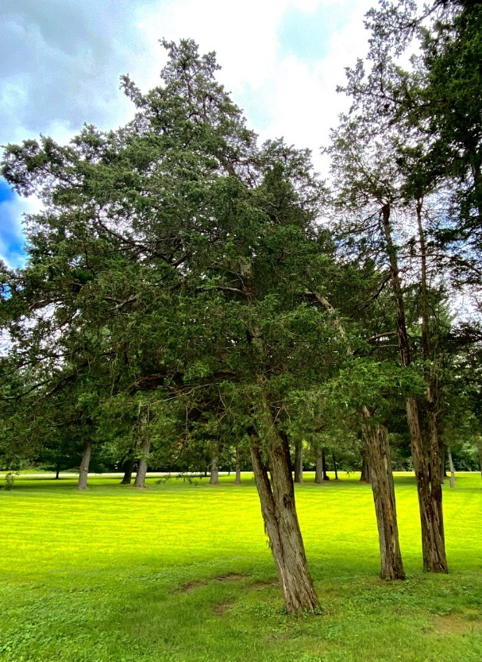 | Evergreen (EVER-GREEN)  – A tree that remains green all year.  These trees often have leaves that look almost like little needles.  Evergreen trees do lose some of their leaves but never all at once. They drop their leaves a little bit at a time all through the year!  *Special mission*  - Count how many trees are still green around your home.  __________________________

