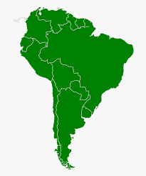

South
America

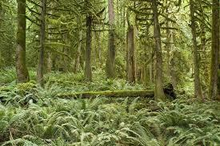
Half of the medicines in the world come from rainforests.
The trees in the rainforest also help clean the air we breathe.

South America
The Amazon rainforest is facing trouble.
The trees are being cut down to make way for mining and cattle grazing, as well for wood.
Solutions:
The government and scientists are taking bold steps to slow down, and eventually stop, the destruction of the forest.

They are educating the
people in the area.

They have also increased police protection for those working to save the trees.

We can also do our part, by planting trees at home that will assist in cleaning the air!
In Martin’s Time
Clearing forests of its trees is not a current problem.
Martin lived during a period in America called ‘The Industrial Revolution.’
It was an era when large factories sprung up to make items that once required purchase from other countries.
It made America rich and powerful, but in the process our country lost some of its oldest forests.
Destruction made way for the factories, homes, and farms for a population that continued to grow.
In 1860, people began to realize the importance of what occurred and worked to reverse the damage.
To preserve the wilderness President Lincoln signed the Yosemite Grant on
June 30, 1864.

Try to grow your own apple tree!

Follow the steps on
the next page.

Trees play an important part in keeping our en- vironment healthy. You can help replace trees taken down in the South American forest by planting some at home.
Spring is a perfect time to begin the process of growing your own apple tree from seed. It is difficult, but not impossible.

Record the process and post it on social media with the #treeheroes

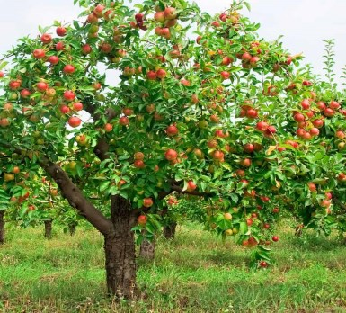
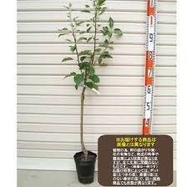
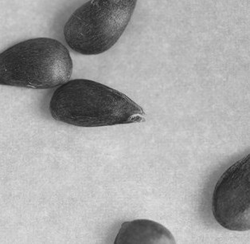
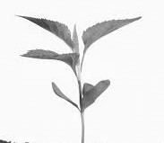
Click to
add photo
Click to
add photo
Click to
add photo
Click to
add photo
Click to
add photo
Apple Seeds
Growing a seedling
from a seed .
Supplies:
- A container with
a lid.
- Clean sand.
How :
- Place a layer of sand on the bottom of the container.
- Put the seeds on top of the sand.
- Cover the seeds
with the sand.
- Put the lid on and punch some holes in it.
- Put it in the fridge 3-4 mos.
* Temp. at : 37-41F

Seedling
After 3 or 4 months in the refrigerator you should see a seedling starting.
Supplies
- A tiny garden pot.
- Potting Soil
How:
- Place some soil on the bottom of the pot, fill
the pot 1/2
way.
- Place the seeds on top of the
soil
  - Cover the seeds with soil.
* Grow it indoors.

Sapling
Once the seedling is too large for the pot transfer it to a larger pot to grow the sapling outside.
Supplies:
- Larger pot and good potting soil.
How:
- Fill the pot
half way with soil.
- Create a ldip
soil about two times wider than
the seedling.
  - Plant the seeds and
cover.

Tree With Apples
Martin Van Buren planted 15,500, most likely grafted, apple trees for an orchard at Lindenwald.
In doing so, he was one of the first in our area to make a large scale business out of apple growing.
New York now produces over 20 different varieties of apples.
Apples are one of the main crops in the Hudson Valley . It’s also where you can visit Lindenwald!

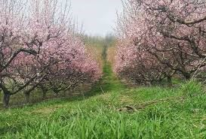
Apple Tree in Bloom
It takes approximately 3-4 years for an apple tree to bear fruit
and blossom.
In mid-late May blossoming apple trees draw visitors
to orchards all over the country.
The colourful leaves of apple trees again draw visitors for gazing in the sea- son of Autumn.

