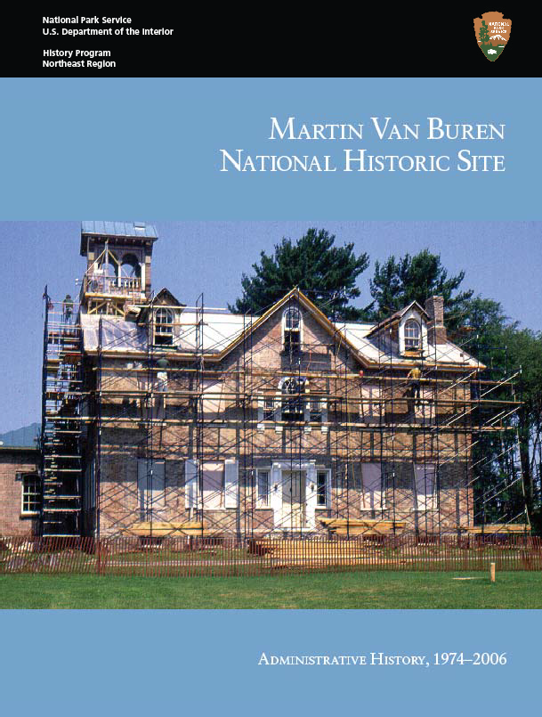

Martin Van Buren National Historic Site

**Administrative History, 1974-2006**

Suzanne Julin

National Park Service

U.S. Department of the Interior Northeast Region History Program

July 2011

**Cover Illustration:** Exterior Restoration of Lindenwald, c. 1980.

*Source: Martin Van Buren National Historic Site*

Table of Contents

|  |  |
| --- | --- |
| List of Illustrations  Acknowledgements Introduction | vii  ix 1 |
| Chapter One: Recognizing Lindenwald: The Establishment Of Martin Van Buren National Historic Site | 5 |
| Chapter Two: Toward 1982: The Race To The Van Buren Bicentennial | 27 |
| Chapter Three: Saving Lindenwald: Restoration, Preservation, Collections, and Planning, 1982-1987 | 55 |
| Chapter Four: Finding Space: Facilities And Boundaries, 1982-1991 | 73 |
| Chapter Five: Interpreting Martin Van Buren And Lindenwald, 1980-2000 | 93 |
| Chapter Six: Finding Compromises: New Facilities And The Protection of  Lindenwald, 1992-2006 | 111 |

Chapter Seven: New Possibilities: Planning, Interpretation and Boundary

Expansion 2000-2006 127

Conclusion: Martin Van Buren National Historic Site Administrative History 143

Appendixes:

Appendix A: Martin Van Buren National Historic Site Visitation,

1977-2005 145

Appendix B: Martin Van Buren National Historic Site Staﬃng 147 Appendix C: Martin Van Buren National Historic Site Studies,

Reports, And Planning Documents 1936-2006 151

Bibliography 153

Index 159

List of Illustrations

Figure 1.1. Location of MAVA on Route 9H in Kinderhook, NY

Figure 1.2. Portrait of the young Martin Van Buren by Henry Inman, circa 1840 Library of Congress

Figure 1.3. Photograph of the elderly Martin Van Buren, between 1840 and 1862 Library of Congress

Figure 1.4. James Leath and John Watson of the Columbia County Historical Society Photograph MAVA Collection

Figure 2.1. The Campbell colonial revival style porch, photographed August 31, 1961 Library of Congress

Figure 2.2. 1982 Van Buren Bicentennial Preview Exhibit Photograph MAVA Collection

Figure 2.3. Interpretive Program at MAVA, 1980 Photograph MAVA Collection

Figure 2.4. 1982 Exhibit Photograph MAVA Collection

Figure 2.5. 1982 historic wallpaper exhibit Photograph MAVA Collection

Figure 2.6. 1982 Van Buren Bicentennial Preview Exhibit Room Photograph MAVA Collection

Figure 2.7. Patricia Dacus Hamm removes historic wallpaper Photograph MAVA Collection

Figure 3.1. Visitors await 1987 opening Photograph MAVA Collection

Figure 3.2. George Berndt and Carol Kohan welcome visitors to the 1987 opening Photograph MAVA Collection

Figure 3.3. Exterior restoration in progress Photograph MAVA Collection

Figure 3.4. Superintendent Bruce Stewart speaking at 1987 opening Photograph MAVA Collection

Figure 4.1. Park oﬃce in house trailer behind Lindenwald, 1997 Photograph MAVA Collection

Figure 4.2. Cinderblock Maintenance Garage directly behind Lindenwald Photograph MAVA Collection

Figure 4.3. South Gatehouse Photograph MAVA Collection

Figure 4.4. Model of George Stephen multipurpose building design Photograph MAVA Collection

Figure 5.1. Michael Henderson and Ruth Piwonka at MAVA 25th anniversary Photograph MAVA Collection

Figure 5.2. Interpreter John Eleby discusses the Formal Parlor, 2001 Photograph MAVA Collection

Figure 5.3. Steven Patricia rendering of Van Buren farmlands MAVA Collection

Figure 5.4. Wayside Exhibit Panel MAVA

Figure 5.5. Interpreter Helen Schneider depicting a Lindenwald domestic Photograph MAVA Collection

Figure 6.1. Removing old trailers behind maintenance garage, 2001 Photograph MAVA Collection

Figure 6.2. New trailer facilities at MAVA Photograph MAVA Collection

Figure 6.3. 2001 Sign on Route 9H protesting “Lindenwald Trailer Park” Photograph MAVA Collection

Figure 6.4. Makeshift Visitor Center attached to trailers Photograph MAVA Collection

Figure 6.5. Superintendent Dan Dattilio and guests at the 2006 reopening of Lindenwald Photograph MAVA Collection

Figure 7.1. Wilentz, Earle, Huston, and Weinbaum, OAH Site Visit, 2005 Photograph MAVA Collection

Acknowledgements

My thanks to Dr. Susan Ferentinos, Public History Manager at the Organization of American Historians. Her skills in coordination and her patience were instrumental in bringing this project to a conclusion. Dr. Paul Weinbaum, former regional historian, played a key role in launching and organizing the project, and his long association with Martin Van

Buren National Historic Site helped to put form to the study. The site is particularly fortunate to have had several staﬀ members who have served there for long periods of time or who have returned to successive posts there. These individuals have a ﬁne sense of the park’s history and an abiding interest its present and its future. I thank Judy Harris, Michael Henderson,

Jim McKay, and, particularly, Dr. Patricia West. Her tenure at the park and her knowledge of every aspect of its development has added immeasurably to this study.

Most of the research for this project took place on site at Martin Van Buren Na- tional Historic Site, and park staﬀ assisted in making that research successful and downright pleasant. Superintendent Dan Dattilio made himself available to answer questions or discuss particular issues. Patricia West spent many hours searching out resources and discussing them with me. Chief Ranger Jim McKay talked with me at length and provided important docu- ments regarding the developing of the park’s interpretive programs. Museum Specialist Judy Harris guided me through the Lindenwald mansion and grounds and shared knowledge about the park’s curatorial issues and programs. Park Ranger Dawn Olson spent many hours over

a copy machine duplicating research documents. Her diligence as well as her keen eye for sa- lient facts and concepts enhanced the research process. Denise Guerrero cheerfully interrupt- ed her own administrative duties to assist with research issues and arranged to have copies of documents shipped to me. Marcia Metzger assisted in compiling photographs and maps.

While the number of oral histories that could be completed was limited by budget restrictions, they added crucial information to the narrative of the site’s history. Each person contacted agreed without hesitation to be interviewed, and each of them provided unhurried, thoughtful, and candid interviews. I thank Dan Dattilio, Warren Hill, Judy Harris, Michael Henderson, Bob MacIntosh, Ruth Piwonka, Marjorie Smith, and Patricia West for sharing their time and knowledge.

At the National Park Service Boston Support Oﬃce, Paul Weinbaum, Dave Clark, and Ed Rizzotto pointed me to important documents and discussed broad issues surrounding Martin Van Buren National Historic Site’s history. Harry Butowski at the National Park Ser- vice’s Washington, DC, oﬃce graciously met with me on a busy afternoon to oﬀer guidance on further research. Staﬀ at the National Park Service Harpers Ferry Center and the National Park Service Technical Information Center, Denver, discussed research issues and provided pertinent documents, and staﬀ at National Archives II, College Park, MD, helped to identify important ﬁles. My thanks and appreciation go to them.

# Introduction

*Introduction*

In 1839, Martin Van Buren, the eighth president of the United States, bought an agricultural estate near his hometown of Kinderhook, NY, in the Hudson River Valley. He renamed the estate Lindenwald. More than 170 years after his purchase, the estate’s mansion and grounds contribute to an understanding not only of Van Buren’s political career and life but also to the eﬀects of agriculture and immigration on nineteenth-century society in the northeastern United States and the roles antebellum politics and the issue of slavery played in the onset of the Civil War. These contributions did not spring from the ground at Linden- wald; they were fostered over several decades by National Park Service (NPS) personnel who faced many obstacles in preserving and protecting this president’s home and lands, providing services to visitors who came there, and interpreting its signiﬁcance to the nation.

The 1974 establishment of Martin Van Buren National Historic Site culminated decades of eﬀorts by numbers of supporters to seek recognition for Lindenwald. The his- toric site, originally about forty acres in size, presented many challenges. This administrative history recounts struggles for designation, appropriate interpretation, restoration, preserva- tion, conservation, and adequate facilities, as well as victories in protecting the mansion, the grounds, and the farmlands Van Buren owned from encroaching development and in deep- ening the understanding of the site’s signiﬁcance. The study ends in 2006, with the inception of a General Management Plan process that will complete long-term planning for the site and allow for development.

The history of the administration of Martin Van Buren National Historic Site from its establishment through 2006 reveals four well-deﬁned themes. The dominant theme is the inability of the NPS to establish permanent facilities at the site. Nearly four decades after its establishment by Congress, administrative oﬃces and visitor services are housed in temporary trailers and a small contact station built by park maintenance staﬀ. A substandard pole barn holds museum collections and records, and maintenance functions are carried out from a converted cement-block garage. These facilities are actually improvements over earlier ac- commodations, which were also considered temporary. Eﬀorts to develop permanent build- ings to house the site’s functions have been complicated by budget issues, National Park Ser- vice standards, the concerns of neighbors immediately adjoining the site, and the necessary protection of the site’s historic core from development. The need for appropriate facilities has deeply inﬂuenced park planning, aﬀected staﬀ morale, and impacted public relations.

A second theme involves the challenges inherent in restoring, preserving, pro- tecting, and furnishing the Lindenwald mansion and addressing the treatment of its immedi- ate grounds. In the ﬁrst ﬁfteen years after the site’s establishment, park staﬀ struggled to re- store and furnish a mansion that had been used as a farmhouse, a convalescent home, and an antique business. This work called for a wide range of skills and knowledge and a great deal of patience on the part of the park staﬀ, NPS experts, and private consultants who contrib- uted to the eﬀort. The mansion’s legacy of multiple ownership and benign neglect presented issues of inappropriate modiﬁcations and deteriorating conditions. The former owner of the mansion was allowed to continue living there during the ﬁrst years of the site’s existence,

presenting a unique and delicate problem for Park Service oﬃcials. Funding cutbacks and the need for professional studies to guide work at the site further hampered swift progress toward a full restoration.

The third major theme is the interpretation of Martin Van Buren’s career and life, as well as the history and signiﬁcance of his property. Because Van Buren purchased the estate near the end of his single presidential term and made his permanent home there after losing his bids for a second term, Lindenwald could not be presented as an inﬂuence on his early years or as a refuge during his presidency. An unfortunate tendency on the part of early staﬀ and planners to refer to the mansion and its surrounding grounds as Van Buren’s “retire- ment home” masked the importance of his post-presidential political career, particularly his two additional campaigns for the presidency. The second of these was waged in 1848 under the banner of the Free Soil Party, which opposed the extension of slavery to western territo- ries. During the 1840s, Lindenwald was no retirement home. It was the base of operations for this former president who continued his commitment to public life and to the preservation of the nation. As planning and studies developed and advanced, the “retirement home” image has given way to a much more nuanced and sophisticated interpretation of the impact of Van Buren’s early political and presidential careers as well as his post-presidential role in national politics. Interpretive work has also shed new light on the Van Buren lifestyle and on the do- mestic and agricultural operations at the Lindenwald estate. The agricultural focus has been

particularly important, bringing new attention to the Van Buren farmlands not included in the original historic site.

This recognition has led to serious work toward expanding the park’s boundar- ies, an issue that constitutes a fourth major theme. The possibility of boundary expansion had been discussed for several decades as a means to protect the site and its viewshed from encroaching development, but a fresh emphasis on the importance of the surrounding agri- cultural lands—particularly the lands originally owned by Van Buren--created a new impetus

to gaining such protection. Upon establishment, the site was slightly more than twenty acres in size, with some additional property protected by conservation easements. Located on a busy state highway and in a bucolic setting less than thirty miles south of the burgeoning Albany capital district and within weekend commuting distance from the New York City metropoli- tan area, the park was immediately subject to development pressures. As those pressures have increased, the staﬀ and supporters of the park have struggled to protect not only the historic core of Lindenwald, but also its larger environment, including more than 200 acres of adja- cent land that Martin Van Buren once owned and farmed. Attention to the original farmlands has led to a growing appreciation of their signiﬁcance to the park and a growing recognition of the value of preserving these lands by including them in the park’s boundaries.

This administrative history addresses these themes and presents a narrative that is intended to help park managers and staﬀ understand how the history of this site has un- folded, how controversies have developed and been addressed, and how major decisions and achievements have been made. Administrative histories rely heavily on the records of those who have worked at or with a given park, and the availability of those records can present

challenges. This is particularly true for relatively new parks such as Martin Van Buren Nation- al Historic Site, founded at the beginning of the National Park Service’s transition to comput-

er use. The ﬁrst twenty years of the park’s history are quite well documented in its central ﬁles, but as communication by telephone and computer began to replace written correspondence, the documentation dwindles. In a 1998 article, Lary M. Dilsaver, professor of geography at the University of Southern Alabama and editor of *America’s National Park System: The Critical Documents,* noted that the advent of e-mail communication and use of word processors has meant that many letters, memos, and drafts of documents are deleted or stored on disks, giv- ing researchers limited access to crucial resources.1 Another research problem arises from the very understandable practice of park and regional staﬀ keeping records that pertain to ongo- ing projects or issues in their desk ﬁles or computer ﬁles. The researcher must depend on their abilities to recall and retrieve such records in order to develop the history of a park.

In this case, these research problems were mitigated by the commitment of both the park staﬀ and the regional staﬀ to assist in the development of a narrative and analysis of the history of Martin Van Buren National Historic Site and their willingness to search out and share pertinent documents. Gaps in the material remain, however, and these situations

present problems in developing consistent and clear citations. Most of the research conducted refers to Martin Van Buren National Historic Site (MAVA) Central Files; other major sources include reading documents held in the MAVA library and desk ﬁles of park staﬀ. The National Park Service Boston Support Oﬃce (BOSO) is another major source of primary documents held in the Planning Files, Planning Library, or in individual desk and oﬃce ﬁles. The NPS Harpers Ferry Center (HFC) also holds particularly important documents pertaining to the development of Martin Van Buren National Historic Site. All of these documents are cited

to reﬂect as clearly as possible their location at the time the research was conducted. Nearly every document gathered during the research was copied, and these copies will become part of the park’s permanent archives, facilitating the eﬀorts of future researchers who may seek out speciﬁc resources cited here.

Other invaluable sources included the park’s planning and resource studies, which are readily available at the park and online, and secondary studies on National Park Service development and history, many of which can be accessed online at <http://www.nps.gov/> npshistory/. In addition, oral histories were indispensable in addressing gaps in information, particularly during the last twenty years of the park’s existence. The number of oral histories conducted was limited due to budget constraints, but each of those interviews provides an important contribution to the park’s history, and the original interviews will also be included in the park’s archives.

Lary Dilsaver deﬁned an administrative history as “a history of the way that a gov- ernment agency carries out its duties and the successes and failures of its management.”2 This administrative history is intended to provide such a study for Martin Van Buren National His- toric Site, which has faced a number of serious problems and seen many successes. As the park faces new challenges and works toward important achievements, this study should provide a background that will aid in understanding the site’s past and in working toward its future.

1 Lary M. Dilsaver, “Some Notes on Thematic and Multi-Park Administrative Histories,” *CRM: A Jour- nal of Heritage Stewardship* 21, no. 9 (1998): 48.

2 Dilsaver, “Some Notes, 46.

Chapter One

*Introduction*

# Recognizing Lindenwald:

**The Establishment Of Martin Van Buren National Historic Site**

**Introduction**

On July 24, 1862, Martin Van Buren died at Lindenwald, his country estate lo- cated a few miles southeast of his birthplace in Kinderhook, NY. The eighth president of the United States, he had purchased the 137-acre property in 1839, during his sole term. In 1841, after losing his bid for reelection, Van Buren moved to the site, established a farm that eventu- ally totaled more than 200 acres, and lived there with his children and grandchildren until his death. Lindenwald passed to his heirs and then into the hands of a series of owners. Most of the agricultural land eventually was sold to farmers, and the estate’s mansion and its immedi- ate grounds served as a residence, a summer home, a farm house, a convalescent center, and an antique store. For nearly seven decades, beginning in the early twentieth century, organiza- tions and individuals worked to gain recognition and protection for Lindenwald, eﬀorts that culminated in 1974 with the designation of Martin Van Buren National Historic Site as a unit of the National Park Service.

**The Setting**

Martin Van Buren National Historic Site is located in northwestern Columbia County in the Hudson River Valley of New York State, about twenty-ﬁve miles south of Albany. This portion of the Hudson River Valley is particularly scenic, with wooded slopes, picturesque villages, and views of the distant Catskill Mountains. The Lindenwald mansion faces New York State Route 9H and a portion of the historic Old Post Road—also called the Albany Post Road—a New York City to Albany route. This section of the road has been closed to traﬃc and incorporated into the site, which also includes the historic South Gatehouse and Farm Cottage, the foundations of the North Gatehouse, a modern cinderblock garage and a pole barn, two double-wide trailers that are connected by a passageway and hold administra- tive oﬃces, and a small visitor contact station.

***Early History***

Before European settlement, the area now occupied by Martin Van Buren Nation- al Historic Site was home to the Mohican Indians, who were agriculturalists as well as hunters and gatherers. In 1609, English explorer Henry Hudson, working for the Dutch East India Company, explored the river that bears his name. He encountered the Mohican people and established good relations with them. Subsequently, the Dutch set up fur trading posts in the region, and Dutch settlers began to occupy what became known as New Netherlands. In the ensuing decades, the Mohicans engaged in a number of local wars—some of them in alliance with the Dutch—and suﬀered dramatic losses in population due to the introduction of Euro- pean diseases, including smallpox and measles. Their tribal lands began to shift into European

ownership, some by legal sales and some by coerced agreements. In the 1700s, most of the remaining Mohicans left for other areas.1

Another ﬁrm, the Dutch West India Company, eventually dominated trade in New Netherlands. The company oﬀered estates called patroonships to stockholders in the compa- ny who would settle at least ﬁfty people on the land and provide cattle, tools, and housing and outbuildings to their tenants. In return, the patroons received rent and other considerations. The plan was only mildly successful because settlers could ﬁnd land elsewhere with fewer re- strictions. In 1664, the British conquered New Netherlands, and it became the colony of New York. The Dutch settlers retained a strong presence, however, and Dutch-speaking families continued to farm the area’s fertile lands, populate its towns, and run its businesses.2

One of these families arrived in New Netherlands in 1631 and took the name Van Buren. A member of the family settled near the present-day village of Kinderhook, and a descendent, Abraham Van Buren, married Maria Hoes Van Alen in 1776. The couple’s third child, Martin, was born in 1782. The future president of the United States grew up with his eight siblings in Kinderhook, where his parents operated a tavern.3

#### President Martin Van Buren and Lindenwald

President Martin Van Buren’s successes belie his modest childhood and point to his obvious talents. His formal education consisted of several years in a one-room school

and ended when he was thirteen. At ﬁfteen, he entered into an apprenticeship with a Kinder- hook lawyer. His initial duties were more janitorial than legal, but they introduced Van Buren to the study of the law. He helped John Van Ness, a member of a locally inﬂuential family, win election to Congress, and in 1801 he went to New York City to work under Van Ness’s brother William Van Ness, a rising attorney. Thus, at a young age Van Buren exchanged the slow-paced small-town life of Kinderhook for the excitement of the country’s largest city, where he could learn about the law and about politics. After passing the bar exam, however, he returned to Kinderhook in 1803 and went into law practice with one of his brothers. He fell into a political skirmish and ran awry of the Van Ness family in 1804 when he failed to support their candidate, Aaron Burr, for the oﬃce of governor. He went to the Van Ness home several months later to oﬀer his legal help to William Van Ness, who had played a

role in a fateful duel between Burr and Alexander Hamilton, but William Van Ness’s father refused to answer his knock. Ironically, Van Buren would eventually enter that door as the owner of the Van Ness property.4

Van Buren launched his own political career in 1812 when he won election to the New York senate. His work ethic, even temperament, ambition, and talent at negotiating

1 Llerena Searle, *A Farmer In His Native Town: Cultural Landscape Report for the Martin Van Buren Farmland* Vol. I (Boston, MA: National Park Service Olmsted Center for Landscape Preservation, 2004), 9-10.

2 Searle, *A Farmer In His Native Town*, 10-11; David L. Uschold and George W. Curry, , *Cultural Land- scape Report for Martin Van Buren National Historic Site: Site History, Existing Conditions, and Analysis* (Boston, MA: National Park Service Olmsted Center for Landscape Preservation, June 1995), 11-13.

3 Ted Widmer, *Martin Van Buren*, The American Presidents Series, Arthur M. Schlesinger, Jr., gen. ed., (New York: Times Books, Henry Holt and Company, 2005), 22-24.

4 Widmer, *Martin Van Buren*, 27-31.

the political process served him well.5 He began to assemble political alliances that historian Ted Widmer has called “more accurately the ancestor of the modern Democratic Party than Thomas Jeﬀerson’s Republicans, though Jeﬀerson gets all of the credit.”6 Van Buren was ap- pointed New York’s attorney general in 1815. In 1821, he won a seat in the U.S. Senate and be- came a popular and inﬂuential man in Washington, DC. His political adroitness won him the sobriquet “Little Magician,” which referred to his small stature and his reputation for success- ful political maneuvering. He returned to New York when he was elected governor in 1828.

Shortly after he took oﬃce, however, President Andrew Jackson oﬀered Van Buren the post of secretary of state, and Van Buren accepted. In 1832, he became Jackson’s vice president. In 1836, Martin Van Buren was elected president of the United States, the youngest president to that date and the ﬁrst born after the country declared its independence.7

The Van Buren presidency was marred by the Panic of 1837, a calamitous ﬁnancial crisis. Although he had inherited the roots of the problem from Jackson, Van Buren received much of the blame for the country’s economic problems. Additional issues, including his sup- port for an independent treasury and the growing debate over slavery, also aﬀected his term in oﬃce. In 1840, he was defeated in his reelection bid by the Whig candidate, William Henry Harrison. After completing his presidential term, he returned to Kinderhook to live.8

Martin Van Buren came home to an estate he had purchased in 1839. The land was originally part of the Thomas Powell Patent, granted to a group of individuals in 1664. A few years later, Jan and Derckje Van Alstyne bought part of the property. In 1682, the Van

Alstynes gave a portion of their holdings to their son, Lambert Van Alstyne, who passed it on to his children when he died. One of Lambert Van Alstyne’s grandsons eventually inherited the parcel that would become Lindenwald.9 In 1787, Peter Van Ness acquired 260 acres of the land from Van Alstyne heirs, and in the late 1790s, he built a two-story Georgian-style brick house facing the Old Post Road to the east. Van Ness died in 1804, and his three sons inherited the estate the family had named Kleinrood. William Van Ness and his family lived in the house, using it as a country home after they moved to New York City in 1810. During this period, Washington Irving often visited the Van Ness family at the estate and later drew from his experiences and observations in the Hudson River Valley for the settings and characters in several of his works. In 1824, William Van Ness was forced to dispose of Kleinrood, and Wil- liam Paulding, Jr. bought the property at a court auction. Paulding was an absentee landlord, and when Van Buren purchased the estate from Paulding in 1839, it was in poor condition.10

#### Changes at Lindenwald

Van Buren moved to the estate he renamed Lindenwald in 1841, but he began making improvements to the property almost immediately after buying it in 1839. He intended his new home to be a combination of a working farm, a comfortable residence, and a gra-

5 Widmer, *Martin Van Buren*, 36-37; 42-43.

6 Widmer, *Martin Van Buren*, 43.

7 Widmer, *Martin Van Buren*, 46, 49-54, 68-71, 87, 90.

8 Widmer, *Martin Van Buren*, 101-105, 109-23, 136-140, 143-144.

9 Searle, *A Farmer in His Native Town*, 10-11.

10 Searle, *A Farmer in His Native Town*, 15-16; Widmer, *Martin Van Buren*, 3.

cious place to entertain visitors. He had ﬁelds cleared and planted, built outbuildings, and constructed two ponds to hold ﬁsh.11 He oversaw necessary repairs and improvements to the exterior of the house, including a partial rerooﬁng, the installation of new window sashes, and a repainting in colors of light yellow with cream and brown trim. In the interior, the major project was the creation of a large dining room at the front of the ﬁrst ﬂoor, often referred to as the main hall. Van Buren opened up the space by having an entry hall wall and a staircase torn down. He had the dining room papered in striking French scenic wallpaper and installed a mahogany accordion-action table that could extend to seat thirty dinner guests. He pur- chased a great quantity of glassware and china to accommodate the large number of people he expected to entertain at Lindenwald.12

In addition to establishing his household, Van Buren expanded his farm holdings at Lindenwald during the 1840s. He added several contiguous parcels to the 137 acres he had purchased in 1839, bringing the total acreage to about 220 by the 1850s. He raised stock in- cluding sheep, pigs and cattle, as well as poultry and horses. He grew grains, potatoes, and hay, and kept some of the land in pasture and some in woods, some in gardens and some in or- chards.13 In the mid-1840s, he added two gatehouses to the property. The structures, probably built by local carpenters, provided housing for farm employees.14 He also built several barns and an attractive cottage for his farm foreman.15 The barns are gone, but the foreman’s cottage has survived on a parcel of land that was sold oﬀ by subsequent owners.

Van Buren came to his country estate a longtime widower. He had married Hannah Hoes, a second cousin, in 1807, and four surviving sons were born to the couple— Abraham, John, Martin, Jr., and Smith Thompson. Another son, Winﬁeld Scott, died at birth. Hannah Hoes Van Buren succumbed to tuberculosis in 1819, and Van Buren never remarried. During his presidency, Abraham and Martin, Jr. were secretaries to their father. Abraham married Angelica Singleton, the daughter of a genteel Southern family, who acted as Van Bu- ren’s hostess during the ﬁnal two years of his presidency.16 Abraham and Angelica Van Buren moved with him to Lindenwald in 1841, and Angelica took over the initial management of

the house. She was aided by a frequently changing group of domestic servants, most of them young Irish immigrants.17

Van Buren did not consider his residency at Lindenwald a retirement from his po- litical career. During his ﬁrst decade at Lindenwald, he traveled and entertained extensively, meeting the public and making inﬂuential connections. In the mid-1840s, he was increasingly

11 Leonard L. Richards, Marla R. Miller, and Erik Gilg, *A Return to His Native Town: Martin Van Buren’s Life at Lindenwald, 1839-1862* ([Boston, MA]: National Park Service, US Department of Interior, Au- gust, 2006), 32-34.

12 Richards, Miller and Gilg, *A Return to His Native Town*, 34-37.

13 Searle, *A Farmer in His Native Town*, 33, 51.

14 John A. Scott, *The Gate Lodges of Lindenwald: Historic Structures Report* (Boston, MA: National Park Service, Northeast Cultural Resources Center, Building Conservation Branch, 2001), x, xii. In some sources, the gatehouses are attributed to Richard Upjohn as part of the late 1840s additions to the estate; Scott’s research indicates they were constructed earlier.

15 Richards, Miller, Gilg, *A Return to His Native Town*, 33-34.

16 Widmer, *Martin Van Buren*, 32, 48; Searle, *A Farmer In His Native Town*, 25

17 Richards, Miller, and Gilg, *A Return To His Native Town*, 44-46.

drawn into the building debate on slavery. He tried but failed to gain his party’s nomination for president in 1844, due in large part to his opposition to the annexation of Texas. In 1848, the newly emerged Free Soil Party nominated Van Buren as its presidential candidate. His af- ﬁliation with that party, which opposed the expansion of slavery into the western territories, reﬂected his own growing concern about the eﬀects of slavery on the future of the country. He was soundly defeated and returned to the company of his family and friends and the comforts of his home at Lindenwald.18

The late 1840s saw signiﬁcant changes at the Hudson River Valley estate. Van Buren asked his youngest son to make his permanent residence at Lindenwald and to assist in managing the property. Smith Thompson Van Buren agreed, with one proviso: he requested an addition to the house that would accommodate his family in an essentially separate living area. Smith and his wife, the former Ellen King James, hired Richard Upjohn, a prominent architect who had designed a number of important buildings including New York’s Trinity Church, to plan the new space. The result was an addition in the Italianate style on the west side of Lindenwald, featuring a striking ﬁve-story tower. In the fall of 1849, only a few months after the construction began and only a few weeks after she gave birth to her second daughter, Ellen Van Buren died of consumption. Van Buren and his son eventually completed the work on the addition and purchased new furniture for the expanded home. In 1855, Smith Van Buren remarried and his second wife, Henrietta Irving, became the mistress of Lindenwald. Martin Van Buren continued to develop the farm, to travel, to entertain friends, and to enjoy his children and grandchildren until his death in 1862.19

#### Ownership of Lindenwald after 1862

After Van Buren’s death, and according to his wishes, the ownership of Linden- wald was divided among his three surviving sons, Abraham, John, and Smith. John Van Buren bought out his brothers’ interests and established his residence there in 1863. He soon found he could not manage the property adequately and sold it to Leonard Jerome, a wealthy New Yorker who spent little time on the estate. In 1867, after suﬀering reverses of fortune, Jerome sold Lindenwald to a local man George Wilder, who operated the farm but lived elsewhere. John Van Buren, a distant Van Buren relative, and James Van Alstyne bought Lindenwald in 1873. Early the next year, they sold most of the property to Adam and Freeman Wagoner, re- taining ownership of about thirty acres. The Wagoner brothers, members of a local farm fam- ily, lived at the Lindenwald mansion for the next forty-three years, and the former Van Buren estate continued to be a part of the area’s agricultural community.20

Bascom H. Birney of Yonkers, New York, purchased all but thirty-six acres of Lin- denwald in 1917 from Adam Wagoner, who was the sole owner by that time. Birney initially used the house at Lindenwald as a vacation home, but eventually he and his family moved there and operated the farm. In 1922, Birney’s daughter Marion took over the property, and in 1930, her sister Clementine Birney deProsse became its owner. The Birney descendants were

18 Widmer, *Martin Van Buren*, 145-50, 152-55.

19 Richards, Miller, and Gilg, *A Return to His Native Town*, 109-118, 121, 128-29; Widmer, *Martin Van Buren*, 164-66.

20 Uschold and Curry, *Cultural Landscape Report*, 59.

absent from Lindenwald between 1925 and 1930; during this period the Schneck family, who worked for the Birneys, cared for the farm. Clementine deProsse, her husband William, and their children returned to Lindenwald in 1930 and operated the farm for sixteen years. During this period, New York State Highway Route 9H was constructed to the immediate east of the property. The deProsse family struggled to maintain Lindenwald during the Great Depression and the World War II years, and the buildings and grounds deteriorated.21

In 1946, Clementine deProsse sold most of the remaining farmland—166 acres— to Dudley Ray Meyer, Jr. The deProsses continued to live in the house on and oﬀ during the ensuing decade and also allowed Meyer to farm some of the acreage they had retained. In 1957, the deProsse family sold the house and the remaining 12.8 acres of the estate, includ- ing the grounds surrounding the house and a woodlot, to Kenneth and Nancy Campbell.

The Campbells, who had long admired Lindenwald, moved there from Putnam County, New York, where Campbell had operated an automobile dealership. They initially lived in the South Gatehouse while they worked on renovation of the mansion. By mid-1958, they had completed exterior work including repointing of bricks, replacement of windows and cornices, and the construction of a sixty-foot wide Colonial-style front porch. Inside, the Campbells painted woodwork, reﬁnished ﬂoors, and added paneling and wallpaper they considered appropriate to rooms on one side of the main ﬂoor. They established an antique dealership, utilizing several of the existing buildings for storage and conducting sales from the mansion, a shop they built behind the South Gatehouse, and other sites on the property. In the process of running the business, the Campbells sold some of the remaining Van Buren furnishings. Despite their good intentions to restore the property, by the 1970s most of the historic farm buildings, the orchards, the garden, and the locust trees that had once lined

the drive were gone.22 The mansion became a combination of residence and business sur- rounded by a few outbuildings utilized as storage structures or sales outlets and overgrown, untended grounds.23 Lindenwald’s signiﬁcance was not forgotten, however, and eﬀorts to save it eventually bore fruit.

#### Early Movements to Preserve Lindenwald

During the ﬁrst two decades of the twentieth century, New York state lawmakers made several attempts to recognize Lindenwald, introducing state legislation in 1907, 1911, 1913, and 1914. The 1907 bill was vetoed by Governor Charles Evans Hughes. The 1911 and 1913 bills failed, as did the 1914 measure, which called for the preservation of the house and its utilization as the summer home of the governor, contingent upon its purchase by the state.24

21 Uschold and Curry, *Cultural Landscape Report*, 78.

22 Searle, *A Farmer in His Native Town*, 73-74, 85, 107-108; Uschold and Curry, Cultural Landscape Report, 59, 78-79, 116; Bruce Stewart to Ross Holland, July 7, 1977, Folder D2215 *Cultural Resource Preservation*, Martin Van Buren National Historic Site [MAVA] Central Files.

23 Searle, *A Farmer In His Native Town*, 107-108; Uschold and Curry, *Cultural Landscape Report*, 78-79; “Remodeled Kinderhook Restores Beauty, Dignity of Historic Landmark,” unidentiﬁed newspaper clip- ping, January 23, 1958 and Katherine Harrington, “Face-Lifting Underway on Kinderhook Landmark,” [Albany, New York], *Knickerbocker News*, July 2, 1958, in Folder Newspaper Clippings, R2 Box Admin. History Records, MAVA Historian’s Records, MAVA Library.

In the late 1920s, Alexander Flick, New York’s state historian, and James Leath, president of the Columbia County Historical Society, mounted a campaign to preserve Lin- denwald. They were joined by Richard Schermerhorn Jr., the descendent of Dutch immi- grants who settled in the area of present-day Albany in the early 1600s. Schermerhorn attend- ed Rensselaer Polytechnic Institute in Troy, New York, and developed a career as a landscape architect, engineer, and city planner, working with prominent professionals in Boston and New York. He opened his own oﬃce in New York City in 1905 and practiced landscape archi- tecture and civil engineering until 1958. He designed numerous public parks, residential sub- divisions, private estates, and cemeteries and was well known as a city planner. He prepared plans for Newark and Princeton, New Jersey; Fort Lauderdale, Florida; and several cities in New York State, including Great Neck, Kings Point, and North Hempstead. During the 1930s, he served as a consultant to the Hudson River Conservation Society, inﬂuencing the develop- ment of plans for a number of towns in the region. A distant Van Buren relative and an en- thusiastic supporter of historic preservation in his home state, Schermerhorn became deeply involved in the movement to recognize Lindenwald.25

Flick contacted New York governor Franklin D. Roosevelt about the project.

Roosevelt indicated his support and referred Flick to the state’s American Scenic and Historic Preservation Society. Flick also appealed to industrialist Henry Ford, who had a strong inter- est in historic preservation, and to the Taconic State Park Commission, which was planning New York’s Taconic Parkway. Schermerhorn contacted numerous public and private organi- zations in his eﬀorts to gain ﬁnancial or moral support for the cause. The Taconic Park group considered acquiring Lindenwald, but eventually decided against the proposition, and other eﬀorts proved equally fruitless.26 The men’s work, however, was encouraged by the Historic Sites Act of 1935.

#### Historic Places and the Historic Sites Act of 1935

By the 1930s, some eighty historic and archaeological sites in the United States were being protected under the Antiquities Act of 1906, which gave the president the authority to es- tablish national monuments or to do so through Congressional action. These properties includ- ed sites such as Scotts Bluﬀ National Monument in Nebraska; Castillo de San Marcos National

24 Patricia West, “Preserving Lindenwald: 1907 to 1974,” unpublished manuscript in possession of the author, 1-2; “Activities to Eﬀect Preservation of Martin Van Buren Homestead,” enclosure to Melvin E. Borgeson, Assistant Regional Oﬃcer, National Park Service to Verne Chatelain, National Park Service, May 29, 1936, Folder New York Miscellaneous, Central Classiﬁed Files, 1907-49 and 1933-49, Proposed Historic Sites (036) New York, 036 New York, Box 3033, Record Group [RG] 79, National Archives at College Park (NACP), College Park, MD.

25 West, “Preserving Lindenwald,” 2; Richard Schermerhorn Jr. “City Planning,” Brooklyn Engineers Club, *Proceedings* 16 (1912): 102, accessed September 21, 2009, <http://www.library.cornell.edu/Reps/> DOCS/shermer.htm; William G. Crawford Jr., “Richard Schermerhorn, Jr., New York Engineer and Landscape Architect: Fort Lauderdale’s First City Planner,” *Broward Legacy* 21, nos. 3-4 (Summer/Fall 1998): 1, 4-5. This article gives a detailed biographical background and overview of Schermerhorn’s career on pages one through ﬁfteen.

26 West, “Preserving Lindenwald,” 2; Richard Schermerhorn Jr. “City Planning,” 102; “Activities to Ef- fect Preservation of Martin Van Buren Homestead;” Melvin J. Weig, “‘Lindenwald,’ The President Mar- tin Van Buren Homestead, Near Kinderhook, New York,” November 3, 1936, 24, Folder H22, Melvin Weig Report, MAVA Central Files.

Monument in St. Augustine, Florida; George Washington Birthplace National Monument in Virginia; and Colonial National Monument, later Colonial National Historical Park, encompass- ing Jamestown, the Yorktown Battleﬁeld, and other sites important to the country’s early history. Many of the nation’s historic battleﬁelds were protected under the Department of War, and a number of prehistoric and historic sites fell under the control of the Department of Agricul- ture’s Forest Service.27 Under Franklin D. Roosevelt’s administration, the National Park Service would become responsible for protecting these signiﬁcant symbols of the country’s history.

The National Park Service was established in 1916 as a bureau in the Depart- ment of Interior. Under its ﬁrst director, Stephen Mather, the service initially concentrated its administrative and development eﬀorts on the large natural parks in the American West,

although it also controlled some prehistoric and historic areas, including Mesa Verde National Park in Colorado and Hot Springs National Park in Arkansas. Both Mather and his assistant, Horace Albright, took a strong interest in protecting military parks and other historic areas.

Albright succeeded Mather as director in 1929 and continued to work toward greater recogni- tion of historic areas.28

The Great Depression of the 1930s severely tried the nation’s economic system and wreaked enormous ﬁnancial hardship on millions of its citizens. Due to newly created public programs, however, the period also saw great strides in public appreciation for historic places and oﬃcial recognition and support for them. Roosevelt, who took presidential oﬃce in 1932, shared with Secretary of the Interior Harold Ickes and National Park Service Director Albright a deep interest in the preservation of signiﬁcant natural and cultural places. That interest— along with the support of National Park Service oﬃcials and like-minded legislators—resulted in the creation of programs that put people to work protecting and improving the country’s valued sites. The Historic American Buildings Survey (HABS), for example, employed archi- tects and other professionals to document historic buildings through photographs and draw- ings. The Civilian Conservation Corps, designed to provide paying work for low-income young men, used many of those men to improve local, state, and national parks and historic areas. In 1933, Roosevelt signed Executive Order 6166, which transferred most publicly held historic places from the Department of War and the U.S. Forest Service to the National Park Service.

The Historic Sites Act of 1935, however, was the most important manifestation of the Roosevelt administration’s commitment to historic places. The act authorized the Secretary of the Interi- or, through the National Park Service, to survey, record, preserve, and manage historic sites and established the Advisory Board on National Parks, Historic Sites, Buildings and Monuments.29

These actions brought a new emphasis on historic sites and properties to the National Park Service. Between 1933 and 1964, the National Park Service added seventy-ﬁve

27 Alvin P. Stauﬀer and Charles W. Porter, “The National Park Service Program of Conservation for Ar- eas and Structures of National Historical Signiﬁcance,” *Mississippi Valley Historical Review*, 1943: 26-27; Horace M. Albright, *Origins of National Park Service Administration of Historic Sites*, accessed June 27, 2010, <http://www.nps.gov/history/history/on-line> _books/albright/origins.htm.

28 Albright, *Origins of National Park Service Administration of Historic Sites.*

29 William J. Murtagh, *Keeping Time: The History and Theory of Preservation in America* (New York: Sterling Publishing, 1988), 54-58; Barry Mackintosh, *The Historic Sites Survey and the National Historic Landmarks Program: A History* (Washington, DC: History Division, National Park Service, Department of the Interior, 1985), 1-6; *Historic Sites Act of 1935*, 49 Stat. 666; 16 U.S.C. 461-67.

historic areas to the system, including national monuments, national historic parks, and na- tional military parks. Nine national historic sites were in this group. Following the passage of the Historic Sites Act, the National Park Service adopted a system of classiﬁcation arranged by themes. The themes have evolved over the years, but the basic concept—classifying properties by national historical signiﬁcance rather than architectural style—remains intact.30

With the passage of the Historic Sites Act and the increased attention within the National Park Service on historic sites, Lindenwald’s supporters gained new hope for its preservation. However, the act stated that the United States could not acquire or contract to acquire properties without a Congressional appropriation. Thus, it did not directly address the supporters’ most pressing need: money to acquire and maintain the property. Responding to an inquiry from Schermerhorn,Verne E. Chatelain, acting assistant director of the National Park Service and the bureau’s ﬁrst chief historian, assured him that the under the new law, the Secretary of Interior could assist local, state, and city governments in preservation eﬀorts. Chatelain told Schermerhorn that the National Park Service would be very interested in the eﬀorts being made to preserve Lindenwald, but reminded him that the agency could provide no funds to aid in those eﬀorts.31 The supporters of Lindenwald’s preservation began to seek other avenues to achieve their goals, but also maintained hope that federal support would be forthcoming at some point.

#### Association for the Preservation of Lindenwald

In May of 1936, a group including Schermerhorn, Flick, and representatives of the New York Historical Society, the Columbia County Historical Society, the Dutch Settlers Society of Albany, the Holland Society, and the Sons of the American Revolution, gathered in Schermerhorn’s Madison Avenue oﬃce to form the Association for the Preservation of the President Martin Van Buren Homestead, Kinderhook, N.Y. The new organization, which sub- sequently took the name Association for the Preservation of Lindenwald, made plans to seek an appropriation from the state of New York in order to buy and maintain the property. With

the Democrats in power in both the state and the federal government and the new emphasis on preservation of historic sites, they expected to attract the support of prominent state and local politicians. They also hoped to engage citizens of both parties who were interested in history in general.32 They were encouraged when the New York State Planning Board and the New York State Historical Association expressed support of the site’s acquisition by the state.33

30 Ronald F. Lee, *Family Tree of the National Park System* (Eastern National Park and Monument Asso- ciation, 1974), accessed June 25, 2010, [http://www.nps.gov/history/history/online_books/lee2/4.b.](http://www.nps.gov/history/history/online_books/lee2/4.b)

31 *Historic Sites Act of 1935*; Verne E. Chatelain to Richard Schermerhorn Jr., November 4, 1935, Folder New York Miscellaneous, Central Classiﬁed Files, 1907-49 and 1933-49, Proposed Historic Sites, 036 New York, Box 3033, RG 79, NACP, College Park, MD.

32 Richard Schermerhorn Jr. to Verne E. Chatelain, May 6, 1936, Folder New York Miscellaneous, Central Classiﬁed Files, 1907-49 and 1933-49, Proposed Historic Sites, 036 New York, Box 3033, RG 79, NACP, College Park, MD; West, “Preserving Lindenwald,” 3.

33 Activities to Eﬀect Preservation of Martin Van Buren Homestead,” enclosure to Melvin E. Borgeson to Verne Chatelain, May 29, 1936, Folder New York Miscellaneous, Central Classiﬁed Files, 1907-49 and 1933-49, Proposed Historic Sites, 036 New York, Box 3033, RG 79, NACP, College Park, MD; West, “Preserving Lindenwald,” 3.

The Association, encouraged by the presence of a New York state resident in the White House, also continued to seek federal support. Eleanor Roosevelt attended a recep- tion in her honor at Lindenwald in 1936, and Franklin Roosevelt, who had communicated with Flick about the project when he was governor of New York, reassured the Association for the Preservation of Lindenwald that the National Park Service would study the site. That summer, National Park Service historian Melvin Weig visited Lindenwald to prepare a report about its signiﬁcance.34

The Association for the Preservation of Lindenwald met at the mansion in Sep- tember of 1936. Approximately seventy people representing seventeen organizations in support of the site’s preservation attended. Vincent Lippe, the group’s acting president, told the audience that he believed appeals for funds to purchase the property should be made ﬁrst to the federal government and then to the state; if these means failed, the association should attempt to raise the money from private sources. State historian Flick emphasized that the cause was a national issue rather than a state or local matter, and all possible avenues should be considered. Melvin Weig, who was completing his report on Lindenwald, also oﬀered his opinion. The most practical way to proceed, Weig believed, was for the state to acquire the property and oﬀer it to the National Park Service.35 National Park Service personnel familiar with the situation became concerned that Weig’s remarks gave Lindenwald’s supporters false hope that the agency stood ready to assume responsibility for the property if it was acquired by the state.36

Weig completed his report on Lindenwald in November 1936, and his support for the site was obvious. “There is no doubt, in the writer’s opinion, that ‘Lindenwald’ is a his- toric site of enough national importance to be preserved as such,” he wrote. The property, he determined, was “unquestionably the best remaining memorial to Martin Van Buren,” whose “life and work, important as they were, are not too well known by modern America.”

Weig added that the preservation of Lindenwald would also help illuminate the history of Dutch settlement and the literary works of Washington Irving.37 In his conclusion, Weig pressed for federal action. He said that Mrs. deProsse seemed willing to give an option on the buildings and about twenty acres of property for $50,000, but he considered $30,000 more reasonable. He believed the acquisition should include the house and the Van Buren furnishings within it, the drives leading from Old Post Road, the grounds around the house, historical outbuildings associated with the estate, and the nearby graves of the Van Ness fam- ily. Weig noted that the Association for the Preservation of Lindenwald intended to take its cause to the state legislature, which might be convinced to purchase the property if the federal government made a commitment to absorb some or all of the cost of restoring and maintain-

34 West, “Preserving Lindenwald,” 3-4.

35 Association for the Preservation of Lindenwald, “Report of Association Meeting at Van Buren Home- stead, Kinderhook, N. Y., September 6, 1936,” 1-2, Folder New York Miscellaneous, Central Classiﬁed Files, 1907-49 and 1933-49, Proposed Historic Sites, 036 New York, Box 3033, RG 79, NACP, College Park, MD.

36 J. Lee Brown to Ronald Lee, October 7, 1936, Folder New York Miscellaneous, Central Classiﬁed Files, 1907-49 and 1933-49, Proposed Historic Sites, 036 New York, Box 3033. RG 79, NACP, College Park, MD.

37 Melvin J. Weig, “‘Lindenwald,’” 28.

ing Lindenwald under the Historic Sites Act. The association, Weig said, hoped to learn as soon as possible whether the National Park Service was willing to assume those obligations.38

The National Park Service response was less enthusiastic than Weig may have hoped. Branch Spalding, acting assistant director of the National Park Service, wrote Schermerhorn in late November to give the Association for the Preservation of Lindenwald permission to use Weig’s report in their publicity and publications. He took the opportunity to warn Schermerhorn that while the National Park Service recognized Lindenwald’s impor- tance, “we are at present without funds for the purchase or restoration of an historic site of this type.”39

Undaunted, the Association for the Preservation of Lindenwald embarked on a concentrated campaign to secure the preservation of the site. In 1937, the organization printed and distributed a pamphlet entitled “Lindenwald, Home of Martin Van Buren, the First President of the United States Chosen from the State of New York: Why It Should Be

Made a Public Historic Reservation.” The pamphlet emphasized the state’s eﬀorts to acquire and preserve other historic properties, including the Saratoga Battleﬁeld, Fort Stanwix, and John Brown’s home, and extolled the importance of historic sites in New York, citing their educational value and their attraction to tourists. Lindenwald, the text noted, was signiﬁcant for many reasons including its age, its architecture, its ownership by the eighth president— the ﬁrst New Yorker to occupy the White House—and its association with other famous men, including Washington Irving. In addition, it was conveniently located and thus acces- sible to visitors.40 Despite Flick’s warning to the group to recognize the property’s national signiﬁcance, the association, perhaps in an attempt to win over the support of the state legislature, continued its emphasis on Lindenwald as a New York State site. The Association also missed—or ignored--the signals from the National Park Service about its role in Lin- denwald’s future. The pamphlet declared “assurance has been given that Lindenwald will be taken over by the Federal Government if New York State will acquire title to it and transfer it. The National Park Service now has the power to assume control of historic properties and to maintain them.”41

Weig had remarked in his report that Americans were not well aware of Martin Van Buren’s accomplishments, and burnishing Martin Van Buren’s image became part of the eﬀort to promote Lindenwald’s preservation. In an interview with the *Buﬀalo Daily Courier* late in 1936, Alexander Flick emphasized Van Buren’s role in the creation of the Democratic party and his importance in the Free Soil movement, and held that Van Buren’s reputation

as a cunning politician was undeserved.42 The pamphlet issued by the association continued

38 Weig, “‘Lindenwald,’” 29-30.

39 Branch Spalding to Richard Schermerhorn Jr., November 27, 1936, Folder New York Miscellaneous, Central Classiﬁed Files, 1907-49 and 1933-49, Proposed Historic Sites, 036 New York, Box 3033, RG 79, NACP, College Park, MD.

40 Association for the Preservation of Lindenwald, “Lindenwald, Home of Martin Van Buren, the First President of the United States Chosen from the State of New York: Why It Should be Made a Public Historic Reservation,” 1937, 1, 13-14, Folder New York Miscellaneous, Central Classiﬁed Files, 1907-49 and 1933-49, Proposed Historic Sites, 036 New York, Box 3033, RG 79, NACP, College Park, MD.

41 Association for the Preservation of Lindenwald, “Lindenwald Home of Martin Van Buren,” 14.

42 West, “Preserving Lindenwald,” 4, n.10.

this somewhat defensive line of reasoning, claiming that the people of the United States had regretted not reelecting Van Buren to the presidency and professing that he was a more com- petent statesman than his reputation indicated.43

In the spring of 1937, the Advisory Board on National Parks, Historic Sites, Build- ings and Monuments considered Lindenwald. The board concluded that because the state

of New York planned to provide funds for the property’s purchase and those plans were well underway, the federal government need not become involved.44 In the meantime, however, the state bill providing for state purchase of Lindenwald failed to pass. The Assembly had ap- proved the measure, but the Finance Committee of the Senate did not report it out of com- mittee.45 Upon learning the fate of the bill, National Park Service Associate Director Arthur Demaray assured Schermerhorn he would notify the advisory board of the development, but he cautioned against hope for further action by that body. The advisory board had made “a very full and careful investigation,” he advised, adding that “your best hope for assistance seems to lie in State action.”46

The Association for the Preservation of Lindenwald subsequently concentrated on state purchase of the property. The Columbia County Historical Society raised funds for the acquisition and negotiated a purchase option with the owners. The historical society also embarked on a letter-writing campaign to promote carefully planned legislative action. The 1938 bill was to be introduced in the New York Assembly, and supporters felt conﬁdent of

its passage. Senator Erastus Corning, who was involved with the Hudson River Valley Survey Commission, would take the bill to the Senate after the commission recommended its adop- tion. Supporters of the bill feared that Senator Jeremiah Twomey would not allow the bill out of the Ways and Means Committee unless he was convinced Governor Herbert Lehman would sign it, and they concentrated their eﬀorts on assuring the two men of the importance of the legislation. James Leath informed Twomey that if the bill did not pass, Van Buren’s

house would lose its historical value because the owners intended to sell oﬀ its historic dining room wallpaper and operate Lindenwald as a roadhouse.47

Schermerhorn tried once more to enlist the National Park Service, asking Director Arno Cammerer to support the eﬀort to save Lindenwald. “I wish your department could ﬁnd some way of being of material aid in this project,” he wrote, adding that if the New York bill failed, Lindenwald probably would never become public property, Van Buren’s legacy would not receive the attention it deserved, and the situation would “reﬂect discredit on our country

43 West, “Preserving Lindenwald,” 5.

44 A. E. Demaray to Justice Vincent E. Lippe, May 20, 1937, Folder New York Miscellaneous, Central Classiﬁed Files, 1907-49 and 1933-49, Proposed Historic Sites, 036 New York, Box 3033, RG 79, NACP, College Park, MD.

45 Richard Schermerhorn Jr.to A. E. Demaray, May 25, 1937, New York Miscellaneous, Central Clas- siﬁed Files, 1907-49 and 1933-49, Proposed Historic Sites, 036 New York, Box 3033, RG 79, NACP, College Park, MD.

46 A. E. Demaray to Richard Schermerhorn, June 15, 1937, New York Miscellaneous, Central Classiﬁed Files, 1907-49 and 1933-49, Proposed Historic Sites, 036 New York, Box 3033, RG 79, NACP, College Park, MD.

47 West, “Preserving Lindenwald,” 6-7.

and its institutions.”48 In the meantime, Cammerer reiterated that while Lindenwald would be appropriate as a New York State Historic Site, under oﬃcial policy the National Park Service could become involved only if the advisory board found the site to be of national historic signiﬁcance, the Secretary of Interior approved the project, and Congress appropriated the necessary funds.49

The 1938 bill was not reported out of committee. Leath’s doctor warned him that the ﬁght was making him ill, and Schermerhorn was deeply discouraged. The two men admit- ted defeat and their long struggle to save Lindenwald came to an end.50 Martin Van Buren’s home remained in private hands. Nearly a decade passed before serious eﬀorts to recognize its historical signiﬁcance resumed.

#### National Historic Landmark Designation

In the late 1940s, Albert B. Corey, New York’s state historian, suggested once again that the National Park Service acquire Lindenwald. Subsequently, Francis Ronalds, the coor- dinating superintendent of Morristown National Historical Park in New Jersey, visited the site and reported on it. Ronalds found the house poorly maintained and believed that most of the original furnishings had been sold oﬀ. He considered the preservation of the property by the state of New York appropriate, but noted that Governor Herbert H. Lehman, who served in oﬃce from 1933 to 1942, had not supported state purchase of the property because the own- ers had “jacked up” their asking price. He advised against National Park Service involvement: “I do not believe we should have anything to do with it.”51

Despite Ronalds’s assessment of the property, supporters continued to urge its recognition during the 1950s, and those eﬀorts bore fruit in the next decade. The National Survey of Historic Sites and Buildings, authorized under the 1935 Historic Sites Act and gen- erally known as the Historic Sites Survey, had languished during the World War II years, but was revitalized in the 1950s in conjunction with Mission 66, a program designed to update the national parks for the system’s ﬁftieth anniversary in 1966. In 1960, the National Park Service instituted the National Historic Landmark designation to recognize nationally signiﬁcance historic sites without bringing them into the park system or committing federal ﬁnancial sup- port for them. In 1961, the Historic Sites Survey reported on an investigation of Lindenwald, saying that the property was in good condition and not signiﬁcantly changed since the Van Buren period.52 Subsequently, the Advisory Board on National Parks, Historic Sites, Buildings

48 Richard Schermerhorn Jr. to Arno B. Cammerer, February 18, 1938, New York Miscellaneous, Central Classiﬁed Files, 1907-49 and 1933-49, Proposed Historic Sites, 036 New York, Box 3033, RG 79, NACP, College Park, MD.

49 Arno B. Cammerer to Richard Schemerhorn Jr. February 17, 1938, New York Miscellaneous, Central Classiﬁed Files, 1907-49, Proposed Historic Sites, 036 New York, Box 3033, RG 79, NACP, College Park, MD.

50 West, “Preserving Lindenwald,” 6-7.

51 Francis S. Ronalds to Regional Director Region One, January 9, 1947, Central Classiﬁed Files, 1907-49 and 1933-49, Proposed Historic Sites, 036 New York, Box 3033, RG 79, NACP, College Park, MD.

52 Mackintosh, *The Historic Sites Survey and National Historic Landmarks Program: A History*, 32-41; National Survey of Historic Sites and Buildings, National Park Service, “’Lindenwald,’ Home of Martin Van Buren, New York,” June 6, 1961, Folder Administrative History, 1961-1975, McKay Files, MAVA.

and Monuments voted their support, and the Secretary of the Interior approved the designa- tion of Lindenwald as a National Historic Landmark. Mr. and Mrs. Kenneth Campbell, the owners, agreed to preserve, to the best of their ability, the historical integrity of the site, to use the property appropriately, and to allow a representative of the National Park Service to visit the site each year. On October 18, 1961, the National Park Service notiﬁed Kenneth Campbell that the Secretary of the Interior had signed the certiﬁcate making Lindenwald a Registered National Historic Landmark.53 Lindenwald remained in private hands but ﬁnally had been recognized as a nationally signiﬁcant historic property.

Between 1964 and 1972, the National Park Service added twenty-nine histori- cal areas to the system, including nine sites or buildings that recognized former presidents.

Other important actions during the 1960s reinforced the National Park Service’s role in the recognition and protection of historic places. A reorganization in 1964 clearly delineated three separate segments of the service: natural, historical, and recreational. Administrative policies for each of the three areas were issued in 1968. The passage of the National Historic Preser- vation Act of 1966 expanded the role of the National Park Service in historic preservation, establishing the National Register of Historic Places and programs to assist states in conduct- ing surveys of historic buildings and areas and developing plans and programs to recognize and protect them. The act also set up the Advisory Council on Historic Preservation to advise Congress and the president. In 1971, President Richard Nixon signed Executive Order 11593, which directed federal agencies to identify federally owned historic resources and to nominate and preserve them. These actions, along with the upcoming bicentennial of the establishment of the United States, increased the visibility of historic places and helped to conﬁrm their signiﬁcance.54 The growing awareness of the value of historic properties helped supporters of Lindenwald take the recognition of Van Buren’s home to the next step.

#### National Historic Site Designation

Late in 1965, Congressman Joseph Resnick of New York received a letter from Edward R. Welles III, a distant Van Buren relative through the Van Alstynes who spent a good deal of time in the Kinderhook area, asking for his help in making Lindenwald a public me- morial to Martin Van Buren. Welles’s maternal grandparents, Mr. and Mrs. William Beekman Van Alstyne of Kinderhook, had taken an early interest in Lindenwald, and Welles was further inspired by a conversation with Mr. and Mrs. Robert Davidson, proprietor of a local book and gift shop. They told him that visitors often complained because they were not allowed access to Van Buren’s home. Welles subsequently initiated a letter-writing campaign and circulated petitions in support of his quest to recognize the property. Resnick replied that he had been considering such action himself and was in the process of having pertinent materials gathered.55 Depending heavily on information Welles provided in his letter, Resnick wrote to

53 Mackintosh, *The Historic Sites Survey and National Historic Sites Program: A History,* 27-33; E. T. [Sawyer], Acting Director, National Park Service, to Mr. and Mrs. Kenneth Campbell, July 3, 1961, Ken- neth F. Campbell to Conrad L. Wirth, Director, National Park Service, n.d., Allen T. Edmunds, Acting Regional Director, to Kenneth F. Campbell, October 18, 1961, all in Administrative History, 1961-1975, McKay Files, MAVA.

54 Lee, *Family Tree of the National Park System*, 6b.

George Hartzog Jr., director of the National Park Service, urging the designation of Linden- wald as a national “monument or shrine.”56

Thus began a sometimes uneasy alliance between Welles and Resnick, who met at some point in Kinderhook. Welles continually peppered Resnick with requests for updates and suggestions. Early in 1966, Resnick reassured Welles that he was receiving Welles’s mes-

sages and he intended to “continue working diligently” to interest government agencies in the acquisition and preservation of Lindenwald. He noted, however, that there were sites in all ﬁfty states vying for a portion of the same pool of resources, and other sources of funding— particularly local sources—should be pursued.57 Welles understood the situation and in his correspondence to potential supporters noted that he would prefer the project be supported by private enterprise rather than public funds.58

Welles worked assiduously to promote Lindenwald’s preservation and recogni- tion. He personally contacted the Hudson River Conservation Society, the American Scenic and Historic Preservation Society, Senator Edmund Muskie of the Senate Committee on Pub- lic Works, and other groups and individuals in order to advance the cause.59 Resnick eventu- ally suggested Welles form a committee of interested parties to share the work. Subsequently, Welles organized the Lindenwald Preservation Committee. He served as its Executive Direc- tor and listed Resnick as a prominent member.60

Welles’ dedication to Lindenwald, his fervent activities to promote its recogni- tion, and his tendency to work alone were met with some trepidation by longtime Columbia County residents. His actions did help to keep the issue before the public, but other personali- ties and entities played equally crucial roles. Chief among them was Albert Callan Jr., editor

of the *Chatham Courier*, a Columbia County newspaper. Callan had followed in his father’s footsteps as the paper’s editor and as an inﬂuential citizen vitally interested in county history. He strongly supported the preservation of Lindenwald through news stories, editorials, and personal eﬀorts. The Columbia County Historical Society Board of Directors, under the lead- ership of its president, Roderic Blackburn, also took an active role in the issue, particularly in encouraging members to contact congressmen.61

55 Joseph Y. Reznick, M.C. to Edward R. Welles III, November 15, 1965, Administrative History 1961- 1975, McKay Files, MAVA; “Van Buren Site Authorized Now Appropriations Needed,” attachment to Ted Welles to Mr. and Mrs. Robert Davidson, October 20, 1974, Folder R2, Administrative History 1961-1975, Box Admin. History Records, MAVA Historians’ Records, MAVA.

56 Joseph Y. Reznick, M. C. to George B. Hartzog Jr., November 15, 1965, Administrative History 1961- 1975, McKay Files, MAVA.

57 Joseph Y. Resnick, M.C. to E. R. Welles, February 28, 1966, Administrative History 1961-1975, McKay Files MAVA.

58 E. R. Welles III to David A Stretch, March 12, 1966, Administrative History 1961-1975, McKay Files, MAVA.

59 Philip E. Dodge to E. R. Welles, May 16, 1966; E. R. Welles to Alexander Hamilton, May 17, 1966; E. R. Welles to Edmund S. Muskie, U.S.S., Senate Committee on Public Works, May 19, 1966; all in Adminis- trative History 1961-1975, McKay Files, MAVA. The ﬁle contains additional correspondence between Welles and parties he contacted.

60 Joseph Y. Resnick, to E. R. Welles, May 23, 1966; E. R. Welles to Joseph Y. Resnick, M.C., December 18, 1966, Administrative History 1961-1975, McKay Files, MAVA.

61 Ruth Piwonka interviewed by Suzanne Julin, April 6, 2010. For an example of Callan’s editorial sup- port, see Albert S. Callan Jr., “Lindenwald,” *Chatham Courier*, June 5, 1969, clipping in Folder R6, Newspaper Clippings, Box Admin. History Records, MAVA Historian’s Records, MAVA.

Resnick, in the meantime, initiated a 1966 National Park Service feasibility study. The evaluation proposed three alternatives: a historic site of 15.186 acres, one of 16.89 acres, and another of 37.22 acres, including scenic easements. The following year, the Advisory Board on National Parks, Historic Sites, Buildings and Monuments recommended the site become a part of the National Park Service system.62

#### 1970 Master Plan

Resnick’s oﬃce received notiﬁcation late in 1967 that the Division of New Area Studies and Master Planning in the Philadelphia Planning Oﬃce of the National Park Ser- vice would study the feasibility of the proposal and develop a *Master Plan* to address the area of land needed for the site, the amount of funding necessary to prepare it, and goals for its development and management. Initial projections indicated the plan would be completed in the spring of 1968. Because of a backlog in work, however, the completion of the study was scheduled for the fall of 1971. After Congressman Hamilton Fish Jr. discussed the issue with President Richard Nixon, the schedule for its completion was moved to 1970. The *Master Plan* was approved and went into print in July of that year.63

The Master Plan, developed to provide background information to Congress and suggest management strategies for the site, called for the proposed unit to be admin- istered by the Superintendent of the Home of Franklin D. Roosevelt and the Vanderbilt Mansion National Historic Sites in Hyde Park, New York. The Hyde Park complex, about ﬁfty miles south of Kinderhook, could provide a staﬀ experienced in maintaining a presi- dential home and accompanying grounds. Under the *Master Plan*, the Van Buren site would be restored to the period between 1849 and 1862, thus including the Upjohn addition

and changes to the original house. The plan deﬁned the interpretive theme as Van Buren’s contribution to American politics.64 The document noted, however, that the property il- lustrated the eighth president’s lifestyle rather than his accomplishments, and “a substan- tial amount of interpretation” would be required in order to “bring out the achievements for which he is remembered.”65 This was a prophetic statement. Interpreters at the park would struggle for decades to ﬁnd ways to illuminate Van Buren’s life and accomplishments through the lens of Lindenwald.

62 West, “Preserving Lindenwald,” 8; *Hearings on S. 3035 and S.3098 Before the Senate Committee on Interior and Insular Aﬀairs, Subcommittee on Parks and Recreation*, 89th Cong. 33 (June 8, 1966),; “En- vironmental Statement Proposed Lindenwald National Historic Site, Columbia County, New York,” enclosure to Acting Director, Northeast Region to Director, National Park Service, April 15, 1971, L7617 MAVA Lindenwald, NHS-DES, Boston Support Oﬃce, National Park Service.

63 Theodore Flynn to Joseph Resnick, n.d. [1967], Shirley Downs to Ted Wells [sic], December 7, 1967, and Theodore Flynn to E. R. Welles, July 27, 1970, Folder R2, Administrative History 1961-1975, Box Admin. History Records, MAVA Historians’ Records, MAVA; Edward S. [Pees] to E. R. Welles, July

10, 1968, Folder Martin Van Buren NHS, Correspondence 1967-1973 (MAVA), National Park Service Washington Support Oﬃce Files.

64 [National Park Service], “Master Plan, Lindenwald National Historic Site, New York,” (1970 Master Plan) February 18, 1970, 17-18.

65 1970 Master Plan, 24.

#### Enabling Legislation and Establishment

After Joseph Resnick left oﬃce, other legislators came to support the Lindenwald designation. In 1969, U.S. Senators Charles E. Goodell and Jacob Javits and Congressman Fish unsuccessfully sponsored legislation calling for the establishment of Lindenwald as a National Historic Site, emphasizing the importance of the scenic environment of the Hudson River Valley.66 The bill was the ﬁrst of several that members of the New York delegation would bring before Congress.

The lawmakers continued to contend with one of the most signiﬁcant barriers to the designation, the reluctance of its owners to donate the property and the inability of local groups to acquire it for donation. At one point, Welles suggested that legislation regarding the Lindenwald designation be combined with that of three other presidential sites under con- sideration, properties representing Presidents William Howard Taft, Dwight D. Eisenhower, and Lyndon B. Johnson. Fish responded that in all three cases, buildings and grounds were donated. “There is no way we are going to get this bill passed, especially in these tight money times, unless your preservation committee or someone donates Lindenwald,” Fish concluded. “I urge you to redouble your eﬀorts to raise the requisite amount of money.”67 In response to a similar request from Welles, Wayne Aspinall, chairman of the Committee on Interior and Insular Aﬀairs, noted that legislation regarding the three sites in question had already been enacted into law and echoed Fish in reminding Welles that the three sites had been donated. He added, “It would be diﬃcult for us to proceed with the consideration of legislation on the presumption that if legislation were to be enacted some public benefactor would voluntarily agree to acquire the lands.” The Van Buren site legislation, he said, “must take its turn along with the other proposals which require a Federal ﬁnancial commitment.”68

In 1971 and 1972, Fish, Javits, and Senator James Buckley introduced bills for the purpose of preserving Lindenwald. The legislation called for the acquisition of the property by the Secretary of Interior. A hearing before the subcommittee on Interior and Insular Aﬀairs illustrated concerns about land preservation issues. When questioned why the National Park Service was asking for ownership or easements over nearly forty-two acres of land in order

to preserve the site, National Park Service Director George Hartzog noted the importance of saving agricultural land and the site’s scenic viewshed and preventing inappropriate develop- ment along the nearby highway, presaging issues that would become important concerns for the park.69 Subsequently, the Committee on Interior and Insular Aﬀairs recommended that the bill pass, with amendments. The amendments limited expenditures for acquisition of land

66 West, “Preserving Lindenwald,” 8-9; Charles E. Goodell to E. R. Welles III, June 4, 1969 and Denni- son Young Jr. to Jacob K. Javits, June 6, 1969, Administrative History 1961-1975, MAVA Files ; and News Release, May 22, 1969, Administrative History 1961-1975, McKay Files [McKay], MAVA.

67 Hamilton Fish Jr., M.C. to E. R. Welles, December 8, 1969, Administrative History 1961-1975, McKay Files, MAVA.

68 Wayne N. Aspinall to E. R. Welles, December 19, 1969, Administrative History 1961-1975, McKay Files, MAVA.

69 A Bill to Establish the Van Buren-Lindenwald Historic Site at Kinderhook New York, and For Other Purposes, H.R. 3619, 92nd Congress, 1st sess.; A Bill to Establish the Van Buren-Lindenwald Historic Site at Kinderhook, NY, and for other purposes, S. 1426, 92nd Cong. (1972) ; West, *Preserving Linden- wald,*” 9.

to $225,000 and expenditures for development to $2,278,000, with ﬂuctuations in construc- tion costs to be taken into account.70 In 1973, Javits and Buckley introduced S. 1496, a similar bill for the establishment of the Van Buren National Historic Site with the same level of expen- ditures as the amended bill of the previous year.71

While the legislation was pending, the National Park Service moved ahead with acquisition of the Campbell property by acquiring a six-month option in August of 1972.

When it became clear the option would expire before the national historic site designation was approved, it was transferred to the National Park Foundation, a privately funded orga- nization established in 1967 and chartered by Congress. The foundation, with the ability to accept and spend funds independent of the National Park Service, negotiated an extension with Kenneth Campbell. The agreement included the condition that the 78-year-old Camp- bell, whose wife had died a few months earlier, would be allowed to live in the house for three years with an option for a fourth year. Campbell formulated a purchase agreement for 12.86 acres of the Lindenwald estate at a total price of $102,000, with the foundation holding the property for sale to the federal government after the designation was in place. The sale to Na- tional Park Foundation was ﬁnalized in 1973.72

Lindenwald’s “turn” ﬁnally came. H.R. 13157, introduced in 1973, proposed the establishment of six National Park Service units, including Clara Barton National Historic Site in Maryland, John Day Fossil Beds National Monument in Oregon, Knife River Indian Villages National Historic Site in North Dakota, Springﬁeld Armory National Historic Site in Massachusetts, Tuskegee Institute National Historic Site in Alabama, and Martin Van Buren National Historic Site in New York. The bill, as amended, called for $213,000 for acquisition of lands and easements, and $2,737,000 for development. The legislation passed on October 16, 1974, and was signed into law by President Gerald Ford.73 Funds authorized in such bills are not necessarily allocated, and the newly designated historical site would struggle to obtain money for development over the next several decades, but Martin Van Buren’s home had ﬁnally earned its place on the national scene. Other battles were to come, but the supporters and promoters of national recognition for Lindenwald had ﬁnally won their ﬁght.

70 Senate Committee on Interior and Insular Aﬀairs, Establishing the Van Buren National Historic Site at Kinderhook, N.Y., S. Rep. No. 92-703 at 1-2 (1972).

71 119 Cong. Rec., pt. 9: 112, (1973).

72 Dwight F. Rettie, *Our National Park System: Caring for America’s Greatest National and Historic Treasures* (Chicago: University of Illinois Press, 1995), 196; [National Park Service], “Support Data, Pro- posed Lindenwald National Historic Site, Kinderhook, New York, March, 1973, Planning, Martin Van Buren F. C.,” Planning Files, Boston Support Oﬃce; West, “Preserving Lindenwald,” 10; Uschold and Curry, *Cultural Landscape Report*, 109; [National Park Service], Project Prospectus, Martin Van Buren Park Book and Legislation, Planning Library, Boston Support Oﬃce.

73 Senate Committee on Interior and Insular Aﬀairs, An Act to Provide for the establishment of the Clara Barton National Historic Site, Maryland; John Day Fossil Beds National Monument, Oregon; Knife River Indian Villages National Historic Site, North Dakota; Springﬁeld Armory National Historic Site, Massachusetts; Tuskegee Institute National Historic site, Alabama; and Martin Van Buren National Historic site, New York; and for other purposes, S. Rep. No. 93-1233, Calendar No. 1170 at 1-7 (1974); West, *Preserving Lindenwald*, 10.

#### Conclusion

The establishment of Martin Van Buren National Historic Site in 1974 marked the end of a series of campaigns that began nearly seventy years earlier. In the process, a number of politicians, organizations, and individuals committed themselves to the issue, often in the face of great frustration. The fact that the core of the property was owned by private parties— ﬁrst the deProsses and then the Campbells—who were unable or unwilling to donate it meant funds had to be found to acquire it. Suﬃcient funding for Martin Van Buren National Historic Site would be a constant thread in the weave of the site’s administration and operations. In 1974, however, more immediately pressing tasks were at hand, including development of the site’s management and restoration of its house and grounds in time for the 1982 bicentennial of Martin Van Buren’s birth. The ﬁrst administrators of the new unit faced formidable tasks.

**Figure 1.1.** Location of MAVA on Route 9H in Kinderhook, NY. *Reprinted from Einhorn Yaffee Prescott Architecture, “Prelimi- nary Analysis of Existing Facility Needs and Parking Require- ments, Martin Van Buren National Historic Site,” pre- pared for National Park Service, December 2008, 48.*

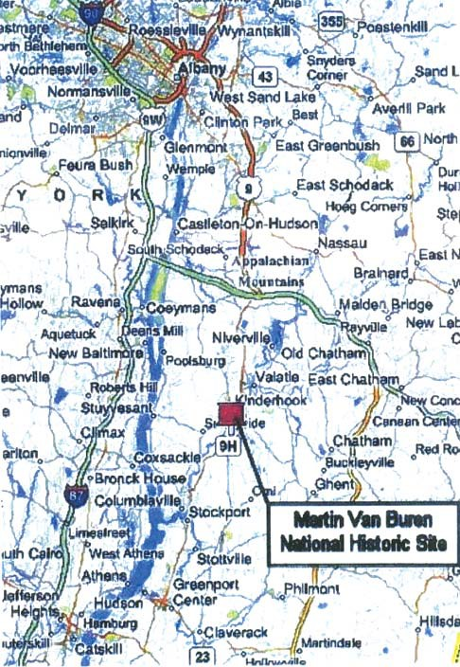

**Figure 1.2.** Portrait of the young Martin Van Buren by Henry Inman. *Source: Library of Congress*

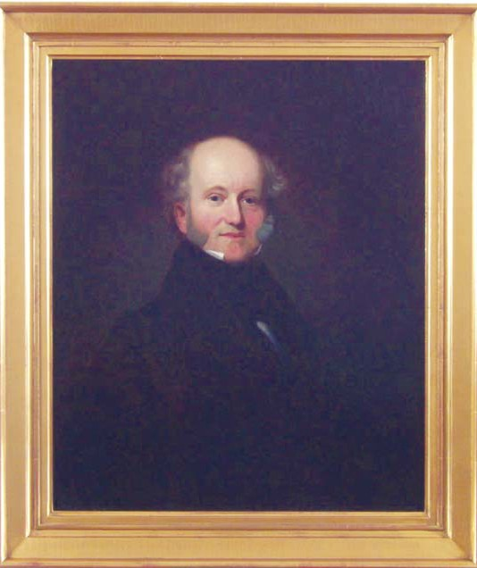

**Figure 1.3.** Photograph of the elderly Martin Van Buren

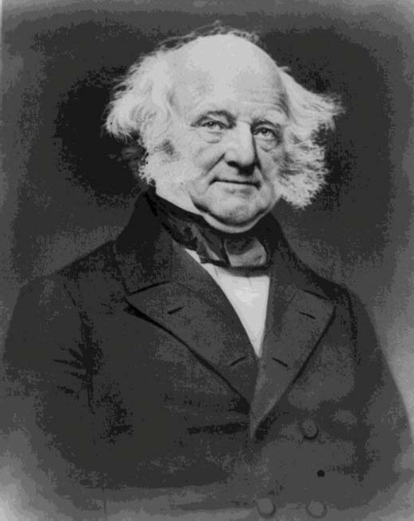

*Source: Library of Congress*

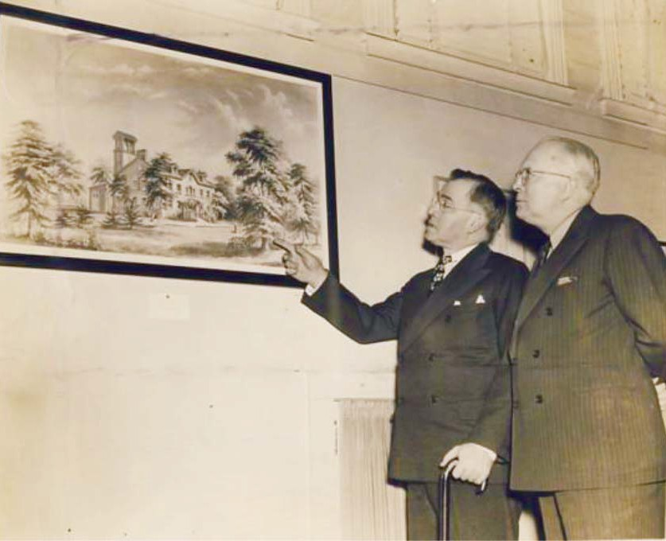

**Figure 1.4.** James Leath and John Watson of the Columbia County Historical Society

*Source: Photograph MAVA Collection*

Chapter Two

*Recognizing Lindenwald: The Establishment of Martin Van Buren National Historic Site*

# Toward 1982:

**The Race To The Van Buren Bicentennial**

#### Introduction

In the spring of 1977, a reporter for a regional newspaper wrote, “Driving along Route 9H in Kinderhook, you’ll pass a ghostly, deteriorating old brick mansion ﬂanked by a muddy entranceway, a small, pink-tinged carriage house (of which there used to be two

matching) and ragged, once-splendorous grounds. This is Lindenwald, the home where Presi- dent Martin Van Buren lived out the ﬁnal years of his life.”1

By that time, Van Buren’s Lindenwald had been a National Historic Site for nearly three years, but the image of a “ghostly, deteriorating” house surrounded by “ragged” grounds reﬂects the fact that little progress had been made toward restoring the property. Between its establishment in 1974 and 1982, the bicentennial of Van Buren’s birth, National Park Ser-

vice professionals and outside consultants and contractors did work toward the restoration of Lindenwald and the organization of its collections, but a number of complicating factors, including the proposed establishment of a landﬁll close to the site and the ongoing residence

of the property’s former owner, occupied a great deal of administrative time and slowed these eﬀorts. By 1982 the staﬀ of Martin Van Buren National Historic Site were able to oﬀer the public a glimpse of Van Buren’s home, but the ultimate goal—a full restoration and opening in time for the bicentennial anniversary—could not be achieved.

#### Land Acquisition

The 12.8 acres purchased from Kenneth Campbell included the historic core of Lindenwald: the mansion and the immediately surrounding grounds. The land around the site was in farmland and woods and resembled the environment as it existed in Van Buren’s day. Population pressures, however, presented threats to that environment. The area was zoned residential with a minimum lot size of two acres. While the nearest residential development was about one-half mile south of the site in the late 1970s, Interstate Highway 90 put the Al- bany metropolitan area within commuting distance of Columbia County, increasing the possi- bility of continued residential growth. In order to preserve and interpret the site, the National Park Service identiﬁed several tracts outside the Campbell property for protection through purchase in fee or through scenic easements.2

1 Nancy-Gail Reed, “Sprucing up Van Buren’s old mansion,” *The Berkshire Sampler*, May 8, 1977. Copy in Folder Old Park Files, MAVA.

2 “Environmental Assessment, Acquisition of Tracts 01-102,-103,-105,-106,-107,-108, and 109,” Revised April 13, 1979, p. 3; North Atlantic Region, National Park Service, Martin Van Buren National Historic Site, Kinderhook, NY.

The 1970 *Master Plan* recommended the acquisition of additional lands in fee to complete a total 22.2 acres, including an area southwest of the house, part of the Old Post Road right-of-way, a triangle of land between State Route 9H and the Old Post Road, and a

small parcel on the northeast side of the property. The triangular area and the northeast tract could provide access, parking, and visitor services; the ownership of part of the Old Post Road right-of-way would serve to retain its historic integrity.3 The *Master Plan* also called for conservation easements on each side of the site to continue agricultural uses on the surround- ing lands and to protect them from inappropriate development. The proposed easements included lands on the south and west sides that had been part of the 220 acres owned by Van Buren. An additional easement east of Route 9H would control development on the land in front of the site. The recommended easements totaled 19.8 acres. The proposed park size at this point in the planning process was 42 acres.4

By the end of March 1980, an Approved Land Acquisition Plan was in place. One tract was the property that had been acquired in fee simple in 1975. Condemnation proceed- ings to acquire fee simple title to three tracts and scenic easements to ﬁve tracts had been initi- ated. In addition, fee title to another tract was to be acquired by donation from the New York State Department of Transportation, and fee title to the parcel between Old Post Road and Route 9H was to be acquired by donation from Columbia County once this portion of the Old Post Road was vacated.5 On October 16, 1980, title in fee simple to the three tracts, and scenic easements to the ﬁve tracts passed to the United States.6 In July, 1982, Columbia County do- nated its tract to Martin Van Buren National Historic Site.7

#### Administration and Operations, 1974-77

While the designation of the national historic site was pending, the National Park Service went through a reorganization that placed Martin Van Buren National Historic Site under the National Park Service’s North Atlantic Region for the ﬁrst two decades of its existence. From 1937 until 1955, New York State was included in Region I, headquartered in Richmond, Virginia, and including twenty-three states on the eastern edge of the United States. Region I was one of four National Park Service regions. In 1955, Region I was di- vided, creating Region V. Region V included sixteen states in the northeastern United States, including New York; its regional oﬃce was located in Philadelphia. In 1971, the National Park Service revised its boundaries, creating seven distinct regions, and New York State was

included in the Northeast Region. Two years later, the Northeast Region was divided into the Mid-Atlantic Region and the North Atlantic Region. The North Atlantic Region encompassed

3 [National Park Service], “Master Plan, Lindenwald National Historic Site, New York” (1970 Master Plan), February 18, 1970, 16.

4 1970 Master Plan, 20; Proposed Lindenwald National Historic Site, Kinderhook, NY, March, 1973, Support Data, n. p.; Planning Files, National Park Service, Boston Support Oﬃce.

5 Land Acquisition Plan For Martin Van Buren National Historic Site, Approved by Regional Director March 19, 1980; Folder L1425 Land Acquisition Plan 1980, MAVA Central Files.

6 Paul K. Cotter to Superintendent, March 9, 1981 (eight memos), Folder L1425 Fed. Real Prop. Mgmt., Martin Van Buren National Historic Site, MAVA Central Files.

7 “Deed for Lindenwald Addition Presented,” *Hudson Register Star,* July 8, 1982; K34 Newspaper Items, MAVA Central Files.

New York and seven other northeastern states, with its regional oﬃce located in Boston. The North Atlantic Region existed until 1995, when the ten National Park Service regions were reorganized into seven ﬁeld areas, and New York sites became part of the Northeast Area with its support oﬃce in Boston.8

Under the 1970 Master Plan, the Lindenwald National Historic Site, renamed Martin Van Buren National Historic Site by the time of its establishment in 1974, was to be administered by the superintendent of the Franklin D. Roosevelt and Vanderbilt Mansion Na- tional Historic Sites (ROVA) in Hyde Park, New York, about ﬁfty miles south of Lindenwald. The plan called for a unit manager to supervise day-to-day operations at the new park, but the initial responsibility fell to ROVA Superintendent Warren Hill. Hill became involved with the site even before 1974, supporting its designation by participating in local informational meet- ings and informal gatherings with residents and the Columbia County Historical Society, and by discussing the proposed park with members of the New York congressional delegation.9

Hill took a strong role in the early development of MAVA.10 By the fall of 1975, he was supervising two park technicians, Richard Lusardi and Harry Steuhl, who greeted visi- tors interested in the site, separating those guests from people who came to buy antiques from Kenneth Campbell. Hill instructed the park technicians to establish relationships with local police and ﬁre departments; investigate the possibility of installing utilities at the South Gate- house; begin a card ﬁle on the history of the development of the house and grounds; obtain pertinent prints and drawings; compile boundary maps, utilities schematics, and ﬂoor plans; and develop work orders for tasks to be accomplished when the site was fully operative.11 The risk of ﬁre at the mansion was a particular concern. Lusardi met with the chief of the local ﬁre department in the fall of 1975 and provided members of the company with a tour of the house to facilitate the chief’s work in developing a ﬁre attack plan for Lindenwald. The ﬁre company also burned a large pile of brush on the property in November and in the following spring.12

In addition to ﬁre prevention and protection, the two technicians assumed much of the responsibility for the overall security and safety of the site. Although most ongoing work

stopped for the season in November of 1975, Lusardi and Steuhl checked the property for dam-

8 Barry Mackintosh, *National Park Service Administrative History: A Guide*, updated by Janet McDon- nell (National Park Service: U.S. Department of the Interior, 2004), 29-32.

9 1970 Master Plan, 18; Warren Hill, interview by Suzanne Julin, July 23, 2009; “Administrative His- tory Prior to Establishment of Lindenwald: Visits to Kinderhook by Warren Hill Superintendent of Roosevelt-Vanderbilt NHS,” Folder Admin History 1961-1995, McKay Files, MAVA. Although Martin Van Buren National Historic Site was established in 1974, few management records for the ﬁrst two years of its existence have been preserved.

10 Warren H. Hill to Walter L. Ferree, January 12, 1976, and Warren H. Hill to Adolph Placezk, January 12, 1976; Folder Daily Yellows January-June, 1976, ACE BAMA-B2, Cat VAMA 4612, Box 3, Reading File 1976-1981, Roosevelt-Vanderbilt, Roosevelt-Vanderbilt National Historic Site (ROVA).

11 Superintendent [Warren Hill] to Richard Lusardi and Harry Steuhl, memorandum, September 11, 1975, Folder Admin History 1961-1975, McKay Files, MAVA; Hill, interview.

12 Richard Lusardi and Harry Steuhl to Superintendent [Warren H. Hill], March 12, 1976, Folder Daily Yellows January-June 1976, ACE BAMA-B2, Cat VAMA 4612, Box 3, Reading File 1976-1981, ROVA. Lusardi left MAVA in the fall of 1981 after accepting a position as chief of maintenance at Lincoln Home National Historic Site in Springﬁeld, IL. Bruce W. Stewart to Regional Director, August 17, 1981, Folder A-3805, North Atlantic Region, Martin Van Buren National Historic Site (Lindenwald ), MAVA Central Files.

age after heavy snowstorms and kept watch over the aged steam furnace, which required fre- quent repairs. Temporary roof work did little to protect the house from heavy rains, and the men placed buckets throughout the third ﬂoor to catch overﬂow. Kenneth Campbell remained in res- idence at Lindenwald and shut oﬀ all but four rooms on the ﬁrst ﬂoor of the house in an attempt to economize on utilities. He had installed extension cords throughout the building, and Lusardi and Steuhl removed them from the basement, where the cords had worn through in many areas. They documented the poor condition of the house’s wiring system and the existence of several 110-volt lines hanging from ceilings.13 One of the energy-related problems was addressed in

the fall of 1976 with the replacement of the mansion’s boiler. Because Campbell still lived in the house, the old boiler had to be removed, the new boiler installed, and heat restored within eight hours. The project acknowledged the historic nature of the building: the contractor was cau- tioned not to damage ductwork, materials, or equipment in the house that were not designated for replacement, because of the potential historic values of these resources.14

The South Gatehouse, which was in an advanced state of disrepair, was stabi- lized during 1975 and 1976. Campbell’s possessions were removed, and workers rebuilt the foundations and walls. They also installed plumbing, electricity, a septic system, and a well.

A wood-shingle roof replaced asphalt shingles, and the building was painted an appropriate peach-tone. The restored gatehouse was put to use as an oﬃce and storage space.15 Extensive work on the grounds also took place during 1976, including brush removal and clearing from what a local newspaper termed “a jungle of secondary growth, underbrush, vines, sumac and weeds.” Workers located twenty trees dating from the Van Buren era during this process.16

Between July 1975 and January 1976, expenses at MAVA went over budget due to seasonal salaries, high telephone bills, security system payments, and a lightning strike that caused nearly $4,000 in damage to the mansion’s security system. Early in 1976, Hill had to

make reallocations to plan for the remainder of the ﬁscal year. His direct responsibilities were eased when Bruce Stewart, historian at Morristown National Historical Park in New Jersey, was appointed to serve as park manager at MAVA in March, 1976.17 However, Warren Hill continued to remain deeply involved after Stewart was named to the post. He took a strong role in the unfolding controversy regarding a proposed county landﬁll and continued to re- port to the regional oﬃce on planning and budget matters in the fall of 1976.18

13 Lusardi and Steuhl to Superintendent, March 12, 1976.

14 Warren H. Hill to Shaker, Travis and Quinn Inc., November 24, 1976, Folder Daily Yellows July-De- cember, 1976; Warren H. Hill to Shaker, Travis and Quinn Inc., January 21, 1977, Folder Daily Yellows, January-June, 1977; “Preconstruction Conference,” December 6, 1976, approved by Warren H. Hill, Folder Daily Yellows, July-December, 1976, ACE BAMA-B2, Cat VAMA 4612, Box 3, Reading File 1976- 1981, ROVA.

15 Lusardi and Steuhl to Superintendent, March 12, 1976; William N. Jackson to Andrea Gilmore, No- vember 3, 1980, Folder H30 Archaeological and Historical Structures, MAVA Central Files.

16 *Hudson Register Star*, January 27, 1977, clipping in Folder H30 Archeological and Historic Structure, MAVA Central Files.

17 Roy F. Beasley Junior to Superintendent, February 23, 1976, and Warren H. Hill to Division Chiefs, March 2, 1976, Folder Daily Yellows January-June 1976, ACE BAMA-B2, Cat VAMA 4612, Box 3, Read- ing File 1976-1981, ROVA.

18 Warren H. Hill to Regional Director, North Atlantic Region, September 30, 1976, Folder Daily Yellows July-December 1976, ACE BAMA-B2, Cat VAMA 4612, Box 3, Reading File 1976-1981, ROVA.

In addition to Stewart, other new staﬀ ﬁlled crucial roles in the site’s development.

Early in 1977, Mary B. Smith accepted the position of curator and began work on the Lin- denwald museum collection. Smith, a graduate of the American Academy of Arts in Chicago, had worked with the Smithsonian Institute, the Roosevelt Library, and the Albert Schweitzer Friendship House. William Jackson took an appointment as Martin Van Buren National His- toric Site’s interpretive historian. A graduate of the State University of New Mexico, Jackson had worked in several national parks, including the Lyndon B. Johnson National Historic Site and Carlsbad Caverns.19 Smith and Jackson were integral to the new site’s restoration, inter- pretation, and collections.

#### Administration and Operations Post-1977

Warren Hill gained a great deal of conﬁdence in Bruce Stewart’s leadership as the development of MAVA continued. In late 1977, Hill and Stewart met with the regional direc- tor, and Hill told him it was “time for a divorce.” Stewart should be the full superintendent of the site and independent of ROVA. By 1978, administrative functions of MAVA were managed at the site.20 That summer, the park hired ﬁve park technicians to provide tours and instituted a volunteer program. Tours were oﬀered on a daily basis, and visitation reached nearly 4,500. The interpretive division established an outreach program for schools and community and professional organizations, and the park oﬀered its ﬁrst special event program, a presentation of *Zarquela,* a nineteenth-century opera.21 In 1979, the season began in May and ended in late September. Daily tours of the grounds allowed visitors to see the restoration work being done on the exterior of Lindenwald. Several cultural activities, including an antique car show, a production of the opera *La Boheme*, and a concert by the West Point Brass Quintet, oﬀered additional entertainment for visitors. The 1979 visitation increased by 10 percent over the pre- vious year.22 As the visibility of the site increased, concerns about the isolated, rural environ- ment and the limited ﬁre and police resources prompted MAVA to employ two night guards for a year’s service in 1978.23

Progress at MAVA, however, was impeded by two major problems: the resi- dency of former owner Kenneth Campbell and a major controversy over a county landﬁll. These issues consumed a great deal of staﬀ time that might otherwise have gone to further- ing park development.

#### The Campbell Residency

Kenneth Campbell’s residency in Lindenwald after it was acquired by the Nation- al Park Foundation and then the National Park Service created particular administrative and

19 Reed, “Sprucing up Van Buren’s old mansion.”

20 Martin Van Buren National Historic Site 1978 Annual Report, 9-10, A-3815, Martin Van Buren Na- tional Historic Site (Lindenwald) in Museum Collection, ROVA.; Warren Hill, interview by Suzanne Julin, July 23, 2009.

21 Martin Van Buren National Historic Site 1978 Annual Report, 5.

22 National Park Service, “Lindenwald Ends Second Season,” news release, n.d., and William N. Jackson to *Poughkeepsie Journal*, June 1, 1979, Folder K3415, Press Release [II], MAVA Central Files.

23 Martin Van Buren National Historic Site 1978 Annual Report, 6.

management problems as well as issues of humanitarianism involving an elderly man facing the loss of his last home and his livelihood. Warren Hill, Bruce Stewart, and the staﬀ at MAVA worked to accommodate Campbell’s residency appropriately and looked after his welfare at the end of his life.

When the National Park Foundation negotiated for the purchase of the property, Kenneth Campbell agreed with the oﬀered price—$102,000—but requested that he be al- lowed to continue to live there and operate his antique business. The foundation met Camp- bell’s terms and negotiated a lease agreement for three years, with an option to renew for an additional year. He paid no rent, but was responsible for heat, utilities, and ﬁre and liability insurance.24 The National Park Service ﬁnalized its purchase of Lindenwald from the Nation- al Park Foundation on August 20, 1975, and the foundation subsequently assigned to the NPS all rights in its lease with Kenneth Campbell.25

Thus, when work began at the new national historic site, Campbell was living there and running his long-standing antique business. His presence created ongoing concerns for the staﬀ who were managing and maintaining the park. In a 1975 memo to the park techni- cians responsible for the site’s initial development and maintenance, Warren Hill cautioned, “Paramount in your responsibilities is assuring a continuing good relationship with Mr. Ken- neth Campbell, the lessee. Be sure to review with Mr. Campbell on each day the work you expect to accomplish that day so that he is fully knowledgeable and is not surprised by work you have accomplished in and around the estate.”26

In 1976, Campbell asked to renew his lease at Lindenwald for the one year al- lowed under the original agreement. The renewal extended the provisions of the agreement to April 24, 1977.27 The diﬃculty involved in relocating Campbell appropriately, however, led to a ﬁfteen-day emergency lease extension and considerable eﬀort by park oﬃcials to solve Campbell’s housing problem and to free Lindenwald from occupancy so that major work could begin there.28 By this time, Campbell was 83 years old. Except for a few relatives, none of whom lived in Columbia County, he was alone in the world. Bruce Stewart tried to assist him in ﬁnding a new place to live, but Campbell—who wanted to stay in the Kinderhook area

— could not accept the fact that prices of real estate were higher than he had anticipated, and could not aﬀord the type of property he preferred. An NPS realty specialist joined in the eﬀort to relocate him, but determined that nothing suitable was available nearby. Campbell repeat- edly asked to rent the South Gatehouse, where he and his wife had lived for a short time after purchasing the property. The gatehouse contained a main room, a compact kitchen, and a bathroom; in addition, a small structure Campbell had erected west of the gatehouse in 1958

24 Hill, interview; Bruce W. Stewart to Chief, Lands Acquisition, North Atlantic Region, April 6, 1977; and Draft Lease Between National Park Service and Kenneth F. Campbell, n. d., Folder H15 Kenneth Campbell, MAVA Central Files.

25 John L. Bryant Jr. to Warren H. Hill, September 23, 1975, Folder L1429 Land Records Lindenwald Surrounding Tracts, MAVA Central Files.

26 Superintendent toLusardi and Steuhl, memorandum, September 11, 1975.

27 Warren H. Hill to Kenneth F. Campbell, March 15, 1976, Folder Daily Yellows January-June 1976, ACE BAMA-B2, Cat VAMA 4612, Box 3, Reading File 1976-1981, ROVA.

28 Bruce W. Stewart to Kenneth Campbell, April 19, 1977, Folder H15 Kenneth Campbell, MAVA Cen- tral Files.

could serve as his antique shop. Stewart conducted a rent survey, traveling to nearby Hudson to investigate apartments that might be considered comparable to the gatehouse, and then ne- gotiated an agreement with Campbell that allowed him to rent the building as well the nearby shop. In the spring of 1977, Campbell moved into the South Gatehouse under a one-year special-use permit at a rent of $64 a month.29

In 1978, Stewart arranged renewal of the special-use permit for the period of one year, allowing Campbell to remain in the gatehouse through the end of May 1979. Stewart justiﬁed the extension by noting Campbell’s advanced age, fragile state of emotional and physical health, and lack of close relatives to care for him. He also stated that the National Park Service had no need to utilize the gatehouse at that time. The permit was renewed in 1979 and again in 1980.30

Campbell’s health began deteriorating rapidly in 1979, and he was hospitalized repeatedly over the next year, but he did not want to move away from the gatehouse. In the meantime, Stewart’s concerns about the situation increased. He was worried not only about Campbell’s well-being, but also about the visual intrusion to the site that Campbell’s use of the gatehouse and the outbuilding presented and about the ﬁre danger posed by Campbell’s residency there. Despite those issues, he recommended an extension of the special-use permit

one ﬁnal time, to April 1, 1981. Late in 1980, he appealed to Campbell’s relatives to address the elderly man’s living situation. By the end of the year, Campbell had been relocated to a nursing home, the shed serving as an antique shop had been boarded up and secured, and the gate- house telephone and utilities were disconnected. Kenneth Campbell died on January 2, 1981.31

The issues presented by Campbell’s residency at the park did not immediately end, however. After his death, legal matters delayed the appointment of an administrator to the estate, and his personal possessions and the antiques from his business ﬁlled both the South Gatehouse and the shed he had built. The regional solicitor pursued the matter, Camp- bell’s nephew was appointed administrator, and the possessions were moved out in late May 1981. The 1950s-era shed was taken down and its elements discarded.32 Campbell’s residency had slowed progress at the park, but the sensitivity to his situation displayed by park staﬀ and the regional administration reﬂected a compassionate approach to a diﬃcult situation.

#### Columbia County Landfill Controversy

The Columbia County landﬁll controversy is indicative of a larger issue facing Martin Van Buren National Historic Site. Located in a rural agricultural area, the park has

29 Bruce W. Stewart to Regional Director, North Atlantic Region, April 11, 1977, Bruce W. Stewart to Super- intendent, Roosevelt-Vanderbilt NHS, May 24, 1977, Bruce W. Stewart to Chief, Land Acquisition Division, June 21 and June 29, 1977, all in Folder H15, Kenneth Campbell, MAVA Central Files; Hill, interview.

30 Bruce W. Stewart to Files, May 25, 1978; Special Use Permit, Martin Van Buren NHS, June 1; and Bruce W. Stewart to Files, May 14, 1980, Folder H15 Kenneth Campbell, MAVA Central Files.

31 Stewart to Files, May 14, 1980, Bruce Stewart to Mrs. Mary Noakes, December 3, 1980, Bruce Stew- art to Harry J. Campbell, December 15, 1980 and January 21, 1981, and Stewart to Regional Director,, March 30, 1981, all in Folder H15 Kenneth Campbell, MAVA Central Files.

32 Stewart to Regional Director, March 30, 1981, Record of Telephone Conversation(s), April 14, 1981, Roger Sumner Babb to Benj. M. Lichtenstein, April 21, 1981, Bruce W. Stewart to Benj. M. Lichtenstein, May 22, 1981, Bruce W. Stewart to Chief, Branch of Procurement and Property Management, North Atlantic Region, July 8, 1981, all in Folder H15 Kenneth Campbell, MAVA Central Files.

been subject to pressures of encroaching development and the growth of surrounding vil- lages, towns, and counties. The landﬁll issue, arising soon after the park’s establishment, introduced staﬀ and community supporters to the diﬃculties of maintaining the setting of this historic site in an area ripe for rapid growth.

In 1975, before work on the park began in earnest, the Board of Supervisors of Columbia County proposed the development of a refuse disposal facility across Route 9H and approximately one-quarter mile north of Martin Van Buren National Historic Site. Warren Hill requested a National Park Service review of the proposal. Bernard Brennan, who owned property adjoining the park, organized the Committee for the Environmental Protection of Lindenwald. The group raised money, hired technical advisors, and enlisted the legal services of local resident John Hanna Jr. of the Albany law ﬁrm Whiteman Osterman and Hanna.33

Upon assuming park management responsibilities in 1976, Bruce Stewart was im- mediately confronted with the landﬁll issue. He notiﬁed the New York Department of Envi- ronmental Conservation that the park’s *Master Plan* anticipated visitation of 25,000 people per year and proposed visitor access and egress from Route 9H, as well as a visitor center and parking lot located adjacent to the road. Trucks bringing refuse to the landﬁll, Stewart pointed out, could pose traﬃc hazards to people visiting the site.34 State oﬃcials requested the pres- ence of a National Park Service representative at a public hearing in July of that year. The purpose of the hearing was to bring forth the facts by which Commissioner Peter A.A. Berle of the Department of Environmental Conservation would make a decision, including issues of environmental impact, county plans to provide a solid waste management system and alterna- tives to such a system, and matters of water quality treatment and control.35

The hearing included eight days of testimony. Warren Hill and Bruce Stewart represented the National Park Service. Members of the Committee for the Environmental Protection of Lindenwald and the Columbia County Historical Society also attended and opposed the application, as did approximately thirty-three other citizens representing them- selves or organizations and presenting unsworn testimony. In addition, private citizens or organizations ﬁled twenty-two written statements in opposition to the landﬁll.36 The objec- tions of the National Park Service were summarized in the proceedings attached to the ﬁnal decision: “Noise and visual pollution would have a major detrimental eﬀect on the develop- ment of the Martin Van Buren National Historic site and the restoration of Lindenwald in its

33 Hill to Regional Director and Warren H. Hill to Ogden Reed, March 1, 1975, Folder Daily Yellows, January-June, 1976, ACE BAMA-B2, Cat VAMA 4612, Box 3, Reading File 1976-1981, ROVA; Hill, interview; Bernard Brennan, Committee for the Environmental Protection of Lindenwald, Concluding Report, July 17, 1980, Folder A-3815, Martin Van Buren NHS (Lindenwald) ROVA.

34 Bruce W. Stewart to Peter Berle, May 26, 1976, Folder Daily Yellows January-June, 1976, ACE BAMA- B2, Cat VAMA 4612, Box 3, Reading File 1976-1981, ROVA.

35 State of New York Department of Environmental Conservation, news release, June 17, 1976, Folder Brennan Hearing Exhibits, Box 649, MAVA.

36 Superintendent’s Annual Report for Roosevelt-Vanderbilt National Historic Sites [1976], attach- ment to Warren H. Hill to Regional Director, National Archives and Records Administration, March 2, 1977, Folder A-2621 Annual Reports 1972-1981, Box ACC-VAM-132 Cat VAMA 4614 Box 1, Resource Management Park Files, VAMA; Proceedings, attached to Decision, State of New York Department of Environmental Conservation in the Matter of the Application of Columbia County (January 27, 1977),

p. 1, Box 649, MAVA.

historic setting.” The Town of Kinderhook objected to the location because of its proximity to the national historic site in an area zoned for residential and agricultural use.37

Late in January 1977, the State Department of Environmental Conservation denied Columbia County’s application for a landﬁll at the Kinderhook site. In his decision, Commissioner Berle emphasized that the denial did not preclude the consideration of an- other application addressing problematic issues—including a high groundwater table, litter control, and traﬃc congestion—and the potential impacts on historic resources in the area. He encouraged Columbia County in its eﬀorts to plan a solid waste disposal program in a manner that would meet the state’s criteria. The Committee for the Environmental Protection of Lindenwald considered the issue closed.38

It was not. Columbia County authorized funding for additional studies pertaining to the proposed landﬁll, and on June 30, 1978, the county again ﬁled an application. Argu- ments about whether the application was new or a resubmittal of the original application immediately arose. John Hanna submitted a seventeen-page brief objecting to the proposed landﬁll on behalf of the Committee and the Town of Kinderhook. The brief argued that the application was not a continuation of the original proceedings, but an entirely new submis- sion, and asked that it be denied on the basis of several points including inadequate respons- es to issues raised in the earlier application process and lack of public notiﬁcation in ﬁling the application.39

Up until that point, Superintendent Stewart had depended on the Committee for the Environmental Protection of Lindenwald to represent the site’s interests in the press and other public arenas, a tactic often employed in the Park Service when units became embroiled in local controversies. Now he decided to enter the fray publicly, although he knew he risked antagonizing the Columbia County Board of Supervisors. With the help of National Park Ser- vice specialists, he drafted an oﬃcial statement opposing the landﬁll, and the Acting Regional Director signed the statement in September. MAVA supporters also continued to oppose the renewed application. One neighbor to the site stated his intention to ﬁle an injunction to halt the construction of the landﬁll if necessary. Ruth Piwonka, executive director of the Columbia County Historical Society, submitted a petition signed by more than 1,500 county residents asking that the new application be denied. Albert Callan Jr., the editor of the *Chatham Courier* who had been instrumental in securing the establishment of MAVA, published news stories about the controversy and editorials opposing the landﬁll. Because of the widespread opposi-

37 Proceedings, attached to Decision, State of New York Department of Environmental Conservation in the Matter of the Application of Columbia County (January 27, 1977), p. 1-2, Box 649, MAVA.

38 Decision, State of New York Department of Environmental Conservation in the Matter of the Ap- plication of Columbia County for approval to construct a solid waste management facility by developing a sanitary landﬁll in the Town of Kinderhook, Columbia County, (January 17, 1977), Folder Brennan Landﬁll Pleadings, Box 649, MAVA; Bernard Brennan, Special Bulletin Number Three, Committee for the Environmental Protection of Lindenwald, [1978], Folder Brennan Landﬁll-1978 Application Cor- respondence, Box 649, MAVA.

39 William J. Spampinato to Laurence [sic] Vernon, August 11, 1978, Folder Brennan Landﬁll-1978 Application Correspondence; Brennan, Special Bulletin; John Hanna Jr. to Peter A. A. Berle, Septem- ber 7, 1978, Folder Brennan Landﬁll-1978 Application Correspondence; all in Box 649, MAVA. April 6, 2010, MMAA.

tion and the need for further information regarding the development of the landﬁll, Commis- sioner Berle ordered additional hearings.40

The ﬁrst of those hearings was held in October, but Columbia County refused to participate, and the proceedings were adjourned. The county stated that it would take part in further hearings if the application was treated as a new one rather than a resubmittal, but no new information would be forthcoming because all the pertinent materials had been submitted and reviewed. On November 2, 1978, Berle denied the county’s application. The county unsuc- cessfully petitioned the state supreme court for a judgment against Berle and the Department of Environmental Conservation, asking that the landﬁll be approved and the permit granted.41

Columbia County eventually abandoned its attempts to locate the landﬁll at the site near MAVA, and the National Park Service granted John Hanna a Certiﬁcation of Ap- preciation for his service as a private citizen and as an attorney for the Committee for the Environmental Protection of Lindenwald in the ﬁght against the landﬁll. NARO Director Jack

E. Stark wrote to Hanna that if the landﬁll had been established, it would have “destroyed the present historic and natural environment surrounding the Martin Van Buren home, and seriously impaired the ability of the National Park Service to develop and manage the site as a

viable unit of the National Park system.” Bernard Brennan made a ﬁnal report to the Commit- tee for the Environmental Protection of Lindenwald in July 1980. The committee had received nearly $18,000 in donations, which was expended on legal fees and expenses—the law ﬁrm

of Whiteman Osterman and Hanna charged only a portion of their usual fee—and techni- cal expertise. In September 1982, the property once slated to be a landﬁll was dedicated as a Columbia County park and recreation area intended in part to serve the visitors who would be attracted to Martin Van Buren National Historic Site once its restoration was complete.

The landﬁll controversy introduced Bruce Stewart and regional and park staﬀ to what would become ongoing issues of protecting Martin Van Buren National Historic Site from the pressures of encroaching development, periodically distracting them from the work at hand. That controversy, however, also served a more positive purpose. The public hearings, news stories, petitions, and local meetings gained the attention of large numbers of local citi- zens, who developed a fresh appreciation of the historic site in their midst. MAVA represented the nation’s history as well as the community’s historical and agricultural heritage, and the ﬁght to protect those values helped solidify their relationship to the park.44

40 Martin Van Buren National Historic Site 1978 Annual Report, 2-3; Hill, interview; Larens M. Vernon to Calvin Sheldon September 12, 1978; Ruth Piwonka to Fred LaViollette, August 23, 1978; Joseph A. Cutro to Peter Berle, [1978]; Ruth Piwonka to Peter A. A. Berle, August 23, 1978, all in Folder Brennan Landﬁll-1978 Application Correspondence, Box 649, MAVA; Ruth Piwonka, interview by Suzanne Julin, April 6, 2010, MMAA.

41 Martin Van Buren National Historic Site 1978 Annual Report, 2-3; Spampinato to Vernon, August 11, 1978;, and Supreme Court of the State of New York, County of Columbia, Petitioner, For a Judgment Pursuant to Article 78 of the Civil Peace Law and Rules against Peter A. A. Berle, 3-9. Box 649, MAVA.

42 Jack E. Stark to John Hanna Jr., April 30, 1979, Folder Brennan Landﬁll 1978 Correspondence, Box 649, MAVA.

43 Bernard Brennan, Concluding Report [to] Committee for the Environmental Protection of Linden- wald, July 17, 1980, Folder Brennan Landﬁll Billing, Box 649, MAVA; *Chatham Courier* Rough Notes September 16, 1982, Folder K34 Newspaper Clippings, MAVA Central Files.

44 Piwonka, interview.

#### Planning

The 1970 *Master Plan* established six objectives for MAVA: land acquisition,

research, an interpretive theme, development, fee collection, and state and local cooperation. The research objective called for an ongoing program for the purposes of management and interpretation of the resource with “the contribution of Martin Van Buren, eighth President of the United States, to the American political tradition” as the interpretive theme. Develop- ment included the establishment of modern facilities for visitor services, parking, and main- tenance located in a separate area from the historic core, development that would “be guided by the architectural character of the site and neighborhood.” The objective of state and local cooperation noted that the staﬀ would “actively participate in community and regional plan- ning.”45 These three objectives became particularly important as the site tried to solve issues of interpretation, reasonable facilities, and the protection of the rural nature of the lands that surrounded Lindenwald.

The Master Plan, written before the oﬃcial designation of Martin Van Buren Na- tional Historic Site, was ambitious in its predictions of visitation and in its framework for the park’s development. By the late 1970s, a formal planning process was in place with the goal of producing a *Development Concept Plan* (*DCP*). A *DCP* process analyzes alternatives for a site’s management and development. After revisions, the park superintendent and the planning team were to determine the alternative that would become the basis for the *DCP*, which would replace the 1970 *Master Plan* with a planning document that better reﬂected contemporary funding realities and policies. The *DCP* addressed particular questions: Should the interior of the mansion be preserved or restored? Should it be completely refurnished in period rooms, or should the Van Buren furnishings and possessions be used as exhibit elements to interpret the former President and his home?46

In the beginning, Superintendent Bruce Stewart considered the *DCP* process crucial to the continued development of the park and its goal of opening by the bicentennial of Van Buren’s birth. When work on the *DCP* was moved from the 1979 to the 1980 ﬁscal year budget, he became alarmed. In a strongly worded letter to the regional oﬃce, he asked, “How are we to provide Park management, maintenance, curatorial, and visitor center functions? If we are to make any progress for 1982 . . . we must have in hand a *DCP* that projects ﬁnal Park development.” The major issues Stewart identiﬁed included maintenance, management, and curatorial functions, as well as decisions about which areas of the house would be furnished and open to the public, and whether a former carriage barn and the North Gatehouse should be reconstructed. In addition, the plan would address use of the grounds for historic versus adaptive purposes, the development of visitor facilities, and a ﬁnal question: “Is our current land acquisition program suitable for park development and management, or should addition- al land acquisition authority be sought?”47 Stewart wrote that letter in 1980, but many of the

45 1970 Master Plan, 17.

46 Attachment to Acting Regional Director, NARO to Superintendent, Martin Van Buren National Historic Site, April 8, 1981; L7616 MAVA, DCA/EA-2, Clark Files; National Park Service, Boston Area Support Oﬃce.

47 Bruce W. Stewart to Terry Savage, August 12, 1980, Folder D18 Planning Program Master Plans Gen- eral, MAVA Central Files.

questions he asked continued to be pondered and argued well into the twenty-ﬁrst century. Despite the need for more realistic guidelines than the *Master Plan* presented, the park’s ﬁrst *DCP* was not completed until 1984.

Diﬃculties involved in other studies also slowed the park’s planning processes. In order to make decisions about restoration, rehabilitation, preservation, furnishings, and other issues, speciﬁc studies were needed to provide information and analysis. NARO supported the development of a Historic Structure Report (HSR) to facilitate restoration and rehabilita- tion work at Lindenwald. HSRs contribute to preservation planning by providing detailed information about a property’s history and its existing condition and make recommenda- tions to guide the treatment of historic properties. In 1977, Dr. John Platt completed a draft manuscript of the MAVA HSR. After review of the document, however, NARO deemed the report inadequate because, although it addressed the broader history of the resource, it lacked architectural history and data related directly to the structure.

Given the nature of the work, NARO suggested that the Platt study be issued as a Historic Resource Study (HRS) rather than a Historic Structure Report. Historic Resource Studies address the history of properties before they became National Park units, providing

information useful for interpretation and management purposes. Subsequently, the HSR proj- ect proceeded under the responsibility of the National Park Service Denver Service Center, which provides planning, design, and construction services to the parks. Some sections of

the report were assigned to the North Atlantic Historic Preservation Center, and by mid- 1980, tensions had developed concerning completion of various parts of the report. The ﬁnal document was printed and distributed early in 1982 as a Historic Resource Study.48 A *Historic Furnishings Report*, originally scheduled to be ﬁnished in 1979,was not completed until 1986.49 The production of these and other important planning documents was crucial to the ongoing restoration, rehabilitation, furnishing, and interpretation of Lindenwald, but the processes moved slowly.

#### Zoning

Initially, the National Park Service and Martin Van Buren National Historic Site depended on local zoning ordinances to protect surrounding viewsheds. In the mid-1970s, Warren Hill worked with others in the surrounding community to advance historic zoning in the MAVA vicinity. He urged the Town of Kinderhook Planning Board to consider recom- mendations for a historic zone. He was particularly concerned about a proposed planned commercial district ordinance that could lead to “possible deterioration of the quality of the

48 Harold D. Unrau, “Editor’s Foreword,” in John D. R. Platt, preparer, *Historic Resource Study Linden- wald Martin Van Buren National Historic Site, New York*, ed. Harlan D. Unrau (Denver, CO: National Park Service, 1982), n.p.; Gerald D. Patten to Regional Director, North Atlantic Region, [June 19, 1980] and Gilbert W. Calhoun to Manager, Denver Service Center, January 4, 1979; Folder H30 Archaeological and Historic Structures H30 (Sites) P26 1950, MAVA Central Files; Deborah Slaton, “Preservation Brief 43: The Preparation and Use of Historic Structure Reports,” accessed March 3, 2009, http://www.nps. gov/hps/briefs/brief43htm; ACE BAMA-B2, Cat VAMA 4612, Box 3, Reading File 1976-1981, ROVA.

49 Carol E. Kohan, “Lindenwald: Its History and Restoration,” October, 1982, Folder D6215 Museum & Exhibit P26 1950 MAVA, MAVA Central Files; William N. Jackson, preparer, *Annual Statement for Inter- pretation and Visitor Services*, Martin Van Buren National Historic Site, December 17, 1980, 31, Folder K1815 Annual Statement for Interpretation, MAVA Central Files.

residential and farming character in this area.”50 The Kinderhook Town Planning Board and the Columbia County Historical Society, in consultation with the NPS, developed a zoning plan in 1975 that would provide a measure of protection to the natural and historic resources in the vicinity of MAVA. Although the zoning proposal had some strong support, it also had strong opposition from those landowners who objected to restrictions on their property and from people interested in commercial development on Route 9H. The proposal was eventu- ally defeated. In early 1977, expressing the belief that any historic zoning proposal would meet the same opposition, the Columbia County Historical Society recommended that congres- sional legislation be enacted to authorize the National Park Service to extend its conservation easements to include one hundred feet on each side of Route 9H extending from one-half mile south of the site to one-half mile north.51

Essentially, the group was asking that the limited development zoning, which had been proposed in the 1970 Master Plan, be altered to the category of a conservation easement. If the National Park Service agreed, the historical society planned to work through their con- gressional delegation to attempt to achieve the change. Bruce Stewart believed that blocking the development of the proposed county landﬁll then under consideration was an unspoken motive on the part of the historical society. While Stewart recognized the reality of the histori- cal society’s concerns, he thought the easement proposal was “the easy way out,” and he con- tinued to support the original concept of historic zoning.52 Stewart characterized his meetings with the historical society as “positive, thorough, and extremely friendly” and decided not to respond formally to their proposal at that time.53 Two public meetings discussed the historic zoning, using examples from Concord, Massachusetts; New Paltz, New York; and other loca- tions that maintained fairly stringent guidelines. Strong local opposition to the restrictions posed by such zoning continued and the Town Planning Board ended their consideration of that particular zoning plan. By 1978, the area was zoned residential with two-acre plots.54

#### Restoring Lindenwald

The complications of the Campbell residency, the controversy surrounding the proposed landﬁll, and the immense amount of work to be done in restoring the mansion and preparing the grounds created strong pressures on Stewart and the MAVA staﬀ as they tried to work toward a full opening by late 1982. The 1970 *Master Plan* stated that the exterior of the mansion would be restored to the 1849-1862 period, and that it was in “good condition”

and would need only “a minimum of restoration and rehabilitation.” The plan also recognized

50 Warren H. Hill to John Warren, February 2, 1976, Folder Daily Yellows, January-June 1976, ACE BAMA-B2, Cat VAMA 4612, Box 3, Reading File 1976-1981, ROVA.

51 Ruth Piwonka to Bruce Stewart, March 3, 1977, Folder 1425 Master Deed Listings Acreage Sheet, MAVA Central Files; [Albert S. Callan Jr.] ,“History Be Damned,” *The Chatham Courier*, April 10, 1975, Folder Newspaper Clippings, Box Admin. History Records, Historian’s Records, MAVA.

52 Bruce W. Stewart to Regional Director, North Atlantic Region, April 18, 1977, Folder L1425 Master Deed Listings Acreage Sheet, MAVA Central Files.

53 Bruce W. Stewart to Deputy Regional Director, North Atlantic Region, May 16, 1977, Folder L1425 Master Deed Listings Acreage Sheet, MAVA Central Files.

54 Bruce W. Stewart to Regional Director, North Atlantic Region, April 3, 1978, Folder L1425 Master Deed Listings Acreage Sheet, MAVA Central Files.

that the South Gatehouse was the only existing historic outbuilding and called for the restora- tion of its exterior, with the interior adapted for employee quarters. The plan also proposed the reconstruction of the North Gatehouse for storage and other uses.55 The *Master Plan* was optimistic; restoration of Lindenwald was a major undertaking.

The restoration was further complicated by policy changes and budget cutbacks. After World War II, the end of gas and tire rationing and the beginning of postwar prosper- ity allowed American families to take to the highways and visit the national parks. During the war years, however, those parks had suﬀered from a lack of funding and personnel. During the Korean War years of the early 1950s, park appropriations remained low, and the parks increasingly struggled to meet the expectations of the public. In the mid-1950s, National Park Service Director Conrad Wirth was successful in initiating Mission 66, a ten-year program of improvement, development, and expansion leading up to the Park Service’s ﬁftieth anniver-

sary in 1966. The impetus provided by public interest in the parks and the Mission 66 program helped lead to growth in the system. Between 1952 and 1972, the National Park Service gained ninety-eight additions. Growth continued in the 1970s, with fourteen more parks—including Martin Van Buren National Historic Site—added to the system in 1974 and 1975. Under the Carter administration (1977-1981), park expansion continued and Park Service budgets increased. More than ﬁfty units were added, including vast areas in Alaska that increased the size of the system dramatically. The period of rapid expansion came to an end with the Rea- gan administration of the 1980s, and only twenty-one new National Park Service units were established from 1981 through 1989. This slowdown reﬂected not only administrative policy that advocated smaller government and reduced government spending, but also a recession that aﬀected the national economy in 1981 and 1982 and resulted in slashed spending for many government programs, including the National Park Service.56 These factors aﬀected Martin

Van Buren National Historic Site. The growth during the 1970s encouraged the establishment of the park and optimism for the future, but the policy changes and economic problems of the 1980s came just as the historic site was addressing some of its most urgent needs.

In mid-1977, Bruce Stewart requested approval to proceed with work aﬀecting the historic property, aiming toward the goal of completing restoration by the 1982 bicen- tennial anniversary. Speciﬁcally, he wanted to remove the colonial-style front porch and a screened-in back porch, both added by Kenneth Campbell in 1958; restore the metal roof on the Upjohn addition; and install an intrusion system to protect against vandalism and bur- glary, as well as a temporary ﬁre detection and alarm system. All the requests were approved except for the removal of the front porch, which was to stay in place until rehabilitation of the roof was complete.57

55 1970 Master Plan, 22.

56 Barry Mackintosh, *The National Park Service: Shaping the System* (Harpers Ferry Center: National Park Service,, 2005), 64-106, accessed March 30, 2009, <http://www.nps.go/history/history/online_books/shap-> ing/index.htm, provides an overview of growth and changes in the national park system after World War II; Lary M. Dilsaver, ed., “A System Threatened, 1981-1992,” chap. 8 in *America’s National Park System: The Critical Documents* (Lanham, MD: Rowman & Littleﬁeld Publishers, 1994), accessed August 4, 2010, [http://www.nps.gov/history/history/online_books/anps/anps_8.htm.](http://www.nps.gov/history/history/online_books/anps/anps_8.htm)

57 [Bruce Stewart] Superintendent to Ross Holland, July 7, 1977, Folder D2215 Cultural Resource Preser- vation, MAVA Central Files. A penciled notation conﬁrms approval via telephone.

Late in that year, Jack Stark, NARO director, submitted the 1970 *Master Plan* for Lindenwald to the Deputy Commissioner of the New York Board of Historic Preserva- tion.. The board reviewed the cultural resources section as required by a Memorandum of Understanding between the National Park Service and the Advisory Council on Historic

Preservation, signed in 1976. Subsequently, the New York State Historic Preservation Oﬃcer reviewed the plan and found no adverse aﬀect on the property. Early in 1978, the plan was submitted to the Advisory Council on Historic Preservation for review. That group found only one area of concern: a proposal to reconstruct the exterior of the North Gatehouse.

Such reconstruction would be acceptable only if it was determined by a professional to meet National Park Service criteria.58

The approvals conﬁrmed the 1970 *Master Plan* as the park’s guiding document and allowed additional work to proceed. Several major projects were in progress by 1978, including the restoration of the metal roof on the Upjohn addition and brickwork repointing along with replacement of carpentry and wood sections. By the end of the year, these projects were nearly completed, and stabilization of the original Van Buren dining hall Brussels car- pet was initiated.59 The porch that Kenneth Campbell added to the house in 1958 was ﬁnally removed, providing architects and archeologists the opportunity to investigate the original façade of the house.60

The treatment of the striking French scenic wallpaper Van Buren had placed in the dining hall shortly after his purchase of the property was a crucial part of the process of restoring Lindenwald. The Zuber factory in France’s Alsace region had produced the wallpa- per, “Paysage a Chasses” (Landscape of the Hunt). Jean Zuber initially designed a panoramic wallpaper in 1803, and followed with more than twenty other such wallpapers during the early nineteenth century. The wallpapers included landscapes from several countries, reproduc- tions of famous battles, and representations of passages from works of literature. Van Buren’s choice was created in 1831 and consisted of thirty-two panels depicting hunting scenes in Alsace. Fifty-one panels were needed to wallpaper the 15 x 40 feet main hall in Lindenwald, so some panels were repeated. Each panel measured 18” wide x 8’ high. Below the chair rail, a decorative dado reproducing a balustrade set oﬀ the scenic wallpaper; the dado was a product of Jacquemart et Benard, another wallpaper producer.61

The wallpaper was a key element in Lindenwald’s signiﬁcance because of its intrinsic historical value as well as its representation of Van Buren’s goals in establishing a spa- cious, elegant dining area that could accommodate large numbers of his political colleagues and social guests. Thus, its restoration was essential. In 1977, Marsha L. Fader, a historical architect with the North Atlantic Historic Preservation Center visited the site to evaluate the wallpaper. She noted its generally good condition between the north and south doors on the

58 Jack E. Stark to Frederick Rath, December 5, 1977, Folder unlabeled [1970 *Master Plan* Corres. (brief, copied), *DCP* 1990 Corresp., multi-use bldg., corresp.] Weinbaum ﬁles, Boston Support Oﬃce.

59 Martin Van Buren National Historic Site 1978 Annual Report, 7.

60 Martin Van Buren National Historic Site 1978 Annual Report, 11.

61 Marsha L. Fader to E. Blaine Cliver, Folder H30 Archeological and Historical Structures, MAVA Cen- tral Files; *Chatham Courier Rough Notes*, January 9, 1986, in Folder K3416 MAVA Newspaper Clippings #1, MAVA Central Files.

partition wall, although paint ﬂaking indicated on-going deterioration. The paper on the north wall, however, exhibited splitting and missing portions, the west wallpaper had been removed, and the east wallpaper had suﬀered water and heating system damage.62

In 1978, the park brought eight wallpaper conservators to the site for a two-day seminar. The information derived from this seminar and from other meetings led to the deci- sion to remove the wallpaper and restore ﬁve of its panels. Further restoration would use that work as a guideline. At her own expense, park curator Mary Smith visited the Zuber factory in France to do further research.63 Beginning in 1979, conservators Patricia and James Hamm spent three weeks removing the wallpaper panels and dado for restoration in a laboratory

in Scotia, New York. They removed varnish and mold, deacidiﬁed the paper, mended and patched it, and applied a ﬁberglass lining. The Hamms used a reproduction of the wallpaper as a guide to design and colors, which they mixed themselves. They completed the restoration of the wallpaper in 1981.64

Major restoration and rehabilitation work on Lindenwald began in March of 1980 and involved historical architects, architectural conservators, and skilled preservation craftspeople. By the fall of 1982, they had repointed exterior brickwork, rebuilt chimneys, and restored or replaced gutter systems, metal work, and exterior decorative elements. The house exterior was repainted in the colors used at the time of the Upjohn remodeling. Sev- eral windows were restored using old photographs and existing marks as guides, and a door was restored to a solid wall. Cuts in funding, however, deferred more extensive work on the interior of the house.65

#### Collections

By 1980, the park owned about one hundred pieces of furniture associated with Lindenwald, but only a small number were suﬃciently documented as authentic Van Buren possessions.66 A *Historic Furnishings Report*, which would develop a furnishings plan for Lindenwald, was pending, and the lack of a ﬁnal plan limited acquisitions during the period leading up to the 1982 celebration. By October of that year, however, the house contained approximately sixty pieces of furniture associated with Van Buren.67 Some important items were acquired during the period, including an Empire pier mirror, a love seat, a footstool, and a Martin Van Buren watch. Clementine B. DeProsse, a former owner of the house, and

62 Fader to Cliver.

63 Martin Van Buren National Historic Site 1978 Annual Report, 7.

64 Mary B. Smith to Bruce W. Stewart, June 24, 1980, and Ed Kallop, Evaluation of Martin Van Buren Wallpaper Conservation Project, August 1, 1979, Folder D5217 CX 1600-80-0047 Wallpaper Preserva- tion, MAVA Central Files; Carol Kohan “Paysage a Chasse’: [sic] Conservators restore 19th-century French hunting scene at Lindenwald,” *Chatham Courier Rough Notes*, January 9, 1986, in Folder K3416 MAVA Newspaper Clippings #1, MAVA Central Files.

65 Carol E. Kohan, “Lindenwald: Its History and Restoration;” Completion Report, Form 10-174, Work Order Title “Rehab Historic Structure,” Martin Van Buren National Historic Site, Completed August, 1981, Folder D623 Completion Reports, MAVA Central Files.

66 Jackson, *Annual Statement for Interpretation and Visitor Services*, 31.

67 Carol E. Kohan, “Lindenwald: Its History and Restoration;” Jackson, *Annual Statement for Interpreta- tion and Visitor Services,* 31.

her daughter Jeanne B. Akers oﬀered the park a Van Buren mahogany sleigh bed in exchange for an exact reproduction; the bed was a major acquisition. Carol E. Kohan, who replaced Mary Smith as curator, made the arrangements for the exchange. The original Martin Van Buren banquet table—a unique table that could seat thirty and folded in accordion style—was located in private ownership in Baltimore, and research began on this important piece of furniture.68 The table and other furnishings and objects would become major issues in the interpretation of Lindenwald.

#### Interpretation

The 1970 *Master Plan* stated the theme of Martin Van Buren National Historic Site as “the life of Martin Van Buren, eighth President of the United States, and his contribution to the American political tradition.” The plan noted that the challenges Van Buren faced in lead- ing the country, including internal improvements and banking policies, were “overshadowed by the deep moral issues raised by Van Buren’s construction of political institutions.” This emphasis on Van Buren’s role in the evolution of the modern political system raised obvi-

ous problems in terms of interpreting Lindenwald, a house that served as the headquarters for Van Buren’s post-presidential agricultural estate. The resources at the site included his house, the gatehouse, some furniture, and a small portion of his farmlands, but although those resources illuminated the way Van Buren lived after 1841, they were not connected directly to his presidency or his pre-presidential political career.69

The 1970 *Master Plan* concluded that objectives of interpretation at the site should include four main tasks: providing visitors with a “basic biographical understanding of Van Buren and his political career;” making a connection between the property and Van Buren’s life “by showing what it reveals about the man;” pointing out Van Buren’s contribu- tion to the development of political parties, including the relevance of those contributions to contemporary citizens; and inspiring visitors to “study Van Buren in more detail.” All the in- terpretive activities would take place in the restored mansion; other historic resources would be utilized for management purposes or used to illustrate the “historic scene.” While visitors would be free to explore the grounds, “overt interpretive developments” were to be kept to “an absolute minimum.”70 The *Master Plan* also said that Van Buren’s interest in the farming

was “indiﬀerent” and development of a “living farm” would be inappropriate.71 Thus, diﬃcul- ties of interpreting Van Buren’s post-presidential home were evident from the beginning: the *Master Plan* essentially ignored his post-presidential political career and the signiﬁcance of his agricultural estate.

In 1977, William Jackson prepared a draft Interpretive Prospectus that summa- rized Van Buren’s role in the development of party politics, his stands on ﬁnancial regulation, states’ rights and other national issues, and the Panic of 1837, which had a profound eﬀect

68 Carol E. Kohan, “Lindenwald: Its History and Restoration,” 8; Carol E. Kohan to Jeanne B. Akers, July 31, 1981, with attached Agreement of Exchange (unsigned copy), Folder D6215, Museum and Exhibit Activities P26 1950 MAVA FT 81, MAVA Central Files.

69 1970 Master Plan, 23.

70 1970 Master Plan, 24.

71 1970 Master Plan, 25.

on his presidency.72 Among other things, the prospectus proposed a “multi-purpose build- ing” that would hold an information desk, audiovisual presentation area, exhibit panels and museum displays, a sales counter, restrooms, three administrative oﬃces, an employee lunch- room, and maintenance facilities. The building would keep “obtrusive development” away from the historical area. A parking lot would accommodate ﬁfty cars and three buses, and wayside exhibits would be located at “stabilized archeological sites.”73

Guided tours of the home would enter the building through the north side en- trance and enter or view thirteen rooms. Visitors would be oﬀered the opportunity to see the basement kitchen and the heating system. The prospectus predicted a large number of school groups visiting the property and urged development of audiovisual presentations and tours to appeal to schoolchildren. The document estimated Lindenwald’s carrying capacity at ﬁfty

people per hour; its schedule of daily tours would be held seven days a week, year-round, with closings only on Christmas, Thanksgiving, and New Year’s Day.74 Jackson’s vision of a mul- tipurpose building set apart from the historic core of the site would reemerge repeatedly as planning for the site progressed. The prospect of year-round mansion tours never developed, however, and those tours remained on a seasonal schedule.

Jackson’s prospectus included a scope of collections statement that noted “furnishings should be as accurate and illustrative as possible, with a minimum amount of conjecture.” However, because the Van Buren family had sold the property after his death and a number of owners had occupied Lindenwald subsequently, many objects that Van Buren had owned could be difficult to identify or had been dispersed or destroyed. Thus, Jackson noted, “appropriate pieces will have to be substituted to adequately represent refurnished Lindenwald.”75

This process became a source of debate and controversy as the *Historic Fur- nishings Report* that was developed in the 1980s addressed the issue of using furnishings and objects not directly identiﬁed with Van Buren or his family to furnish Lindenwald. The

prospectus also called for archaeological investigations of outbuildings, driveways, and water and sanitation systems at Lindenwald and restoration of the grounds and selected outbuild- ings, if suﬃcient evidence supported reconstruction. Reconstruction of the North Gatehouse, Jackson said, was “imperative” to “achieve the symmetry” of the architecture of the property, and he hoped a historic structures report would support this reconstruction.76

The prospectus addressed issues that would arise repeatedly during the site’s ﬁrst three decades: the appropriate interpretation of Lindenwald; the construction of a multiple- use building that would allow the removal of adaptive uses and non-historic buildings from the historic core and increase the ability of the park staﬀ to maintain and interpret the site; the

72 Martin Van Buren National Historic Site 1978 Annual Report, 4;. James Corson of NARO wrote Bruce Stewart after a fall, 1978 meeting, “I am sorry that much of what Bill carries back is bad news . . . Playing the heavy is no fun at all.” Jim Corson to Bruce Stewart, October 4, 1978, Folder K1817 Interpretive Ac- tivities and Planning, MAVA Central Files; William N. Jackson, “Draft Interpretive Prospectus for Mar- tin Van Buren National Park Service,” 3-11, Folder H22 Interpretive Prospectus, MAVA Central Files.

73 William N. Jackson, “Draft Interpretive Prospectus for Martin Van Buren National Historic Site ,” 13-14.

74 Jackson, “Draft Interpretive Prospectus for Martin Van Buren National Historic Site,” 15-24.

75 Jackson, *Annual Statement for Interpretation and Visitor Services*, 31.

76 Jackson, *Annual Statement for Interpretation and Visitor Services*, 33.

question of what degree of conjecture could be used in furnishing the house; and the issue of reconstructing the North Gatehouse and restoring the grounds. Staﬀ in the regional of- ﬁce and in the National Park Service Harpers Ferry Center, which assists in the planning and design of interpretive exhibits, publications, audiovisual aids, and furnishings, reviewed the draft. Because of major diﬀerences in views about the interpretation of the site and issues of preservation versus adaptive use, the document was shelved, leaving MAVA without a formal interpretive plan.77

The furnishing of Lindenwald became one of the most important issues in the site’s interpretation. In the spring of 1981, the staﬀ curator from the Branch of Historic Fur- nishings at the Harpers Ferry Center spent a month at MAVA reviewing the documentation for the mansion’s furnishing. She considered the written information “sadly limited.” That opinion was not a criticism of the staﬀ who were collecting and documenting furnishings for the mansion. They had researched archives across the country, the papers of Martin Van Buren and Angelica Singleton Van Buren, and a number of other possible sources. Except for the historic wallpaper and remnants of historic carpets, however, documentary evidence

for furnishings—including about sixty-one pieces of furniture with “acceptable” provenance and a number of accessory items—was sparse. Even given the paucity of documentation,

the curator judged the existing evidence suﬃcient for moving ahead to determine rooms to be furnished, plan the furnishings, and establish a route for tours.78 The Deputy Manager at Harpers Ferry urged the NARO director to facilitate those decisions in order for his oﬃce

to prepare a task directive for the park curator. Such a directive would allow her to prepare a Historic Furnishing Plan to be circulated early in 198279 and implemented by the bicentennial month, December 1982. In reality, that plan would take much longer to prepare.

#### Administrative and Visitor Facilities

The establishment of facilities to serve visitors and for operational purposes quickly became an ongoing issue at MAVA. The 1970 *Master Plan* noted that “[there] is more than adequate space for administrative oﬃces inside the mansion.”80 The plan suggested that an area for visitor services and sales could be located in one of the rooms on the ﬁrst ﬂoor and that two rooms on the second ﬂoor could be prepared for educational programs and meet- ing use, with appropriate audiovisual resources and changing exhibits. Another second-ﬂoor room could be utilized as a library, and curatorial functions and storage space for museum collections could be housed in the basement, once that space was restored.81

These plans for management, administration, and curatorial use of the house eventually failed because such uses would have negative eﬀects on the historic fabric of Lin-

77 Martin Van Buren National Historic Site 1978 Annual Report, 4; Jim Corson to Bruce Stewart, Oc- tober 4, 1978, Folder K1817 Interpretive Activities and Planning, MAVA Central Files; Jackson, “Draft Interpretive Prospectus for Martin Van Buren National Historic Site,” 3-11.

78 Sarah M. Olson to Chief, Branch of Historic Furnishings, Harpers Ferry Center, June 10, 1981, Folder D6215 Museum and Exhibit Activities P25 1950 MAVA FT 81, MAVA Central Files.

79 Ellsworth R. Swift to Regional Director, North Atlantic Region, June 17, 1981, Folder D6215, Museum and Exhibit Activities P25 1950 MAVA FT 81, MAVA Central Files.

80 1970 Master Plan, 22.

81 1970 Master Plan, 25, 31.

denwald. In August 1978, MAVA and NARO agreed to exclude administrative, maintenance, and curatorial uses from the mansion at Lindenwald.82 The South Gatehouse was also deemed inap- propriate for permanent administrative or visitor uses because its proximity to Route 9H created problems of noise level and security.83 In September of that year, the administrative oﬃces were moved to a used, rented, single-wide house trailer that was placed behind the mansion and a cinderblock garage, built during the Campbell ownership of the property, that served mainte- nance functions.84 By 1981, another used trailer was put in place to house temporary park of- ﬁces and services, including the park library, and the two trailers were joined by a small breeze- way.85 The arrangements were considered temporary. In the early 1980s, the park attempted to lease a nine-room house closely adjacent to the site that could provide more reasonable accom- modations, but a lack of action by the General Services Administration Space Management Of- ﬁce doomed that eﬀort, and the house was eventually rented to a private party. Bruce Stewart’s frustration with the situation was evident in his description of the existing trailers as “battered, worn, and unsafe” and unlikely to project the “professional NPS image” to the public.86

The needs for administrative, maintenance, curatorial, and visitor use facilities continued as a topic of planning discussions in the early 1980s. Despite decisions to exclude administrative and visitor functions from the mansion, consideration of using several rooms in the house for exhibit or visitor service purposes rather than furnishing them to reﬂect their place in Van Buren’s life periodically resurfaced. Bruce Stewart was adamantly opposed to such use, although he recognized that the site as it existed oﬀered few reasonable alternatives for facilities; the mansion and the South Gatehouse were the only surviving historic build- ings, and the results of a Historic Grounds Report and related archaeological studies were not conclusive enough to warrant reconstruction of outbuildings that might have been adapted to park uses. Therefore, Stewart noted, “we will have to live, more or less, with the present two historic structures and the present natural setting of the Van Buren estate. The historic setting cannot be restored without heavy reliance upon conjecture, hence it is not permitted.”87 The inability to act on suppositions about what outbuildings *might* have looked like closed oﬀ an avenue of development for the park, to Stewart’s dismay.

#### The Van Buren Bicentennial

From the time he assumed primary responsibility for the park, Bruce Stewart planned to complete the restoration of the mansion and the South Gatehouse, ﬁnish the

82 Acting Regional Director, North Atlantic Region to Superintendent, Martin Van Buren National His- toric Site, et. al., April 8, 1981, Folder L617 MAVA, DCA/EA-2, Clark Files, BOSO.

83 Patricia West, interview by Suzanne Julin, June 17, 2008.

84 Martin Van Buren National Historic Site 1978 Annual Report, 10; David L. Uschold and George W. Curry, *Cultural Landscape Report for Martin Van Buren National Historic Site* (Boston: National Park Service, 1995), 61.

85 *Annual Statement for Interpretation and Visitor Services Martin Van Buren National Historic Park,* [Oc- tober 14, 1981], 12; Bruce W. Stewart to Regional Director, North Atlantic Region, April 22, 1983, Folder D6215 Museum and Exhibit P26 1950,MAVA, MAVA Central Files.

86 Stewart to Regional Director, April 22, 1983; Judy Harris, interview by Suzanne Julin, June 18, 2008.

87 Bruce W. Stewart to Bronwyn Krog, July 6, 1981, Folder H30 Archeological and Hist Structures (Sites) P26 1950, MAVA Central Files.

acquisition of lands in fee and scenic easements, and accomplish construction of visitor facili- ties and parking in time for the bicentennial of Martin Van Buren’s birth in 1982.88 As early as 1978, however, the likelihood of reaching those ambitious goals fell into doubt. In his report for that year, Stewart expressed his opinion that “the National Park Service will be signiﬁcant- ly embarrassed if we fail to meet the house restoration/rehabilitation by the wide margin envi- sioned in the current development schedule.” To satisfy the interests of the public, he added, “many other Site development packages can and should be deferred to delayed. The historic house is our prime resource. It is our prime responsibility.”89 When Stewart asked that ad- ditional development funds be moved into the 1981 program so that the park could prepare the house in time for the bicentennial, Gilbert Calhoun, Acting Regional Director, replied that funds could not be moved. All that was necessary, he stated, was for the house to be in “pre- sentable condition” and available for visitor use by 1982.90 Although restoration of the man- sion’s exterior continued to progress, Stewart acknowledged to the local press that federal budget reductions would aﬀect the work on Lindenwald, which might have to be “reduced in scale and scope for the next few years.”91

The restoration of Lindenwald and the anticipation of the bicentennial of Van Buren’s birth became increasingly important to local residents, but Stewart continued to be pessimistic about meeting the public’s expectations. Edward L. Kallop Jr., the NARO staﬀ cu- rator, acknowledged that the eﬀorts to ready the property for the bicentennial were exacting a heavy toll on the MAVA staﬀ, and particularly on Superintendent Stewart. “The house and its restoration is for you an everyday concern,” Kallop wrote Stewart. “For me it is not and every time I visit Lindenwald I am impressed with the progress and how much is in fact being accomplished.” Kallop gently suggested that the public would be more interested in what had

been accomplished than disappointed by what had not. “All this is to suggest a possibility, and that maybe you are assuming the worst unnecessarily,” Kallop added. He suggested Stewart make “an interpretive asset out of a preservation liability” by stressing “the care and atten- tion to every detail of the restoration process,” an avenue that seemed to him “preferable to apologetics.” Kallop supported the idea of an alternative plan for furnishing a small portion of the house for the 1982 opening. He concurred with Stewart, curator Carol Kohan, and oth- ers that, in the interim, walls should be painted rather than papered, plain curtains should be installed, and a “modest exhibit” featuring the Zuber wallpaper in the main hall could serve as a forecast of the eventual interpretation of the mansion as a whole.92

Thus, a “Bicentennial Preview” became the solution to the problem. The Colum- bia County Historical Society established the Columbia County Bicentennial Committee to

88 Historical Architect, Branch of Historic Preservation, Midwest/Rocky Mountain Team, DSC to As- sistant Manager, Mid-Atlantic/North Atlantic Team, DSC, [April 7, 1978], Folder H30 Archeological and Historical Structure , MAVA Central Files; Hill, interview.

89 Martin Van Buren National Historic Site 1978 Annual Report, 4-5.

90 Gilbert W. Calhoun to [Bruce W. Stewart], September 25, 1979, Folder H30 Archeological and Hist Structures, (Sites) P261950, MAVA, MAVA Central Files.

91 Budget Cuts to Slow Van Buren Restoration,” *Hudson Register Star*, January 20, 1981, clipping in K34 Martin Van Buren, Newspaper Items, MAVA Central Files.

92 Edward L. Kallop Jr. to Superintendent, Martin Van Buren National Historic Site, Folder D6215 Mu- seum and Exhibit P26 1950, MAVA, MAVA Central Files.

help develop and coordinate the celebration and the activities that led up to it. The committee sponsored a walking tour of Kinderhook and a picnic and a Van Buren ball in mid-August. On the evening of August 14, 1982, about 400 people, most of them in period costumes, attended the ball held in a tent on the MAVA grounds. The picnic the next day drew 1,500 people.93

The oﬃcial bicentennial festivities opened on the weekend of September 30 with a parade and concerts, and about 500 visitors toured the property on that Sunday.94 On October 1, part of the main ﬂoor of Lindenwald was opened, with Van Buren furniture and possessions in view to suggest its appearance during his residency there. The original Van Buren dining table, on loan from its owners for the occasion, was a special feature of the celebration. It was on display in the breakfast room. Exhibits about the former president and the restoration and preservation of the site added general interest to the tours.95

The event was not without drama. Delivery on an order for appropriate uphol- stery was repeatedly delayed and speciﬁcations misinterpreted or ignored. The curatorial staﬀ of two worked “feverishly” to complete the preparations, and managed to ready everything about one hour before the reception guests began arriving.96

The preview events continued into December, with guided tours every half hour from 9 a.m. to 4:30 p.m. Joseph Rayback, author of several works on Van Buren, attended a function at the site on October 23 and that evening spoke about Van Buren at a meeting in Kinderhook.97 On November 5, the park held a candlelit function. Park curator Carol Ko- han greeted guests wearing a replica of a dress once owned by Van Buren’s daughter-in-law, Angelica Singleton Van Buren. Superintendent Stewart noted that the event would provide an “indication of how Van Buren, his family and servants might have lived here in the days before electricity.”98 The U. S. Postal Service conducted a special stamp cancellation at Lindenwald on December 5, and the Eastern National Park and Monument Association oﬀered a cacheted cover for sale. The cover carried a Martin Van Buren stamp issued in 1938 and a twelve-cent torch stamp, marked with the special cancellation. The group also oﬀered some uncancelled covers so that collectors might purchase them for cancellation at the site.99

93 *Hudson Register Star*, January 27, 1983, Folder K34 Newspaper Items MAVA, Mava Central Files; Phyllis Ewing, “Mr. and Mrs. Robert Rubin Loan Van Buren Dining Table to Lindenwald,” in *The Van Buren Chronicles*, Summer 1993, n.p.; Linda L. Mazur to Park Files, August 24, 1982, Folder K1816 Interpretive Activities, MAVA Central Files.

94 Carol E. Kohan to Mrs. William Berner, October 8, 1982, D6215 Museum and Exhibit P26 1950, MAVA Central Files; “General Information,” attachment to Bruce Stewart to Trustees, Friends of Lindenwald, April 24, 1991, Folder April ’91, Box Unprocessed Material Reading Files 1 of 12, MAVA Library.

95 National Park Service, “Lindenwald Preview Begins October 1,” news release, n.d. [1982], Folder K3415 Press Releases [II], MAVA Central Files.

96 Digest of Events Related to PX 1950-02-0177, Standard Trimming Corp., n.d. Folder D6215 Museum & Exhibit P26 1950 MAVA, MAVA Central Files.

97 National Park Service, ,“Bicentennial Preview Concludes in Late December,” n.d. [1982], Folder K3415 Press Releases [II], MAVA Central Files.

98 National Park Service, “Special Evening Program at Lindenwald,” news release, n.d. [1982], Folder K3415 Press Releases [II], MAVA Central Files. The reproduction of Angelica Van Buren’s dress was created by Anne R. Adams of Upper Nyack, New York. Carol E. Kohan to Anne R. Adams, November 10, 1982, Folder D6215, Museum and Exhibit P26 1950 MAVA, MAVA Central Files.

99 National Park Service, “Special Cachet and Cancellation at Lindenwald,” news release, n.d. [1982], K3415 Press Releases [II], MAVA Central Files.

Bruce Stewart pronounced the three-month preview a “good start.” The visitors, he noted, were “very pleased with what they see in Martin Van Buren’s retirement home, Lindenwald.” Lindenwald was closed on December 23, 1982 to allow for continuing work. Beginning in May 1983, visitors were able to tour three partially furnished rooms and three exhibit areas, but a complete restoration remained a long-term goal rather than an immedi- ate priority.100

The preview that introduced visitors to the work that was transforming Linden- wald resulted in a particularly positive development. In the spring of 1983, the Columbia County Bicentennial Committee met to ﬁnalize its work and voted to reorganize itself as the Friends of Lindenwald. The organization intended to help plan special events, to evaluate park documents that required public review, to assist in fund-raising, to cooperate with other eﬀorts to study Martin Van Buren’s role in American politics and history, and to convey the importance of Martin Van Buren National Historic Site. The group became a signiﬁcant force in the support and development of the park.101

#### Conclusion

In the fall of 1979, Bruce Stewart sent Warren Hill a newspaper clipping about the site as it approached its ﬁfth year of existence. His accompanying note read, “As you were the midwife during the gestation and labor period—I thought you would be interested!”102 In his reply, Hill congratulated Stewart on ﬁve years at MAVA. “You have not only survived but thrived,” Hill noted, adding “I still hope you can meet that 1982 opening date!”103

That goal proved to be unrealistic, but the festive three-month preview oﬀered a satisfying glimpse into the mansion and illustrated the work being done to bring Lindenwald back to the gracious and well-cared for home it had been during Van Buren’s residency there. The preview was the culmination of the 1974-82 period. During that period, Warren Hill and Bruce Stewart faced immediate issues: a resident former owner in frail health who continued to operate his antique business from the property, the threat of a major landﬁll near the park, and cutbacks in park budgets. By 1982, they had solved major problems, made signiﬁcant progress toward major goals, and introduced Lindenwald to the public. Other signiﬁcant chal- lenges lay ahead.

100 “Van Buren site: Preview Celebration draws many visitors,” *Hudson Register Star*, January 27, 1983, in K34 Newspaper Items, MAVA Central Files.

101 “General Information,”,April 24, 1991; “Friends of Lindenwald will Organize Saturday,” *The Chatham Courier Rough Notes*, March 24, 1983, Folder K34 Newspaper Items, MAVA Central Files.

102 Bruce Stewart to Warren Hill, Routing and Transmittal slip, October 26, 1979, August 27, 1979, Folder A-3815 Martin Van Buren National Historic Site (Lindenwald), ROVA.

103 Warren H. Hill to Superintendent [Bruce Stewart], November 5, 1979, Folder A-3815 Martin Van Buren National Historic Site (Lindenwald), ROVA.

**Figure 2.1.** The Campbell colonial revival style porch

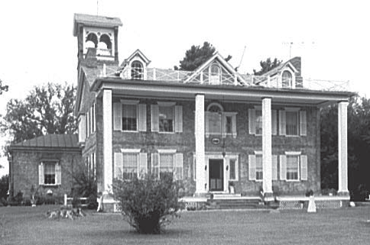

*Source: Library of Congress*

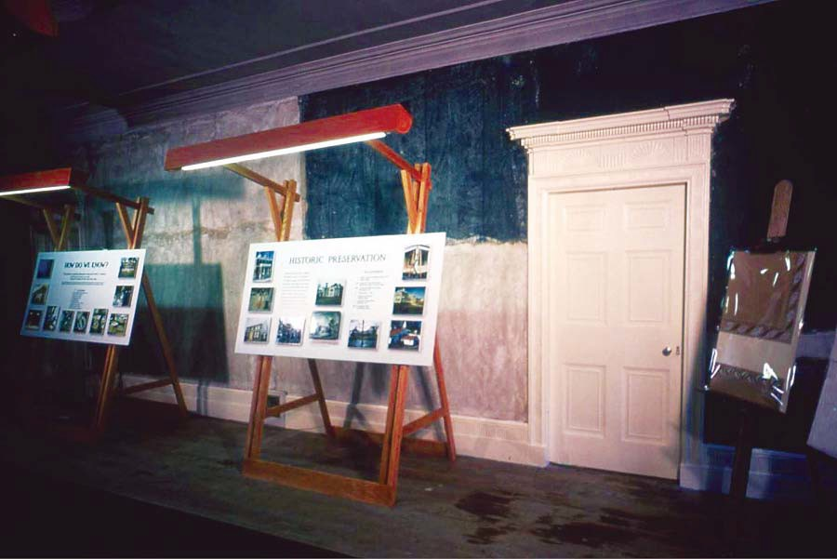

**Figure 2.2.** 1982 Van Buren Bicentennial Preview Exhibit

*Source: Photograph MAVA Collection*

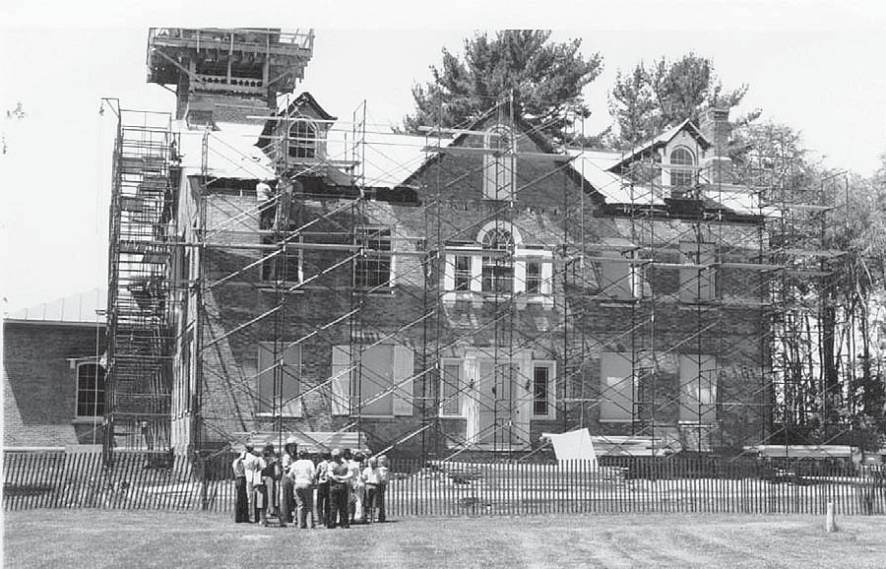

**Figure 2.3.** Interpretive Program at MAVA, 1980

*Source: Photograph MAVA Collection*

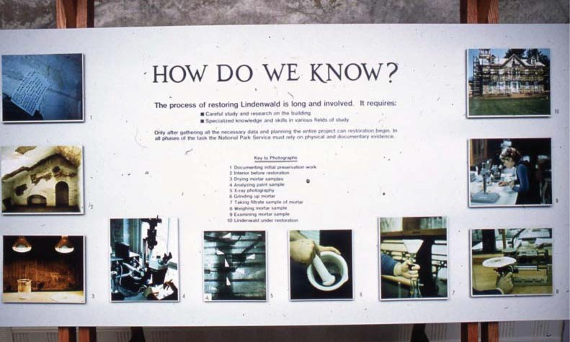

**Figure 2.4.** 1982 Exhibit

*Source: Photograph MAVA Collection*

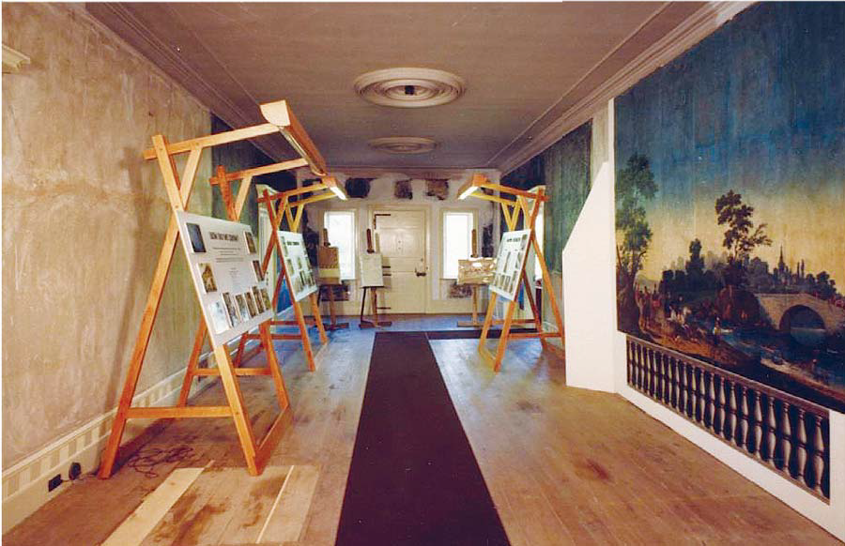

**Figure 2.5.** 1982 historic wallpaper exhibit

*Source: Photograph MAVA Collection*

**Figure 2.6.** 1982 Van Buren Bicentennial Preview Exhibit Room

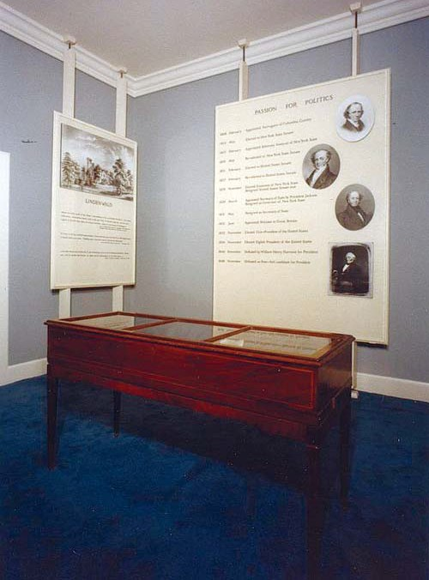

*Source: Photograph MAVA Collection*

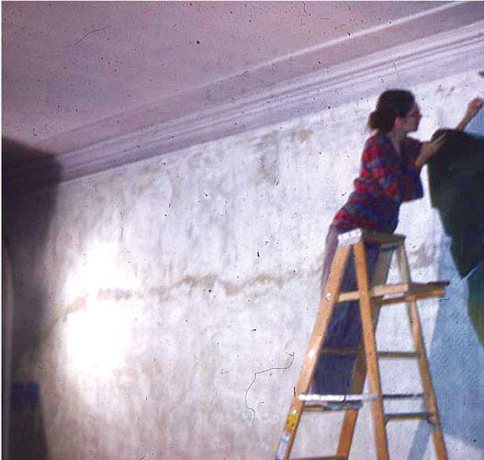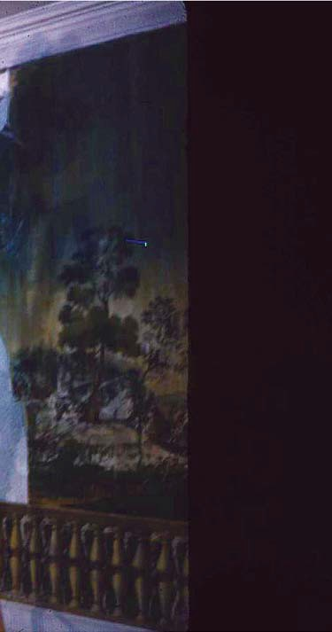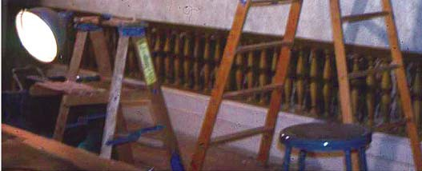

**Figure 2.7.** Patricia Dacus Hamm removes historic wallpaper

*Source: Photograph MAVA Collection*

Chapter Three

*Toward 1982: The Race To The Van Buren Bicentennial*

# Saving Lindenwald:

**Restoration, Preservation, Collections, and Planning, 1982-1987**

#### Introduction

Despite Bruce Stewart’s disappointment in the failure to complete the resto- ration of the property in time for the bicentennial of Martin Van Buren’s birth, the 1982 preview was successful in introducing Lindenwald as a national historic site. The following ﬁve years saw a period of intense work and planning that proceeded under diﬃcult circum- stances as a national economic recession and policies of a new administration aﬀected fund- ing within the National Park Service. Secretary of the Interior James Watt, who served from 1981 to 1983 under Ronald Reagan, declared his intention to pull back from the expansion of the National Park System that had occurred during the 1960s and 1970s to concentrate on visitor services at the most heavily used, well-known parks. Funds for restoration of the Lindenwald mansion were deferred for three years in a row, and work all but stopped by early 1983.1 A few months later, the staﬀ was heartened by a quarter million dollar alloca- tion; although the amount fell far short of the $878,000 ﬁgure the National Park Service estimated necessary to complete the restoration, it allowed for vital installations of security, heating, and electrical systems and some continuation of interior restorations.2 The com- pletion of a *Historic Furnishings Report* and a *Development Concept Plan* helped to advance planning at the site, and the opening of the mansion to the public in 1987 achieved a major goal.

#### Restoring and Maintaining Lindenwald

During the period leading up to the 1982 Martin Van Buren bicentennial event, restoration of the mansion at Lindenwald had proceeded slowly and sporadically, and nearly came to a halt in 1983 due to budget cuts. The pace began to pick up after October 1983, when the park received notiﬁcation that funds for the restoration had been appropriated for the 1984 budget, allowing work to continue. Some of that work began immediately once fund-

ing was in place. The foundation for the reconstruction of the Van Buren-era front porch was

1 Carol E. Kohan to Mrs. Robert C. L. Timpson, February 14, 1983, Folder D6215 Museum & Exhibit P26 1950 MAVA, MAVA Central Files; Lary M. Dilsaver, ed., “A System Threatened, 1981-1992,” chap. 8 in *America’s National Park System: The Critical Documents* (Lanham, MD: Rowman & Littleﬁeld Pub- lishers, 1994), accessed August 4, 2010, [http://www.nps.gov/history/history/online_books/anps/anps_8.](http://www.nps.gov/history/history/online_books/anps/anps_8) htm; “General Concept,” attachment to Bruce W. Stewart to Chief, Planning and Design, North Atlantic Region, May 10, 1983, D18 Draft *Development Concept Plan* (*DCP*) 1983, MAVA Central Files. Stewart noted that park management is becoming increasingly embrassed [sic] vis-à-vis the local community, and the public in general, over the lack of demonstrable development at the site.”

2 “Van Buren Site Gets $250,000,” *Hudson Register Star*, May 2, 1983, Folder K34 Newspaper Items, MAVA Central Files.

poured and framing and assembling of its parts began.3 Other work proceeded with the help of the North Atlantic Historic Preservation Center (NAHPC). The NAHPC was established at the Charlestown Navy Yard, a part of the Boston National Historical Park, in 1977 and included a laboratory and research facility that assumed responsibility for “the preservation, restoration, reconstruction and the historical aspects of adaptive use of all historic structures on the List of Classiﬁed Structures within the North Atlantic region.”4 Their work at MAVA began under the supervision of Edward Sturm, a NAHPC exhibit specialist, in June of 1984.

The crew restored historic window wells and the Upjohn tower, completed the reconstruction of the front porch as well as details on the exterior, and worked on the restoration and pres- ervation of the basement until funding for the interior work was cut. The restoration of the exterior of Lindenwald was completed in July 1985.5

The design of the mansion’s roof and its deteriorating condition posed a challenge from the time restoration work on the house began. Wood shingles were installed on the roof of the original mansion in 1980 by a contracted company, with work proceeding under Park Service guidelines and speciﬁcations. The roof was inspected annually and held up relatively well until 1987, when heavy summer rains produced small leaks and examination showed

that the shingles were deteriorating from beneath and the roof itself had suﬀered damage. A project inspector recommended immediate replacement, and the pine shingles were replaced with red cedar shingles.6 Ensuing work by an outside contractor proved unsatisfactory, and although park maintenance staﬀ tried to mitigate the eﬀects of the roof’s deterioration, it continued to be a serious problem. In 1990, NARO approved the replacement of the badly deteriorated metal roof and gutters on the Upjohn addition with a new 24-gauge metal roof. The site enlisted a historical architect who declared that the particular qualities of the roof required very specialized skills not found even in contractors who worked constantly with modern metal roofs.7 The condition and stability of Lindenwald’s roof would continue to be an important and time-consuming issue.

3 “Lindenwald restoration resumes,” *Hudson Register Star*, October 25, 1983, in K34 Newspaper Clip- pings, 8/83 to 7/7-85, MAVA Central Files.

4 Denis Galvin to Superintendents, North Atlantic Region, April 18, 1977, and attachment “Role & Func- tion Statement,” North Atlantic Historic Preservation Center, Folder H30 Archeological and Historic Structures, MAVA Central Files.

5 National Park Service, untitled, n.d. [1984], National Park Service, “Porch to be dedicated at Linden- wald,” n.d. [1984],; National Park Service, “Lindenwald Exterior Completed,” n.d. [1985], news releases, all in Folder K3415, Press Releases [II],MAVA Central Files; *Chatham Courier Rough Notes*, July 18, 1985, in K3416 MAVA newspaper Clippings #1; “Lindenwald’s restoration gets funded,” *Hudson Register Star*, January 25, 1984, Folder K34 Newspaper Clippings 8/83 to 7/7-85 , both in MAVA Central Files.

6 Bruce W. Stewart to Charles P. Clapper, February 18, 1988, and Michael L. Fortin to E. Blaine Cliver, August 14, 1987; Folder D5217 MVB Roof Contract CX 1600-7-0019, MAVA Central Files; XXX Form, Assessment of Actions Having an Eﬀect on Cultural Resources, Approved May 4, 1988; Folder MAVA 1990 XXX#2034, Weinbaum Files, BOSO.

7 XXX Form, Assessment of Actions Having an Eﬀect on Cultural Resources, Approved July 19, 1990; Folder MAVA 1992 XXX Files, XXX #450, 2287, 2310; Weinbaum Files, BOSO. Correspondence be- tween the park and the contractor and the historical architect and the park are in Folder D5217 MVTB Roof Contract CX 1600-7-0019, MAVA Central Files.

#### Collections and Storage

During the early 1980s, park curator Carol Kohan continued to research pieces that may have been part of Van Buren’s household. In the fall of 1983, for example, she con- tacted the Dunsmuir House, a historic estate in Oakland, California, after Gary Holloway, the president of a Martin Van Buren Fan Club headquartered in San Francisco, told Kohan he had seen Van Buren dinner service pieces on display there. She asked for photographs and any information the owners could provide on the provenance of the pieces. Kohan wrote to a Van Buren descendent living in Florida about several pieces of silver and a sofa associated with Van Buren, and assured the family that the park would be grateful to receive any or all of the items at any time the family considered such a donation appropriate.8 She corresponded with a conﬁdante of a descendant of Smith Thompson Van Buren and asked him for permis- sion to contact the relative who had indicated the presence of a miniature and several pieces

of silver in his possession.9 Kohan continued the long process of identifying Van Buren pieces and diplomatically suggesting their importance to the national historic site that recognized his signiﬁcance. The utilization of the site’s collections was an equally important task.

The park developed a Scope of Collections Statement draft in the summer of 1984, noting that exhibits—temporary or permanent—might be more useful in interpreting Van Buren’s career and achievements than the furnished house, which would basically rep- resent his post-presidential lifestyle. That statement distilled the challenge that continually faced staﬀ at MAVA: how to develop this historic house in a way that would reﬂect Martin Van Buren’s political career as well as his life at Lindenwald. The scope divided the museum collection into ﬁve categories of furnishings, objects, artifacts and documents. The ﬁrst cat- egory included items that had been present at Lindenwald during Van Buren’s residency there (1841-62); the second category encompassed those things associated in some way with Van Buren during his lifetime (1782-1862). The third category covered items that did not necessar- ily have a direct link to Lindenwald or Van Buren, including period and reproduction pieces. The fourth category held things associated with archaeological research at the site, or the re- sults of such research. The ﬁfth and ﬁnal category included commemorative items pertaining to Martin Van Buren, the establishment of the site, and important events including the 1982 bicentennial.10 The distinctions among categories of furnishings, objects, artifacts, and docu- ments—and particularly the distinction between the things that had been present at Linden- wald during Van Buren’s residence and the period and reproduction pieces—became vitally important to the completion of the *Historic Furnishings Report* and to the eventual furnishing of the mansion.

As the museum collection developed, its storage became a signiﬁcant issue. In the late 1970s, the bulk of the collection had been placed in storage at a General Services Ad-

8 Carol E. Kohan to Dunsmuir House, September 26, 1983; Carol E. Kohan to Martin Van Buren Morris, October 12, 1983, both in Folder D6215 Museum Exhibits, P26 1950 MAVA, MAVA Central Files.

9 Carol E. Kohan to Gary L. Holloway, December 20, 1983; Folder D6215 Museum Exhibits, P26 1950 MAVA, MAVA Central Files.

10 Scope of Collections Statement, Draft, August 21, 1984, attachment to Bruce W. Stewart to Staﬀ Cura- tor, North Atlantic Region, August 21, 1984; Folder D6215 Museum Exhibits, P26 1950 MAVA, MAVA Central Files.

ministration facility in Scotia, New York, to protect it while restoration work in the mansion continued. The arrangement was unsatisfactory, however. Monitoring the collection long-dis- tance was diﬃcult, and staﬀ became concerned that the GSA could not provide the safekeep- ing that the collection required. In the spring of 1983, the collection was returned to MAVA and stored in available rooms on the ﬁrst and second ﬂoors of the mansion. That solution was only temporary, and Carol Kohan appealed to the regional curator for assistance in developing an adequate storage facility at the site.11

The regional curator suggested MAVA try to ﬁnd private funding for the collec- tion’s storage. Kohan replied that such fundraising was beyond the time and abilities of MAVA staﬀ and added, “If our restoration funding had not been deferred these past three years, the house would have been ready to receive most of the collection.”12 A Washington oﬃce staﬀ curator involved in trying to solve the storage problems reiterated the general feeling of frus- tration: “I think that before any money is spent restoring the house, money should be found to store the Van Buren furniture. It’s about time we get the priorities straight as to taking care of the objects as well as the structure.”13

After other alternatives for caring for these important objects proved too expen- sive, Kohan suggested the construction of a 40’ by 48’ pole barn, to be designed and con- structed by the MAVA maintenance staﬀ. She estimated the cost at $10,000 and believed the building could be completed in four to ﬁve weeks. Once constructed, the pole barn could be disassembled and moved to another location when it was no longer needed for collec- tion storage. She urged a fast decision.14 By early November, plans were underway to build the pole barn at a cost of $18,000 or less, including a limited heating source and an electric system suﬃcient to power a few light bulbs. Superintendent Stewart suggested a location southwest of the mansion where no archaeological sites would be aﬀected, and the building

would not intrude upon park events. In addition, its distance from Route 9H diminished the chances of vandalism and theft, the ground was level, and no signiﬁcant trees or vegetation would have to be sacriﬁced to make room for the structure.15 The pole barn was approved and under construction by the end of the year. The regional director noted that the pole barn was an intrusion on the historic scene; he anticipated that the work on the mansion would be completed by 1985, and at that time the objects would be moved into the house and the pole barn taken away.16 In fact, the pole barn would remain in place well into the twenty-ﬁrst century.

11 Carol E. Kohan to Regional Curator, May 16, 1983; Folder D6215 Museum Exhibits, P26 1950 MAVA, MAVA Central Files.

12 Carol E. Kohan to Regional Curator, July 15, 1983; Folder 06215 Museum Exhibits, P26 1950 MAVA, MAVA Central Files.

13 Diana Purdue, Staﬀ Curator, to Chief, Preservation Assistance Division, October 14, 1983; Folder D6215 Museum Exhibits, P26 1950 MAVA, MAVA Central Files.

14 Carol Kohan to Tom Vaughan, Diana Pardue, Don Cumberland, September 28, 1983; Folder D6215 Museum Exhibits, P26 1950 MAVA, MAVA Central Files.

15 Bruce W. Stewart to Deputy Regional Director, NARO, November 3, 1983; Folder D6215 Museum Exhibits, P26 1950 MAVA, MAVA Central Files.

16 Herbert S. Cables Jr. to Superintendent, December 22, 1983; Folder D6215 Museum Exhibits, P26 1950 MAVA, MAVA Central Files.

#### The Van Buren Table

The single most signiﬁcant piece of furniture connected with Van Buren’s Linden- wald was a mahogany dining table that measured only twenty-ﬁve inches wide when closed, but ﬁfteen feet long when opened with leaves inserted. A unique accordion mechanism made the transformation possible. The table, designed in the New York Regency style, is similar

to the furniture produced by the Duncan Phyfe shop in New York in the early nineteenth century, but it is unsigned and cannot be attributed directly to Phyfe. Van Buren probably bought the piece in 1816 when he was a New York state senator and was furnishing his house in Albany. Although there is no direct evidence proving that the table was used in the White House during Van Buren’s administration, a dining table was packed and sent from Albany to Washington in 1829. After Van Buren moved to Lindenwald, he had the main hall enlarged to accommodate the table, which eventually included an extension that provided an additional ﬁve feet of length and was probably built precisely to ﬁt the original table. Thirty dining chairs completed the set. After Van Buren’s death, Aaron Vanderpoel, a Kinderhook lawyer and the son of Van Buren’s personal physician, purchased the table. It remained in the Vanderpoel family for 120 years. In 1982, the owners of the table loaned it to Martin Van Buren National Historic Site to help commemorate the bicentennial of Van Buren’s birth. Because the main hall wallpaper was being restored, the table was displayed in the breakfast room.17

In 1984, the owners oﬀered the table at auction at Christie’s in New York. Park curator Carol Kohan contacted a number of organizations in an attempt to raise money to buy the table, but none could assure funding. The Friends of Lindenwald also tried in vain to raise funds for the purchase of the table.

Bruce Stewart and Kohan attended the sale of the table at Christie’s.18 Bidding started at $40,000 and quickly rose past $100,000. The table was ﬁnally sold for $170,000 to private art collectors Mr. and Mrs. Richard Manney of New York City. The Manneys oﬀered to loan the table to the park while they prepared to move to a new home in the Hudson Valley, but the park could not accept the oﬀer due to the restoration work underway. Kohan, howev- er, suggested that the Manneys might consider a short-term loan of the table once restoration was completed. Both Bruce Stewart and Kohan expressed appreciation that the table would remain in the Hudson River Valley under the protection of discerning owners, as well as their hopes that the table would at some point again grace Lindenwald, at least temporarily. The park continued to follow the ownership of the table.19

17 Phyllis Ewing, “Mr. and Mrs. Robert Rubin Loan Van Buren Dining Table to Lindenwald,” in *The Van Buren Chronicles*, Summer 1993, n.p.

18 Carol E. Kohan to Regional Curator, North Atlantic Region, December 23, 1983; Bruce W. Stewart to Regional Director, NARO, May 10, 1993; Bruce W. Stewart, “Statement to owner of Martin Van Buren Dining Table” June 23, 1993; all in Folder D6215 Museum Exhibits, P26 1950; National Park Service, untitled, news release, n.d. [1984], Folder K3415 Press Releases [II]; MAVA Central Files.

19 Carol Eve Kohan to Mr. and Mrs. Richard Manney, January 25, 1984 and Carol E. Kohan to Regional Curator, NARA, January 27, 1984, both in Folder D6215 Museum Exhibits, P26 1950 MAVA, MAVA Cen- tral Files. Bruce W. Stewart to Regional Director, May 10, 1993, puts the 1984 sale price at $184,000.,Carol

E. Kohan to Regional Curator, North Atlantic Region, December 23, 1983 and Bruce W. Stewart, “State- ment to owner of Martin Van Buren Dining Table” June 23, 1993, in Folder D6215 Museum Exhibits P26 1950 MAVA, MAVA Central Files; National Park Service, untitled, news release, n.d. [1984], Folder K3415 Press Releases [II], MAVA Central Files.

#### Historic Furnishings Report

The development of a *Historic Furnishings Report* (HFR) was extremely important to the ongoing work at Lindenwald. An HFR provides the background for the development “of a furnishing plan for a particular time in history.”20 Although site staﬀ were normally

not enlisted to research and write such detailed reports, Bruce Stewart believed that Carol Kohan’s training and experience and her knowledge of the park’s collection made her the best person to develop the report. Sarah Olson, head of the Harpers Ferry Center Historic Furnishings Division, met with Stewart and Kohan and agreed with Stewart’s assessment, and Kohan proceeded with the work.21

In early 1981, Bruce Stewart estimated that a draft report would be forthcom- ing within twelve months.22 The preparation of the document proved to be more taxing than he had anticipated. “Various challenges were encountered in the preparation of the *Historic*

*Furnishings Report for Lindenwald*,” Carol Kohan noted in its preface, ﬁnally released in 1986. Among those challenges were the many forms the mansion had taken since Van Buren’s resi- dence there: farmhouse, tea room, convalescent home, and antique store. The antique busi- ness, particularly, confused the interpretation of a number of furnishings on the site, raising questions about whether they were Van Buren pieces or items collected by the Campbells, who had operated the antique business. Kohan noted that “some of the questions may never be resolved.”23 Van Buren had left no photographs and few descriptions of the interior of the house during his years there, and his correspondence and that of his family had to be carefully sifted for hints about the furnishings of Lindenwald.24

National Park Service policies also presented particular issues. Under those poli- cies, the furnishing of the mansion had to be accomplished with “minimum conjecture,” a requirement that confronted sites including historic houses with fundamental problems. The ﬁrst draft of the MAVA HFR recommended the use of “reproduction or period furnishings and objects only when their absence would be misleading.” A review by regional staﬀ curator David Wallace, who had visited Martin Van Buren National Historic Site in the fall of 1984, noted several concerns. These included the citation of Kenneth Campbell’s statements about the provenance of particular furnishings without supporting evidence and the need for additional comparisons from other, similar houses to support furnishing “problem areas” such as the base- ment rooms. The review said the plan called for furnishing too many rooms with too little evi- dence, and suggested furnishing only two of the bedrooms: Van Buren’s bedroom and a guest bedroom. The review also asked for additional evidence of each room’s use and furnishings.25

20 Program Formulation System for Professional Services and Development-Type Descriptions, Folder H30 Archeological and Hist Structures (Sites), P26 1950 MAVA, MAVA Central Files.

21 Carol Kohan to Patricia West, e-mail message, March 19, 2010, MAVA.

22 Bruce W. Stewart to Regional Director, North Atlantic Region, Attention: Regional Curator, April 13, 1981, Folder D215 Museum and Exhibit Activities, P26 1950 MAVA FT 81, MAVA Central Files.

23 Carol E. Kohan, *Historic Furnishings Report for “Lindenwald,” Martin Van Buren National Historic Site*

(Harpers Ferry Center: National Park Service, 1986), v.

24 Kohan, *Historic Furnishings Report*, v-vi.

25 Sarah H. Olson to Superintendent, Martin Van Buren National Historic Site, April 10, 1985, Folder Martin Van Buren NHS Correspondence File, National Park Service Harpers Ferry Center, Harpers Ferry, WV (HFC).

George Berndt, the MAVA chief of interpretation, wrote an *Interim Interpretive Prospectus* that was approved in 1985, while the *Historic Furnishings Report* was being com- pleted. The prospectus became part of the controversy surrounding the use of conjecture to furnish rooms in Lindenwald. In a letter to Bruce Stewart, Dwight Pitcaithley, chief of the Division of Cultural Resources, pointed out that the prospectus said that “ﬁlling empty spaces with non-original items substantially dilutes integrity” and that the variable levels of furnishings in the rooms meant that “special eﬀort will be needed to make the experience a coherent one.” That responsibility would lie with the HFR and more particularly with the

interpreters at the site. Reviewers believed the HFR went well beyond the recommendations in the site’s own interpretive plan by its suggestions to include items indicated by “‘period practice/common sense.’” They also noted that the interim prospectus made clear that the interpretation of the site was never intended to be dependent upon its furnishings and held that incompletely furnished rooms could be just as eﬀective in an interpretive sense as those that were fully furnished.26

After the draft HFR was forwarded to NARO, the regional director complimented Kohan on a well-written and thoroughly documented report, but took issue with the “con- jectural” nature of portions of the furnishing plan. Bruce Stewart had held that visitors could be informed and educated by interpreters about the fact that furnishings and objects with a documented link to Van Buren were mixed with other furniture and objects that were typi- cal of the period but without a documented tie to the former president. The regional direc- tor’s position remained that visitors—no matter what they were told—would perceive what they saw as a picture of rooms as they actually were, rather than a representation of how they might have looked.27 The diﬀerence of opinion and reviews of the work continued into 1986. The Park Service’s chief curator and chief historian questioned whether the documentary evidence available was suﬃcient “to meet minimal conjecture criterion.”28 Notes of a phone call between Sarah Olson, the historic furnishings curator, and Ed Kallop of NARO indicate a continued concern with refurnishing based on “conjecture.” Olson recommended that fully recreated rooms should be limited to Van Buren’s bedroom and the most completely docu- mented rooms on the ﬁrst ﬂoor. She also suggested other uses for rooms not recreated such as displays of furniture and collections and exhibits about the restoration.29

The attention to the problem of conjecture in furnishing the house proved an ongoing problem for both Carol Kohan and Bruce Stewart. Stewart maintained that he and Kohan considered the degree of conjecture in the report as minimal and in keeping with NPS policy. Refurnishing the site without some degree of conjecture, he held, was impossible. “The integrity was lost when Van Buren died and the house passed to other hands. In truth, there is nothing, with the exception of the scenic wallpaper found in situ in Room 105, that

26 Dwight T. Pitcaithley to Superintendent, Martin Van Buren NHS, August 7, 1986, Correspondence File, Martin Van Buren NHS, HFC.

27 Herbert S. Cables Jr. to Manager, Harpers Ferry Center, June 9, 1986; Draft *Historic Furnishings Report*, Folder H3019, MAVA Central Files.

28 Director, National Park Service, to Regional Director, North Atlantic Region, June 4, 1986; Folder Mar- tin Van Buren NHS Correspondence File, HFC.

29 Record of telephone conversation between Sarah Olson, HPC and Ed Kallop, NARA, July 15, 1986; Correspondence File, Martin Van Buren NHS, HFC.

can be positively associated both with Van Buren and a particular room at Lindenwald.” He concluded that “realistically ‘adroit and intelligently deductive conjecture’ is the best that can be achieved” in refurnishing the mansion.30

In October 1986, Dwight Pitcaithley and staﬀ members drove to Martin Van Buren National Historic Site to discuss the HFR and particularly the diﬀerences of opinion concerning how the house should be furnished. The Division of Cultural Resources held that the refurnishing should be limited to four categories: “original furnishings, likely or probable original furnishings, possible original furnishings, and period reproduction pieces based on good evidence that the object did reside in Lindenwald during the historic period.” Stewart wanted to include three additional categories: “furnishings associated with the Van Buren family or friends, objects not likely or not probably original, and period or reproduc- tions based on period practice and common sense.” The addition of these three categories to the list of criteria formed the core of the disagreement.31

As Pitcaithley pointed out in his report of the meeting, the ﬁrst four categories were based on National Park Service policy established in 1978. Instituted by F. Ross Hol- land Jr., then chief of Cultural Resources Management Division at WASO, the policy held that refurnishing of historic spaces should be done only when it could be accomplished with a minimum of conjecture and only when it signiﬁcantly added to the visitors’ understanding of a park theme. Before 1978, the Park Service had no policy on refurnishing and as a result, Pitcaithley said, many refurnished spaces misled visitors into believing they were seeing ac- curate historic reproductions of rooms. While Pitcaithley admitted that the policy had been largely ignored, he believed it was gaining new signiﬁcance. In spite of Pitcaithley’s interpre- tation of the oﬃcial policy, Stewart and Kohan continued to argue that what visitors saw had more impact than what they heard, and seeing partially empty rooms would lead them to be- lieve that Van Buren lived in that environment. They also held that other historic spaces had been furnished using some degree of conjecture, that the restoration of the house involved conjecture, and that pieces of the park’s collections had belonged to Van Buren family and friends and should be displayed appropriately to illustrate Van Buren’s lifestyle.32

The disagreement was not simply one between the park and the regional of- ﬁce, but also a philosophical diﬀerence between interpreters and curators. The *Interim Interpretive Prospectus*, written by George Berndt, MAVA’s chief of interpretation, reﬂected adherence to the established policy strongly advocated by Pitcaithley. Kohan and Lynne Leopold-Sharpe, the acting regional curator, supported by Superintendent Stewart, argued for the expanded treatment. The curators held that visitors would not comprehend partially furnished rooms; the interpreters believed that partially furnished rooms could be inter-

preted appropriately. The meeting at Lindenwald ended with Kohan and Stewart agreeing to discuss the matter further and consider compromises.33

30 Bruce W. Stewart to Regional Director, North Atlantic Region, June 10, 1986, Correspondence File, Martin Van Buren NHS, HFC.

31 Dwight T. Pitcaithley to Acting Chief, Division of Cultural Resources, NARO, October 14, 1986; Cor- respondence File, Martin Van Buren NHS, HFC.

32 Pitcaithley to Acting Chief, October 14, 1986.

33 Pitcaithley to Acting Chief, October 14, 1986; National Park Service Comments, Martin Van Buren NHS Administrative History, First Draft, 3, March 19, 2010.

Shortly after Pitcaithley issued his report, Bruce Stewart conﬁrmed to NARO’s acting chief of the Division of Cultural Resources that the three categories the park had ar- gued for would be removed as recommendations in the HFR. Still, he added “it is my honest belief that the interpretation selected for Lindenwald diminishes and perhaps impoverishes the rich potential of the Site for visitor understanding of the Park themes.34 Subsequently, a decision was reached to furnish seventeen rooms in the mansion, but only with documented Van Buren pieces.35

The eﬀorts of Stewart and Kohan to broaden the interpretation of the furnishings policy within the context of the HFR were largely futile. In the introduction to the report, Ko- han noted that a “the narrowest interpretation of the furnishings policy was applied,” and that “for the foreseeable future, interpreters rather than furnishings will bear the burden of placing Van Buren in the context of his time.” She predicted that controversy over the appropriate- ness of furnishings as a means of interpretation would continue.36 The completed report, more than 400 pages long, used published works, Martin Van Buren’s papers, and family correspondence to document the Van Buren family’s life in the Lindenwald and their descrip- tions of the house and its furnishings. Kohan also used these sources to discuss the utilization of rooms, evidence of furnishings and accessories used in the home between 1841 and 1862, and recommendations for continued furnishing of the mansion.37

The controversy over the Martin Van Buren National Historic Site HFR took on wider implications, leading the chief of the Division of Historic Furnishings to issue a memo to all the regional chiefs of Interpretation and Cultural Resources. Sarah Olson’s memorandum, based on lengthy discussions with each of the members of the division, took issue with the oﬃcial stance and illuminated the curator-interpreter philosophical divide.

Historical rooms that were only partially furnished, Olson held, did not “serve to disclose a historical lifestyle which, with few exceptions, remains the interpretive rationale for us- ing this medium.” Such rooms created “incomplete settings,” many of them highlighting particular pieces of furniture better oﬀ being displayed in a museum. Original pieces did not “relieve us of the need to exhibit complete settings that make historical sense.” She also held that many sources could provide adequate documentation for furnishing historic rooms: “We do not have to wring our hands helplessly before every site that predates the age of photography.”38

In reality, Kohan saw the actual furnishing of the rooms as a compromise. Park curatorial staﬀ accepted the fact that some rooms would be sparsely furnished due to the lack of speciﬁc documentation; Harpers Ferry Center supported the stance she and Stewart took on items like curtains and bedding. Original furnishings in the rooms were highlighted, and

34 Bruce W. Stewart to Acting Chief, Division of Cultural Resources, North Atlantic Regional Oﬃce, Octo- ber 21, 1986, Correspondence File, Martin Van Buren NHS, HFC.

35 Sarah M. Olson to All Regional Chiefs of Interpretation and Cultural Resources, November 21, 1986, Correspondence File, Martin Van Buren NHS, HFC.

36 Kohan, *Historic Furnishings Report*, vi.

37 Carol E. Kohan to Mrs. William Coke, April 11, 1985; Folder D6215 Museum Exhibits, P26 1950 MAVA, MAVA Central Files.

38 Sarah M. Olson to All Regional Chiefs, November 21, 1986.

visitors experienced a sense of Martin Van Buren’s lifestyle, even without period details that could not be documented.39

Current policies reﬂect similar issues. In discussing historic furnishings, the NPS *Management Policies 2006* states that: “Generalized representations of typical interiors will not be attempted except in exhibit contexts that make their representative nature obvious. Reproductions may be used in place of historic furnishings, but only when photographic evidence or prototypes exist to ensure the accurate recreation of historic pieces.” Structures can be refurnished with rigorous professional evaluation, a planning process that conﬁrms

such refurnishing is “essential” to an understanding of the park’s cultural resources, and when adequate evidence of the structure’s original furnishings exists to enable appropriate refur- nishing without depending on examples from other structures.40

Professionals continue to disagree about the strict prohibition of general, rather than speciﬁc, representations in historic furnishings. Secretary of the Interior standards for the restoration of buildings and landscapes exist and guide such restorations, but there are no such standards for museum furnishings. Outside the NPS, curators typically follow less stringent guidelines, allowing them to practice a degree of conjecture by studying period photographs or other images, period objects, and inventories of similar structures, and some historic houses are completely refurnished based on such comparative evidence. Although in general NPS places restraints on these practices, some recreated historic interiors within the Park Service are based on such evidence. At MAVA, a more liberal policy gradually evolved, allowing the use of some furnishings, objects, and accoutrements that are not original to the house in order to present a fuller picture of what the rooms may have looked like. 41

#### Development Concept Plan

In early 1981, a task directive for a *Development Concept Plan* (*DCP*) set new plan- ning for MAVA in motion.42 *DCP*s guide the development of speciﬁc sites, and the directive noted that this would provide a basis for decision-making at MAVA for the following ﬁve to ten years. In addition to recommendations for the treatment of the interior of the mansion, grounds restoration, and removal of non-historic buildings, the *DCP* would address the es- tablishment of visitor and administrative facilities and in large part replace the outdated 1970 Master Plan. “Circumstances have shifted considerably in the past decade to the present era of scarce money and construction budget cuts,” the task directive stated, and alternatives rec- ognizing that reality needed to be considered.43 Stewart believed the plan would create little

39 Carol Kohan to Patricia West, e-mail message, March 19, 2010, MAVA.

40 U. S. Department of the Interior, National Park Service, “*Management Policies* 2006,” 5.3.5.5.5 Historic Furnishings, [http://www.nps.gov/policy/mp2006.pdf.](http://www.nps.gov/policy/mp2006.pdf)

41 National Park Service Comments, Martin Van Buren NHS Administrative History First Draft March 19, 2010, MAVA; Patricia West, interview by Suzanne Julin, June 17, 2008, MAVA.

42 Record of Decision, Finding of No Signiﬁcant Impact, *Development Concept Plan*, Martin Van Buren NHS, memorandum, Superintendent to Regional Director, North Atlantic Region, March 30, 1987, in L7617 MAVA DCA-EA-2, Clark Files, BOSO.

43 Analysis of Planning Alternatives/Environmental Assessment, *Development Concept Plan*, Martin Van Buren National Historic Site, transmittal of Final Task Directive, Acting Regional Director to Superinten- dent, et. al., April 9, 1981, Folder L7617 MAVA DCA-EA-2, Clark Files, BOSO.

public controversy, and that close contact with park neighbors during the planning process and a public meeting could provide information and oﬀer a “relaxed atmosphere” for people to discuss their concerns.44 The reality was more complicated.

The ﬁrst roadblock to completing the *DCP* was the suspension of work on the plan in August 1981, due to staﬀ changes and budget cuts. More than two years later, prog- ress on the document resumed, with George Berndt, chief of interpretation at MAVA, doing the bulk of the work. He completed a draft in the spring of 1984 that included three planning alternatives. The ﬁrst alternative was the 1970 Master Plan, which placed visitor services, ad- ministrative functions, and curatorial storage within the mansion, called for construction of

a new maintenance facility in the historic core and recommended reconstruction—without adequate documentation—of a barn and the North Gatehouse. The second alternative was an adaptive use plan that would utilize areas in the mansion for park management purposes and provide for the construction of an access road and parking lot that could threaten cul- tural resources and impact the historic core. The preferred alternative called for Lindenwald to be restored to its 1850-62 appearance and visitor access to be provided to the ﬁrst and second ﬂoors as well as the basement, if the stairway was determined adequate for such use. Historic landscape features, when they could be identiﬁed, would be restored as funding allowed. Obviously intrusive non-historic landscape features would be removed and utilities placed underground. The exterior of the South Gatehouse would be restored and the inte- rior utilized for park purposes, and the North Gatehouse foundation would be stabilized and interpreted. A visitor parking lot would be placed in the northeast corner of the site, and the National Park Service would seek the donation of the portion of Old Post Road that ran in front of the site and close it to traﬃc once a reconﬁguration of Route 9-H was accomplished. A “visitor orientation facility” would be located in the cinderblock garage behind the man- sion, which would be expanded to the west to provide space for administrative, maintenance, and curatorial functions.45

The *DCP* draft went out for public review in June 1984. Neighbors living around the park boundary expressed concern about vegetative screening of the parking lot from their views and the location of the access road, which one of them considered unaccept- able because of its proximity to his property.46 In July, an *ad hoc* committee of the Friends of Lindenwald supported the preferred alternative in the *DCP* in general, but voiced some reservations. They disagreed with the suggestion to expand the maintenance garage behind Lindenwald to include visitor and museum storage facilities because the enlarged structure would “be very conspicuous . . . and would not contribute to the interpretation of the site

in its period of signiﬁcance.” The committee recommended that any new construction of buildings or parking lots take place out of sight of the historic house, preferring that such construction be located in places invisible to visitors to the house and grounds. The orga-

44 Final Task Directive, April 9, 1981. Superintendent, Martin Van Buren NHS to Associate Regional Di- rector, Planning and Resource Preservation, December 27, 1982, Clark Files, BOSO.

45 *Development Concept Plan*/EA [1984] Martin Van Buren National Historic Site, 4-6, MAVA Files.

46 Joseph A. Cutro to Bruce Stewart, Superintendent, May 15, 1984; Bruce W. Stewart to Mr. and Mrs. Henry Weil, June 4, 1984; Bruce W. Stewart to Associate Regional Director, May 22, 1984; Charles P. Clapper Jr. to Superintendent, June 27, 1984; all in Folder L7617 MAVA DCA-EA-2, Clark Files, BOSO.

nization also suggested that the NPS began to explore, “in earnest,” expansion of the site to protect its integrity.47

Other interested parties voiced similar opinions. The Columbia County Board of Supervisors said that the plan did not reﬂect appropriate site development because it placed the park administrative and visitor structure in the historic core.48 After reviewing the *DCP*, the New York State Historic Preservation Oﬃce concluded that construction of a building and parking lot so close to the mansion might be “problematic” and suggested the park con- tinue to explore alternative locations for subsidiary structures in a “more remote location.”49 These dialogues sounded a theme that would grow stronger as the park developed—if visi- tor, administrative, and curatorial facilities could not be incorporated into the mansion itself, expanded boundaries would provide room for appropriate development of facilities for those functions while protecting the integrity of the historic areas of Lindenwald.

Superintendent Bruce Stewart recognized the professional and public objections to the *DCP*. In a memorandum to the regional director, he referred to a local newspaper article about the plan as “a growing issue in this county and upper Hudson Valley area. There seems to be a growing public feeling that the present *DCP* be scrapped, and a return to the general concepts proposed by the 1970 Master Plan.”50 The Columbia County Board of Supervisors and the Friends of Lindenwald had adopted resolutions to Congress asking that body to ap- propriate funds that would continue the work at the site under the 1970 *Master Plan* instead of the proposed *DCP*. In particular, the Friends of Lindenwald called for the construction of

a visitor and management complex to be developed outside of the historic core, rather than to the immediate west of the mansion.51

The *DCP* was revised in reaction to the extensive comments, and the new docu- ment became available for public comment early in 1986. The major change was a new alter- native calling for a proposed multipurpose building to be constructed outside the historic core (instead of expanding the garage at the rear of the house) to hold visitor services and adminis- trative and curatorial functions.52 Under this alternative, administrative and curatorial func- tions and storage would continue to be housed in the rental trailers and the pole barn until the multipurpose building was constructed. At that time, the pole barn, which provided curatorial storage, would be moved to the northwest corner of the property and used for maintenance functions. The multipurpose building would be built in the North Field, the area of land at

47 Attachment to Albert S. Callan Jr. to Herbert S. Cables Jr., August 29, 1984, Folder D18, *DCP* Review by Public Committee, MAVA Central Files.

48 Congress Urged to fund completion of Lindenwald,” *Chatham Courier Rough Notes*, July 19, 1984, Folder K34 Newspaper Clippings, 8/83-7/7/85, MAVA Central Files.

49 Julia S. Stokes to Herbert S. Cables Jr., April 13, 1984, Folder D18, *DCP* Review by Public Comments, MAVA Central Files.

50 Bruce W. Stewart to Regional Director, North Atlantic, July 20, 1984, K34 Newspaper clipping 8/83-7-

/7/85, MAVA Central Files.

51 Martin Van Buren National Historic Site, *Development Concept Plan*/EA [1986], 6; “Congress urged to fund completion of Lindenwald,” *The Chatham Courier Rough Notes*, July 19, 1984, Folder K34 Newspa- per clipping 8/83-7/7/85, MAVA Central Files.

52 *Hudson Register Star*, January 16, 1986, in Folder K3416 MAVA Newspaper Clippings #1, MAVA Cen- tral Files.

the northern edge of the park that had never been part of Van Buren’s farm. The parking lot would be located on a tract east of the multipurpose building, and a connecting road would be established between Route 9-H and the Old Post Road. Planners carefully considered the concerns of neighbors that the development in the North Field would adversely aﬀect their properties, but they concluded that placing new buildings in other areas of the park would intrude on the historic resources and that in the interest of safety, the access road could not be located anywhere else. Stewart promised the adjacent landowners that landscaping to screen their property from the site would be a signiﬁcant part of the overall design, and he asked them to participate in the review of the landscape plans.53

The two other alternatives included continued use of the 1970 *Master Plan* and the adaptive use alternative, both of which would have placed all park functions except main- tenance within the mansion. These alternatives were considered problematic because adap- tive uses of the mansion could have negative eﬀects on the historic fabric of the structure. The preferred alternative, however, also presented a serious problem. Park Service oﬃcials noted that funding for the proposed multipurpose building would be diﬃcult to obtain.54

The *DCP* plans formulated in the 1980s and the responses they engendered fo- cused on one of the most complex issues facing the park: How could MAVA establish appro- priate visitor, curatorial, administrative, and maintenance functions without intruding on the site’s historic resources or alienating its neighbors, who valued the quiet, rural environment of their homes and whose support was important to the site? That question posed an ongoing di- lemma for park managers, even as they dealt with other problems that arose as the park—and the region—developed.

#### Development Threats to Lindenwald

In the mid-1980s, Columbia County, and particularly the Kinderhook area, con- tinued to be an increasingly attractive target for encroaching development. New York City residents were drawn by low prices for land, houses, and estates for weekend and summer homes. The short commute to Albany and its environs encouraged residential construction for those who worked in the capitol area. The interest inspired growth as well as speculation in property. In June 1987, a real estate agent stated that the value of undeveloped land in the area had tripled in the previous three years. The surging demand encouraged 700 Kinderhook citizens to sign a petition in 1987 asking the Kinderhook Town Board to temporarily halt new development and create a full-time professional planner position in order to prevent uncon- trolled growth.55

Martin Van Buren National Historic Site did not escape this pressure. During the 1970s, the site had been threatened by the proposal for a nearby county landﬁll; in the 1980s, the threats involved residential development. Ironically, one of the ﬁrst of these occurred when

53 Bruce W. Stewart to Mr. and Mrs. Joseph Cutro, January 13, 1986, Folder L7617 MAVA DCA-EA-2, Clark Files, BOSO; Bruce W. Stewart to Regional Director, North Atlantic Region, March 30, 1987, Folder E7617 Environ Impact Hudson R. Dredging, MAVA Central Files.

54 Bruce W. Stewart to Regional Director, March 30, 1987; Finding of No Signiﬁcant Impact, *Develop- ment Concept Plan*, March 30, 1987, 2-3.

55 *Albany Times Union,* June 14, 1987, in Folder K3416 MAVA Newspaper Clippings #2, MAVA Central Files.

Bernard Brennan, who owned land adjacent to the park and who had been instrumental in the successful ﬁght against the landﬁll proposal, put his property up for sale. The Patten Corp., a development business specializing in acquiring and selling large rural holdings, made an oﬀer on the land. The corporation planned to subdivide the sixty acres into four lots and a twenty- acre trust-protected environmental area. That area would be accessible only to the residents

of the subdivision, to be named Lindenwald Meadows or Lindenwald Estates. The Friends of Lindenwald and other citizens raised concerns about the proposed development’s proximity to Martin Van Buren National Historic Site, and the Patten Corp. withdrew its oﬀer after Brennan declined to extend a second option. The Kinderhook Town Board proposed that the Depart- ment of Interior buy the land, but Bruce Stewart informed them such a purchase was unlikely, because it would have to be accomplished through an act of Congress.56 Henry Birdseye Weil, another neighbor of the park, tried to put together a partnership with the Columbia Land Con- servancy to acquire the land; when that failed, he purchased the sixty acres himself.57 Thus, the park was spared the pressures of nearby residential development for the time being. Those pres- sures and the intense personal interest of park neighbors in the park’s operations and growth, however, would continue to present park managers and planners with issues and problems.

#### 1987 Opening

After the 1982 preview, the National Park Service set the full opening of Linden- wald for the fall of 1986, marking the 150th anniversary of Martin Van Buren’s election to the presidency. Once again, plans for the opening to coincide with a major anniversary were

premature, and it was delayed.58 Despite that delay, however, visitors to the park were allowed glimpses into the interior of the mansion prior to its formal unveiling. In September 1983, the park held a reception and candlelight tour to allow the public to view some of the interior of the mansion before furnishings were taken to storage in anticipation of the ongoing preservation work.59 In 1985, the park oﬀered guided tours from Wednesday through Saturday, 9:30 a.m. to 4:00 p.m., through September 5, as well as architectural tours of the exterior of the house on weekends. The South Gatehouse was opened for the remaining weekends in September, with park interpreters on hand to answer questions, and a self-guiding brochure was available for vis- itors.60 In 1986, the park oﬀered limited tours of the mansion every half hour, 9:00 AM to 4:30 PM, Wednesday through Sunday, from the end of May through Labor Day. The tours included a few rooms in the basement and accommodated the ongoing preservation work.61

56 *Hudson Register Star*, June 11, 1987, *Chatham Courier*, June 4, 1987, in Folder K3416 MAVA Newspa- per Clippings #2, and *Hudson Register Star*, May 1, 1987, in Folder K3416 MAVA Newspaper Clippings #1, MAVA Central Files.

57 Thomas H. Martin to File, August 3, 1989, 4, Folder L617 MAVA DCA/EA-2, Clark Files, BOSO.

58 National Park Service, “Lindenwald Opening and Summer Events Announced,” news release, n.d. [1987], Folder K3415 Press Releases [II], MAVA Central Files.

59 National Park Service , “Candlelight Tour at Lindenwald,” news release, n.d. [1983], Folder K3415 Press Releases, MAVA Central Files.

60 National Park Service, “Hours Extended for Fall at Lindenwald,” news release, n.d. [1985], Folder K3415 Press Releases [II], MAVA Central Files.

61 National Park Service, “Summer Season to Start at Martin Van Buren Site” and “Lindenwald Exte- rior Completed,” news releases, n. d. [1986] and n.d. [1985], Folder K3415 Press Releases [II], MAVA Central Files.

Announcing that the restored Lindenwald would ﬁnally open in 1987, Superinten- dent Stewart noted, “After several ﬁts and starts, after several years of laborious and painstak- ing restoration, the long-awaited day is almost here.”62 That day came on Sunday, June 14, 1987. The *Chatham Courier* reported the event, noting that the “oﬃcial dedication and open- ing of Lindenwald, President Martin Van Buren’s retirement home at Kinderhook on Sunday last, culminated a long and ofttimes frustrating eﬀort to acquire and then restore this structure to its original state.” The paper praised the eﬀorts of Park Service staﬀ who “labored arduous- ly and painstakingly” to restore the house and collect its furnishings. In a burst of sentimental- ity, the newspaper declared that “Martin Van Buren relished the better things in life and we are certain his spirit must dwell happily now in his beautifully restored residence.”63

About 800 people attended the grand opening of Van Buren’s home that after- noon, including thirteen descendents of the former president. A ribbon-cutting ceremony, a local band playing John Philip Sousa marches, and tours of the house marked the occasion.64 In addressing the guests, Bruce Stewart alluded to the controversy about that policy that had dictated the furnishing of the rooms. “If some areas seem sparsely furnished,” he said, “it is because we did not have the information to accurately furnish these areas. The search for ad- ditional original furnishings will continue . . . in these areas let your mind recreate the possible life that might have occurred here.”65

During the following three months, more than 8,000 visitors entered Lindenwald, participating in nearly 900 half-hour tours. Guests were also drawn by weekend events that included vocal and instrumental concerts, a Civil War encampment, and the reenactment of a nineteenth century magic show. The 1987 season ended with a late evening candlelight tour of the mansion, with seasonal decorations throughout. In 1988, Lindenwald reopened on April 16 and within the next six months, more than 11,000 people toured Van Buren’s home. In that year, the house remained open for daily tours through the end of October, and Wednesday through Sunday from November 1 through December 5.66 The mansion, after many years in private ownership and additional years under restoration, was ﬁnally open to public view.

#### Conclusion

During the period between the bicentennial preview in 1982 and the opening of Lindenwald in 1987, major advances were made at the park. The completion of the *Historic*

62 National Park Service,, “Lindenwald Opening and Summer Events Announced,” news release, n.d. [1987].

63 *Chatham Courier*, June 18, 1987, in Folder K3416 MAVA Newspaper Clippings #2, MAVA Central Files.

64 *Albany Times Union*, June 15, 1987, in Folder K3416 MAVA Newspaper Clippings #2, MAVA Central Files.

65 *The Independent*, June 18, 1987, in Folder K3416 MAVA Newspaper Clippings #2, MAVA Central Files.

66 National Park Service “Martin Van Buren National Historic Site has successful summer following June 14, 1987 Opening,” news release, n. d. [1987], National Park Service, “Lindenwald Opening and Summer Events Announced,” n.d. [1987]; National Park Service, “Candlelight Tour to End Linden- wald’s Season,” news release, n.d. [1987], National Park Service, “Martin Van Buren National Historic Site Welcomes a Record Number of Park Visitors in 1988,” news release, all in Folder K3415 Press Releases (II), MAVA Central Files.

*Furnishings Report* and the *Development Concept Plan* engendered controversies within the Park Service and within the surrounding community, but both documents helped to clarify the park’s goals. Fully opened at last, the mansion at Lindenwald became a source of pride, entertainment, and education for local residents and for its visitors. The possibilities of devel- opment on the surrounding lands and the ongoing discussion about the appropriate location for a multipurpose building began to open a discussion about expansion of the park boundar- ies. The seeds of issues that would dominate park administration and planning in the ensuing years were planted during this period.

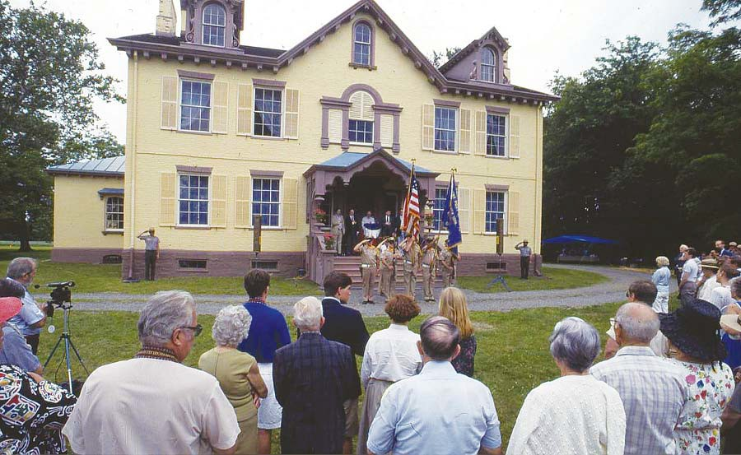

**Figure 3.1.** Visitors await 1987 opening

*Source: Photograph MAVA Collection*

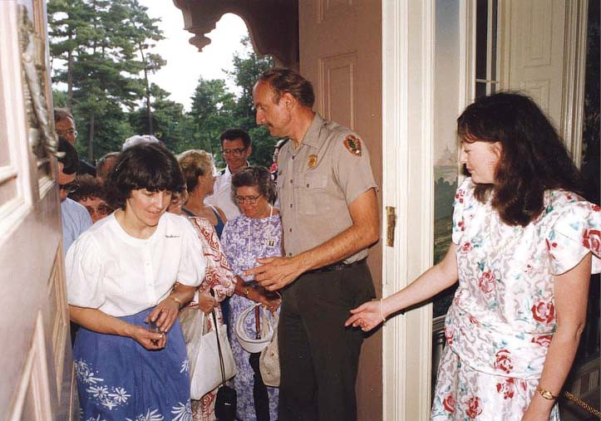

**Figure 3.2.** George Berndt and Carol Kohan welcome visitors to the 1987 opening

*Source: Photograph MAVA Collection*

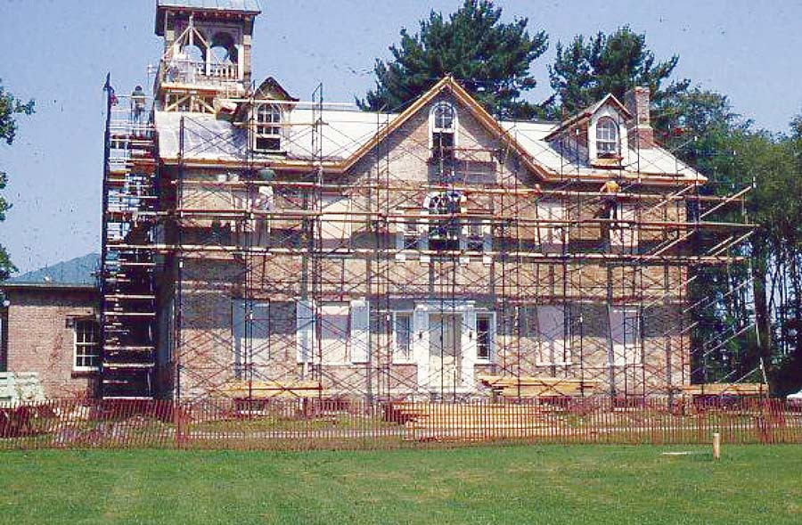

**Figure 3.3.** Exterior restoration in progress

*Source: Photograph MAVA Collection*

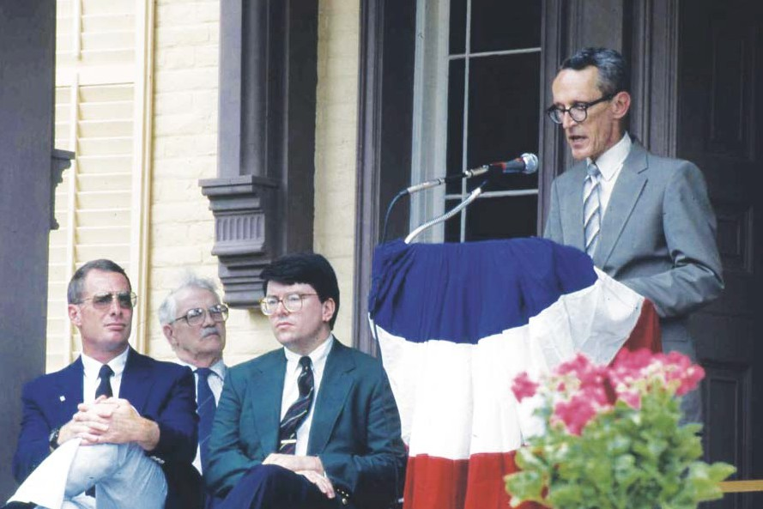

**Figure 3.4.** Superintendent Bruce Stewart speaking at 1987 opening

*Source: Photograph MAVA Collection*

Chapter Four

*Saving Lindenwald: Restoration, Preservation, Collections, and Planning, 1982-1987*

# Finding Space: Facilities and Boundaries, 1982-1991

#### Introduction

From the beginning of its development, the establishment of visitor, adminis- trative, and curatorial facilities at Martin Van Buren National Historic Site presented many challenges. The residency of Kenneth Campbell and the presence of his antique business, the long period of restoration of Lindenwald, and the lack of buildings on the site that could rea- sonably serve park needs resulted in a series of short-term solutions. As operations began at the park, oﬃcials brieﬂy placed administrative oﬃces in the South Gatehouse and then in the mansion itself. Beginning in 1978, the administrative functions were moved to rental trailers behind the mansion, a measure intended to be temporary. The use of the cinderblock garage for maintenance functions and the pole barn for curatorial storage facilities in the pole barn were also considered temporary, but those buildings served the park for decades. The strug- gle to provide permanent, appropriate facilities for visitors, staﬀ, maintenance, and storage became an ongoing issue that absorbed administrative time and aﬀected staﬀ morale. During the late 1980s and early 1990s, an attempt to erect a permanent multipurpose building led to controversy and, ultimately, disappointment. That struggle also inspired increased consider- ation of an expansion of the park’s boundaries, which could protect the original Van Buren farm lands as well as provide space for development of the park’s facilities.

#### Boundary Issues

By the early 1980s, the land acquisition plan for the park, consisting of lands in fee and conservation easements, was well in place and the threat posed by the proposed county landﬁll had been put to rest. Development pressures continued to be a concern to the park, however. A *Land Protection Plan* completed in 1984 noted that all the lands surrounding the park were in compatible uses, including farming and as sites for non-intrusive residences; noncompatible uses, if they occurred, would include subdivision and residential development and the introduction of commercial development.1 The *Land Protection Plan* dealt primar-

ily with existing lands and easements, but oﬃcials were beginning to ponder seriously the importance of the surrounding farmlands. In 1987, the National Park Service began planning a study of the lands adjacent to the MAVA to assess whether the established boundary was

1 *Land Protection Plan*, Martin Van Buren National Historic Site, approved October 18, 1984, n.p., Folder MAVA *Land Protection Plan*, MAVA Planning Files, Boston Support Oﬃce.

adequate to protect the site from threats posed by development and the escalating land values that might encourage landowners to sell their property for residential subdivisions or other uses. The National Park Trust, a program of the National Parks and Conservation Association, expressed interest in the study; the trust had the ability to acquire privately owned properties within park boundaries and hold them for eventual acquisition by the NPS.2

The park instituted the study in cooperation with the Columbia Land Conservan- cy under an agreement between the Conservancy and the NPS. Ruth Piwonka of the Colum- bia County Land Conservancy completed much of the initial research for the project, looking at the park from surrounding public roads, pondering the view sheds, and evaluating how

the lands in their current conditions compared to how they appeared in Van Buren’s time. She also researched the 1855 census, which listed farms in the area and the crops they were producing, to establish the importance of agriculture there. She recommended the protection of a view shed that stretched to the Town of Kinderhook line, an area that contained working farms with lands in productive agricultural use.3

The results of her work were utilized in writing the Adjacent Lands Resource Analysis, issued by the National Park Service in the fall of 1990. The report concluded that the retention of the agricultural setting was imperative to the integrity of the property, but also noted that the site was probably removed from most of the pressure of encroaching suburbanization, which was likely to take place in the northern central portion of the Town of Kinderhook. The study recommended the original Van Buren farmlands and the surrounding setting should be protected through conservation easements and limits on development of

open agricultural portions of the surrounding lands. The NPS stated its intention to work with local planners in supporting historic preservation zoning and the strict interpretation of com- mercial zoning.4 The report recognized the importance of the farmlands but emphasized that the signiﬁcance of the site was based on Van Buren’s political career, not his accomplishments as a farmer: “The goal is not to recreate and interpret his farm, but to retain the active farm operation and the open character. Thus, federal acquisition is not recommended or required.” The lands analysis concluded that such protection could be achieved through additional ease- ments, and through cooperation with local entities in zoning and land use planning.5

2 Herbert S. Cables Jr. to Ruth Piwonka, November 14, 1987; Frances H. Kennedy to Bruce M. Stewart [sic], November 17, 1987; Bruce W. Stewart to Frances H. Kennedy, November 20, 1987; Martin Van Buren National Historic Site Fiscal 1989 Budget Brieﬁng Statement, all in Folder L1425 Adjacent Lands Study Land Acquisition Easement #1, MAVA Central Files.

3 National Park Service, Martin Van Buren National Historic Site, Adjacent Lands Resource Analysis, with assistance by the Columbia Land Conservancy, September, 1990, i-ii; Ruth Piwonka, interview by Suzanne Julin, April 6, 2010, MAVA.

4 National Park Service, Martin Van Buren National Historic Site Adjacent Lands Resource Analysis, i-ii.

5 National Park Service, Martin Van Buren National Historic Site Adjacent Lands Resource Analysis, 17.

Despite the modest and measured recommendations in the Adjacent Lands Re- source Analysis, minds continued to turn toward expansion of the park’s boundaries through land acquisition. Early in 1991, the North Atlantic Regional Director approved a Statement for Management which stated that the government-owned lands and the adjacent conservation easements were not adequate to “protect the important historic setting” of Martin Van Buren National Historic Site from “negative visual impacts.”6 Thus, serious consideration of expan- sion of the park’s boundary began and would continue for the following two decades.

#### The First Multipurpose Building Controversy

From the beginning of MAVA’s existence, staﬀ and administrators had struggled with the issue of developing appropriate, permanent facilities to serve visitors and provide oﬃce and storage space. During the 1980s, the pressure to develop those facilities at the park increased. By the fall of 1982, the park was budgeting $80 per month for rented portable toilets for visitors and $350 per month for the two rented house trailers that served the park’s admin- istrative and curatorial functions.7 The trailers provided workspace for the superintendent, the chief of interpretation, the curator, the chief of maintenance, the administrative oﬃcer, the park secretary, a park technician, a museum aide, and a maintenance clerical aide. In addition, the trailers housed equipment, ﬁles, and some curatorial storage. Already well-used when the park rented them, the trailers presented a dilapidated appearance.8 Maintenance workers continued to operate from the cinderblock garage located directly behind Lindenwald. Neither the admin- istrative trailers nor the maintenance garage, both of which housed important records, had ﬁre or burglar alarms; the pole barn, installed as a temporary space for the museum collection in 1983, did not have such systems until 1989.9 In the meantime, consideration of a multipurpose building, which had been proposed early in the site’s existence, continued to develop. In 1985, George Stephen, the regional architect, drew up preliminary plans for such a building.10

Plans did not necessarily translate to reality. The preferred alternative of the 1986 *Development Concept Plan* called for the construction of the multipurpose building, but no immediate progress was made in funding and deﬁnitive planning.11 In 1988, Superintendent

6 Statement for Management, Martin Van Buren NHS, Kinderhook, New York, Approved by Regional Director, January 9, 1991, n.p.

7 A-76 Report, Contracts Awarded for Commercial and Industrial Activities, attachment to Bruce W. Stewart to Regional Director, June 15, 1983, Folder S7215 A-76 (Drafts), MAVA Central Files.

8 Bruce W. Stewart to Regional Director, April 22, 1983, Folder D6215 Museum & Exhibit, P26 1950 MAVA, MAVA Central Files.

9 Superintendent to Regional Director, June 7, 1990, Folder H1817 Security, MAVA Central Files.

10 George Stephen to Chief, Engineering and Maintenance September 26, 1988, Folder D24 Projected Projects FY 87, 88, 89, MAVA Central Files.

11 *Chatham Courier*, February 20, 1986, in Folder K3416 MAVA Newspaper Clippings #1, MAVA Cen- tral Files.

Bruce Stewart and Richard Ouellette, chief of maintenance, submitted a Development/Study Package Proposal that proposed the design and construction of a visitors’ center on the North Field, northeast of Lindenwald’s mansion, an area outside the boundaries of the original Van Buren farm. The proposal also suggested a second phase of the project that would link ad- ministrative oﬃces to the visitor’s center.12 The proposal, along with the preferred alternative of the 1986 *DCP*, set into motion serious planning of the park’s permanent facilities, but also touched oﬀ opposition and controversy.

Henry Birdseye Weil, the park neighbor who had purchased adjacent lands to protect them from development, immediately became involved in the issues surrounding the planning of the multipurpose building. He considered the preferred alternative in the 1986 *DCP* objectionable, particularly the siting of park facilities in the North Field. He maintained that the National Park Service had acquired the North Field and scenic easements on other tracts in the cause of preserving the agricultural nature of the lands, and erecting modern buildings on the property was not in keeping with that cause. In addition, he charged that the plan to site the buildings on the North Field was in part an attempt to reduce the attractiveness of the adjacent lands and thus reduce the threat of residential development, a threat that had become a moot point after he purchased the adjoining lands. The Adjacent Lands Resource Analysis for MAVA was being conducted by the NPS with the assistance of the Columbia Land Conservancy, and Weil predicted that the study would result in an expansion of the park. He believed that existing structures or parcels that might be included in such an expansion would be better suited to the MAVA’s administrative and maintenance needs than the North Field site and strongly suggested that new construction be postponed until the study was completed and the *DCP* was revised accordingly.13

In January of 1989, George Stephen and a landscape architect visited the park and suggested some modiﬁcations in the siting of the new building. While the siting would follow the general concept proposed in the *DCP*, the building could be recessed slightly from the Old Post Road in a way consistent with the setbacks of other buildings in the area. In discussing these adjustments with the park, the NARO director acknowledged that no other land con- trolled by the park provided a less intrusive site, the current facilities were woefully inad- equate, and the park could not forestall action while pursuing a boundary expansion.14

12 Development Study Package Proposal No. 118, Martin Van Buren NHS, Folder DD2215, 10-238, Visi- tor Center 1992, MAVA Central Files.

13 Bruce W. Stewart to Regional Director, October 19, 1988, Folder L1425 Adjacent Lands Study Land Acquisition Easement #1, MAVA Central Files; Henry Birdseye Weil to Bruce W. Stewart, November 25, 1988, Folder L1425 Adjacent Lands Study Land Acquisition Easement #1, MAVA Central Files.

14 Herbert S. Cables Jr. to Acting Superintendent, Martin Van Buren National Historic Site, March 7, 1989, Planning MAVA II, Planning Files, BOSO; Park Comments, *Martin Van Buren NHS Administrative History*, First Draft, March 19, 2010.

Weil had also criticized the proposed design of the building and made pointed suggestions. He urged the construction of a building designed to look as though it had been built in the historic era. The NPS had taken some of his suggestions into account in consider- ing a modiﬁcation of the building’s design but other factors—including accessibility require- ments and NPS policy that required a “clear distinction” between historic structures and new construction—limited the ability to conform to Weil’s wishes. The New York State Historic Preservation Oﬃce supported the standard of diﬀerentiation between old and new build- ings.15 In a meeting on April 5, 1989, regional and park staﬀ reached several decisions about the multipurpose building. It would be constructed in the North Field, with the possibility

of some slight repositioning. The building would be one-story and the architect would revise the plans to “reﬂect new considerations” and “local concerns.” Landscaping would provide appropriate screening with mature plants. The group agreed that progress on construction should not be impeded by the need for revised planning.16

But planning did impede progress. The design of the building became an issue between the park and the State Historic Preservation Oﬃce, requiring additional attention and meetings. In the spring of 1989, George Stephen again visited Martin Van Buren National Historic Site in response to concerns about the “proper integration” of the building with its surroundings. Stephen, Superintendent Stewart, Curator Kohan, and Chief of Maintenance Ouellette drove an area encompassing approximately a ﬁve-mile radius of the park, docu- menting by photograph the buildings they saw there. They identiﬁed ﬁve local characteristics that reﬂected mid-nineteenth century architecture, including low roof pitches, broken pedi- ment gables, horizontal windows under eaves on the second ﬂoor of the houses, the lack of dormers, and metal roofs. The low roof pitches and broken pediments, Stephen concluded, were typical of the mid-nineteenth century Italianate style; the horizontal windows, the lack of dormers, and the metal roofs represented the vernacular architecture of the region. Some buildings dating to the period before the mid-nineteenth century featured wide clapboards or shingles. All of the buildings on Old Post Road near the park, the report stated, were nine- teenth and early twentieth century buildings that did not have the distinctive mid-nineteenth century features that reviewers had noted as desirable.17

In reporting these ﬁndings, George Stephen stated that those concerned with the design had realized that because of its function and required size, the multipurpose building

15 Herbert S. Cables Jr. to Acting Superintendent, Martin Van Buren National Historic Site, March 7, 1989; Park Comments, Martin Van Buren NHS Administrative History, First Draft, March 19, 2010.

16 Superintendent to Chief, Planning and Resource Preservation, NARO, April 7, 1989, Folder Planning MAVA II, Planning Files, BOSO.

17 George Stephen to Chief, Engineering and Maintenance, NARO, April 25, 1989, Unlabeled File [1970 *Master Plan* Corresp. (brief, copied) *DCP* 1990 Corresp. Multi-use Building Corresp.], Weinbaum Files, BOSO.

probably could not mimic the small, two-story residences in the area. A structure sensitive to local architecture, set back from the road and shielded by plantings, he said, would “do as much as anything to ensure that the building integrates harmoniously with its environment.” His ac- companying sketch illustrated an end-gabled building with a low-pitched metal roof and a bro- ken pediment over its entrance. Horizontal windows appeared under the overhanging eaves.18 Stephen’s hope that the argument over design had been settled was premature, however.

Henry and Elisabeth Weil met with park staﬀ in mid-August 1989 to express their vehement opposition to the proposed multipurpose building and threatened to ﬁle an injunc- tion to stop its construction. They expressed their dislike of the proposed modest design of the building; they continued to insist that a style imitative of the existing historic resources would be more appropriate. They proposed that the development be delayed while attempts were made to acquire additional lands that could be used for the building site. However, in recognition of the fact that funds might be lost if the building were not constructed on sched- ule, they suggested its location be changed to a wooded tract in the park, because the woods would screen the building from view. Park staﬀ recommended that the National Park Service consider this option, even though the location within the woods would put the building on former Van Buren farm property, which had been considered inappropriate for development. Carol Kohan, acting superintendent in Bruce Stewart’s temporary absence, warned the re- gional director that if this option was not reasonable, the National Park Service had to “accept the possibility of legal action.”19

In the meantime, questions arose regarding Section 106 compliance. Section 106 of the National Historic Preservation Act of 1966 (NHPA) requires that any federal undertak- ing must consider historic resources and the agency must complete appropriate review proce- dures if such resources are present. The proposal to place the building in the North Field was submitted to the State Historic Preservation Oﬃce (SHPO) for compliance review, but Na- tional Park Service staﬀ subsequently discovered that the site had been included in the 1986 *DCP*, and that the state oﬃce approved the plan in the spring of that year. Thus, the National Park Service concluded that requirements for compliance had been fulﬁlled.20

As planning continued, however, the Weils did mount a legal challenge based on compliance issues. The National Environmental Protection Act of 1970 (NEPA) requires federal and state agencies to identify and justify impacts to the environment that may result

from their projects. Basic procedures include Environmental Assessments (EA) to determine whether a project will have a signiﬁcant impact on the environment, and the more detailed

18 George Stephen to Chief, Engineering and Maintenance, NARO, April 25, 1989.

19 Carol Kohan to Regional Director, NARO, August 14, 1989, L617/EA-2, Clark Files, BOSO.

20 Steven H. Lewis to Orin Lehman, April 24, 1989, Folder L7617 MAVA DCA/EAS (Accordion File), Clark Files, BOSO.

and complex Environmental Impact Statements (EIS), which are required when a project is identiﬁed as having the potential to signiﬁcantly aﬀect the environment. The 1986 MAVA *DCP* included an EA that resulted in a Finding of No Signiﬁcant Impact (FONSI) on the environ- ment. Weil’s attorney, Thomas Martin, held that the National Park Service had developed

the FONSI to avoid preparing an EIS, which he considered “most certainly required.” He maintained that aesthetic changes constituted an impact on the environment of Martin Van Buren National Historic Site, particularly its viewshed. If the latest *DCP* was implemented, Martin said, Weil would be injured because of the loss of integrity of a site he had helped to preserve and to his own adjoining property due to litter, damage to air quality, and trespass. He also might suﬀer economic harm if the development aﬀected the value of his undeveloped property.21 Subsequently, the Solicitor’s Oﬃce reviewed the materials and concluded that the environmental compliance issue on which the Weils based their legal challenge was a valid one and might result in a temporary injunction. The Solicitor’s Oﬃce suggested a NEPA compli- ance amendment be done immediately, but MAVA staﬀ did not have the expertise to do such an amendment.22

The NPS continued to address the concerns of the Weils and other park neigh- bors. The regional planning staﬀ reinvestigated the possibility of siting the multipurpose building within the woods, but concluded again that the location was inconsistent with Na- tional Park Service policy; potential archeological resources existed within the historic core and the NPS was obligated to protect them.23 The region’s chief of planning and design invit- ed the Weils to further discuss their alternative proposals for the site. During a mid-November 1989 meeting, the Weils presented new revisions to the existing proposal: moving the build- ing seventy-ﬁve feet to the west and seventy-ﬁve feet to the north, relocating the pole barn to the south of its proposed location, changing the entrance sidewalk from straight to curved, concentrating the planned vegetation screening around the buildings rather than planting in a straight line, and eliminating the use of hemlocks in the screening. Although the planning staﬀ noted that the historic property line would need to be located before the building could be re- sited, they were amenable to the changes the Weils suggested.24

In February 1990, Planning and Resource Preservation staﬀ began work on an amendment to the 1986 *Development Concept Plan*/Environmental Assessment due to the is-

21 Thomas H. Martin to File, August 3, 1989, 4, 8-10, 13-24 Folder L617/EA-2, Clark Files, BOSO.

22 Martin Van Buren NHS to Dave Clark, September 9, 1989, e-mail message, Folder L617 MAVA CDA/ EA-2, Clark Files, BOSO.

23 Charles P. Clapper to Regional Director, NARO, November 13, 1989, Folder L617 MAVA CDA/EA-2, Clark Files, BOSO.

24 Terry W. Savage to Henry B. Weil, September 26, 1989, Folder MAVA BII Planning, Planning Files, BOSO; Marjorie Smith, Draft, Synopsis, Martin Van Buren National Historic Site Multi-Use Building Siting Meeting, November 14, 1989, Folder L617 MAVA CDA/EA-2, Clark Files, BOSO.

sues raised by the proposed multipurpose building location. The draft amendment was issued in March and carefully reviewed the plans put forth by the preferred alternative in the 1986 *DCP* that recommended placing a multipurpose building in the North Field. It oﬀered a re- vised alternative that also sited the building in the North Field, but proposed a slightly smaller parking lot than originally envisioned and called for two major changes in the multipurpose building: curatorial storage space would be located to the rear of the building rather than in its basement, and the audio-visual room would be enlarged to accommodate approximately ﬁfty people. In addition, the building would be set back from Old Post Road in accordance with other neighborhood structures and recessed into the property’s tree line; the alternative sited the building about seventy feet further back from Old Post Road than the 1986 plan had called for. This placement would allow for the development of plantings on the property’s northern edge to screen the new construction from view. A curving path would take visitors from the parking lot to the multipurpose building and then to the mansion. The pole barn, planned for use as a maintenance building, would be relocated closer to the new building to reduce the need for pavement and road construction.25

The *DCP* draft also spoke to issues that had arisen concerning the design of the multipurpose building, among them the idea that the new building could be constructed to look like an original historic building and the suggestion that a two-story building would be more compatible with the surrounding architecture. “There are constraints on design of pub- lic buildings, especially in historic areas,” the plan noted, citing NPS management policies that required new construction in such areas to harmonize with historic features, but not imi- tate them. The design of a new park building, the plan stated, “is mainly driven by the park functions which it must house.”26 The proposed building had been redesigned from its 1986 version to more accurately reﬂect vernacular architecture. A two-story building, the *DCP* noted, would not serve the necessary functions, would increase costs, including $60,000

to $70,000 for a hydraulic elevator for access for the disabled, and would interrupt a logical organization of work and visitor space. In addition, such a building—although it would take up less land than a one-story building—would be more visually intrusive and more diﬃcult to screen with plantings.27

Thus, the preferred alternative in the *DCP* draft addressed many of the concerns raised by the Weils and other interested parties about the multipurpose building, including its siting, its architectural design, and the methods of screening it from the neighbors. It also

25 Don L. Klima to Gerald D. Patten, May 23, 1980, Folder L7617 MAVA DCA/EASS (Accordion ﬁle), Clark Files, BOSO; “Draft *Development Concept Plan*/Environmental Assessment Amendment, Martin Van Buren National Historic Site,” March 1990, (*DCP*/EA Draft, March 1990), 6-7, MAVA.

26 *DCP*/EA Draft, March 1990, 7.

27 *DCP*/EA Draft, March 1990, 8,.

discussed other issues, including its eﬀect on the natural resources at the site. The parking, roadways, and building site would have a minimal eﬀect on the landscape, water quality, and long-term air quality. Visitors would ﬁnd convenient parking and sanitary facilities and an appropriate approach to the mansion. The integrity of the mansion would be protected by moving all operational functions to the multipurpose building area, and neighbors, while tem- porarily aﬀected by construction, would be screened from views of the site by plantings.28

The other alternatives proposed by the plan were: no or minimum action, leaving interpretive and visitor functions in the mansion and the non-historic outbuildings in place; the historic core alternative, which would locate the multipurpose building in the woodlot near the mansion, on part of the grounds owned by Van Buren; an oﬀ-site alternative, which would require the acquisition of adjacent agricultural property once owned by Van Buren and rehabilitation of existing farm buildings to serve park purposes; and a second oﬀ-site alterna- tive which proposed NPS acquisition of land that was near but not contiguous to the site and had never been owned by Van Buren. The land held farm buildings that could be adapted to park purposes. The draft *DCP* explained the environmental and operational issues and costs of each alternative, as well as their eﬀects on cultural resources.29 Clearly, the *DCP* amend- ment was designed to respond to the issues that had been raised by the public and most par- ticularly by the park neighbors.

The draft *DCP* amendment was available for public review from March 5 through April 4. The park received ten letters of support for the preferred alternative, including one from Dudley Ray Meyer, who owned most of the former Van Buren farmland immediately adjacent to the park. The plan noted that owners of two of the neighboring properties, however, con- tinued to oppose the proposed development.30 Along with the Weils, Joseph and Angela Cutro objected to the preferred alternative, including the location of the parking lot and the siting of the proposed building. They were particularly concerned with the eﬀects on their own property, including the “loss of starry nights” and various forms of pollution. They reminded NPS oﬃcials that the scenic easement the federal government held over their property was expected to pre- serve the historic scene of Van Buren’s property; they, in turn, expected the federal government to refrain from changing that scene through park development. If the NPS proceeded with the preferred alternative, the Cutros suggested, they might seek “injunctive relief.”31

The draft *DCP* amendment illustrated the proposed multipurpose building designed by George Stephen. The one-story building presented an oﬀ-center, utilitarian

28 *DCP*/EA Draft, March 1990, 10-11.

29 *DCP*/EA Draft, March 1990, 12-27.

30 Bruce Stewart to Regional Director, April 9, 1990, Folder MAV HQ/VC, Planning Files, BOSO.

31 Joseph and Angela Cutro to Bruce Stewart, April 4, 1990, Folder D18 Re Draft *DCP* 1986, Planning Files, BOSO.

entrance, and a few small windows tucked under the low-pitched roof.32 Joseph Cutro took exception to the design and held that the arguments that new buildings should not be built to imitate historic ones were invalid. He cited visitor centers he had observed in other parks and the newly constructed Weil house, the design of which he considered “a contemporary style and architecturally harmonious to the President’s home.”33 In a letter to Senator Alfonse M. D’Amato, Cutro described the planned design for the multipurpose building as resembling “a modern thruway restaurant in an [sic] nineteenth century historic area.”34 The Cutros also suggested constructing the buildings within the historic core rather than in the North Field,

but because of the historical and archaeological signiﬁcance of the area, the Park Service con- tinued to consider that proposal “an alternative of last resort.”35

The Advisory Council on Historic Preservation reviewed the draft *DCP*/EA in May 1990 and expressed no objections to the preferred alternative,36 but the opposition of the two sets of neighbors continued to mount. At the end of May, Thomas Martin, Henry Weil’s lawyer, sent Bruce Stewart a “Demand for Relief,” charging that the *DCP*/EA amendment was “an

after-the fact document written to justify a decision that has already been made” and that it did not comply with NEPA, which says that environmental impacts have to be considered before such decisions are ﬁnalized, including, in the case of a national historic site, impacts on the visual environment. He also complained that the *DCP*/EA failed to address fully the “contex- tuality” of the building design.37 Within a few days, Weil’s lawyer also contacted Gerald Patten, the NARO director, demanding once again that environmental impact statements be prepared; without an EIS, Martin promised, the project would be “enjoined.” He urged the director to meet with him and Mr. Weil “before you make a decision to go ahead without environmental clearances.”38 Patten responded that the Park Service was involved in a redesign of the façade of the proposed building and Stewart was working on a reply to the demand for relief.39

32 Draft *Development Concept Plan*/Environmental Assessment Amendment, Martin Van Buren National Historic Site, March 1990, Figure V, MAVA.

33 Joseph Cutro to John J. Scheriﬀ, June 8, 1990. Correspondence between Cutro and Scheriﬀ in Folder L7617 MAVA CDP/EAS (Accordion File), Clark Files, BOSO reﬂects the arguments about the appropri- ate architectural style for the proposed multipurpose building.

34 Joseph A. Cutro to Alfonse M. D’Amato, August 22, 1990, L7617 MAVA DCA/EAs (Accordion File), Clark Files, BOSO.

35 Gerald D. Patten to Gerald R. Solomon, June 21, 1990, Folder MAVA HQ/VC, Planning Files, MAVA.

36 Don L. Klima to Gerald D. Patten, May 23, 1980, Folder L7617 MAVA DCA/EAS (Accordion File), Clark Files, BOSO.

37 Thomas H. Martin to Bruce W. Stewart, May 22, 1990, Folder L7617 MAVA DCA/EAS (Accordion File), Clark Files, BOSO.

38 Thomas H. Martin to Gerald Patten, June 1, 1990, Folder L7617 MAVA DCA/EAS (Accordion File), Clark Files, BOSO.

39 Gerald D. Patten to Thomas H. Martin, June 7, 1990, Folder L617 MAVADCA/EAS (Accordion File), Clark Files, BOSO.

Attached to Martin’s letter to Stewart was a document written by Weil. In “His- tory of a Neighbor’s Attempt to Inﬂuence a Proposal by the National Park Service to Con- struct a ‘Multi-Purpose Building’ At the Martin Van Buren National Historic Site,” Weil said that he and his wife had not objected to the siting of the multipurpose building as it had been presented in the 1986 *DCP* because the National Park Service had assured them that this was only a concept with no guarantee of funding and neighboring land owners would be involved in any eventual decision making. The Weils had worked with the Columbia Land Conservancy to ﬁght the proposed development of the former Brennan property. When

those attempts failed, they bought the land privately in 1988, began to farm it, and planned to relocate a historic house there, adding to the “ambiance of Lindenwald” as well as providing private housing for their family. When building stakes went up in the North Field, the appre- hensive Weils contacted Bruce Stewart. They found that plans for the multipurpose building were progressing.40

Weil reiterated his claims that the National Park Service had failed to comply with NEPA and NHPA. He also disagreed with the park’s position that the historic Van Buren farmland was not an appropriate place for a new building and noted that the “*overall* historic, aesthetic, and environmental integrity of the Park” was paramount. Weil said the only results of the meetings between he and his wife and NPS oﬃcials were revised plans that diﬀered just slightly from “the rigid stance of NPS.” He insisted they did not want to “eliminate” the planned multipurpose building and other buildings, but wanted to “ensure that they are designed and sited in an environmentally, historically, and aesthetically appro- priate manner.”41

In mid-July 1990, the chief of Environmental Quality of the Department of Inte- rior stated that he believed the NPS was complying with the provisions of NEPA and NHPA in the case, and appropriate NEPA documentation would be prepared for the amendment to the 1986 environmental assessment.42 Stewart responded oﬃcially to the “letter of demand” in mid-August 1990. He noted that the draft *DCP*/EA went through appropriate public review, and that the park was considering further redesign of the multipurpose building. He also stated that the possibility of the park expanding its holdings of lands in fee was not under ac-

40 Henry B. Weil, “History of a Neighbor’s Attempt to Inﬂuence a Proposal by the National Park Service to Construct a ‘Multi-Purpose Building’ At the Martin Van Buren National Historic Site,” attachment to Thomas H. Martin to Bruce W. Stewart, May 22, 1990, Folder L617 MAVA DCA/EAS (Accordion File), Clark Files, BOSO.

41 Henry B. Weil, “History of a Neighbor’s Attempt to Inﬂuence a Proposal by the National Park Service to Construct a ‘Multi-Purpose Building’ At the Martin Van Buren National Historic Site,” BOSO.

42 Jacob J. Hoogland to Lucinda Low Swartz, July 16, 1990, Folder L7617 MAVA DCA/EAS (Accordion File) Clark Files, BOSO.

tive consideration and reiterated his conﬁdence that the environmental assessment conducted in conjunction with the project complied with NEPA.43

In the meantime, NARO submitted the plans and an elevation for the latest design for the multi-purpose building to the SHPO. The entrance wing was planned to contain ex- hibits, an audiovisual room, restrooms, storage, and a space for seasonal staﬀ. A second wing extended to the northwest and held administrative oﬃces, reception and clerical area, a lunch room, lavatory, conference/library, and rooms for technical and curatorial work. Extending to the west was a large square area for curatorial storage. The SHPO’s oﬃce expressed concerns with the design. When the regional director did not approve the plans, NPS architects began working on modiﬁcations to the façade.44

The Amendment to the 1986 *DCP* was approved in September 1990. The pre- ferred alternative called for a $2.6 million dollar project which would remove the non-historic gravel driveway to the west of the mansion, place utilities underground, and provide appro- priate landscaping. The South Gatehouse would be restored for park use, and the portion of the Old Post Road in front of Lindenwald closed to traﬃc. A commodious parking lot and an outdoor interpretive display would serve visitors. As funding permitted, a new multipurpose building would hold visitor facilities and administrative oﬃces, storage, and curatorial work areas. The cinderblock garage would be taken down and rental trailers removed. The pole barn would be relocated to the northeast corner of the property and maintenance functions moved there.45 The multipurpose building would be sited in the North Field, with a series of paths leading visitors from the parking lot to the mansion and to the new building. George Stephen’s modiﬁed design featured a long facade with steeply pitched, cedar-shingled, end- gabled roof, clapboard siding, rectangular paned windows and prominent oﬀ-center entrance with a broken pediment roof and fanlight. Compared to the much simpler façade presented in the *DCP* draft, the building featured elements that reﬂected a compatibility with vernacular buildings in the area.46 It was not a replica of a historic building, however, and like the draft *DCP*, the ﬁnal document elaborated on “the constraints on design of public buildings,” ex- plaining NPS policies that held new construction should harmonize with historic features but

43 Bruce W. Stewart to Thomas H. Martin, August 16, 1990, L7617 MAVA DCA/EAS (Accordion File), Clark Files, BOSO.

44 Gerald D. Patten, Regional Director, to Orin Lehman, July 19, 1990; Herbert S. Cables Jr. to Orin Lehman, February 20, 1986, Unlabeled File [1970 *Master Plan* Corresp (brief-copied), *DCP* 1990 Cor- resp, Multi-use bldg corres], Weinbaum Files, BOSO; *Hudson Register-Star*, August 20, 1990.

45 Amendment to the *Development Concept Plan*/Environmental Assessment of 1986, approved by Regional Director September 4, 1990, MAVA; *Chatham Courier*, February 20, 1986, in Folder K3416 MAVA Newspaper Clippings #1, MAVA Central Files.

46 Martin Van Buren National Historic Site, Amendment to the *Development Concept Plan*/Environmen- tal Assessment of 1986, September 1990, 5-9, MAVA.

should not imitate them; a “clear distinction” between historic buildings and new buildings had to be maintained.47

The argument over design was not over, however. Shortly after NARO director Gerald Patten approved the amended *DCP*, Julia Stokes of the NYSHPO informed him of the results of that oﬃce’s review of elevation drawings in accordance with Section 106 of the NHPA and subsequent regulations. While the SHPO did not object to the building’s impact on Martin Van Buren National Historic Site, and agreed that the most appropriate site for the building and the parking lot were in the North Field, the oﬃce was concerned about its impact on the surrounding National Register of Historic Places-eligible resources, including a rural historic district. The SHPO suggested that the east-west wing of the building be rede- signed to honor regional barns, perhaps by adding gabled dormers to the roof.48

Patten disagreed, noting the survey of local architecture done the previous year. He cited the pitched roof, the attempt to achieve a “domestic” scale for a multi-functional building, and traditional clapboard walls as features consistent with the local architecture. He also observed that the building would be screened by large trees.49 The SHPO replied that while they realized the multipurpose building would not resemble local structures and would be screened from sight of all historic structures except the nearby Cutro house and barn, their suggestion to include dormers represented an attempt to break the scale in the roof plane and suggest local agricultural buildings without replicating the Cutro barn, which featured a cupola.50 The argument continued for months. After speaking with the SHPO early in January 1991, NARO Historian Paul Weinbaum reported to the Cultural Resources Management Division that the Advisory Council had approved the amended plan, and that while the SHPO could not be convinced of the appropriateness of the building’s design, they would not continue to take issue over it—although they would give their opinion to the public if asked.51

In the meantime, collection storage issues at the park reinforced the need for new facilities. The park had developed a *Collection Storage Plan* based on an on-site assessment

47 Martin Van Buren National Historic Site, Amendment to the *Development Concept Plan*/Environmen- tal Assessment of 1986, September 1990, 7.

48 Julia S. Stokes to Gerald D. Patten, September 13, 1990, Unlabeled File [1970 *Master Plan* Corresp (brief- copied), *DCP* 1990 Corresp, Multi-use bldg corres], Weinbaum Files, BOSO; Julia S. Stokes to Bruce W. Stewart, November 13, 1990, Folder L617 MAVA DCA/EAS (Accordion File), Clark Files, BOSO.

49 Gerald D. Patten to Orin Lehman, November 16, 1990, Unlabeled ﬁle [1970 *Master Plan* Corresp (brief-copied), *DCP* 1990 Corresp, Multi-use bldg corres], Weinbaum Files, BOSO.

50 Julia S. Stokes to Gerald D. Patten, Regional Director, December 24, 1990, Unlabeled ﬁle [1970 *Master Plan* Corresp (brief-copied), *DCP* 1990 Corresp, Multi-use bldg corres], Weinbaum Files, BOSO.

51 P. Weinbaum to Chief, Cultural Resources Management Division, January 8, 1990 [1991], Unlabeled ﬁle [1970 *Master Plan* Corresp (brief-copied), *DCP* 1990 Corresp, Multi-use bldg corres], Weinbaum Files, BOSO.

done in August 1989 by regional staﬀ, working closely with curator Carol Kohan. The plan noted that the storage facilities at MAVA were temporary, pending the completion of the new multipurpose building. The imminent construction of that building oﬀered opportuni- ties to plan ideal collections storage, and the plan reviewed approved storage procedures.

The MAVA collections at that time included 3,000 items relevant to Van Buren, Lindenwald, or the establishment of the historic site. Five hundred of these items were exhibited in the house. The Campbell collection, which was stored at the Springﬁeld Armory National His- toric Site (SPAR), included 416 items. Eighty-seven of them were to be included in the site collection, and many of the remaining items were slated for deaccessioning. The archaeology collection, consisting of more than 26,000 items, most of them small, was stored in MAVA’s temporary pole barn, in a small metal shed, or at SPAR. Notably, the plan did not discuss in detail the shortcomings of the pole barn as an adequate collections storage site; with the new multipurpose building on the horizon, its temporary status may have made such a discussion seem unnecessary.52

While planning, meetings, and reviews continued, funding for the badly needed multipurpose building remained elusive. Finally, MAVA and NARO staﬀ formulated what they believed was a workable solution. By constructing the multipurpose building in phases using annual repair and rehabilitation monies, the project could be completed over a period of four years.53 After more than a year of planning, in the spring of 1991, Bruce Stewart be- gan to discuss the ﬁnal design for the multipurpose building. The building would be a one- story wood frame structure with a wood-shingled roof and clapboard siding, designed to be compatible with existing structures and screened by hemlock trees, apple trees, and decora- tive shrubbery. The ﬁrst phase of construction would include the foundation and the shell of the structure. A second phase would take the building nearly to completion, with the ﬁnal details ﬁnished in ﬁnal phases.54

Construction was scheduled to begin in July 1991. On June 11, the WASO Budget Oﬃce of the Planning and Construction Branch notiﬁed Stewart that the project was disap- proved because of its manner of funding; the oﬃcials considered the project new construction rather than an improvement of existing facilities, which would have allowed the costs under repair/rehabilitation funds. New construction required the project to be considered in the

52 *Martin Van Buren National Historic Site Collection Storage Plan*, 1989, Folder H1815 Collections, NPS Areas, MAVA Central Files.

53 Statement for Management, Martin Van Buren NHS, Kinderhook, NY, approved January 9, 1991, n.p.; Michael Henderson, interview by Suzanne Julin, April 5, 2010.

54 National Park Service , “New Visitor Center Planned for ‘Lindenwald,’” news release, April 4, 1991, Folder K3415 Press Releases [II], MAVA Central Files; National Park Service , “Final Development of Martin Van Buren National Historic Site to Begin This Summer,” news release, May 3, 1991, Folder K3415 Press Releases [II], MAVA Central Files.

line item construction program for the entire National Park Service, submitted annually for Congressional action.55

Stewart was not completely surprised; he had become increasingly nervous about the funding issue. He held out some hope that the situation might still be resolved, but in preparation for more bad news, he drafted a news release and prepared a brieﬁng statement. He suggested to NARO that Congressman Gerald Solomon and the Friends of Lindenwald be advised of the problem, warning them of the probability of negative public reaction to the fact that the project might be delayed due to the funding issues. The ultimate bad news came when the NPS comptroller conﬁrmed to Stewart and NARO that the project could be funded only through line item construction funds. The park would need to compete with other

NPS units all over the country, including units larger, more visible, and better patronized, to achieve the planned development.56 The inability to fund the project brought an abrupt end to the immediate plans for the multipurpose building. The park staﬀ continued to work in the rented house trailers.57

#### Conclusion

The 1982-91 period was one of increasing frustration for management and staﬀ at Martin Van Buren National Historic Site, as they continued to work in substandard condi- tions and without the necessary facilities to achieve goals related to cultural resource preser- vation and visitor services. The highly visible nature of the park, with close neighbors deeply concerned with every aspect of its development, complicated attempts to plan new facilities. Fiscal policies and budget constraints doomed the construction of those facilities and foiled the park’s plans to create space for its visitor, administrative, maintenance and curatorial

functions. The process highlighted another issue that had been raised several times during the park’s history: a potential expansion of the park boundaries. Such an expansion would rec- ognize the signiﬁcance of the surrounding lands and protect them from undesirable develop-

55 Bruce W. Stewart to Regional Director, July 12, 1991, Folder July ’91, Box Unprocessed Material Read- ing Files, 1 of 12, MAVA Library; Annual Report 1991, 1, attachment to Bruce W. Stewart to Regional Director, NARO, Folder January 1992, Unprocessed Material Reading Files, 2 of 12, MAVA Library.

56 [Bruce W. Stewart] to Regional Director, NAR, June 15, 1991, Folder June 1991, Box Unprocessed Materials Reading Files, 1 of 12, MAVA Library; “National Park Service Brieﬁng Statement, Proposed Park Visitor Facility/Park Operations Building, Martin Van Buren National Historic Site, Kinderhook, New York,” attachment to Bruce W. Stewart to Regional Director, NARO, July 2, 1991, Folder July ’91, Box Unprocessed Materials Reading Files, 1 of 12, MAVA; Bruce W. Stewart to Edie Shean Hammond, Oﬃce of Communications, NARO, July 3, 1991, Folder K3415 Press Releases [II], MAVA Central Files; Michael Henderson, interview by Suzanne Julin, April 5, 2010; Michael Henderson to Patricia West,

e-mail message, March 12, 2010.

57 Attachment to Bruce W. Stewart to Edie Shean Hammond, Oﬃce of Communications, NARO, July 3, 1991, Folder K3415 Press Releases [II], MAVA Central Files; Michael Henderson, interview by Suzanne Julin, April 5, 2010; Michael Henderson to Patricia West, e-mail message, March 12, 2010.

ment. In addition, as park neighbor Henry Weil had noted and as the 1990 *DCP* amendment had suggested, a boundary expansion could alter the debate over development in the North Field, opening up the possibility of park functions being located in buildings on adjacent property. The recognized need for appropriate facilities and the discussions about boundary expansion would continue.

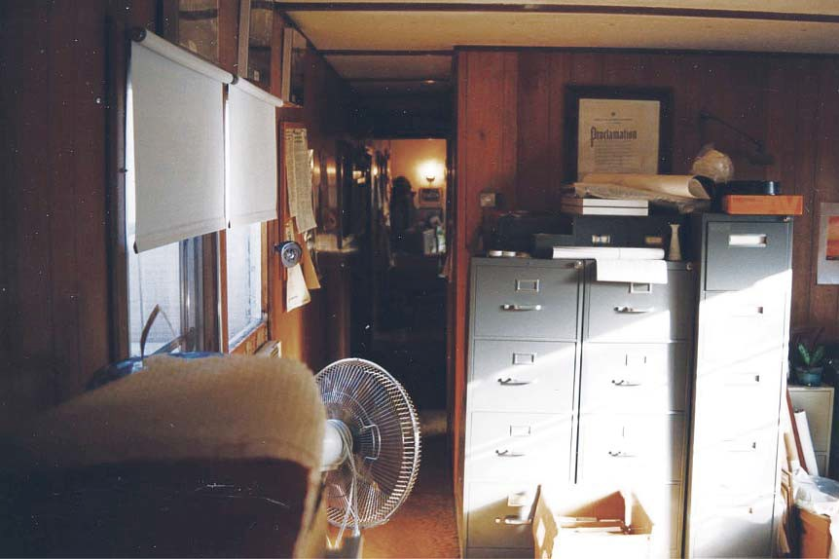

**Figure 4.1.** Park ofﬁce in house trailer behind Lindenwald, 1997

*Source: Photograph MAVA Collection*

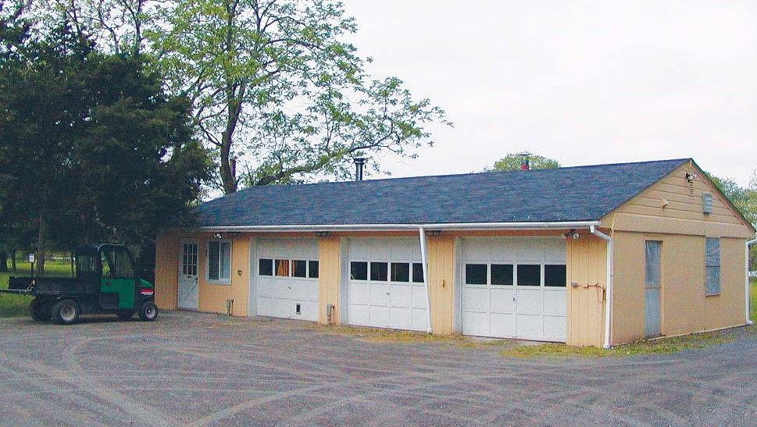

**Figure 4.2.** Cinderblock Maintenance Garage directly behind Lindenwald

*Source: Photograph MAVA Collection*

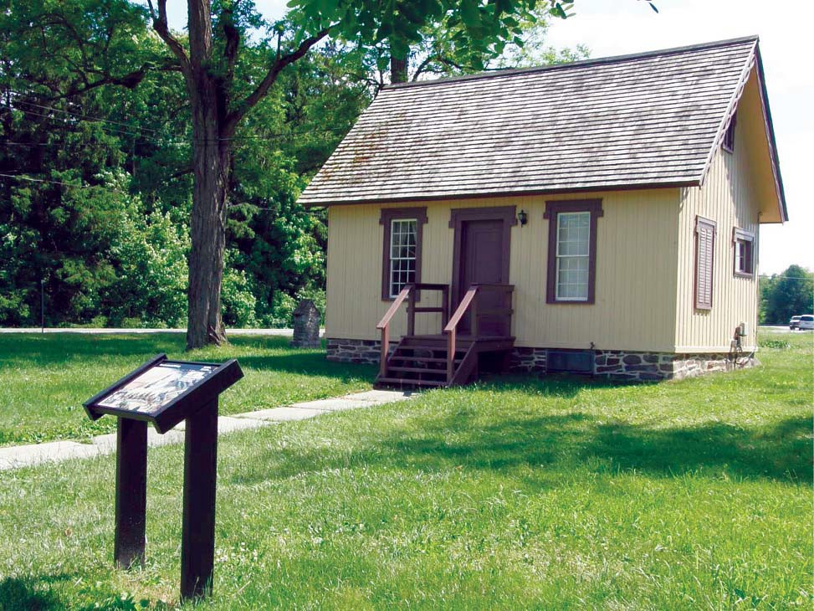

**Figure 4.3.** South Gatehouse

*Source: Photograph MAVA Collection*

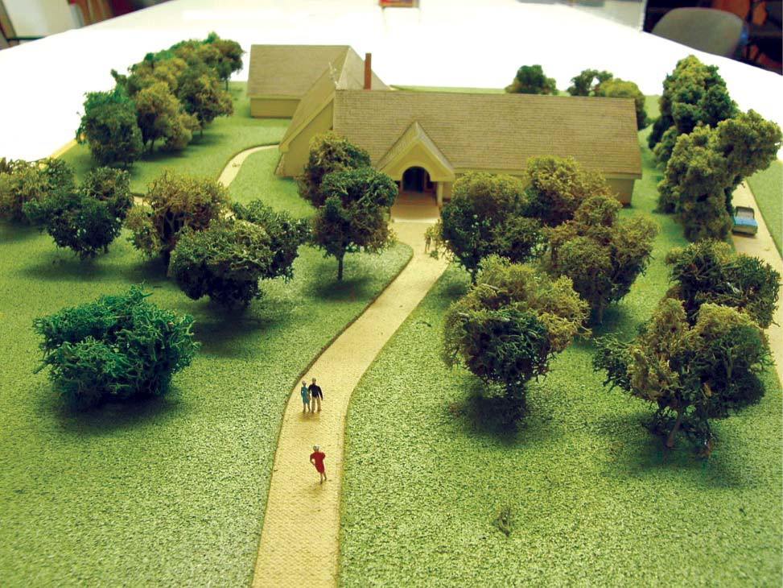

**Figure 4.4.** Model of George Stephen multipurpose building design

*Source: Photograph MAVA Collection*

Chapter Five

*Finding Space: Facilities and Boundaries, 1982-1991*

# Interpreting Martin Van Buren and Lindenwald, 1980-2000

#### Introduction

In 1995, MAVA Superintendent Michael Henderson wrote an article for *The Van Buren Chronicles,* the quarterly newsletter issued by the Friends of Lindenwald. In it, he said that interpretation “involves the revelation of connections among objects, people, activities, and ideas. Our goal is to grasp an understanding of … people’s social, religious, economic and political identity, in a word, their culture.”1 His words reﬂected the complex challenges of interpretation at MAVA.

From the time of Martin Van Buren National Historic Site’s establishment, inter- pretive staﬀ worked to create understanding of its signiﬁcance for visitors to the park. The characterizations of Lindenwald as Van Buren’s “retirement home” limited that understand- ing and presented the estate as a museum representing the genteel rural lifestyle of a president whose career was behind him. Interpretation at the site was further complicated by the lack of facilities outside the mansion that could provide venues for visitors to learn more about Van Buren and his times. As interpretation at MAVA evolved, however, the staﬀ recognized that Van Buren’s political career reached beyond his presidential term and also acknowledged the signiﬁcance of his mansion and agricultural estate as a property that shaped the lives of his family members, workers, servants, and neighbors. Particularly after the mid-1990s, interpre- tation at MAVA became increasingly sophisticated, aﬀording visitors a broader view of Van Buren, his politics, and life at Lindenwald.

#### Interpretation in the National Park Service

Before the 1930s, most National Park Service sites focused on nature rather than history. Except for a small number of Native American sites in the southwest, discussions of historical background were peripheral to visitors’ understanding and enjoyment. Visitors could enjoy parks that featured magniﬁcent and unique scenery without accompanying explanations, but they would have diﬃculty recognizing the signiﬁcance of a historic site without learning who had been there, what had happened there, and why the park was important to the coun- try’s history. In 1933, Franklin D. Roosevelt’s Executive Order 6166 transferred many battle- ﬁelds, monuments, and other sites from the Department of War and the Department of Forest-

1 Michael D. Henderson, “Thoughts on Landscape Restoration at Lindenwald,” *The Van Buren Chroni- cles*, Winter 1995, n.p., MAVA.

ry to the National Park Service. Historic areas became increasingly important elements within the system, and interpretation became a key to visitors’ appreciation of those properties.2

From 1933 through 1951, encouraged in large part by the passage of the 1935 Historic Sites Act, the National Park Service established a number of parks based on historical signiﬁcance, including several battleﬁelds and six presidential sites. From 1952 through 1972, another sixty-one historical units became part of the system. From 1973 to 2004, seventy- eight of 131 newly created parks were primarily historic in nature; Martin Van Buren National Historic Site was one of them.3 As historic sites increased, so did the issues associated with interpreting them. NPS oﬃcials and staﬀ struggled to determine whether interpreters should design programs directed at people with a special interest at the site, or those with no previous interest or knowledge, how to focus presentations on the broad signiﬁcance of the sites rather than on arcane facts, how to focus on education rather than entertainment, and the relative importance of communications skills and educational background.

Several factors particularly inﬂuenced the evolution of NPS interpretation in the years after 1950. The development of audiovisual resources meant that some of the previously personal services provided by interpreters were replaced by self-directed activities. During the Mission 66 period, when the NPS worked toward its ﬁftieth anniversary, the implementa- tion of visitor centers as places of orientation, education, and interpretation became increas- ingly important. Before the Mission 66 initiative, only three identiﬁed visitor centers existed within the system; by 1960, there were ﬁfty-six such centers, and the number increased to 281 by 1975. As a result, park personnel and their audiences relied more heavily on the centers to provide information and education. With exposure to television and other media, the expec- tations of audiences changed, requiring new considerations of appropriate interpretation. Af- ter 1950, eﬀorts to deﬁne interpretive objectives and the roles of interpreters helped to move interpretation forward. On the other hand, chronic underfunding and lack of recognition of the importance of interpretation served to hold back that progress.4

#### Early Interpretive Planning at MAVA

From the beginning, interpretive planning at MAVA was linked to the question of space: How would tours be conducted and how would rooms be interpreted, given the issues of conjecture and appropriate furnishing? How and where would basic interpretive informa- tion and broader interpretive programs be presented to the public, given the lack of a devel-

2 Barry Mackintosh, *Interpretation in the National Park Service: A Historical Perspective* (Washington, DC: National Park Service, 1986), 18-19.

3 Barry Mackintosh, *The National Parks: Shaping the System*, 52-53, 71, 84, 90.

4 Mackintosh, *Interpretation in the National Park Service*, chaps. 3-5, provides an excellent overview of the development of interpretation in the National Park Service to the 1980s.

oped visitor center outside the Lindenwald mansion? How could the site as a whole be inter- preted without reconstructing buildings or recreating the historic landscape? The eﬀorts to develop an interpretive plan also faced the ongoing dilemma of how to interpret Martin Van Buren’s political and presidential career through the lens of Lindenwald.

The ﬁrst attempt at interpretive planning at MAVA in the late 1970s failed. William Jackson’s draft Interpretive Prospectus addressed both Van Buren’s political legacy and the need for facilities at the site that would serve interpretive needs. His plan, which proposed a multipurpose facility to replace the positioning of administrative, visitor, and curatorial func- tions within the mansion and suggested reconstruction of historic buildings, created contro- versy and did not advance beyond the draft stage. By the time George Berndt ﬁnished writing the 1985 *Interim Interpretive Prospectus*, the multipurpose building concept was a constant theme in the park’s planning for interpretive goals, but budget constraints meant that it could not be built in the immediate future. The *Interim Interpretive Prospectus*, therefore, established a plan for a temporary visitor facility and developed objectives that would be appropriate for that facility as well as the proposed multipurpose building. The prospectus included a brief review of Van Buren’s life and political career as well as an overview of the property and its changes under Van Buren’s ownership.5

These issues became more pressing after 1980. As the opening of the site ap- proached, attention turned toward serving visitors, and interpretation of the site’s history became increasingly central to the park’s mission. The 1985 *Interim Interpretive Prospectus* identiﬁed its objectives as the interpretation of Van Buren, his political career and the events associated with that career, and his life at Lindenwald. The prospectus deﬁned the interpretive themes as “Martin Van Buren, President and Statesman,” “Martin Van Buren—Master Politi- cian,” and “Martin Van Buren and Lindenwald.”6 Although most of the objectives and themes emphasized Van Buren’s pre-presidential and presidential political careers, the document emphasized that the site did not “illustrate Van Buren’s public service, but rather his retire- ment years, his lifestyle and personality.”7 Thus, the prospectus acknowledged the problems inherent in addressing the ﬁrst two themes. The mansion, considered the park’s most impor- tant resource,8 presented the main challenge: how could Lindenwald be utilized to convey the signiﬁcant political themes identiﬁed in the prospectus?

5 *Interim Interpretive Prospectus*, Martin Van Buren National Historic Site, Kinderhook, NY, 1985, Introduction, 5-6, Correspondence File, Martin Van Buren NHS, National Park Service Harpers Ferry Center (HFC).

6 *Interim Interpretive Prospectus*, 1985, 7-10.

7 *Interim Interpretive Prospectus*, 1985, 8.

8 *Interim Interpretive Prospectus*, 1985, 10, 13.

To address this issue, the *Interim Interpretive Prospectus* suggested forty-ﬁve-min- ute guided tours of the mansion accompanied by a ten-minute audiovisual presentation. Until the proposed multipurpose building provided a permanent visitor center, a temporary visitor contact station would be established in the mansion. Visitors would enter through the west door, located at the rear of the mansion. The northwest room on the ﬁrst ﬂoor would hold a staﬀed information desk and incorporate sales of books and other items oﬀered by the park’s partner association. A ten-minute slide program would be shown in the west central room, historically the nursery, which could seat ﬁfteen visitors. The rear hall would contain exhibits, political posters, and reproductions of Van Buren family portraits. Upon completion of the new multipurpose building, all the interim interpretive functions would be removed from the mansion. The plan suggested the slide presentation eventually should be replaced by a video program developed by the National Park Service Harpers Ferry Center, with emphasis on Van Buren’s presidency, including the Panic of 1837 and his election defeat in 1840. The prospec- tus noted that the 1970 *Master Plan* suggested furnishing a few rooms as necessary to illustrate Van Buren’s life there, and using the other rooms for adaptive purposes. The prospectus took a wider view, saying that suﬃcient evidence and furnishings justiﬁed setting up a number of rooms, and anticipated that the *Historic Furnishings Report*, then in progress, would provide the necessary framework for furnishing these rooms, including several located in the base- ment.9

The *Interim Interpretive Prospectus* also proposed a wayside exhibit near the visi- tor parking lot to explain the layout of the property during Van Buren’s time and interpretive signs indicating the locations of buildings no longer in existence as well as labeling the South Gatehouse and the North Gatehouse foundation. The grounds would be maintained to retain the “tranquil, peaceful” mood of Van Buren’s time, but the document speciﬁcally noted that no recommendations to restore the grounds to a historically accurate appearance were being made, in part because the evidence uncovered during the development of the site’s Historic Grounds Report was not suﬃcient for an accurate restoration.10 Publications, postcards, fold- ers, slides, and other materials could provide visitors with more information about Van Buren and Lindenwald. The prospectus suggested the production of a forty- to sixty-page booklet, perhaps drawn from the HSR and HFR, to provide the public with additional information about the mansion’s architecture and furnishings.11

The *Interim Interpretive Prospectus* included many suggestions important to the site, but reﬂected an established attitude toward Lindenwald’s history that neglected to ad-

9 *Interim Interpretive Prospectus*, 1985, 13-14, 17-19, HFC.

10 *Interim Interpretive Prospectus*, 1985, 20, 24.

11 *Interim Interpretive Prospectus*, 1985, 21-22.

dress important aspects of the site’s signiﬁcance. Despite the document’s stated objectives and themes, its details suggested the interpretation of Lindenwald itself would focus on Van Bu- ren’s lifestyle, with nods to his pre-presidential and presidential careers. Because the emphasis was placed on Van Buren’s early career and presidency, recognition of that period essentially would end with his 1840 defeat, and his political inﬂuence and attempts to gain oﬃce after that time—while he was in residence at Lindenwald—would be largely ignored.

#### Shifts in Interpretation

Although the 1985 prospectus reﬂected an ongoing dilemma in interpreting Van Buren’s political career and a continuing emphasis on the historic site as his post-presidential “retirement” home, a broader interpretation of Lindenwald began to emerge in the early 1980s with attention to the servants who supported the Van Buren family’s lifestyle. The park staﬀ decided to address the basement area of the house because they could document the functions of three of its rooms as kitchen, laundry room, and servants’ dining room. A few furnishings—a cast iron cook stove, water pumps, laundry boilers and drying racks—survived to provide a picture of the servants’ working conditions. Although strict application of the National Park Service’s policy limiting the use of period artifacts with no documented con- nection to the site made furnishing the basement spaces diﬃcult, three basement rooms were prepared for tours during the 1986 summer season.12

These rooms helped to move interpretation past the study of Van Buren’s presiden- cy and appreciation of the family furnishings at Lindenwald to an understanding of the people who worked there and made the Van Buren lifestyle possible. In a wider sense, bringing atten- tion to the servants’ rooms facilitated exploration of the antebellum social and political changes that the workers represented. Much of this interpretation was based on the work of Patricia West. West came to the park as a seasonal interpreter in 1981 and then joined the curatorial staﬀ. She left in 1987 to pursue graduate studies. She earned a Ph.D. in U. S. history and wrote

a book entitled *Domesticating History: The Political Origins of America’s House Museums*, which was published in 1999, shortly after she returned to MAVA as park curator in 1998.13

West’s scholarship, particularly a 1985 research paper entitled “The House Ser- vants of Lindenwald,” incorporated archival sources, pertinent secondary sources, and analyses of the architecture of Lindenwald to discuss the signiﬁcance of the history of Linden-

12 Friends of Lindenwald, *The Van Buren Chronicles,* April 1989; Summary of Curatorial Division Ac- complishments, 1986, Folder D6215 Museum Exhibits Activities [III], MAVA Central Files; Carol E. Kohan, “Interpreting Lindenwald’s Servants,” in *The Van Buren Chronicles*, April 1989; Patricia West, interview by Suzanne Julin, June 17, 2008.

13 *Van Buren Chronicles*, April 1989; Patricia West, interview by Suzanne Julin, June 17, 2008, MAVA; Pa- tricia West, *Domesticating History: The Political Origins of America’s House Museums* (Washington [DC]: Smithsonian Institution Press), 1999.

wald’s servants. The architectural evidence included rooms in the third ﬂoor attic, the tower stairs that served as the route to the family quarters on the second ﬂoor, and the three base- ment rooms. West’s research took the history of Lindenwald beyond a narrow focus on the president’s personal life, political history, and possessions, and expanded it into the lives of Americans and immigrants with direct ties to the site and to wider social issues in antebellum history. In 1996, a bedroom in the basement was opened, providing additional interpretive opportunities. Along with the servants’ dining room, the kitchen, and the laundry room, the bedroom, furnished with a hastily made bed, a rocking chair, and clothing hung on pegs, helps to tell the story of the women who worked at Lindenwald.14

While West’s work helped to expand the interpretive boundaries at MAVA, for the most part interpretation continued to follow established assumptions about the signiﬁcance of the site well into the 1990s. Early in 1991, NARO approved a Statement for Management for Martin Van Buren National Historic Site, noting that the establishment of the park intended to preserve Lindenwald as the place where Van Buren “retired at the end of his administration to spend the last twenty-one years of his life as an elder statesman and gentleman farmer.” His “retirement,” according to the statement, focused on entertaining the “great and near great,” writing his memoirs, and “maintaining an active interest in politics,” a deﬁnite understatement in light of the two campaigns he mounted after the 1840 defeat for reelection.15

Although the 1990s would see great strides in interpretation at MAVA, the early part of the decade was a particularly diﬃcult period in the interpretive development at the park. The illness and 1993 death of Chief of Interpretation John “Bud” Miller, who had re- placed George Berndt, left the park without interpretive leadership for a time. Despite wider scholarly attention to some aspects of the social history of Lindenwald, interpretation of the site continued to focus on the third theme from the 1985 prospectus: “Martin Van Buren and Lindenwald.” This emphasis on the former president’s lifestyle led to a concentration on the museum collection and the decorative arts. Tours included much discussion of architectural features and objects rather than more wide-ranging analyses of the site’s signiﬁcance.16

14 *Van Buren Chronicles*, April 1989, n.p.; Patricia West, interview by Suzanne Julin, June 17, 2008; see West, *Domesticating History*, for her scholarship on historic houses; Patricia West, “The House Servants of Lindenwald,” unpublished manuscript, 1985, in possession of the author; Patricia West, “‘The New Social History’ in Historic House Museums: The Lindenwald Example,” *Museum Studies Journal* 2 (Fall 1986): 22-26; Patricia West, “Irish Immigrant Workers in Antebellum New York: The Experience of Domestic Servants at van Buren’s Lindenwald,” *Hudson Valley Regional Review* 9 (September 1991): 112-26. West’s work has been cited recently for breaking new ground in the ﬁeld of house museum interpretation. Carol E. Kohan, “Interpreting Lindenwald’s Servants,” in *Van Buren Chronicles,* April

1989, n.p, and Summer, 1996, MAVA Library. See Jennifer Pustz, V*oices from the Back Stairs: Interpreting Servants’ Lives at Historic House Museums* (DeKalb: Northern Illinois University Press, 2010), 34.

15 “Statement for Management, Martin Van Buren NHS, Kinderhook, NY, approved January 9, 1991, MAVA.

16 Chief Ranger to Park Historian, March 17, 2010, MAVA.

Early in 1995, James McKay came to the park as chief ranger. McKay began his career with the National Park Service in 1981 and served in posts at the Statue of Liberty and Ellis Island, Lowell National Historical Park, Saint-Gaudens National Historic Site, and the National Park Service regional oﬃce in Boston. His duties had included resource manage- ment, law enforcement, emergency medical services, and wildland ﬁreﬁghting, but his greatest interest was in American history and interpretation.17 Superintendent Michael Henderson hired McKay and gave him the freedom to take interpretation at the park in new directions.

Michael Henderson became MAVA’s superintendent late in 1994. Henderson was very familiar with Martin Van Buren National Historic Site. He initially worked there as a seasonal museum aide, a post he learned about when his car broke down in front of the park

in the mid-1980s and he engaged staﬀ members in conversation. He became the site’s museum technician in 1987 when Patricia West resigned to pursue her graduate degree. After Hender- son completed his master’s degree, Bruce Stewart hired him as museum curator to replace Carol Kohan, who had accepted a position as midwest regional curator. In the early 1990s,

he was promoted to a post working with the NARO curator, which he held until becoming MAVA’s superintendent.18

McKay initially concentrated on reenergizing the ﬁrst two themes in the 1985 Interpretive Prospectus, Martin Van Buren as president and statesman and Martin Van Buren as a master politician. He began to incorporate information and analyses of these themes into tours and talks.19 McKay, West, and Henderson revisited the foundations of the 1985 Inter- pretive Prospectus and began to consider a revision of those themes that might guide a more sophisticated analysis of Martin Van Buren and his ties to Lindenwald.20

A poignant addition to the park’s collection inﬂuenced their reconsideration of interpretation at the site. In 1998, the park acquired a Bible presented to Van Buren by his niece, Christina Cantine, the daughter of his late wife’s sister, on the occasion of his seventieth birthday in 1852. At the time, the nation was becoming deeply embroiled in the issues surrounding slavery, issues that had inspired Van Buren to run—unsuccessfully—as

the Free Soil candidate for president in 1848. Part of Cantine’s inscription to her uncle read, “To teach us to number our days, that we may apply our hearts unto wisdom.”21 Another

17 Jim McKay to Suzanne Julin, e-mail message, April 20, 2010, MAVA.

18 Michael Henderson, interview by Suzanne Julin, April 5, 2010, MAVA; Patricia West, interview by Suzanne Julin, June 17, 2008; Michael D. Henderson to Mr. and Mrs. Joseph Cutro, February 10, 1995, Folder February 1995, Box Unprocessed Material Reading Files, 3 of 12, MAVA Library.

19 Chief Ranger to Park Historian, March 17, 2010.

20 Chief Ranger to Park Historian, March 17, 2010; Michael Henderson and Patricia West, “Looking to History Problem in ‘Amistad,’” *Albany Times Union*, December 28, 1997.

21 Patricia West, “’To Teach us to Number Our Days:’ The Return to Lindenwald of Martin Van Buren’s Bible,” in *The Van Buren Chronicle*s, Fall/Winter, 1998, MAVA.

section illustrates a politically astute family with a deep commitment to the country during a time of crisis:

Stir up, O

Lord thy strength and come and help us. Take and defend Our country in this its

hour of peril. Revive in our hearts a spirit

of devotion to the public good.22

The inscriptions inspired park staﬀ to seriously consider Van Buren’s post-presidential poli- tics as essential components of the interpretation of the site.

Finally, some of the interpretive and curatorial issues raised by the *Historic Fur- nishings Report* about the degree of conjecture to be used in furnishing rooms in the mansion began to be resolved. As curator and then superintendent at the park, Michael Henderson encouraged and followed a more liberal philosophy. For example, a few of the rooms in- cluded candlesticks that could be documented, but Henderson also installed oil lamps that householders of Van Buren’s stature were commonly using by the mid-nineteenth century. Henderson believed it was more misleading to have only documented candlesticks in a room than to display the more modern lighting that could illustrate how Van Buren actually lived.

In another example, a private party oﬀered to donate a set of nineteenth-century green-glass ﬁngerbowls to MAVA. According to the donor’s information, the ﬁngerbowls—used to cleanse ﬁngers during a formal meal—had been used at Lindenwald. Henderson could not document the presence of those particular items at the site, but he could point to proof that Van Buren had purchased ﬁngerbowls during his presidency and that ﬁngerbowls had been used at Lin- denwald. Subsequently, the donated ﬁngerbowls were included at the mansion.23 As a result of these practices, rooms in Lindenwald were increasingly furnished with items that did not have clearly documented connections to Van Buren or the property, but that were appropriate given the carefully studied history of the era, Lindenwald, and the life of the Van Burens

By 2000, a broader view of the acquisition and display of appropriately researched furnishings, objects, and decorative accoutrements at MAVA was well accepted. In that year, for example, the park acquired a small Staﬀordshire ceramic dog. Oral history in the owner’s family held that Van Buren had given the dog to one of their ancestors, an Irish domestic worker at the mansion. Although curators could not ﬁnd the woman’s name on census rolls

at Lindenwald, corroborating evidence was strong enough to accept the donation of the dog and put it in place in the servant’s bedroom.24 Such additions, along with the general shift at

22 Chief Ranger to Park Historian, March 17, 2010.

23 Michael Henderson, interview by Suzanne Julin, April 5, 2010, MAVA; Michael D. Henderson, “Fur- nishing Lindenwald: The Green Fingerbowl Example,” in *The Van Buren Chronicles*, Summer, 1992, n. p., MAVA.

24 *The Van Buren Chronicles*, Fall/Winter 2000, n.p., MAVA.

MAVA toward a more liberal view of what constituted adequate evidence, led to a more fully furnished and more easily interpreted mansion.

#### Popular Perceptions of Martin Van Buren

During the 1980s and 1990s, Martin Van Buren National Historic Site faced the challenge of taking positions on popular representations of Martin Van Buren that were less than reverent, a phenomenon that began in Van Buren’s lifetime and has continued to ﬂourish. In late 1988, the nationally syndicated Doonesbury comic strip by cartoonist Garry Trudeau ran several segments depicting the ﬁctionalized theft of Van Buren’s skull by the secret Skull and Bones Society associated with Yale University. The column appeared on the heels of the election of Yale alumnus George H. W. Bush as president of the United States, the ﬁrst sitting vice president to be elected since Van Buren. Trudeau had been critical of Bush, and his strip satirized the supposed honor that the theft of the skull bestowed on the new president.25

The reaction from Martin Van Buren National Historic Site was less than light- hearted. Carol Kohan, at that time the acting superintendent in Bruce Stewart’s absence, stated the park’s oﬃcial position: the comic strip was “in extremely poor taste” and “gro- tesque,” and she feared that the publicity might encourage vandalism at Van Buren’s gravesite in the Kinderhook Cemetery.26 George Berndt emphasized that there was no factual basis to the strip—Van Buren’s grave had not been disturbed—and lamented the fact that the column could contribute to the “negative image” of politicians in general.27 However, Kohan wrote

to Trudeau and—while expressing oﬃcial distaste at any hint of grave-robbing—asked the car- toonist to consider donating the original drawings of his Van Buren-related comic strips to the site. Such a contribution, Kohan noted, would continue a tradition of political cartoons that were developed during Van Buren’s lifetime and that he displayed in his home even though many of them “scorned and viliﬁed” him.28 Trudeau responded by sending to the park copies of proof sheets of the strip that ran from December 19 through December 26, 1988.29

In 1997, the popular television show *Seinfeld* aired an episode that featured two of its characters involved in confrontations with the “Van Buren Boys,” a ﬁctional New York

street gang whose secret eight-ﬁngered sign represented Van Buren’s status as the eighth presi- dent of the United States. When Jerry Seinfeld asked his neighbor Cosmo Kramer if a gang

25 The Doonesbury column ran in syndicated papers throughout the United States; this source is based upon the columns in the Albany (NY) *Times Union*, December 19, 20, 21, 28, 29, 30, 1988; Steve Martin, “Doonesbury Satire Hits Close to Home,” *Poughkeepsie Journal*, December 20, 1988.

26 “Doonesbury puts Van Buren’s Curator in a Bad Humor,” Albany *Times Union*, December 20, 1988.

27 Carol E. Kohan to Garry Trudeau, December 22, 1988, Folder D6215 Museum Exhibits Activities [III], MAVA Central Files.

29 Proof Sheets, Universal Press Syndicate, Folder Gary [sic] Trudeau Winter 1988-89, Box Commemo- rative Collection, MAVA.

named for Van Buren really existed, Kramer replied “Oh, yeah, and they’re just as mean as he was.”30 The episode introduced Martin Van Buren as a political ﬁgure to many members of a new television generation.

During the same year, the release of the movie *Amistad*, directed by Stephen Spielberg and released by Dreamworks SKG Studio, provided a more serious challenge to the interpretation of Van Buren’s presidency. The movie dramatized the mutiny of West Africans on a Spanish ship bound for slavery in Cuba. The ship sailed north into U. S. waters and was captured by the U. S. Navy. Resulting court decisions freed the Africans to return to their homeland. In the movie, Van Buren was depicted as an unintelligent, unprincipled politician whose only concern was his own reelection. *Amistad*, in particular, provided further impe- tus to MAVA staﬀ to contemplate Van Buren’s political career and his position on slavery.

The movie provided opportunities to publicly address perceptions of Martin Van Buren and convinced park staﬀ that incorporating discussion of the slavery controversy would enrich interpretation of the site’s history and could help to engage park visitors.31

A C-SPAN (Cable-Satellite Public Aﬀairs Network) *American Presidents* episode, part of a year-long series highlighting presidents’ homes, inspired further reﬂection. Linden- wald was featured in a live two-hour broadcast in early May 1999. Interior and exterior images of the mansion, videotape of surrounding scenes, and a call-in session with park staﬀ provid- ed a national audience for MAVA. In a particularly important moment during the live broad- cast, a caller challenged Superintendent Henderson to explain why the nation should have

a memorial to a man who was not an abolitionist. Henderson, an African-American, quickly pointed out that Lindenwald’s existence as a National Historic Site was at that very moment providing the public with the opportunity to discuss antebellum slavery in a national forum. The success of this exchange further encouraged park staﬀ to believe that Van Buren and slav- ery formed a dynamic topic. They began to see Lindenwald as a lens through which the role that Van Buren’s generation played in the coming of the Civil War could be understood.32

#### Events and Exhibits, Educational Outreach, and Recreational Activities

As serious consideration of the interpretation of Martin Van Buren and Linden- wald evolved, park staﬀ also developed new ways to engage area residents and the wider public who came to the site. During the election year of 1984, for example, the park oﬀered

30 Darin Henry, “The Van Buren Boys,” aired February 6, 1997, <http://www.Seinfeldscripts.com/The-> VanBurenBoys.htm, accessed March 8, 2010.

31 Chief Ranger to Park Historian, e-mail message, March 17, 2010; Henderson and West, “Looking to History Problem in ‘Amistad,’”.

32 “C-Span to Broadcast *American Presidents* Episode Live from Martin Van Buren National Historic Site, news release, n.d., McKay Files, MAVA.

several programs about campaigning and elections during the early 1800s.33 In 1986, Edward Sturm, who was directing the restoration of Lindenwald, presented an illustrated lecture about the work.34 In 1988, the park’s Junior Ranger program entertained fourth-graders from local schools, who built shadow boxes representing scenes from Van Buren’s life;35 in 1989, the park mounted an outdoor exhibit focused on Van Buren’s presidency and featured a theatrical production called “In Search of Martin Van Buren,” performed by students from a local middle school.36 The next year, the park sponsored a series of entertainments including concerts, a fashion show, a presentation by professional actors portraying several presidents, dramatic pro- ductions, and a Civil War encampment.37 Special events during 1991 included a living history presentation featuring Lucy McCaﬀrey as Angelica Van Buren, and “Martin Van Buren, The Musical,” performed by fourth graders from Martin Van Buren School. By the end of August, nearly 2,000 people had attended special events at MAVA during the year.38 In 1995, the site presented several concerts, a carriage show, a living history presentation with an actress depict- ing Louisa May Alcott, and another Civil War encampment.39 The year 1997 marked the 200th anniversary of the construction of Lindenwald, originally built by Judge Peter Van Ness. The staﬀ at MAVA planned a June celebration that included musical performances and a display of early nineteenth-century military gear. An exhibition of farm animals and a demonstration of pre-mechanized plowing emphasized a new interest in the agricultural history of the site. Park staﬀ oﬀered limited tours to the third-ﬂoor servants’ rooms and the tower.40

In recognition of the anniversary, the Friends of Lindenwald presented a sympo- sium that focused on Georgian architecture in New York and Europe. One of the presenters, Frederick Lindstrom, senior architect of the Historic American Building Survey, spoke about Lindenwald and the work of Richard Upjohn in designing and executing its addition, and a tour of the mansion completed the symposium.41 Other events during the anniversary year included “spin doctor” talks—twenty-minute ranger-led discussions about Van Buren’s campaign and presidency held twice daily while the park was open—and a Columbia County carriage show.42

33 “Friends of Lindenwald, Kinderhook, New York, Newsletter,” (FL) Spring 1984, n.p., MAVA. *Friends of Lindenwald* was the title of the Friends of Lindenwald newsletter until 1989, when it was retitled *The Van Buren Chronicles.*

34 FL, December 1986, n. p., MAVA.

35 FL, Fall 1988., n. p., MAVA.

36 *The Van Buren Chronicles,* October 1989, n. p.

37 *Van Buren Chronicles*, Spring 1990.

38 *Van Buren Chronicles*, Summer 1991.

39 *Van Buren Chronicles*, Spring, 1995.

40 National Park Service “‘Little Red’ Turns 200-Occasion to be Celebrated at Lindenwald June 29,” news release, n.d., Folder K3415 Press Releases [II], MAVA Central Files.

41 *Van Buren Chronicles,* Fall/Winter 1997.

42 Martin Van Buren National Historic Site, “1997 Oﬀerings,” McKay Files, MAVA.

In 1998, the park sponsored a nineteenth-century farming exhibit at the Kinder- hook Public Library as well as a July lecture series at the library. One of the lectures featured a discussion of the ﬁlm *Amistad*. Others included a presentation on American portraiture, a

session on nineteenth-century games and pastimes, and another on the commercial history of the villages of Kinderhook and Valatie. A “Songs of September” fall concert series, a fall walk- ing tour, and a student art contest drew people to the site.43 These events helped local citizens and travelers enjoy Martin Van Buren National Historic Site and become more familiar with Van Buren and the history of Lindenwald.

The park also worked to incorporate Martin Van Buren into the local educational system. During the 1990s, WASO and NARO particularly emphasized the development of educational programs. New York State social studies educational curriculum for seventh- and eighth-graders includes the study of U. S. and state history, and in 1996 the park developed a curriculum for seventh- and eighth-grade students entitled “Martin Van Buren: A Passion for Politics.44 The curriculum included topics to be addressed, including the election of 1827, the spoils system, the formation of new political parties, and the Panic of 1837. A historical over- view provided summaries on each of the topics. A glossary of deﬁnitions, terms, and concepts further expanded the material presented, and the package included two sample lesson plans. The park oﬀered two in-class visits by park rangers to present the lesson plans, encouraged visits to the site, and publicized the programs to the six school districts in Columbia County. The districts were reluctant to include the new materials in their established programs, however, and limited staﬃng levels at the park precluded additional work or promotion. The project was shelved.45

During the late 1990s, McKay began to institute recreational events including hikes and bike tours. Those events in part reﬂected Superintendent Henderson’s growing concern with the possible eﬀects of suburban development on the park, which led McKay and other park staﬀ to take a wider view of the site. By occasionally moving activity outside of the historic house, Van Buren’s agricultural operations and historic and contemporary land use decisions were incorporated more fully into the interpretive program.46 For both staﬀ and visitors, this shift helped lead to a broader understanding of the importance of the lands sur- rounding the Lindenwald mansion.

43 Martin Van Buren National Historic Site, “Oﬀerings, 1998,” McKay Files, MAVA.

44 James A. McKay to Patricia West, e-mail message, May 12, 2010, MAVA.

45 “Martin Van Buren: A Passion for Politics,” curricula for seventh and eighth grade students, n.d. [1996], Martin Van Buren National Historic Site, U.S. Department of the Interior, National Park Service, McKay Files, MAVA; Michael D. Henderson to Seventh or Eighth grade teachers (form letter), May 16, 1996, McKay Files, MAVA; James A. McKay to Patricia West, e-mail message, May 12, 2010, MAVA.

46 Chief Ranger to Park Historian, March 17, 2010, MAVA.

A new feature at MAVA deepened that understanding and helped to tie the in- terpretation of Lindenwald to Van Buren’s political career. In 1996, the park obtained fund- ing to develop a wayside exhibit. McKay wrote the initial draft of the text, which discussed Van Buren’s love of his home and its surroundings. That draft evolved into a more nuanced presentation, entitled “Fertile Political Ground,” emphasizing Van Buren’s use of the property to maintain political relationships by entertaining prominent guests and his campaigns for

the presidency in 1844 and 1848, both conducted while he was living at Lindenwald. The text particularly addressed the signiﬁcance of the latter campaign, conducted under the banner of the Free Soil Party. The party opposed the westward spread of slavery and reﬂected Van Buren’s deep concerns about the threat the expansion of slavery posed to the future of the United States.47

Funding from the National Park Foundation and assistance from the Friends of Lindenwald allowed the park to contract with artist Steven N. Patricia to complete a render- ing of Lindenwald for use as a focal point for the project. Patricia painted an aerial oblique view of Van Buren’s estate as it existed in 1850, based on the 1995 *Cultural Landscape Report*. McKay had become increasingly intrigued with the historical signiﬁcance of Van Buren’s farmlands, and the project reﬂected the park’s growing concern about potential development threats to those lands. The Patricia illustration, which later became the main panel for one of the waysides, led both visitors and staﬀ to contemplate the importance of Lindenwald’s farm- land setting. The ﬁnal series of eleven outdoor exhibits along a three-quarter mile loop trail interpreted Van Buren’s politics and his estate, providing information about the park to its visitors, particularly those who visited the site during the time when the mansion was closed.48

Budget restrictions in ﬁscal year 2000 curtailed interpretive programs at the park, and catastrophic ﬁres in the western United States further aﬀected the park’s interpre- tive resources. McKay and Ranger Dawn Olson were redirected to ﬁreﬁghting, and planned events had to be reorganized or cancelled. Opening of the visitor season was delayed by two weeks, eliminating the opportunities for many school groups to visit the park at the end of their school year. Seasonal programs and tours were limited to ﬁve days a week rather than seven.49 While these circumstances limited opportunities to further expand interpretation, the advances made in the 1990s had been crucial in expanding the understanding of the site’s signiﬁcance.

47 Chief Ranger to Park Historian.

48 Michael D. Henderson to Grant Director, National Park Foundation, October 15, 1996, Folder Nat. Park Found. Grant Application for MAVA NHS, MAVA Central Files; Attachment to Acting Superin- tendent to Fee Coordinator, e-mail message, May 22, 1997, McKay Files, MAVA; Martin Van Buren National Historic Site, Project One-Completion of park wayside loop trail, n.d. McKay Files, MAVA.

49 Martin Van Buren NHS Northeast Region Annual Report 2000, [MAVA] 460/D23, scanned Septem- ber 25, 2001, provided by Patricia West, MAVA.

#### Conclusion

During 1980-2000 period, MAVA continued to serve local residents and park visitors with a variety of entertainments, exhibits, and activities that helped to introduce them to the site and to the history of Lindenwald and the region. By the mid-1990s, the staﬀ began to develop an increased understanding of the importance of Lindenwald to the antebellum political scene and a growing awareness of Van Buren’s place in the story of the turbulent years preceding the Civil War. Their work helped lay to rest the earlier image of Lindenwald as a gracious retirement home for a former president, interesting primarily because of its archi- tecture and elegant furnishings. Interpreting the property to illuminate Van Buren’s political convictions and activities helped tie Lindenwald to the broad sweep of American history.

In addition, the park began to interpret the people who enabled the Van Buren family to live a privileged lifestyle at Lindenwald, shedding light on the management and working of large estates and the roles of immigrants as servants and farm workers. These developing interpretations enlarged the signiﬁcance and the appeal of Martin Van Buren National Historic Site. Finally, the park staﬀ began to pay deeper attention to the Van Buren farmlands outside the park boundaries. These lands, still in agricultural use for the most part, became increasingly important as part of interpretation at MAVA. As the park moved into the twenty-ﬁrst century, its interpretation continued to broaden and to shed light on the history of Van Buren, the region, and the country’s history.

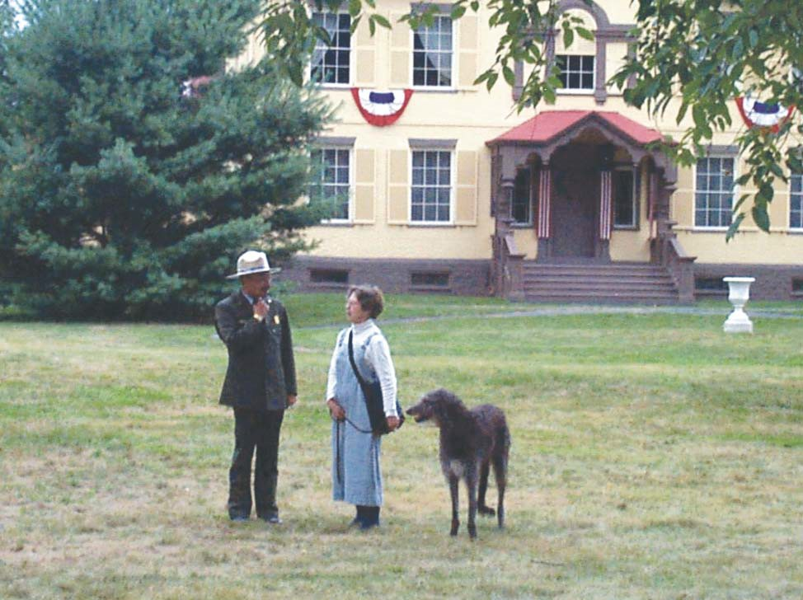

**Figure 5.1.** Michael Henderson and Ruth Piwonka at MAVA 25th anniversary

*Source: Photograph MAVA Collection*

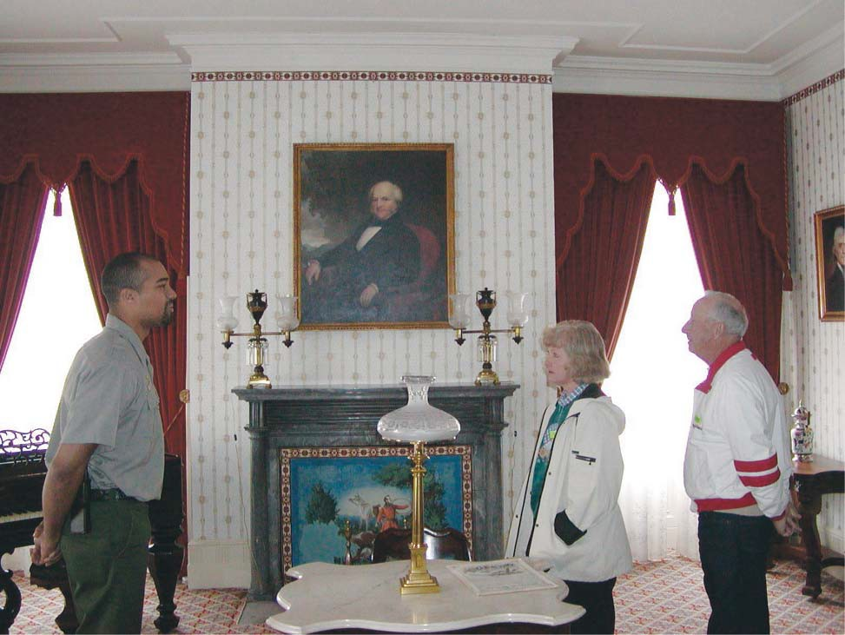

**Figure 5.2.** Interpreter John Eleby discusses the Formal Parlor , 2001

*Source: Photograph MAVA Collection*

**Figure 5.3.** Steven Patricia rendering of Van Buren farmlands

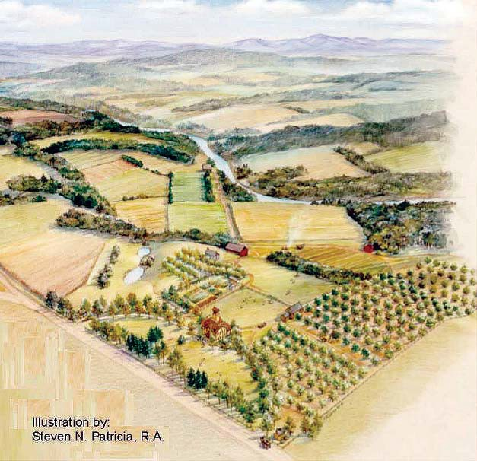

*Source: MAVA Collection*

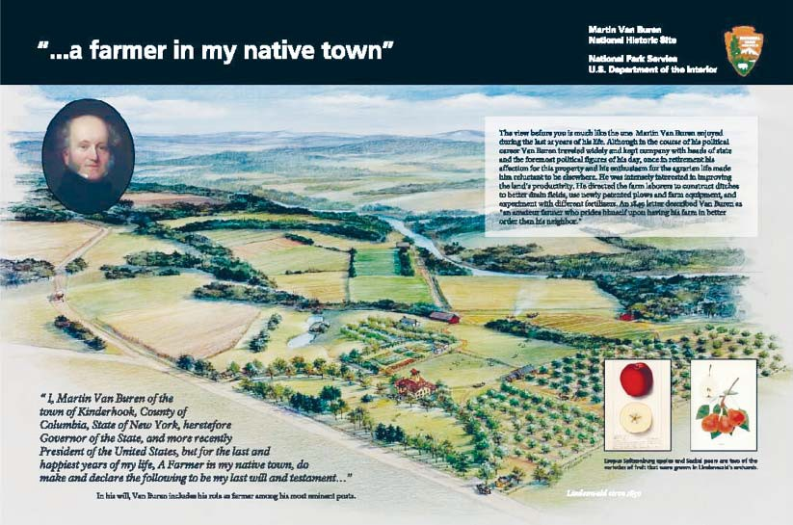

**Figure 5.4.** Wayside Exhibit Panel

*Source: MAVA*

**Figure 5.5.** Interpreter Helen Schneider depicting a Lindenwald domestic *Source: MAVA Collection*

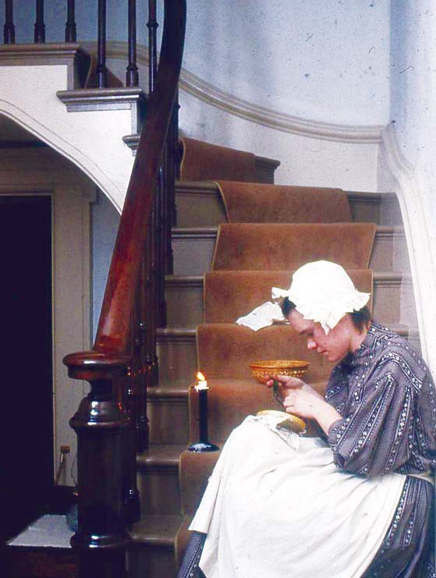

Chapter Six

*Interpreting Martin Van Buren and Lindenwald, 1980-2000*

# Finding Compromises:

**New Facilities and The Protection of Lindenwald, 1992-2006**

#### Introduction

The first attempt to construct a multipurpose building at MAVA ended in failure in 1991. That failure, along with continued funding issues and the deaths of valued staff members, affected the morale at MAVA. Throughout the 1990s, the need for appro- priate visitor services, maintenance, administrative, and curatorial storage facilities re- mained a dominant issue at Martin Van Buren National Historic Site. In 2000, the attempt to establish a permanent multipurpose building failed again, but a temporary solution provided improved, though still temporary and inadequate, facilities for staff and a small visitor contact station. As the park moved into the twenty-first century, concerns about the protection of Lindenwald and its furnishings led to a major effort to put environmen- tal and fire safeguards in place. To complete the work, the mansion closed for two years, and park staff faced the challenge of interpreting Lindenwald and engaging visitors in other ways.

#### Only Temporary: New Facilities at MAVA

After years of planning and negotiating for facilities that would allow for perma- nent curatorial, administrative, and maintenance spaces as well as spaces for exhibits and visi- tor services, the failure of the multipurpose building project in 1991 deeply aﬀected the staﬀ. For more than a decade, they had worked in deteriorating house trailers and a cinderblock garage, and they no longer saw a bright light at the end of the tunnel. Two deaths in quick suc- cession further dampened their spirits. John “Bud” Miller, a very popular chief of interpreta- tion, died in December of 1993, and Bruce Stewart, who had been a dedicated leader, died

in February of 1994. Both men had succumbed to cancer, raising fears that crop dusting on adjacent ﬁelds was a health hazard.1

After Stewart’s death, former MAVA Curator Michael Henderson applied for the superintendency at MAVA and was awarded the job, arriving in November 1994. Curator Phyllis Ewing had been acting superintendent until Henderson arrived. He remained at the park until 1999, when he became superintendent at Morristown National Historical Park in New Jersey. Henderson, returning to Kinderhook from a post in the regional oﬃce, was very

well-liked among the staﬀ. His appointment as MAVA superintendent helped to ease some of the emotions and frustrations resulting from the previous trying years. In addition, he made a

1 Patricia West, interview by Suzanne Julin, June 17, 2008, MAVA;“A Remembrance,” in *The Van Buren Chronicles*, Spring 1994, n.p., MAVA.

concerted eﬀort to establish relationships with park neighbors and to keep them informed of issues that faced the park.2

The frustrations did not end, however. The staﬀ suﬀered yet another blow when Martin Van Buren National Historic Site was placed on a list of 200 historic sites across the country that might be closed if a proposed 10 percent budget for the National Park Ser-

vice was put into place in 1996. Congressman Gerald Solomon’s oﬃce considered the list a “scare tactic,” and the closing never occurred.3 The most pressing problem during the 1990s remained the staﬀ’s occupancy of the substandard trailers and garage and their inability to provide reasonable services to visitors because of the lack of appropriate facilities.

#### The Second Multipurpose Building Controversy

After the disappointment in 1991 when funding for park facilities was disap- proved, MAVA persisted in pursuing the concept of a multipurpose building. The project was placed in the 1994 construction budget, but was later removed. However, NARO requested that Harpers Ferry Center continue to plan for the eventual development of the building despite the lack of funding, and Harpers Ferry personnel met with the MAVA superintendent and staﬀ to begin discussing exhibits and designs. Planners recommended a lobby design that would provide a simple but signiﬁcant introduction to Martin Van Buren and a brief video

to be shown in the visitor center’s theater. The plans, however, were tempered by reality. The Harpers Ferry staﬀ recognized the “frustration and disappointment” MAVA expressed over the delay of a facility and worked to develop proposals, such as a children’s “trunk” to be circulated in area schools, that could meet immediate needs.4

In the meantime, MAVA staﬀ continued to work in the rented house trailers placed to the rear of the mansion, with maintenance functions located in the cinderblock garage and collections stored in the pole barn. Early in 1995, a National Park Service struc- tural ﬁre specialist visited the site and outlined several important safety issues. The trailers had no ﬁre detection or alarm systems. Because they were designed to serve as housing, their conversion to oﬃce space created barriers that further complicated safe egress in case of ﬁre. The introduction of electrical oﬃce equipment and the use of portable space heat- ers created a heavy load on the electrical system, and the amount of oﬃce materials, col- lections, and paper storage increased the ﬁre hazard. The interior ﬁnish of the trailers and its ﬁberboard ceiling furthered the risk of a fast-moving ﬁre. The inspector concluded that the use of the house trailers for oﬃce and storage purposes created a “serious life safety and conservation problem.” He estimated that the time from the ignition of a ﬁre to its full involvement, if early eﬀorts to subdue it were unsuccessful, was two to three minutes, and staﬀ members might not be able to outrun it. Although there were steps that could reduce

2 Michael Henderson, interview by Suzanne Julin, April 5, 2010, MAVA; Patricia West, interview by Suzanne Julin, June 17, 2008; Michael D. Henderson to Mr. and Mrs. Joseph Cutro, February 10, 1995, Folder February 1995, Box Unprocessed Material Reading Files, 3 of 12, MAVA Library.

3 *Hudson Register-Star,* August 6, 1995, Folder K3416 MAVA Newspaper Articles #6, MAVA Central Files.

4 Manager to Regional Director, Att: Chief of Interpretation, received July 21, 1993, Folder D6215 Mu- seum Exhibits and Activities [III], MAVA Central Files.

the level of hazard, he noted, until the trailers were eliminated, the site faced a high risk of ﬁre danger.5

Subsequently, park employees ﬁled a notice of hazards at the worksite with the Occupational Safety and Health Administration (OSHA), citing ﬁre dangers due to overloaded electrical outlets and single exits from the trailers. This was a strategy to work through the ap- propriate channels to insure work safety and encourage development of appropriate work- spaces. OSHA acknowledged that the complaint had been ﬁled and requested an immediate investigation on the part of the park as well as plans for corrective action.6

Superintendent Henderson responded promptly. He noted that the construc- tion of the multipurpose building and a new maintenance shop would solve the safety issues. “With the current budget forecasts for the next seven years,” he added, “I hope that this small project will be able to compete for the scarce Federal dollars.” In the meantime, the park worked to address safety concerns. A safety oﬃcer and safety committee were in place, ﬁre egress maps were prominently posted, and ﬁre extinguishers provided. Circuit breakers

protected major appliances and computer equipment was plugged into surge protectors. Each trailer had two door exits, one of them had additional window exits, and ﬁre detectors were in place in both trailers.7

In his report, Henderson added that he had contacted the National Park Founda- tion to investigate the possibility of their purchase of new temporary modular structures that the park might lease as an “interim solution” until the permanent buildings were funded and constructed.8 The employees’ notiﬁcation to OSHA had resulted in a review of the workplace that pointed out its inadequacies and dangers, and Henderson’s response indicated that the park was doing all that it could, given the circumstances, to insure employee safety; only re- placement of the trailers could solve the ongoing problems.

Despite those eﬀorts to reduce the ﬁre hazards, a supervisory park ranger who vis- ited to evaluate the site two years later reported that the risks essentially remained unchanged. He suggested a few minor corrections, including the revival of a park safety committee that could identify risk behavior and develop ways to avoid accidents.9 The eﬀorts on the part of the park administration and staﬀ to call attention to its plight and to ﬁnd reasonable solutions continued to circle back to them. The people most vulnerable because of the dangers were called upon to address those issues without the necessary resources to aﬀect the most crucial needed changes needed—stable, safe workplaces.

The ﬁght for appropriate park facilities continued while the staﬀ struggled with substandard working conditions. In 1995, Superintendent Henderson brought the General Services Administration (GSA) regional space representative to the park to explore the pos-

5 Joe Mazzeo to Superintendent, Martin Van Buren National Historic Site, March 3, 1995, Folder A7615 Leased Modular Buildings, MAVA Central Files.

6 John M. Tomich to Martin Van Buren, National Park Service, December 7, 1995, Folder A7615 Leased Modular Buildings, MAVA Central Files.

7 Michael D. Henderson to John M. Tomich, December 11, 1995, Folder December 1995, Box Unpro- cessed Material Reading Files, Box 4 of 12, MAVA Library.

8 Michael D. Henderson to John M. Tomich, December 11, 1995.

9 Supervisory Park Ranger to Loss Control Manager, June 6, 1997, Folder A7615 Leased Modular Build- ings, MAVA Central Files.

sibility of renting local space for park operations. Two years later, after unsuccessful eﬀorts to ﬁnd suitable space in the immediate area, he saw two options if a permanent building could not be constructed: establish a headquarters sixteen miles away in Hudson, New York, the closest place GSA could rent space that met government standards, or lease new house trailers and install them at the park. The new trailers would increase rental costs from $14,000 a year to approximately $60,000 a year, but would provide safe, sanitary work space for staﬀ and reasonable restroom facilities for visitors.10

Henderson saw the plan as a short-term alternative, but he also continued to pursue the longer term goal of permanent construction at the park. He asked architect Kate Johns, whom he knew through a colleague, to design a simple, small, and inexpensive building that would reﬂect but not mimic historic architecture in the area and that could be built by the park’s maintenance staﬀ. She retroﬁtted a Habitat for Humanity plan to a Greek Revival house design that she believed would blend with local architecture, contain the elements necessary for park and visitor operations on the ﬁrst ﬂoor, and hold a locker and shower area and me- chanicals in a basement. Upon review, however, both the National Park Service and the New York State Historic Preservation Oﬃce recommended removing the Greek Revival elements and creating a simple clapboard building with an asphalt or tin roof to harmonize with typical nineteenth-century vernacular architecture in the area. A BOSO engineer advised that ground- water levels precluded the construction of a basement for the building. A larger issue emerged in terms of contracting policy. The architect was told to stop work when it was determined Henderson inadvertently had sought Johns’s services without going through proper admin- istrative channels for contracting. In the meantime, park maintenance staﬀ rehabilitated the interior of the South Gatehouse, and it was used as a visitor contact station beginning in 1995.11

At about the same time, an alternative included in the most recent *DCP* was revived. That alternative called for acquisition of Van Buren lands outside the park as a vi- able solution to the dilemma presented by the need for park facilities. The adjacent Meyer farm property included more than 100 acres of land that had been part of the Van Buren estate, a large barn with two additions, three greenhouses, an auto repair shop, a garage, a house, and two silos. Dudley Ray Meyer Jr. had suggested various prices for the land, ranging from $750,000 to $1.2 million; three appraisals put the value of the property at $300,000 to

$450,000. The owner’s lowest asking price and the approximately $200,000 needed to bring the buildings up to federal standards indicated a total cost of at least $950,000. There was little likelihood the park could acquire the land through donation.12 The alternative presented op- portunities for solutions to the facilities problem, but also would require additional studies, planning, an expansion of the park’s boundary, and a substantial ﬁnancial commitment.

10 Bruce Blackistone to Michael Henderson, e-mail message, November 27, 1995; Michael Douglas Hen- derson to Deputy Regional Director, October 28, 1997, both in Folder A7625 Leased Modular Build- ings, MAVA Central Files; Superintendent to Deputy Regional Director, October 28, 1997, Folder A7615 Leased Modular Buildings, MAVA Central Files.

11 James A. McKay to Mr. and Mrs. Joseph Cutro, February 23, 1998, Folder L7617 MAVA DCA/EAS (Accordion File) Clark Files, BOSO; Chief Ranger to Park Historian, March 17, 2010, MAVA; Trip Report, March 19, 1999, Folder L7617 MAVA DCA/EAS (Accordion File), Clark Files, BOSO; Michael Henderson, interview by Suzanne Julin, April 5, 2010.

12 Trip Report, March 29, 1999, Folder L617MAVA DCA/EAS (Accordion File), Clark Files, BOSO.

Henderson, however, continued to consider the alternative. He feared that if Meyer sold the farm or passed it on to his heirs, the new owners would use the land for non- agricultural purposes. He was ﬁrmly committed to the idea that visitors to the site should be able to see the same general landscape that Martin Van Buren saw and to experience land being used for farming as it was in the former president’s residence on the property. He dis- cussed with the Columbia Land Conservancy the protection of a much larger piece of land that would encompass not only the Meyer farm but also other holdings in the Town of Kin- derhook, creating trails that would bring attention to the historic and natural resources of the surrounding area as well as the national historic site. The NPS was not particularly supportive of the idea, but the Columbia Land Conservancy did some basic development work on the project.13 In the meantime, the Open Space Institute, an organization dedicated to the protec- tion and conservation of natural and historic landscapes, expressed an interest in acquiring the Meyer farmland with the intention of eventually turning the property over to the NPS. Henderson helped to negotiate terms between the two parties that could expedite such a sale and transfer.14

By 1999, Henderson had accepted the superintendency at Morristown National Historical Park in New Jersey, and Vivien Rose was assigned to be MAVA’s acting superinten- dent pending a permanent replacement for Henderson. Rose came to the park from Women’s Rights National Historical Park in Seneca Falls, New York, where she served as a cultural resources manager. Upon arriving at MAVA, she was confronted with the substandard work- ing conditions and visitor service facilities that she considered a more pressing issue than the expansion of the park’s holdings. She expressed her belief that the ongoing planning was addressing a problem that already had a solution: appropriate funding by Congress and the National Park Service for the infrastructure of the park. Rose believed that the purchase of the farmlands, while desirable for conservation of resources, interpretation, and protection from development, was not necessary for the establishment of operational and visitor ser- vice facilities. In fact, such an acquisition would require additional planning and compliance procedures and would keep staﬀ in the sub-standard trailers for at least another year. All that was necessary, Rose said, was to fund and implement what had already been planned.15 The long history of struggles to obtain funding and put such implementation into place, however, proved that the issue was more complicated.

In 1997, Michael Henderson had suggested the installation of new, modern units for administrative space and storage. With no funding for further progress on a multipurpose building, the park turned to this as the most viable temporary solution possible with short- term funds allotted mainly because of the safety concerns for staﬀ and visitors, and Hender- son had worked with the regional oﬃce to facilitate the rental of the new trailers. The decision to place them in the North Field was based on signiﬁcant factors: the North Field was not

part of Van Buren’s original properties, and the location was supported by the State Historic Preservation Oﬃce. Archaeological compliance work had been completed there, and a septic

13 Michael Henderson, interview by Suzanne Julin, April 5, 2010.

14 Patricia West, interview by Suzanne Julin, June 17, 2008, MAVA.

15 Vivien Rose to “Colleagues,” e-mail message, April 2, 1999, Folder L7617 MAVA DCA/EAS (Accor- dion File), Clark Files, BOSO.

system had been put in place in anticipation of the foiled 1991 construction. Establishment of the new entrance road was a part of the proposed project and would address long-standing safety concerns. The park obtained funding in 1999 to put the temporary solution in place while planning toward a permanent facility continued. The park also received funding for the construction of a temporary visitor contact station of approximately 1,200 square feet, consid- erably smaller than the 6,000- square-foot building proposed in the early 1990s.16

By the fall of 1999, Steve Beatty had assumed the superintendent position at MAVA. He had worked at several parks, including the Blue Ridge Parkway and Cumberland Gap National Historical Park, and served as superintendent at Springﬁeld Armory National Historic Site in Massachusetts.17 His arrival at MAVA put him in place to preside over one of its most controversial episodes: the establishment of the temporary trailers in the North Field. Park maintenance staﬀ prepared the old trailers for removal in December 1999 and in 2000 installed the new double-wide house trailers, which were ready for use by April. The main- tenance staﬀ built the small temporary visitor contact station next to the trailers, and it was functional by the Fourth of July of 2000. The installation of the new units created far better workplaces than park staﬀ had used during the previous two decades. A conference room and library were ready by the end of the ﬁscal year, oﬃces were handicapped accessible, and for the ﬁrst time, the entire staﬀ could be accommodated in the lunchroom space.18

Those new facilities improved staﬀ morale but created uproar in the surrounding community. Residents complained about the physical appearance of the trailers, their location in the North Field, and the fact that they were installed with little notice to the park neighbors. One couple who had lived adjacent to the park for twenty-ﬁve years wrote a letter to the local newspaper, saying “we watched with shock and horror as it appeared a trailer court was being established in the meadow to the immediate north of Lindenwald.” The couple noted that they had reviewed National Park Service plans for visitors and administrative facilities and “had anticipated an appropriate structure” instead of a “horrendous intrusion.”19 The argu- ment extended to local government. Because the trailers were in a Kinderhook Town Historic Zone but did not meet building codes, they violated zoning and subsequently were used as a bad example in a call to change or eliminate the Town Comprehensive Plan.20

Superintendent Beatty acknowledged that the new units created “some embaras- ment” [sic] for the National Park Service and deterioration in local support for the site. “They are another generation of Temporary solutions for which the NPS is now locally infamous,”

16 Patricia West, Draft, “Section 106 Case Report, Martin Van Buren National Historic Site, April 1999,” Folder L7616, MAVA DCA/EAS (Accordion File), Clark Files, BOSO; Park Comments, Martin Van Bu- ren NHS Administrative History First Draft, March 19, 2010; Michael Henderson, interview by Suzanne Julin, April 5, 2010; James A. McKay to Mr. and Mrs. Joseph Cutro, February 23, 1998, Folder L7617 MAVA DCA/EAS (Accordion File), Clark Files, BOSO; Chief Ranger to Park Historian, March 17, 2010, MAVA Central Files.

17 *The Van Buren Chronicles*, Fall/Winter 1999, n.p., MAVA.

18 Martin Van Buren NHS Northeast Region Annual Report 2000, [MAVA] 640/D23, scanned September 25, 2001, provided by Patricia West, MAVA; Michael Henderson, interview by Suzanne Julin, April 5, 2010.

19 Caryn Anne L. Moore and Ronny L. Moore to Editor, “Appalled by Park Service,” unidentiﬁed news- paper clipping, n.d. [April, 2000], clipping in Folder K3415 Press Releases [II], MAVA Central Files.

20 Martin Van Buren NHS Northeast Region Annual Report 2000, [MAVA] 460/D23, scanned Septem- ber 25, 2001, provided by Patricia West, MAVA.

he said. Beatty also admitted that park neighbors and other local residents had not been fully informed about the installation of the units, causing a considerable amount of conster- nation among them. Four of the property owners on the north side of the site had “written letters with copies to everyone they can think of, including oﬃcials at all levels.”21 By this time, the Open Space Institute had purchased the Meyer farmlands, and Beatty made an attempt to resolve the situation by asking permission to move the units there. OSI dismissed the idea. They had leased most of the land to the Roxbury Farm, an organic agricultural operation and Community Supported Agriculture (CSA) unit. The lease did not address the incorporation of park structures, and the farm was unlikely to be willing to give up any of the leased acreage.22

The trailers remained in the North Field, to the discontent of the park’s neigh- bors. Members of the public also objected to a reduction in the normal amount of landscape maintenance resulting from staﬀ’s work on the installation of the new facilities. The establish- ment of an evergreen screen in November 2000 somewhat eased the negative reaction to the trailers,23 but a planting of hemlock trees that was designed to soften the view of the units began to die in drought conditions. The park was slow to remove them, and the two rows

of dead trees remained in front of the buildings for about two years, creating more dismay among neighbors and visitors.24 Part of the problem arose from oﬃcial policy: the New York SHPO stipulated that the trailers had to display an obviously temporary image; decorative details like shutters or extensive plantings were inappropriate. What the public saw, however, were unadorned house trailer units on minimally landscaped ground serving oﬃcial functions at a historic site. The staﬀ enjoyed working in the clean, safe space, but regretted the negative image the facilities presented to the public.25

#### Parking Lot , Entrance Road, and Museum Storage

Although the temporary solution to the failed multipurpose building project was the most important development at the park during the period, the issues of the entrance road, parking lot, and museum storage space also created controversy. Prior to 1994, the employees parked in a lot south of the mansion, reached by a road across the Meyer property, and visitors parked along the Old Post Road. Plans for the park called for the development of a larger parking lot north of the mansion that could accommodate visitors, buses, and em- ployees’ private vehicles. The employee lot became an issue in late 1994 when the adjacent landowner denied further utilization of the road across his property leading to the lot. The refusal came on the heels of a controversy that emerged when the park opposed his plans to develop a business on his property. To provide access to the lot, the park built a temporary

21 Steven Beatty to Bob McIntosh, e-mail message, May 18, 2000, copy in ICON/*DCP* Letters, MAVA Central Files.

22 Joseph J. Martens to Steven M. Beatty, May 9, 2000, Folder ICON/*DCP* Letters, MAVA Central Files.

23 Martin Van Buren NHS Northeast Region Annual Report 2000, [MAVA] 460/D23, scanned Septem- ber 25, 2001, provided by Patricia West, MAVA.

24 Martin Van Buren NHS Northeast Region Annual Report 2001, [MAVA] 460/D24, scanned Septem- ber 25, 2001, provided by Patricia West, MAVA; Chief Ranger to Park Historian, March 17, 2010, MAVA.

25 Patricia West, interview by Suzanne Julin, June 17, 2008.

gravel path on a plastic liner over the historic property. Superintendent Henderson requested assistance from NARO in funding the design of the permanent visitor and employee parking lot included in the 1990 *DCP*. Appropriate archaeological studies had been completed, and the plan for the lot had been approved by the New York State Historic Preservation Oﬃce.26 However, the park faced another problem when local companies were reluctant to bid on the construction, and the project to build a new parking lot was cancelled after appropriated funds expired.27

The park also began planning to construct a new entrance road oﬀ Route 9-H at the northern end of the property on the parcel of land between Old Post Road and 9-H. By relocating the entrance road, the park could close the south end of Old Post Road where it intersected with the highway, increasing safety for pedestrians and allowing the park to restore the historic road to the size it had been during Van Buren’s residency. The park received fund- ing from the Federal Lands Highway Program to construct the road, and the project was car- ried out under a cooperative agreement with the Town of Kinderhook that obligated the park to deal with the unsafe intersection at Route 9-H and the Old Post Road.28

Controversy about the design of the entrance road arose almost immediately, however. One of the park neighbors consulted an engineer who informed him the location of the road would destroy some of a berm that provided him sound protection, would aﬀect the trail to the nature area on the other side of Highway 9H, and would create “some headlight glare” from traﬃc entering the access road.29 By March 1999, the redesign and siting of the road was still being argued, and the estimated cost had reached more than $70,000.30 The new entrance road was ﬁnally completed and opened in mid-May 2001, and the former Old Post Road entrance was closed.31

In the spring of 2002, a two-person team from the Northeast Museum Services Center visited MAVA to evaluate collection storage and to develop temporary solutions to the storage problems. The team observed the “truly appalling condition” of the pole barn that housed museum collections and made a number of recommendations for improving col- lection storage32. Superintendent Beatty took exception to those recommendations as being “simply unrealistic,” especially suggestions for moving the collections into the trailers that

26 Michael D. Henderson to Chief, Development Division, NARO, February 14, 1995, Folder H30 Emer- gency Technical Asst. on MAVA Parking Lot, MAVA Central Files.

27 Michael D. Henderson to Joseph Cutro, November 6, 1995, Folder H30 MAVA Parking Lot, MAVA Central Files; Phyllis Ewing to Patricia West, April 8, 2010; Michael Henderson, interview by Suzanne Julin, April 5, 2010, MAVA.

28 James A. McKay to Mr. and Mrs. Joseph Cutro, February 23, 1998, and Trip Report March 29, 1999, both in Folder L617 MAVADCA/EAS (Accordion File), Clark Files, BOSO.

29 Edward H. Arnold to Joseph Cutro, February 13, 1990, Folder L7617 MAVADCA/EAS (Accordion File), Clark Files, BOSO.

30 Lee J. Konkle to Town of Kinderhook Town Board, March 3, 1999, Folder L7616 MAVA DCA/EAS (Accordion File), Clark Files, BOSO.

31 Martin Van Buren NHS Northeast Region Annual Report 2001, [MAVA] 460/D24, scanned Septem- ber 25, 2001, provided by Patricia West, MAVA.

32 Director, Northeast Museum Services Center to Park Manager, Martin Van Buren National Historic Site, July 29, 2002, Folder Trip Report, Collection Storage Conditions, MAVA Central Files.

were providing staﬀ oﬃce and conference space.33 In 2004, the park upgraded the exterior of the deteriorating pole barn, but the facility remained substandard for museum storage.34

#### Cultural Landscape Report

In the meantime, the park also began planning the implementation of a recently approved Cultural Landscape Treatment Plan. In 1993, the park initiated a cultural landscape report (CLR) to be developed by the State University of New York (SUNY) College of Envi- ronmental Science and History at Syracuse. The CLR was designed to provide a complete his- tory of the site’s landscape, document existing conditions and evaluate their historic integrity, and develop a treatment plan recommending measures designed to preserve the historic land- scape and management policies that would ensure its preservation.35 The report, prepared by David Uschold under the direction of Project Manager George Curry of SUNY, was issued in draft form in the spring of 1994 and as a ﬁnal report in June 1995.36 The report concluded that “the overall form of the property remains intact, and retains its integrity as both the country seat and the working and experimental farm.”37 The CLR and the subsequent treatment plan provided the basis for ongoing landscape planning, restoration, and maintenance, and the records of the development of the report reveal a growing recognition of the signiﬁcance of the surrounding farmlands.

#### The Van Buren Table: Lost Again

As the park struggled to provide adequate space for collections, the most impor- tant and elusive of Martin Van Buren’s furnishings again drew the staﬀ’s attention. In 1992, Curator Michael Henderson had contacted the owners of the table to seek permission to reproduce the piece for exhibition in Lindenwald’s main hall. When the table was sold at Sotheby’s in New York the next year, he arranged for John Kovacik, a cabinetmaker special- izing in reproductions, to make measured drawings of the table. Robert M. Rubin bought the table at that auction and promptly lent it to MAVA, where it graced Lindenwald’s main hall for about nine months. After the table was returned, Phyllis Ewing, who had been cura- tor at MAVA from 1993 until 1997 and acting superintendent following the death of Bruce Stewart, put the project of reproducing the table out to bid. Kovacik was awarded the contract. He sought out mahogany that was comparable to the wood used for the original table and subcontracted with a brass reproduction company to duplicate the original cast- ers. The painstaking process of reproducing the table took many months, but resulted in an accurate replica of this signiﬁcant piece of furniture. The reproduction was placed in the

33 Park Manager to Director, Northeast Museum Services Center, July 15, 2002, Folder Trip Report Col- lection Storage Condition, MAVA Central Files.

34 Martin Van Buren National Historic Site FY 04 “State of the Park” Narrative 11/22/04, provided by Patricia West, MAVA; Park Comments, Martin Van Buren NHS Administrative History First Draft, March 19, 2010.

35 Hudson (NY) Register-Star, June 4, 1993.

36 *The Van Buren Chronicles*, Summer, 1994, n.p.; David L. Uschold and George W. Curry, C*ultural Land- scape Report for Martin Van Buren National Historic Site: Site History, Existing Conditions, and Analysis* (Boston: National Park Service, June 1995).

37 Uschold and Curry, *Cultural Landscape Report for Martin Van Buren National Historic Site*, 187.

main hall, where Van Buren had used the original table to entertain family, , friends, and political colleagues.38

In the fall of 2002, MAVA curator Patricia West received a call from Sotheby’s inquiring about the history of the Van Buren dining table. She soon learned that the original table was again scheduled to be auctioned. West attempted to make arrangements with the table’s owner to purchase the piece or to trade it for the reproduction table in Lindenwald, but his personal situation dictated that the table had to be sold at auction in order to receive the highest possible price. West then turned to an attempt to obtain funds earmarked to acquire seriously endangered resources. Arguing that the table was a “character-deﬁning feature” of Lindenwald, she worked closely with Laurel Racine of the Northeast Museum Services Cen- ter and other park service professionals in conﬁrming Van Buren’s ownership of the table and securing the special funds. To facilitate the purchase, Eastern National, an NPS partner orga- nization, agreed to bid on the table, creating a base price that could then be used for purchase of the table by the National Park Service.39

MAVA staﬀ members joined Barbara Bell, the Eastern National employee who was to do the actual bidding; Van Buren descendents Nick Hammersley and Mary Leigh Whitmer; and John Kovacik, the craftsman of the reproduction table, at the auction. They watched with trepidation as people handled this valuable historic artifact, leaned on it, and placed pock- etbooks and briefcases on its surface. Once the bidding started, Eastern National was pitted against another bidder and within a few minutes, the organization’s bid limit was reached. The opposing bidder won the table with a bid of more than $300,000.40

Patricia West had written a letter to be used in the event Eastern National was unsuccessful in acquiring the table. The letter contained information about the historic sig- niﬁcance of the table, invited the new owner to visit Lindenwald, and expressed the park’s deep interest in knowing the location of the table. Sotheby’s could not reveal the name of the purchaser, but delivered the letter on the park’s behalf. The park received no reply, and the location of the original Van Buren table remains unknown.41

#### 2004 Closing and HVAC and FD/FS Installation

In 2004, a major project referred to as HVAC (heating, ventilation, and air condi- tioning) and FD/FS (ﬁre detection and ﬁre suppression) closed down Lindenwald and occu- pied many hours of staﬀ time in order to upgrade climate control and ﬁre safety systems in the mansion.42 The project was prompted by long-standing issues. The mansion was heated by an oil-ﬁred furnace augmented by electric space heaters; aging wiring systems provided elec- tricity. The existing ﬁre detection system was considered inadequate to protect the mansion and the valuable objects and furnishings within it, some of them on loan from other institu- tions. The local volunteer ﬁre department was located a few miles from the site, but a lim-

38 *The Van Buren Chronicles*, Summer, 1993, n. p.; Winter/Spring 1998, n.p., MAVA.

39 Patricia West, “MVB’s Dining Table . . . Going, Going, Gone,” *The Van Buren Chronicles*, Spring, 2006, 2.

40 West, “MVB’s Dining Table . . . Going, Going, Gone,” 2.

41 West, “MVB’s Dining Table . . . Going, Going, Gone,” 3.

42 Martin Van Buren National Historic Site FY 04 “State of the Park” Narrative 11.22.04, provided by Patricia West, MAVA.

ited amount of water for ﬁre suppression was available in an underground storage tank. The basement was damp; the upper stories often suﬀered the eﬀects of roof leaks.43 Despite the obvious need for the upgrading of systems that could protect the mansion, MAVA curatorial staﬀ dreaded the complex process; they had heard rumors of destruction of artifacts during construction projects at other historic houses.

Dan Dattilio was appointed superintendent at MAVA in 2003, following the retire- ment of Steven Beatty late in 2002 and a stint by Scott Rector of ROVA as acting superinten- dent. Dattilio, who began his career in the park service in 1976, came to MAVA from Minute Man National Historical Park in Massachusetts, where he had served as assistant superin- tendent. He saw the need for the HVAC project and strongly urged that it begin as soon as possible. The house was closed late in 2003 with plans for it to be reopened after one year with the project completed. Preparations for the work began in January 2004.44

Park staﬀ was largely responsible for the process of preparing the collection for storage. The curatorial staﬀ packed the museum collection, including 702 objects and 157 large pieces, which were wrapped and stored. Patricia West engaged two interns from the University at Albany public history program to help with packing, and volunteers from the Friends of Lindenwald also assisted. Staﬀ inventoried and recorded furnishings and objects as the packing continued. West encouraged them to play music as they packed and arranged special Friday afternoon lunches, and the congenial atmosphere helped to make up for the

emotional and professional pressure involved in taking the furnishings in the mansion’s rooms apart. After a room’s furnishings and objects were packed, maintenance staﬀ moved the furniture and boxes to a part of the room that would not be impacted by the construction and built partitions around them. Fine art specialists came in to pack the house’s paintings, and the National Park Service Architectural Preservation Division assisted the maintenance staﬀ in covering walls, ﬂoors, and other features to protect them from damage. The group ﬁnished the packing in six and one-half weeks rather than the eight weeks scheduled for the job.45

The HVAC work did not start immediately after the packing was completed, however, and the originally planned one-year closure of Lindenwald stretched to more than two years. The process created concern about the eﬀects of humidity and temperature varia- tions on the furniture and packed objects and the danger of destruction to the original ele- ments of the house. MAVA staﬀ also needed to serve visitors during the period of closure. To address that need, staﬀ developed a continuous video loop presentation that ran in the visitor center and gave tours of the exterior of the house. On weekends, the contractors put away tools, cords, and materials so that visitors could be taken into the house on limited “hard-hat” tours. Programs about agriculture on Van Buren’s estate, including the reproduction of some of his hops ,and the installation of the wayside exhibits helped to engage visitors who could not enter the house. Harvest Day, instituted in 2003 as a one-day fall presentation to recognize

43 Project Agreement, Lindenwald Fire Protection and Mechanical Upgrade, January 30, 2004, 1, Binder Lindenwald Home Rehab Projects 2004, MAVA Superintendent Oﬃce Files; *The Van Buren Chronicles*, Winter 2004, 1, 2, 5, MAVA.

44 Judy Harris, interview by Suzanne Julin, June 18, 2008, MAVA; *The Van Buren Chronicles*, Spring, 2004, 1.

45 Judy Harris, interview by Suzanne Julin, June 18, 2008, and Dan Dattilio, interview by Suzanne Julin, April 13, 2008, MAVA; *The Van Buren Chronicles*, Spring 2004, 1-2, MAVA; Martin Van Buren National Historic Site FY 04 “State of the Park” Narrative 11.22.04, provided by Patricia West, MAVA.

the signiﬁcance of agriculture at Lindenwald, presented demonstrations and activities on the grounds in 2004 and 2005 and evolved into an annual event. Staﬀ also prepared and presented oﬀ-site activities to local schoolchildren who could not access Lindenwald through ﬁeld trips. Although the staﬀ had received training in dealing with irate visitors who might be disap- pointed in ﬁnding the mansion closed, no such situations arose. Instead, many of the people allowed to tour the house during construction expressed interest in the steps being taken to protect it.46

After the HVAC construction work was ﬁnally complete, the task of returning the rooms of Lindenwald to their former appearance began. The wallpaper had to be carefully vacuumed, and maintenance staﬀ moved furniture from side to side in each room to allow for that process. Objects were unpacked, checked against the inventory, and returned to their usual setting. Everything in the house emerged from the process intact, although some of the iron objects in the basement rooms developed slight rust due to humidity.47

Lindenwald reopened in May 2006 with a new white cedar roof and special sys- tems to solve the problems of moisture seepage that had plagued previous roof treatments, a new drainage system to keep moisture away from the foundation, new heating, ventilating,

and dehumidiﬁcation systems, and a new ﬁre detection and suppression system. The suppres- sion system uses dense fog instead of water, thus minimizing damage to the interior of the house and its furnishings. On May 20, Martin Van Buren National Historic Site celebrated the reopening with a rededication attended by local and national oﬃcials and more than 250 guests. Regular public tours of the house resumed.48

#### Computer Systems at MAVA

During the 1990s, computer technology helped to transform the day-to-day func- tions and the internal management of the National Park Service. Work was completed on the computer rather than on paper forms, the NPS network gave everyone nearly instant access to park-wide information, multiple large databases needed to be attended to, and contracting and planning, particularly, required long hours on the computers. Thus, managers spent much less time maintaining close connections to the park’s resources by walking the site and talking to staﬀ, and more time in front of their computer screens. MAVA began installing and imple- menting a computer system in the late 1980s. Dial-up Internet was installed in the mid-1990s, and a local company placed the ﬁrst server in the original house trailers in 1996. The comput- er system was upgraded at the end of the 2000 ﬁscal year to meet Park Service standards.49 Its escalating importance would have a substantial impact on the work culture at MAVA.

46 Judy Harris, interview by Suzanne Julin, June 18, 2008, and Dan Dattilio, interview by Suzanne Julin, April 13, 2008, MAVA; *The Van Buren Chronicles*, Spring 2004, n. p. , Summer 2005, n. p., and Fall, 2005,

n. p., MAVA.

47 Judy Harris, interview by Suzanne Julin, June 18, 2008.

48 Richard Roth, “Back Home with OK,” K3416 Newspaper Articles, MAVA Central Files; *The Van Bu- ren Chronicles,* Fall 2006, 1.

49 Patricia West, interview by Suzanne Julin, June 17, 2008; Martin Van Buren NHS Northeast Region Annual Report 2000, [MAVA] 460/D23, scanned September 25, 2001, provided by Patricia West, MAVA; Chief Ranger to Park Historian, March 17, 2010, MAVA Central Files.

#### Conclusion

The period from 1992 to 2006 at MAVA saw vast improvements in working condi- tions and the safety of Lindenwald, but those improvements came at a price. The installation of new rented trailers, the construction of the small, modest visitor contact station, and the re- inforcement rather than the replacement of the pole barn were compromises that ameliorated some immediate problems but also indicated that the construction of appropriate, permanent facilities remained a long-term goal rather than a more immediate objective. The unexpectedly long two-year closing of the mansion for the HVAC/FR/FS installation placed new demands on the staﬀ and called for the design of programs that could provide visitors with fulﬁlling experiences at MAVA even though they could not enter most areas of its mansion, reinforcing interest in the Lindenwald cultural landscape and farm. The Van Buren table reproduction represented another compromise; with permanent acquisition of the original table apparently impossible, the reproduction allowed a realistic representation of Lindenwald’s main hall, where Van Buren entertained guests and strengthened bonds with political colleagues. These compromises took their toll on staﬀ morale but also advanced important goals at the site.

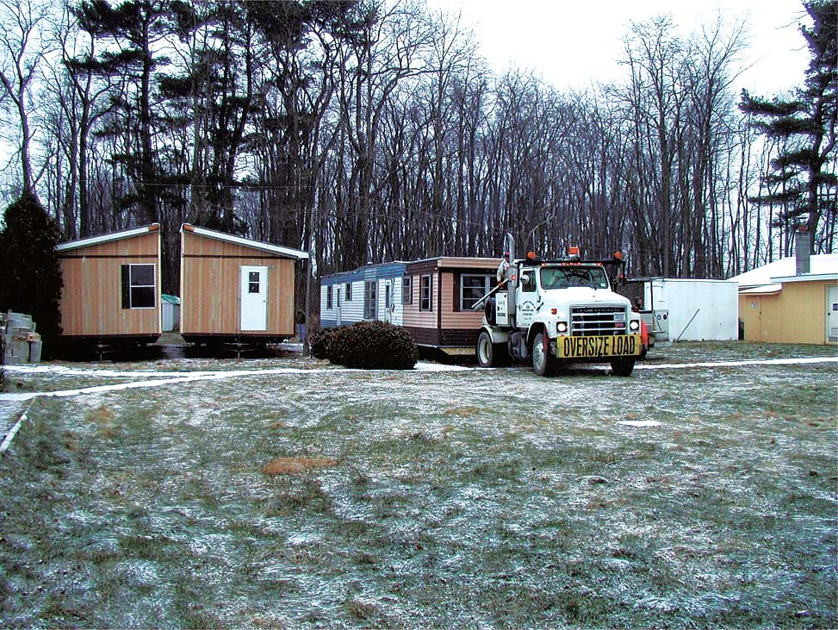

**Figure 6.1.** Removing old trailers behind maintenance garage, 2001

*Source: Photograph MAVA Collection*

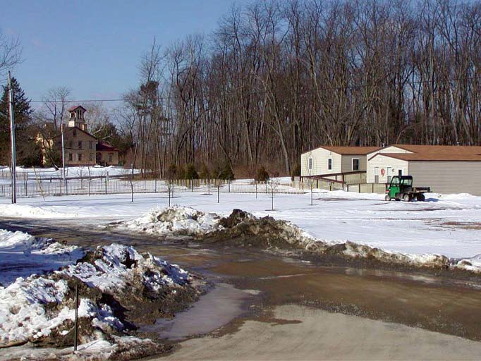

**Figure 6.2.** New trailer facilities at MAVA *Source: Photograph MAVA Collection*

**Figure 6.3.** 2001 sign on Route 9H protesting “Lindenwald Trailer Park”

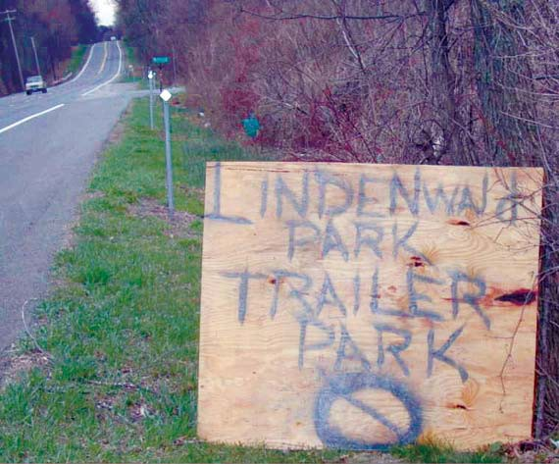

*Source: Photograph MAVA Collection*

**Figure 6.4.** Makeshift Visitor Center attached to trailers

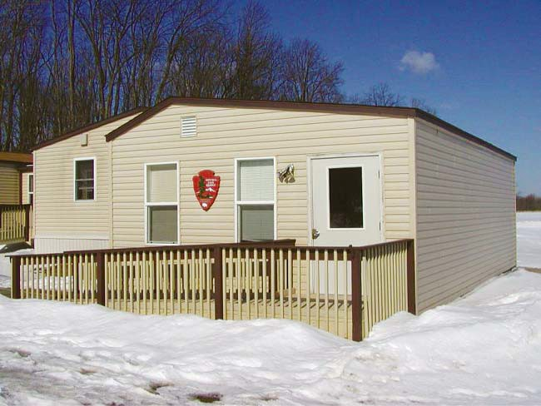

*Source: Photograph MAVA Collection*

**Figure 6.5.** Superintendent Dan Dattilio and guests at the 2006 reopening of Lindenwald

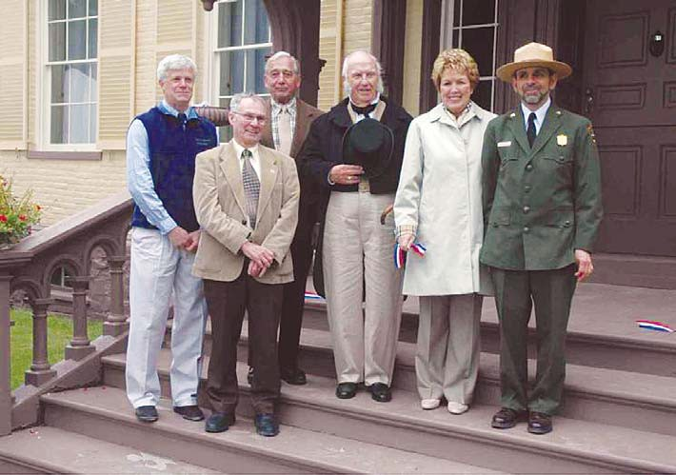

*Source: Photograph MAVA Collection*

Chapter Seven

*Finding Compromises: New Facilities and The Protection of Lindenwald, 1992-2006*

# New Possibilities: Planning, Interpretation and Boundary Expansion 2000-2006

#### Introduction

The beginning of the twenty-first century brought temporary solutions to the problems of inadequate facilities at Martin Van Buren National Historic Site. It also

brought the beginning of new planning initiatives and possibilities that addressed many of the site’s long-standing issues. The ongoing concern with development pressures upon the surrounding landscape combined with new opportunities to protect Van Buren’s original farmlands. A fresh look at the significance of the former president’s political career and life at Lindenwald suggested broader interpretation of the site, a rationale for greater pro- tection of its surrounding environment, and enhanced abilities to plan for its future. The expansion of park boundaries, a concept discussed since the late 1970s, began to move toward reality as planning efforts necessary to achieve such expansion and to support park development were put into place.

#### Open Space Institute and Roxbury Farm

The 1990 *Adjacent Lands Analysis* had concluded that the surrounding farmlands could be protected through easements and cooperation with local government planning eﬀorts, but park staﬀ and other oﬃcials became increasingly concerned about commercial de- velopment and particularly about the importance of keeping the Meyer property, part of Van Buren’s original farm acreage, in agricultural use. Development pressures continued to aﬀect the area surrounding Martin Van Buren National Historic Site during the 1990s. A property across Highway 9-H and south of MAVA held a long-standing car repair business in an area zoned agricultural or ﬁve-acre residential after the establishment of the business. The Kinder- hook Zoning Board ruled that the owner could divide the property into two parcels and could sell used cars from the property. The Town of Kinderhook issued business licenses to Linden Farms and Sleepy Hollow Candles, located on the Meyer farmland, and the owners erected a new building on an existing foundation in 1994 and set up a gift shop in the building, estab- lishing commercial use on agricultural land.1

The Meyer farmland, consisting of lands originally owned by Martin Van Buren, was a key to the protection of the historic holdings, the Lindenwald viewsheds, and agricul- tural use in the immediate area. In the late 1990s, the Open Space Institute (OSI), a non-proﬁt organization dedicated to protecting natural and historic landscapes through means including land acquisition and conservation easements, began negotiating for the purchase of the Meyer farm with the stated intention of conveying an interest in the property to the United States

1 Phyllis Ewing to Jeﬀ Winegard, January 13, 1995, Folder L1425 Letter to Mr. Jeﬀ Winegard (Re: tax maps and property owners), MAVA Central Files.

to beneﬁt the Van Buren site. In February of 2000, Beaverkill Conservancy, an OSI aﬃliate, bought the 125-acre Meyer property. Approximately 10.6 acres of this land was within the original park boundary and protected by a scenic easement, but the remainder of the land had no protection until the purchase.2 During the process of the land sale negotiations, Beaverkill Conservancy proposed an agreement that would give the National Park Service the authority to manage the property, including an OSI lease to Roxbury Farm, a biodynamic Community Supported Agricultural organization,. Under this agreement, NPS would erect boundary signs and proceeds of the lease would go to Beaverkill Conservancy. The proposed agreement, however, was not feasible for the NPS. Except for the 10.6-acre parcel, the area was outside the boundaries of the historic site. Legally, the Park Service could not acquire any interest in the lands without an expansion of park boundaries.3

#### 2000 Development Concept Plan/Environmental Assessment

The potential availability of the former Van Buren farmlands triggered an update of the park’s *Development Concept Plan*.4 During the time the Meyer farm was being acquired by the Open Space Institute, the park, under the leadership of Superintendent Steve Beatty, embarked on a project to develop a *DCP* to replace the previous major planning documents— the 1970 Master Plan, the 1986 *Development Concept Plan*, and its 1990 amendment. The park had never had a General Management Plan—a major planning document that sets the overall management direction for an NPS unit—and still operated principally by the 1970 Master Plan, developed before the park was authorized.5 In addition to the need for a more up-to- date planning document given the potential availability of the farmlands, the new *DCP* could also address the ongoing issue of permanent facilities at the park and plans for preservation and management of the park’s landscape. The latter goal was prompted by the completion

of the 1995 Cultural Landscape Report, which gave the park a documented record of the landscape’s history and recommendations for its protection and management.6 The park was cooperating with the Town of Kinderhook in planning for the new entrance road, and the *DCP* could address related needs and issues. Finally, the town of Kinderhook had drafted a *Comprehensive Plan,* and the park hoped to update their own planning in conjunction with the town’s planning work.7

Progress on the new *DCP* was underway by mid-1999, and a draft document was issued in March 2000. The draft presented three alternatives. The ﬁrst was the continuation

3 Martin Van Buren NHS Northeast Region Annual Report 2000, 460/D23, scanned September 25, 2001, MAVA; Dan Dattilio, interview by Suzanne Julin, April 13, 2008, MAVA; ”Open Space Institute acquires portion of viewshed,” *Hudson Register Star*, February 21, 2003; Jack Mabb “Khook land deal seen as a winner,” *The Independent*, March 4, 2003, Folder H30 Meyer Property (Open Space Institute) Mr. Joe Martens and Dan Luciano, MAVA Central Files; Tony Conte to Steven Beatty, February 7, 2000, Folder Ray Meyer Property L1415, MAVA Central Files.

4 Steven M. Beatty to Roland Vosburgh, n.d. [May, 2000], Folder ICON/*DCP* Letters, MAVA Central Files.

5 Steven M. Beatty to Regional Director, NARA, May 22, 2000, Folder L7617 MAVA DA/EAS, (Accor- dion File), Clark Files, Boston Support Oﬃce.

6 Chief Ranger to Park Historian, March 17, 2010, MAVA.

7 National Park Service, Martin Van Buren National Historic Site *Development Concept Plan*/Environ- mental Assessment Draft, March 1990, 1, 6, MAVA.

of existing practices, particularly the 1990 *DCP* recommendation for placing a modern mul- tipurpose building in the North Field. The alternative also called for a modiﬁcation to the park boundary that would allow the acquisition of 126 acres of historic Van Buren farmlands outside the park in fee ownership. The second alternative suggested a boundary expansion allowing the acquisition of the historic farmlands, the reuse of farm buildings for park facili- ties that would replace the temporary trailers in the North Field, a small contact station in the North Field designed to suggest the appearance of a modest farmhouse, and an expansion

of a landscape treatment plan that would allow landscape restoration and reestablishment of original dirt roads. The third alternative called for a similar expansion of landscape restora- tion and construction of park facilities in the North Field rather than reuse of existing farm buildings. The buildings would include the farmhouse-style contact station referred to in the second alternative and an approximately 9,000-square-foot building designed to resemble a barn, which would hold the administrative, maintenance, and curatorial functions of the site, as well as curatorial storage.8

This new version of the park’s *DCP* included alternatives that could solve one of the biggest park problems: how to replace the North Field trailers with facilities that would provide adequate, permanent space while satisfying public demands and the standards of the National Park Service and the New York State Historic Preservation Oﬃce. The plan carefully noted that the 1,500-square-foot contact station would “suggest, but not replicate” a small farmhouse and that the 9,000- foot “barn-like” structure together with the “farmhouse-like” contact station, would “maintain the rural tone” of the area.9 Thus, the plan tried to address the issues that had become controversial during the formulation of the 1990 *DCP* amendment.

Signiﬁcantly, the 2000 *DCP* also attempted to address issues that proved to be very important in terms of the planning process. Both the second and third alternatives proposed an expansion of the park boundary that would include not only the original Van Buren farm- lands, but also “the unpaved Old Post Road; the Old Post Road loop in the Town of Kinder- hook west of Route 9H a passing through the Site; a corridor running along the bank of the Kinderhook Creek between the villages of Kinderhook and Stuyvesant Falls; and 15 parcels of land that lie within the Site’s viewshed.” In addition, the alternatives proposed including within the boundary in less-than-fee ownership the Columbia County park known as the Martin Van Buren Nature Area and the Luykas Van Alen National Historic Landmark, owned by the Columbia County Historical Society.10

The concept stemmed in part from the discussions during Superintendent Mi- chael Henderson’s tenure among the park, the Columbia County Land Conservancy, and other interested parties who recognized the historic and natural resources existing in the area of Martin Van Buren National Historic Site and between the villages of Kinderhook and Stuyvesant. The idea lent itself to a recognition and preservation of those resources and the development of a trail system that could link them together, a concept referred to as the

8 National Park Service, Martin Van Buren National Historic Site *Development Concept Plan*/Environ- mental Assessment Draft, March 1990, 1, 6, MAVA.

9 National Park Service, Martin Van Buren Historic Site [sic] *Development Concept Plan* Environmental Assessment, National Park Service, Draft, March 2000, 10, 13, MAVA.

10 NPS, Martin Van Buren Historic Site [sic], *Development Concept Plan* Environmental Assessment, March 2000, 10.

Kinderhook Creek Conservation and Heritage Corridor. Upon assuming the post of superin- tendent at MAVA, Steve Beatty became involved in the discussions and enthusiastic about the prospects of expanding the park’s boundary to include that corridor.11

The planning process slowed, however, when a National Park Service review noted that the goals of the *DCP*—particularly the recommendation for expanding the park boundary—reached beyond those appropriate for the *DCP* level. The *DCP* did not include the justiﬁcation of the signiﬁcance of the property necessary to develop a legislative support package that could help move a boundary expansion through Congress; a Boundary Study or a General Management Plan was necessary in order to address such an expansion. Con- sequently, the NPS halted the *DCP* process in 2002 and began a Boundary Study to evaluate the adequacy of the park’s boundary and to develop alternatives that would oﬀer additional protection to the site’s resources.12

#### Boundary Study

The failed attempt to revise the *DCP*, particularly the issues raised by the pro- posed creation of a historic corridor, motivated the inception of the Boundary Study. It was also spurred by the recognition of changing land-use patterns in Columbia County and in the Town of Kinderhook. During that 1970s, new housing starts in the Town of Kinderhook increased by more than 150 percent. That growth slowed to 12.6 percent after 1980, but most residential clusters continued to be built on former agricultural land, not within the villages themselves. Between 1982 and 1992, the number of farms in Columbia County decreased by nearly 20 percent and the number of acres in farmland decreased by nearly 27 percent. The traditionally agricultural area of the Town of Kinderhook and Columbia County in general was undergoing change that could directly aﬀect Martin Van Buren National Historic Site as agricultural land gave way to commercial and, in particular, residential development.13

In 1995, when the National Park Service reorganized the ten regions of the Na- tional Park Service into seven ﬁeld areas, the former North Atlantic Region, including sites in New York, was included in the Northeast Area, which held parks in Maine, New Hampshire, Vermont, Massachusetts, Rhode Island, Connecticut, New Jersey, Pennsylvania, and Mary- land. In 1997, the seven ﬁeld areas were redesignated as regions.14 Marjorie Smith from the

11 Martin Van Buren Historic Site [sic] *Development Concept Plan* Environmental Assessment, National Park Service, Draft, March 2000; Michael Henderson, interview by Suzanne Julin, April 5, 2010; State of the Park, Martin Van Buren National Historic Site, FY 2002, 460/D-28, scanned October 28, 2004, MAVA; Boston Support Oﬃce, Northeast Region, National Park Service, *Martin Van Buren National Historic Site Boundary Study/Environmental Assessment 2003* (Boundary Study 2003) 3; Chief Ranger to Park Historian, March 17, 2010, MAVA.

12 State of the Park, Martin Van Buren National Historic Site, FY 2002; *Boundary Study 2003*, 3; Michael Henderson, interview by Suzanne Julin, April 5, 2010; Bob McIntosh, interview by Suzanne Julin, April 8, 2010, MAVA; Dan Dattilio, interview by Suzanne Julin, April 13, 2008; Comments, Martin Van Buren National Historic Site Administrative History Draft, March 24, 2010, Martin Van Buren National His- toric Site Museum Collection, Administrative Archives, Administrative History.

13 *Boundary Study,* 2003, 39-40; Chief Ranger to Park Historian, March 17, 2010, MAVA.

14 *National Park Service, National Park Service Administrative History: A Guide* (U.S. Department of the Interior, National Park Service, 2004), 29-32, provides an outline of the evolution of the National Park Service regional structure.

Division of Planning in the Northeast Region’s Boston Support Oﬃce held primary responsi- bility for conducting the Boundary Study for Martin Van Buren National Historic Site. Smith had been involved with the 1990 Adjacent Lands Resource Analysis for the park and she had also worked with George Stephen on the proposal and site plan for the multi-use building that failed to materialize in the early 1990s. Thus, she was familiar with the park, its surroundings, and its particular issues.15

In conducting the boundary study, Smith and her team considered the alternatives proposed by the *DCP*. They concluded that the *DCP* proposal for boundary expansion in- cluded lands that did not have to be owned by the National Park Service to be protected. The Van Alen house property was owned by the Columbia County Historical Society, the county park was already in public ownership, and the proposed trail system could be owned by another entity. Instead, they looked at lands that they believed the NPS needed to own in fee or less-than-fee in order to protect the park’s resources and surroundings. Given the growing development pressures in the area, the Boundary Study team believed this might be the last chance to protect the historic setting of the park. Primarily, they considered the lands actually owned by Martin Van Buren and the lands important to the protection of the historic set- ting of the Van Buren property. Working with a private ﬁrm, they selected important vantage points within the park and had the viewsheds from those points surveyed and mapped.16

A draft of the *Boundary Study*/Environmental Assessment was distributed in June 2002 for review and comment.17 The study detailed three alternatives. Alternative A, for the purposes of comparison, assumed the site’s boundaries would remain as they were, includ- ing 20.3 acres in fee ownership and 18.3 acres in conservation easements. Alternative B called for a modiﬁcation of the boundaries to include the 167 additional acres of the lands north of Route 9-H that were originally part of the Van Buren farm. Through negotiations with land- owners, the lands would be acquired in fee or less-than-fee ownership, and existing conserva- tion easements would not change. Alternative C, like Alternative B, would modify the Martin Van Buren National Historic Site boundaries to include the 167 acres of original Van Buren farmland and would expand the conservation easements by about 160 acres, encompassing four parcels crucial to the historic setting. The National Park Service favored Alternative C because of its potential for protecting the original Van Buren farmlands as well as surrounding agricultural lands from development and encouraging the interpretation of the agricultural importance of the site.18

The Columbia Land Conservancy also favored Alternative C and noted that Columbia County had less publicly owned open space of any of the seven surrounding coun- ties. The preservation of public open space implicit in Alternative C would help to retain the agricultural landscape and give landowners an alternative to selling to developers by oﬀering them an opportunity to sell their lands or easement rights to conservancy groups. In the pro-

15 Marjorie Smith, interview by Suzanne Julin, April 16, 2010, MAVA.

16 Marjorie Smith, interview by Suzanne Julin, April 16, 2010, MAVA; *Boundary Study* 2003, Appendix B, 92, includes a map indicating the boundary expansion proposed in the 2000 *DCP* draft.

17 Marjorie Smith to Steve Beatty et al. August 8, 2002, Folder Draft Boundary Study, Draft Envir. Assess- ment, 1 of 2, MAVA Central Files.

18 *Boundary Study* 2003, 4-5, MAVA.

cess, the expansion would enhance Martin Van Buren National Historic Site and advance the county’s tourism industry.19 Written comments and oﬃcial positions by the Town and Village of Kinderhook and the Village of Valatie also indicated strong support for Alternative C.20

Ongoing discussion of a boundary expansion, however, raised controversy. At a meeting in nearby Valatie on June 26, 2002, one of the twelve people attending endorsed

Alternative A and another supported Alternative C. Several of the other attendees complained about the National Park Service’s previous actions at the site and questioned the need for the proposed boundary expansion.21 As planning continued and the public commented on the future of the site, the installation of the trailers, the construction of the small visitor center, and the development of the parking lot continued to be sources of deep resentment among park neighbors and local residents who saw a contradiction between the actions at the park and the goals of saving the original Van Buren farmlands from development and protecting the historic views. One couple wrote about “the utmost importance of protecting not only

the Park’s vistas, but those of the immediate historic community from the good intentions of the park itself!” The temporary administrative oﬃces housed in trailers, the makeshift visitor center and the parking lot constituted “a serious detriment” to the area that should be con- sidered in future planning. The couple commented that when Martin Van Buren rode into Kinderhook, “he did not see a paved parking lot or a visitor center obstructing his view of the beautiful meadow overlooking the Kinderhook Creek valley and the mountains.”22

Other area residents shared their feelings. After the Kinderhook Town Board approved a motion in August 2002 in support of a boundary expansion, twenty-four neigh- bors of the park submitted a petition opposing it. The petition accused the National Park Service of poor stewardship of the site that allowed “public eyesores,” referring to the new trailers installed in 2000.23 The petition also expressed concerns that National Park Service regulations would restrict the rights of private landowners who lived within the boundaries and whose properties were acquired by the Park Service in less-than-fee status to hunt, ﬁsh, hold ﬁrearms, or maintain ﬁre pits on their properties. These issues reﬂected misinformation circulating among interested parties, misinformation that became a nagging part of the ongo- ing discussion about the boundary expansion. The Kinderhook Town Board, satisﬁed that the regulations did not apply to the private landowners, voted to reaﬃrm the motion, despite heated public comment.24

A month later, nineteen of the site’s neighbors submitted a letter to the Columbia County Tourism Subcommittee opposing the expansion of the park’s boundaries because

of the perceived threats to private property rights and objections to the way in which the

19 Judy Anderson to Steven M. Beatty, June 29, 2002, Folder ICON-*DCP*-Correspondence, MAVA Cen- tral Files.

20 *Boundary Study 2003*, 4-5.

21 *Boundary Study 200*3, 4-5.

22 Ron and Caryn Moore to Steven M. Beatty, June 17, 2002, Folder ICON-*DCP*-Correspondence, MAVA Central Files.

23 *Hudson Register Star*, August 8, 2002, Folder Draft Boundary Study, Draft Envir. Assessment, 1 of 2, MAVA Central Files.

24 *Hudson Register Star,* August 8, 2002, Folder Draft Boundary Study, Draft Envir. Assessment, 1 of 2, MAVA Central Files; Marjorie Smith, interview by Suzanne Julin, April 16, 2010, MAVA.

park property had been managed in the past, particularly the use of trailers and the failure

to properly care for trees planted to screen them from view.25 In November, a dozen local resi- dents spoke in support of the proposed expansion at the county tourism committee meeting, but the members of the committee decided not to move forward with any oﬃcial statement because at least two aﬀected property owners had taken stands against the expansion. The committee believed the National Park Service needed to resolve the issues that fueled this op- position, which stemmed from continued fears of restrictions on actions on private property and the resentments about the newly installed trailers.26

Throughout the fall and winter of 2002 and 2003, local citizens continued to question what a boundary expansion would mean to them. A candidate for election to the Kinderhook Town Board made his opposition to the proposed plan an important part of his campaign; the campaign was successful and he was elected to the board. Shortly after the elec- tion, the Kinderhook Board of Supervisors Tourism Committee voted against a resolution in support of the expansion.27

Early in 2003, a local newspaper expanded on the local fears about the eﬀects of the expansion. “Would the land owners within the new boundary be subject to park rules and regulations? Could the National Park Service enact the power of eminent domain, and force owners to sell for the good of the community?” These and other question prompted a second vote by the Kinderhook Town Board. The ﬁrst had been unanimous in favor of the proposed boundary expansion. The second vote was four to one in favor. In discussion prior to the vote, a continuing issue reared its head: the “obtrusive” visitor parking lot and “temporary” build- ings. Area residents questioned what the park would do with additional acreage if the bound- aries were expanded.28

Despite the issues of National Park Service stewardship and concerns about re- strictive regulations on lands within the park boundary, the concept of the boundary expan- sion had broad local support. The Open Space Institute and one of the adjoining property owners were particularly enthusiastic about National Park Service land acquisition or ease- ments that could protect the park’s historic setting. OSI and the Columbia County Land Conservancy had achieved a strong presence in the area, and their goals of preserving open space and agricultural lands resonated with many local residents. The Kinderhook Town Board, aware of other communities negatively aﬀected by development, had a diﬀerent vision for their community, one that honored its rural and agricultural heritage. Many of the area’s residents shared that vision.29

The 2003 ﬁnal version of the Boundary Study/Environmental Assessment basi- cally reprised the three alternatives presented in the draft. The ﬁrst provided no change in the

25 Attachment to Dan Dattilio to Mr. and Mrs. Henry Weil, November 8, 2004, Folder 11-8-04 Weil Let- ter, MAVA Central Files; *Boundary Study 2003*, 4-5.

26 Jack Mabb, “Lindenwald Expansion Hits Snag,” *The Independent*, undated clipping [November, 2002] in Folder Draft Boundary Study-Environmental Assessment [2 of 2], MAVA Central Files.

27 “Lindenwald Boundaries Should Expand,” The Independent, December 13, 2002, Folder ICON/*DCP* Letters, MAVA Central Files.

28 Mindy Potts, “The Expansion of the Martin Van Buren Historic Site,” *Hudson River Sampler*, Febru- ary 2003, Folder ICON/*DCP* Letters, MAVA Central Files.

29 Marjorie Smith, interview by Suzanne Julin, April 16, 2010, MAVA.

boundary; the second alternative called for adjustment of the boundary to match that of Van Buren’s original farm, except for about thirty-ﬁve acres that had been developed for non- agricultural use; and the third alternative proposed expanding the boundary to include the re- maining historic portions of the Van Buren farm as well as the four parcels of land that would help to protect the historic setting. The National Park Service oﬃcially identiﬁed this option, Alternative C, as its preferred alternative. Alternative C also had garnered the most public sup- port, based on public testimony and communications.30

The Boundary Study included a particularly important element: its “Historical Overview” discussed the agricultural history of the area and linked Van Buren’s life story, lifestyle, and politics to the estate he established. “For Martin Van Buren,” the study empha- sized, “the purchase, occupancy and development of Lindenwald represented an expression on the land of his deepest political convictions.”31 By elaborating on the signiﬁcance of Van Buren’s philosophical roots in agrarianism and his attention to and enjoyment of his farm, the study helped to justify a boundary expansion that would include his original farmlands.32 The recognition of the importance of the agricultural lands surrounding the original MAVA site had been growing over the decades; now it was being acknowledged in formal studies and acted upon.

The MAVA Boundary Study/Environmental Assessment and Finding of No Signiﬁcant Impact (FONSI) statement were completed in 2004. The Environmental Assess- ment satisﬁed the requirement under the National Environmental Policy Act (NEPA) for compliance with that law and the FONSI, determining that the boundary change would not adversely aﬀect the historic site or other historic resources, ﬁnalized the study pro- cess.33 On May 16, 2005, Congressman John Sweeney introduced legislation in Congress to expand MAVA from its size of about 38.5 acres—20.2 acres held in fee and 18.3 acres protected under conservation easements—to about 300 acres. The legislation argued that the existing boundary did “not adequately protect natural and cultural resources that contribute to the signiﬁcance of the historic site,” that the original conservation easements did not protect signiﬁcant views, that the development of facilities required for the opera- tion of the park might not be appropriate within its current boundaries because of their

eﬀect on historic and scenic resources, and that the boundary adjustment would protect the agricultural and historic heritage of the site. In addition, the boundary expansion would aid the interpretation of the site by combining the original farmland with the present holdings, therefore allowing for “a more accurate portrayal” of Van Buren’s property and illustrating his “broader political and agrarian beliefs” by providing the public access to agricultural and scenic resources.34

30 *Boundary Study 2003*, 55-63, 5; Marjorie Smith, interview by Suzanne Julin, April 16, 2010.

31 *Boundary Study 2003*, 15-19, discusses Van Buren’s Jeﬀersonian philosophy.

32 *Boundary Study 2003*, 15-19; Bob McIntosh, interview by Suzanne Julin, April 8, 2010.

33 Martin Van Buren National Historic Site FY 04 “State of the Park” Narrative 11.22.04, provided by Patricia West, MAVA.

34 H.R. 2384, 109th Cong., 1st sess. (2005), *To adjust the boundary of Martin Van Buren National Historic Site, and for other purposes*, copy of bill in Legislative Support Data Package, MAVA Superintendent Of- ﬁce ﬁles.

The boundary expansion could address the most pressing issues facing Martin Van Buren Historic Site: appropriate interpretation of Van Buren and his life at Lindenwald; preservation of the contributing resources and the surrounding agricultural environment; and the development of permanent facilities in areas away from the historic core and acceptable to park neighbors and the immediate community. Congressman Sweeney’s bill failed to make it out of committee, but other pieces of legislation would have more success.35

While the Boundary Study was in process, the protection of Van Buren’s origi- nal property moved forward. By mid-2001, OSI had oﬃcially stated its intention to convey its interest in the lands to the United States in two ways: in fee on the upper table nearest the site, and by an easement over the lower terrace lands near Kinderhook Creek, which would

remain privately owned and in agricultural use. The regional director notiﬁed the organization that a boundary revision approved by Congress was a prerequisite to such a conveyance, along with an appropriate appraisal and an Environmental Site Assessment. Subsequently, negotia- tions among the National Park Service, OSI, and the Roxbury Farm owners continued for several years, pending a boundary adjustment.36

In April 2004, Roxbury Farm purchased 102 acres of the former Van Buren farm- lands from the Open Space Institute. An agricultural easement protected the land in perpetu- ity, reﬂecting OSI’s commitment to preserving agricultural lands.37 The easement recognized the land’s value as an agricultural resource, as a part of the historic Van Buren farm, as a neigh- bor of Martin Van Buren National Historic Site, and as an important element of the region’s agricultural history. The easement ensured that the property would remain in agricultural use, thus preserving open space, and “natural, historic, recreational, habitat and scenic values,” while protecting against uses “inconsistent with these conservation purposes.”38 In the de- cades since the establishment of Martin Van Buren National Historic Site, NPS oﬃcials—and MAVA superintendents and staﬀ in particular—had been concerned about the potential for commercial or residential development on the former Van Buren lands adjacent to the park.

The OSI purchase of the lands, the sale to Roxbury Farm, and the ensuing conservation ease-

35 In 2008, Senator Hillary Clinton and Congresswoman Kirsten Gillibrand introduced a similar bill. At a subsequent hearing before the Senate Subcommittee on National Parks, Senator Clinton testiﬁed in sup- port of S. 2535, “A Bill to revise the boundary of Martin Van Buren National Historic Site,” and the Na- tional Park Service supported the legislation. S. 2535 was added to the Omnibus Public Land Manage- ment Act of 2008, but was not considered. The Omnibus Bill was reintroduced in the 111th Congress.

President Barack Obama signed the Omnibus Public Land Management Act of 2009, which changed the Martin Van Buren National Historic Site boundaries from thirty-nine acres in fee and easement to 300 acres authorized in fee and easement. Twenty-six acres were to be donated in fee simple; 101 acres were to be donated as easements with provisions for access; 134 acres can be acquired on a willing seller basis. Dan Datillio, edits to Chapter Seven, “Toward a New Interpretation: Historical Signiﬁcance and Broader Horizons,” draft.

36 Marie Rust to Jennifer Grossman, July 16, 2001, receipt signed by Jennifer Grossman, August 2, 2001; David Funk to Dan Dattilio, e-mail message, January 30, 2004 in Folder OSI-Roxbury-Easement, Su- perintendent’s Files, MAVA. The folder contains additional correspondence and e-mails regarding the negotiations and discussions concerning an acceptable conservation easement.

37 *The Independent,* April 6, 2004, clipping in Folder OSI-Roxbury-Easement, Superintendent’s Files, MAVA.

38 Conservation Easement between Jean-Paul Courtens and Jody Lynn Bolluyt and Open Space Conser- vancy, Inc., April 2, 2004, 1, Folder OSI-Roxbury-Easement, Superintendent’s Files, MAVA.

ment helped put those fears to rest. As the park continued to work toward a boundary expan- sion, the Van Buren farmlands remained in agricultural use.

#### Moving Forward: Interpretation and Planning

As MAVA increasingly reﬂected on the signiﬁcance of the surrounding agricultural land, the Boundary Study and other studies helped to establish the framework for a boundary expansion that would recognize the importance of Van Buren’s holdings and the surround- ing landscape as well as a broader interpretation of the site. An NPS-commissioned Special History Study, written by historian Reeve Huston, then assistant professor of history at the University of Arizona, highlighted Van Buren’s experiences as a farmer. “The ‘Little Magician’ after the Show: Martin Van Buren, Country Gentleman and Progressive Farmer, 1841-1862” concentrated on Van Buren’s years at Lindenwald through the lens of his eﬀorts to develop his farm, eﬀorts he particularly turned to after losing the 1848 election. Huston presented

Van Buren as a progressive farm owner who did not work with his own hands, but monitored carefully what was happening on his farm, corresponded with other prominent men who owned similar enterprises, kept up with new advances in agriculture, and always watched the bottom line. Although most of the production of the farm was intended for use at Linden- wald, Van Buren sold hay, potatoes, fruit, and hops, and experimented in raising sheep and cattle for proﬁt.39 “In all aspects of the Lindenwald enterprise,” Huston noted, “Van Buren sought to use cutting-edge breeds, seeds, and techniques.”40 The study helped to bring a new perspective to MAVA, emphasizing the role of mid-nineteenth century well-to-do farmers in the region and their contributions to agriculture.

Another NPS report, *A Farmer In His Native Town: Cultural Landscape Report for the Martin Van Buren Farmland* (2004), written by Llerena Searle and produced by the Olmsted Center for Landscape Preservation, documented the development of Van Buren’s farm as well as its contemporary condition. The report conﬁrmed that the lands originally

owned by Van Buren retained their historic integrity, with most of the land still in agricultural use. *A Farmer In His Native Town* expanded on the 1995 cultural landscape report by David L.Uschold and George W. Curry, *Cultural Landscape Report for Martin Van Buren National Historic Site: Site History, Existing Conditions, and Analysis*, also completed under the aus- pices of the Olmsted Center. The Uschold and Curry study concentrated on the property encompassed by Martin Van Buren National Historic Site. Searle’s study, by examining Van Buren’s original farmlands and identifying features that required protection, helped develop a foundation for the justiﬁcation of a boundary expansion that would include those lands. It also addressed issues of restoration and reconstruction. Restoration of the original Van Buren farm was nearly impossible, Searle noted; it would require removal of many post-Van Buren buildings, reconstruction of other Van Buren-era buildings, and restoration of ﬁeld patterns, and documentation for accurate restoration did not exist. She suggested that the historic core

39 See Reeve Huston, “The ‘Little Magician’ after the Show: Martin Van Buren, Country Gentleman and Progressive Farmer, 1841-1862,” Special History Study, [2000], MAVA. A version of this study was published in *New York History* 85 (Spring 2004): 93-121.

40 Huston, “The ‘Little Magician’ after the Show: Martin Van Buren, Country Gentleman and Progres- sive Farmer, 1841-1862,” 20, MAVA.

follow a “restoration approach” with the surrounding farmland taking a “rehabilitation ap- proach,” reﬂecting Van Buren’s progressive agricultural practices. She did note that adequate documentation might exist for possible reconstruction of the North Gatehouse, three barns, the orchards, farm roads, and the Van Buren garden. Searle stated that reconstruction is a “costly and complicated treatment alternative,” but she opened the possibility that signiﬁcant Van Buren buildings—particularly the North Gatehouse, which was a highly visible part of the estate—could be reconstructed at some point.41

Studies like those conducted by Searle and Huston opened up new avenues at MAVA. Interpreters at the park had long struggled with linking the site to Van Buren’s life and achievements before he actually lived there. In 2003, with the assistance of the National Park Service Harpers Ferry Center, the park proposed new themes in an Interpretive Foundation, including Van Buren’s role in antebellum politics and the importance of agriculture, especially the original Van Buren farmlands, to the site.42 At that time, the National Park Service, under a cooperative agreement with the University of Massachusetts at Amherst, was working to pro- duce a new historic resource study. Exploring Van Buren’s political career after his presidency and employing recent scholarship on the region and on other historical themes including architecture, agriculture, landscape, and labor, the new HRS could present a broader interpre- tation, illuminating not only Van Buren’s post-presidential political career and life at Linden- wald, but also addressing the roles of the people who worked and lived on the estate.43 On a larger scale, the need for a new interpretive document reﬂected recent scholarship within the National Park Service that particularly addressed the history and signiﬁcance of slavery to the history of the Civil War and the Civil War battleﬁelds.44

In 2006, the National Park Service issued the HRS, *A Return to His Native Town: Martin Van Buren’s Life at Lindenwald, 1839-1862*, written by Leonard L. Richards, Marla R. Miller, and Erik Gilg. *A Return to His Native Town* reviewed recent scholarship and examined Van Buren’s loss of the presidency, his subsequent unsuccessful campaign to reclaim it, and his run for the oﬃce under the banner of the Free Soil Party. Finally, the HRS examined his life at Lindenwald after 1848, when he began to concentrate on his family and on Lindenwald.45

While the new HRS provided a more complete picture of the signiﬁcance of Van Buren’s years at Lindenwald than previous documents had, the park reached for an even more comprehensive and balanced interpretation of the site. Regional Historian Dr. Paul Weinbaum arranged for the assistance of the Organization of American Historians (OAH) site visit pro- gram to bring historians of the period to MAVA to evaluate its interpretive programs and goals

41 “Frequently Asked Questions about the Boundary Study at Martin Van Buren National Historic Site,” November 12, 2004, Folder Legislative Support Data Package, MAVA Superintendent Oﬃce ﬁles; Ller- ena Searle, *A Farmer In His Native Town: Cultural Landscape Report for the Martin Van Buren Farmland* (Boston, MA: National Park Service, 2004), 3-4, 158-59; David L. Uschold and George W. Curry, *Cul- tural Landscape Report for Martin Van Buren National Historic Site* (Boston, MA: National Park Service, 1995), 3-5.

42 Patricia West, “Rethinking Martin Van Buren Historic Site,” in Leonard L. Richards, Marla R. Miller, and Erik Gilg, A *Return to His Native Town: Martin Van Buren’s Life at Lindenwald, 1839-1862* (U. S. Department of the Interior, National Park Service, August 2006), 167-68.

43 Richards, Miller, and Gilg, *A Return to His Native Town*, .ix.

44 Patricia West, interview by Suzanne Julin, June 17, 2008.

45 See Richards, Miller, and Gilg, *A Return To His Native Town*.

and to suggest possible new directions. Sean Wilentz, Jonathan Earle, and Reeve Huston, all noted scholars of antebellum politics and society, reviewed the draft historic resource study and participated in a site visit in November 2005. They submitted reports that were included in the printing of *A Return to His Native Town*.46 The three scholars were impressed by the site and its potential, despite the fact that the ongoing HVAC work restricted their ability to expe- rience the interior of Lindenwald. They also recognized the dedication and professionalism of the park staﬀ. Their comments reﬂected their knowledge of the complexities of Van Buren’s political career as well as their recognition and understanding of the interpretive challenges facing the park’s staﬀ.

Sean Wilentz, professor of history at Princeton University and author of *Chants Democratic: New York City and the Rise of the American Working Class, 1788-1850* (1984) and *The Rise of American Democracy: Jeﬀerson to Lincoln* (2005), among other works, noted that while Van Buren’s role in the development of democratic politics was signiﬁcant, most of his inﬂuence in that arena took place before his residency at Lindenwald. He commented that the park might consider addressing Van Buren’s early experiences in Kinderhook as a forma- tive period in the development of his political philosophy. He also suggested that the site pay greater attention to the end of Van Buren’s presidency and the 1840 campaign, given that he purchased the property in 1839. Finally, Wilentz stressed Van Buren’s role in the political controversies surrounding slavery and the Free Soil movement, particularly his failure to win the nomination for the presidency in 1844 and his candidacy on the Free Soil ticket in 1848. Although he considered the political themes most important, Wilentz agreed that MAVA could also provide lessons in early nineteenth century agriculture in the Northeast and social history involving immigration issues and domestic servants on rural estates.47

In his report, Reeve Huston of Duke University, author of *Land and Freedom: Rural Society, Popular Protest, and Party Politics in Antebellum New York* (2000) and the special history study, “The ‘Little Magician’ After the Show,” suggested three major themes in the interpretation of the site: Van Buren’s role in the development of the two-party system in the United States; Lindenwald as the site of the planning of Van Buren’s post-presidential career, including his candidacy for president under the banner of the Free Soil party; and Linden- wald as a representation of the antebellum notion of reﬁned rural retirement in the North and the social issues such retirement presented, including class, ethnicity, and gender. Hus- ton especially emphasized the role of Lindenwald’s domestic servants and farm laborers and recognized Van Buren’s interest in farming. However, he questioned the value of the park’s acquisition of portions of the original farm, unless the land could be a true reﬂection of farm- ing during Van Buren’s time. He saw more value in expending resources on restoration of the cultural landscape and other similar projects that would illustrate Lindenwald as a reﬂection of Van Buren’s social position when he was in residency there.48

Jonathan Earle, associate professor of history at the University of Kansas and author of *Antislavery and the Politics of Free Soil* (2004), acknowledged the problems of in-

46 Patricia West, “Rethinking Martin Van Buren Historic Site,” in Richards, Miller, and Gilg, *A Return to His Native Town,* 167-68.

47 Sean Wilentz, “Site Visit Report,” in *A Return to His Native Town*,” 171-76.

48 Reeve Huston, “Site Visit Report,” in *A Return to His Native Town*,” 177-86.

terpreting Martin Van Buren’s political signiﬁcance in the home he had established after his presidency, and noted that Van Buren did not have the presence in the public mind of other presidents—Washington or Lincoln, for instance—that would enhance the importance of that home. He emphasized, however, the signiﬁcance of Van Buren’s opposition to the annexation of Texas and its aftermath as well as his important role in the Free Soil movement. Earle pro- posed these as the themes that could tie his political life to Lindenwald and suggested that Van Buren had intentionally developed Lindenwald as a place where he could continue his inﬂu- ence in American politics. In addition, he recognized that the mansion and the farmland could represent more general stories of domestic labor and agriculture during the period.49

The OAH site visit resulted in crucial suggestions for addressing Van Buren’s post- presidential political career with Lindenwald as a base and also recognized the signiﬁcance of domestic servants and of active farming at the site. Wilentz, Huston, and Earle provided fresh insights to the MAVA staﬀ and further encouraged the expansion of the site’s interpretation that had begun in the mid-1990s.50

The *DCP* process, the *Boundary Study*, and the Historic Resource Study all advanced planning and interpretation at MAVA, but the site continued to lack an important planning instrument—a General Management Plan (GMP). In the 1980s, GMPs became the primary documents guiding the development of parks in the National Park Service system, replacing former broad planning processes, including Master Plans. Congress appropriates money to the NPS speciﬁcally for the purpose of preparing GMPs; these funds assist park staﬀ involved in the GMP process by providing access to planning professionals within and from outside the National Park Service. The completed GMP provides a framework that helps park administrators and interested parties recognize and understand available resources and identify development and management goals to further the protection of those resources and the enhancement of visitor use. The GMP also allows planning to develop from its general framework to the implementation of more speciﬁc goals.51

Each park in the National Park Service is required to have a GMP in order to plan development for a twenty-year period. The GMP process, however, requires substan- tial federal resources. Limits to those resources, the demands of larger and better known parks, and the needs of newly established parks consistently pushed MAVA farther down the priority list for parks needing to develop GMPs, and the park entered the twenty-ﬁrst century without this important planning tool.52 Thus, the park’s quests for permanent facilities and other goals were stymied by the lack of a GMP, which would have provided the requisite long-term planning.

In 2004, Northeast Regional Director Marie Rust advised Superintendent Dan Dattilio that the park’s main goals should be to resolve the boundary adjustment issue and to

49 Jonathan Earle, “Site Visit Report,” in *A Return to His Native Town*, 187-91.

50 Patricia West, interview by Suzanne Julin, June 17, 2008.

51 Dan Dattilio, interview by Suzanne Julin, April 13, 2008; National Park Service, *General Management Planning Dynamic Sourcebook*, Version 2.0, March 2008, 2-4 ; Dan Dattilio, comments on Martin Van Buren National Historic Site Administrative History Draft, [March 24, 2010], MAVA.

52 Michael Henderson, interview by Suzanne Julin, April 5, 2010; Bob McIntosh, interview by Suzanne Julin, April 8, 2010; Dan Dattilio, comments on Martin Van Buren National Historic Site Administrative History Draft [March 24, 2010], MAVA.

gain a place in the GMP program. Subsequently, the superintendent and park staﬀ made ef- forts to address these matters, including a round table meeting with NPS professionals and lo- cal stakeholders in April 2005. During the meeting, citizens and local oﬃcials expressed their concerns about a perceived neglect of MAVA by the NPS.53 Early in 2006, the park received good news. MAVA received approval to develop a GMP, and the process began in October of that year.54 The largest roadblock to MAVA’s continued progress as a park had been removed.

#### Conclusion

The historic resources of Martin Van Buren National Historic Site and its adjacent lands —many of them once in Van Buren ownership—inspired a wider consideration and interpretation in the post-2000 period. Although the attempt to develop a new *Development Concept Plan* failed, the eﬀort raised essential issues about the direction of park planning and the continued development threats to the surrounding area. The sale of the original Van Buren farmlands, the new *Historic Resource Study*, the *Boundary Study*, and the proposed boundary expansion addressed themes that had preoccupied the administration of Martin Van Buren National Historic Site from its beginning: an interpretation of the estate that that could reﬂect the signiﬁcance of Martin Van Buren’s political career as well as his private life as a family man and farmer, and the protection of Lindenwald and the surrounding agricultural lands from encroaching development. With OSI’s purchase of the farmlands and the subsequent sale

to Roxbury Farm with a conservation easement protecting the lands from development, the preservation of the agricultural lands was assured. MAVA moved forward toward a boundary expansion and a General Management Plan.

53 Dan Dattilio, interview by Suzanne Julin, April 13, 2008, MAVA; Dan Dattilio, comments on *Martin Van Buren National Historic Site Administrative History* Draft, [March 24, 2010], MAVA.

54 Dan Dattilio, interview by Suzanne Julin, April 13, 2008.

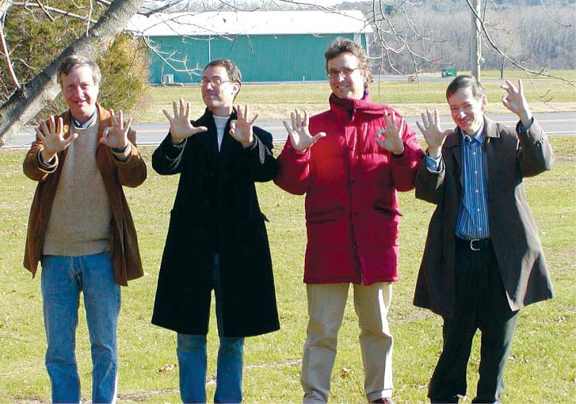

**Figure 7.1.** Wilentz, Earle, Huston, and Weinbaum, OAH Site Visit, 2005

*Source: Photograph MAVA Collection*

Conclusion

*New Possibilities: Planning, Interpretation and Boundary Expansion 2000-2006*

# Martin Van Buren National Historic Site Administrative History

For more than three decades, staﬀ at Martin Van Buren National Historic Site have contended with development pressures, highly interested neighbors, funding problems, inadequate facilities, and the challenge of interpreting a presidential home in ways that would illuminate Martin Van Buren’s political career, agricultural endeavors, and private life. In the process, the site has become more signiﬁcant than its original supporters envisioned. Martin Van Buren National Historic Site has moved from an image as a gracious presidential retire- ment home to one that represents the complexities of mid-nineteenth-century politics and the eﬀects of the spread of slavery, reveals a president many people view as obscure, illuminates the lives of servants, and emphasizes the importance of agricultural land in the nineteenth century as well as in our own times.

Battles here have been hard-fought; some have been lost and some won. Martin Van Buren National Historic Site is not being encroached upon by landﬁlls, fast-food outlets, strip malls, or housing developments with euphonic names like “Lindenwald Estates.” Its views look upon land that Van Buren farmed and that is still being farmed today. The man- sion has been restored and protected, and its rooms have been furnished using a degree of conjecture based on intelligent research and reasoning, resulting in a historic house that of- fers a realistic picture to visitors. On the other hand, the site still manages with “temporary” administrative, visitor, maintenance, and collection storage facilities, some of which have been “temporary” for the past thirty years. The trailers and the small visitor contact station in the North Field present a sharp visual contrast to the Lindenwald mansion and other buildings on surrounding sites.

The challenges confronting this small historic site—the need for appropriate facili- ties, the need to restore and protect that home and its setting, the need to develop a sophisti- cated interpretation of a president and his home, the need to serve visitors and consider park neighbors, and the need to protect the larger landscape—have become intertwined during the years of the park’s existence. Protecting and restoring the mansion at Lindenwald appropri- ately required removing administrative and visitor functions from the house but demanded a place for those functions to go. The only solutions have been temporary; the limited area of the site and the deep concerns of its neighbors have helped to prevent permanent construc- tion. Interpreting Martin Van Buren appropriately is dependent upon a sense of the environ- ment he lived in at Lindenwald, an environment threatened to one degree or another by area

*MMaarrtitninVVaannBBuurreennNNaatitoionnaallHHisistotorricicSSitieteAVdimsitiantiisotrna, t1iv9e77H-2is0to0r5y*

development. The most pressing issues come back to the need for space: adequate space for park functions and the protection of the landscape that occupies the larger space that is expe- rienced from the site.

Change is in store. The Omnibus Public Land Management Act of 2009 enlarged the boundary of MAVA to include approximately 261 additional acres of land and gave the Secretary of the Interior the authority to acquire land within the boundary from willing sell- ers. With the passage of that legislation, work on the park’s General Management Plan devel- opment shifted focus to the park within its new boundary. The GMP is currently underway and will serve to support development objectives so long sought by park staﬀ, local oﬃcials and citizens.

Appendix A

*Martin Van Buren National Historic Site Visitation, 1977-2005*

# Martin Van Buren National Historic Site Visitation, 1977-2005

Statistics for visitation at Martin Van Buren National Historic Site are inconsistent in terms of recording and accuracy, but available records do provide a broad understanding of visitation levels and changes in those levels over the decades since the site was established. The numbers have been gleaned from annual reports and a report chart. Research has uncov- ered no recording of the numbers of visitors for 1974, when the park was established, through 1976, or for the years 1993 and 1994.

The numbers of visitors signiﬁcantly increased in 1982, the year of the Van Buren bicentennial preview, and 1987, the year of the full opening of the mansion. After 1987, visita- tion continued to increase until 2000. Due to budget restrictions in 2000, the park was open for tours only ﬁve days a week. Visitation increased after 2000—although never reaching the levels of the late 1990s—until 2005, when the mansion was closed for the HVAC installation.

**Year Visitation**

1977 1,995 (approximate)

1978 2,600 (approximate)

1979 2,650 (approximate)

1980 6,000

1981 4,100 (approximate)

1982 10,622

1983 7,100 (approximate)

1984 6,000 (approximate)

1985 5,747

1986 5,200 (approximate)

1987 11,500 (approximate)

1988 12,283

1989 12,211

1990 12,107

1991 16,071

1992 15,199

1993 -------

1994 -------

1995 19,930

1996 18,335

1997 23,536

1998 22,151

1999 21,045

2000 14,786

*Martin Van Buren National Historic Site Visitation, 1977-2005*

|  |  |
| --- | --- |
| **Year** | **Visitation** |
| 2001 | 16,670 |
| 2002 | 16,756 |
| 2003 | 15,314 |
| 2004 | 15,314 |
| 2005 | 11,165 |

Appendix B

*Martin Van Buren National Historic Site Administrative History*

# Martin Van Buren National Historic Site Staffing

Staﬃng at Martin Van Buren National Historic Site has followed the same general organizational plan since on-site positions were established in 1976: Oﬃce Automation As- sistants, Clerk-Typists and other administrative staﬀ, have reported directly to the Superinten- dent. The remainder of the staﬀ is separated into three Divisions, which by 1980 were labeled the Curatorial Division, the Maintenance Division, and the Interpretation/Visitor Services Division. The Curatorial Division includes the Curator, Museum Specialists, and Museum Technicians. The Maintenance Division includes the Chief of Maintenance/Facility Manager, Maintenance Mechanics, Maintenance Workers and Laborers. The Visitor Services Division includes the Supervisory Park Ranger, permanent Park Ranger, and seasonal Park Rangers and Park Guides. MAVA’s Supervisory Ranger had both Interpretation/Visitor Services and Law Enforcement responsibilities from 1995-2004, when the position reverted to Interpre- tation/Visitor Services only. Numbers of permanent staﬀ have ﬂuctuated slightly, and the number of seasonal workers has ﬂuctuated widely. During a period in the 1980s and 1990s, no seasonal workers were hired for several years; in contrast, thirteen temporary workers were hired in 1980 during restoration of the mansion. While variations in reporting employee sta- tistics make exact comparisons diﬃcult, the information below illustrates changes in staﬃng during the park’s history.

1974 Managed by staff of Roosevelt-Vanderbilt Historic Site

1975 Two Roosevelt-Vanderbilt Park Technicians, sixteen hours per week at MAVA, September through December

1976 Two Roosevelt-Vanderbilt Park Technicians, sixteen hours per week at MAVA through spring of 1976

Full-time Park Manager beginning May 1976

Full-time Park Maintenance Worker beginning May 1976 Two full-time Laborers beginning July 1976

One Clerk-Typist beginning July 1976

Historian, Curator and additional Maintenance Worker positions approved for Fiscal Year 1977

1977 Park Manager Park Historian Park Curator

Two Maintenance Workers Three Laborers Administrative Clerk

1978 Park Superintendent

Park Historian Park Curator Maintenance Chief

Two Maintenance Workers Two Laborers

Three Seasonal Maintenance Workers Administrative Clerk

Clerk-Typist

Five Seasonal Park Technicians

1979 Seven full-time permanent employees One part-time employee

7.7 FTEs, seasonal or temporary employees

1980 Thirteen temporary employees, including carpenters, a painter, and day laborers, were hired to assist in rehabilitation work.

1991 14.04 FTEs (Fiscal Year)

1992 15.51 FTEs (Fiscal Year)

1998 15.96 FTEs (Fiscal Year)

1999 15.83 FTEs (Fiscal Year)

2000 14.54 FTEs (Fiscal Year)

2001 13.56 FTEs (Fiscal Year)

2002 Ten permanent full-time employees

One permanent part-time employee (administrative clerk)

Six seasonal employees; two full-time positions vacant (Fiscal Year)

Two full-time positions vacant (Fiscal Year)

2003 As of September 2003:

Superintendent

Office Automation Assistant

Human Resources Specialist (shared with other parks) Museum Curator

Museum Specialist Museum Technician Facility Manager

Two Maintenance Mechanics

Maintenance Worker Laborer

Supervisory Park Ranger (VS/LE) Permanent Park Ranger

Two seasonal Park Rangers Four seasonal Park Guides

One seasonal Park Guide position vacant (as of September 1, 2003)

2005 As of April 1, 2005:

Superintendent

Office Automation Assistant

Human Resource Specialist (shared with other parks) Museum Curator

Museum Specialist Museum Technician Facility Manager

Two Maintenance Mechanics Maintenance Worker Laborer

Supervisory Park Ranger Permanent Park Ranger Two seasonal Park Rangers Four seasonal Park Guides

One Seasonal Park Guide position vacant

### Individuals holding major management positions in succession to the present:

***Superintendent***

Warren Hill, Bruce Stewart, Michael Henderson, Steven Beatty, Daniel Dattilio

***Chief of Interpretation/Visitor Services***

William Jackson (also Park Historian), George Berndt, John Miller, James A. McKay (also Law Enforcement from 1995-2004)

***Curator***

Mary Smith, Carol Kohan, Michael Henderson, Phyllis Ewing, Dr. Patricia

West (also Park Historian)

***Chief of Maintenance/Facility Manager***

Richard Lusardi, Vincent Grimaldi, Richard Ouellette, Randall Ross, Wilson Echevarria, Jon Colson

Appendix C

# Martin Van Buren National Historic Site Studies, Reports, And Planning Documents 1936-2006

|  |  |
| --- | --- |
| 1936 | Weig Report |
| 1961 | National Historic Landmark Designation |
| 1966 | National Register of Historic Places Nomination |
| 1966 | National Park Service Feasibility Study |
| 1970 | Master Plan |
| 1976 | Historic American Buildings Survey |
| 1977 | Historic Structures Report, Historical Section |
| 1979 | Archaeological Impact Assessment |
| 1980 | Historic Wall Finishes Study |
| 1980 | Addendum to Historic Structures Report |
| 1981 | Historic Grounds Report: Introductory Section |
| 1982 | Statement for Interpretation |
| 1982 | Archaeological Survey, Utility Lines |
| 1982 | Historic Resource Study |
| 1982 | Historic Grounds Report |
| 1983 | *Land Protection Plan* |
| 1983 | Historic Grounds Report: Archaeological Data Section |
| 1984 | Archaeological Survey, Electric Line Easement |
| 1985 | *Interim Interpretive Prospectus* |
| 1986 | *Development Concept Plan* |
| 1986 | Historic Furnishings Study |
| 1989 | Collections Storage Plan |
| 1990 | Scope of Collection Statement |
| 1990 | Amendment to 1986 *DCP* |
| 1990 | Adjacent Lands Resource Analysis |
| 1991 | Archaeological Collections Management Plan |
| 1995 | Cultural Landscape Report |
| 1995 | Collections Condition Survey |
| 1996 | Collections Management Plan |
| 1997 | Preservation Treatment Plan, Landscape |
| 1997 | Cultural Landscape Treatment Plan |
| 2000 | Draft *Development Concept Plan* |
| 2001 | Historic Structures Report, Gatelodges |
| 2002 | Cultural Landscape Report for Van Buren Farm |
| 2003 | Interpretive Planning Foundation |
| 2003 | Boundary Study/EA |

*Martin Van Buren National Historic Site Studies, Reports, and Planning Documents 1936-2006*

*Bibliography*

|  |  |
| --- | --- |
| 2004 | Archaeological Overview and Assessment |
| 2004 | Biological Survey |
| 2005 | Interpretive Concept Plan |
| 2006 | OAH Scholars Statement of Signiﬁcance |
| 2006 | *Historic Resources Study* |

## Bibliography

#### Archives and Records

**National Archives II. College Park, Maryland. Record Group 79. National Park Service. Boston Support Oﬃce, Clark Files.**

. Boston Support Oﬃce, Planning Files.

. Boston Support Oﬃce, Weinbaum Files.

. Harpers Ferry Center, Martin Van Buren Historic Site Correspondence Files.

. Martin Van Buren National Historic Site Box 649, Museum Collection. .

. Martin Van Buren National Historic Site, Central Files.

. Martin Van Buren National Historic Site, Museum Commemorative Collection.

. Martin Van Buren National Historic Site, E-mail correspondence.

. Martin Van Buren National Historic Site, McKay Files.

. Martin Van Buren National Historic Site,Superintendent’s Files.

. Martin Van Buren National Historic Site, Unprocessed Archival Reading Files.

. Roosevelt-Van Buren National Historic Site, Museum Collection.

. Roosevelt-Van Buren National Historic Site, Reading Files.

. Washington Support Oﬃce, Martin Van Buren NHS Files.

#### Books and Articles

Albright, Horace M. *Origins of National Park Service Administration of Historic Sites.* Accessed June 27, 2010. <http://www.nps.gov/history/history/on-line> _books/albright/ origins.htm.

Association for the Preservation of Lindenwald. “Lindenwald, Home of Martin Van Buren, the First President of the United States Chosen from the State of New York: Why It Should be Made a Public Historic Reservation,” 1937.

Dilsaver, Lary M. ed. *America’s National Park System: The Critical Documents.* Rowman and Littleﬁeld, Publishers, 1994. Accessed August 4, 2010. http://www.npsgov/his- tory/history/online_books/anps/anps_8ahtm.

.“Some Notes on Thematic and Multi-Park Administrative Histories.”

*CRM: A Journal of Heritage Stewardship* 21, no. 9 (1998): 48.

Lee, Ronald F. *Family Tree of the National Park System*. Eastern National Park and Monument Association, 1974. Accessed June 25, 2010. <http://www.nps.gov/history/history/> online_books/lee2/4.b.

Mackintosh, Barry. *The Historic Sites Survey and the National Historic Landmarks Program: A History.* Washington, D C: History Division, National Park Service, Department of the Interior, 1985.

. *Interpretation in the National Park Service: A Historical Perspective.* Washington, D C: National Park Service, 1986. Accessed June 28, 2010. <http://www.nps.gov/> history/history/online_books/mackintosh2/index.htm.

. *National Park Service Administrative History: A Guide.* Updated by Janet McDonnell. US Department of Interior, National Park Service, 2004. Accessed March 16, 2008. [http://www.nps.gov/history/history/hisnps/NPSHistory/guide.pdf.](http://www.nps.gov/history/history/hisnps/NPSHistory/guide.pdf)

. *The National Parks: Shaping the System*. Washington, D C, Harpers Ferry Center, National Park Service, 2005. Accessed February 5, 2010. <http://www.nps.gov/> history/history/online_books/shaping/index.htm.

Murtagh, William J. *Keeping Time: The History and Theory of Preservation in America.* New York: Sterling Publishing Co. Inc., 1988.

Rettie, Dwight F. *Our National Park System: Caring for America’s Greatest Nation- al and Historic Treasures.* Chicago: University of Illinois Press, 1995.

“Richard Schermerhorn, Jr., New York Engineer and Landscape Architect: Fort Lauderdale’s First City Planner.” *Broward Legacy,* Vol. 21, nos. 3-4, Summer/Fall 1998: 1-5.

Schermerhorn, Richard, Jr. “City Planning.” Brooklyn Engineers Club, *Proceed- ings* 16 (1912): 102. Accessed September 21, 2009. <http://www.library.cornell.edu/Reps/> DOCS/shermer.htm.

Deborah Slaton. “Preservation Brief 43: The Preparation and Use of Historic Structure Reports.” Accessed March 3, 2009. http:/[www.nps.gov/hps/briefs/brief43htm..](http://www.nps.gov/hps/briefs/brief43htm)

Stauﬀer, Alvin P. and Charles W. Porter. “The National Park Service Program of Conservation for Areas and Structures of National Historical Signiﬁcance.” *Mississippi Valley Historical Review* (1943): 26-41.

West, Patricia. *Domesticating History: The Political Origins of America’s House Mu- seums.* Washington [DC]: Smithsonian Institution Press, 1999.

. “Irish Immigrant Workers in Antebellum New York: The Experience of Domestic Servants at Van Buren’s Lindenwald.” *Hudson Valley Regional Review* 9 (Septem- ber 1991): 112-26.

. “‘The New Social History’ in Historic House Museums: The Linden- wald Example,” *Museum Studies Journal* 2 (Fall 1986): 22-26

. “MVB’s Dining Table . . . Going, Going, Gone.” *The Van Buren Chron- icles.* Spring, 2006: 2.

. “Rethinking Martin Van Buren Historic Site.” Richards, Leonard L., Marla R. Miller, and Erik Gilg. *A Return to His Native Town: Martin Van Buren’s Life at Lin- denwald, 1839-1862.* U. S. Department of the Interior, National Park Service, August 2006.

Ted Widmer. *Martin Van Buren*. The American Presidents Series, gen. ed. Arthur

M. Schlesinger Jr. (New York: Times Books, Henry Holt and Company, 2005), 22-24.

#### Reports and Studies

Huston, Reeve. “The ‘Little Magician’ after the Show: Martin Van Buren, Country Gentleman and Progressive Farmer, 1841-1862.” National Park Service, *Special History Study*, [2000].

Jackson, William N. “Draft Interpretive Prospectus for Martin Van Buren NHS, National Park Service.”

Kohan, Carol E. *Historic Furnishings Report for ‘Lindenwald,’ Martin Van Buren National Historic Site.* US Department of the Interior, National Park Service, Harpers Ferry Center, 1986.

National Park Service. *General Management Planning Dynamic Sourcebook.* Ver- sion 2.0. March 2008.

. *Interim Interpretive Prospectus.* Martin Van Buren National Historic Site, Kinderhook, NY, 1985.

. *Martin Van Buren National Historic Site Adjacent Lands Resource Analysis.* With assistance by the Columbia Land Conservancy. September 1990.

. *Martin Van Buren National Historic Site Amendment to the Develop- ment Concept Plan/Environmental Assessment of 1986.* September 1990.

. Martin Van Buren National Historic Site Annual Reports.

. Boston Support Oﬃce, Northeast Region. *Martin Van Buren National*

*Historic Site Boundary Study/Environmental Assessment 2003.*

. *Martin Van Buren Historic Site [sic] Development Concept Plan.* Draft.

March 2000.

. *Martin Van Buren National Historic Site Development Concept Plan/ Environmental Assessment.* March 1990.

. *Master Plan, Lindenwald National Historic Site, New York.* 1970.

. Statement for Management, Martin Van Buren NHS, Kinderhook, NY. Approved January 9, 1991.

Platt, John. D. R. Harlan, D. Unrau, and Harold D. Unrau, eds. *Historic Resource Study Lindenwald Martin Van Buren National Historic Site New York.* Denver: Denver Service Center, National Park Service, 1982.

Richards, Leonard L., Marla R. Miller, and Erik Gilg. *A Return to His Native Town: Martin Van Buren’s Life at Lindenwald, 1839-1862.* US Department of the Interior, National Park Service, August 2006.

Scott, John A. *The Gate Lodges of Lindenwald.* National Park Service, Northeast Cultural Resources Center, Building Conservation Branch, Historic Structures Report.

Searle, Llerena. *A Farmer in His Native Town: Cultural Landscape Report for the Martin Van Buren Farmland.* Boston, MA: National Park Service, 2004.

Uschold, David L. and George W. Curry. *Cultural Landscape Report for Martin Van Buren National Historic Site.* Boston, MA: National Park Service, 1995.

Weig, Melvin J. “Activities to Eﬀect Preservation of Martin Van Buren Homestead.”

#### Interviews

Dattilio, Dan. Interviewed by Suzanne Julin, April 13, 2008. Harris, Judy. Interviewed by Suzanne Julin, June 18, 2008. Henderson, Michael. Interviewed by Suzanne Julin, April 5, 2010. Hill, Warren. Interviewed by Suzanne Julin, July 23, 2009.

McIntosh, Bob. Interviewed by Suzanne Julin, April 8, 2010. Piwonka, Ruth. Interviewed by Suzanne Julin, April 6, 2010. Smith, Marjorie. Interviewed by Suzanne Julin, April 16, 2010. West, Patricia. Interviewed by Suzanne Julin, June 17, 2008.

#### Newspapers and Newsletters

*Albany Times Union Chatham Courier*

*Chatham Courier Rough Notes Hudson Register Star*

*Hudson River Sampler The Independent Knickerbocker News Poughkeepsie Journal*

*The Van Buren Chronicles, Friends of Lindenwald newsletter*

#### Miscellaneous

Dan Dattilio, comments on Martin Van Buren National Historic Site Administra- tive History Draft, [March 24, 2010], MAVA.

Ewing, Phyllis to Patricia West, e-mail message to author, April 8, 2010.

Henry, Darin. “The Van Buren Boys.” Aired February 6, 1997. Accessed March 8, 2010. [.http://www.Seinfeldscripts.com/TheVanBurenBoys.htm.](http://www.Seinfeldscripts.com/TheVanBurenBoys.htm)

Martin Van Buren National Historic Site. Park Comments, Martin Van Buren NHS Administrative History First Draft, March 19, 2010.

“Martin Van Buren: A Passion for Politics,” Curricula for seventh and eighth grade students, n.d. [1996]

West, Patricia. “The House Servants of Lindenwald.” Unpublished manuscript, 1985. In possession of the author.

. “Preserving Lindenwald: 1907 to 1974.” Unpublished manuscript. In possession of the author.

#### Legislative Documents

H.R. 2384. 109th Cong., 1st sess. *To adjust the boundary of Martin Van Buren Na- tional Historic Site, and for other purposes.*

H. R. 3619. 92nd Cong., 2d sess. *A Bill to Establish the Van Buren-Lindenwald His- toric Site at Kinderhook New York, and for other purposes.*

*Historic Sites Act of 1935*, 49 Stat. 666-668.

S. 1426. 92nd Cong., 2d sess. *A Bill to Establish the Van Buren-Lindenwald Historic Site at Kinderhook, NY, and for other purposes.*

Senate Committee on Interior and Insular Aﬀairs. *An Act to Provide for the estab- lishment of the Clara Barton National Historic Site, Maryland; John Day Fossil Beds National Monument, Oregon; Knife River Indian Villages National Historic Site, North Dakota; Spring- ﬁeld Armory National Historic Site, Massachusetts; Tuskegee Institute National Historic site, Alabama; and Martin Van Buren National Historic site, New York; and for other purposes,* 93d Cong., 2nd sess.

Senate Committee on Interior and Insular Aﬀairs. *Establishing the Van Buren Na- tional Historic Site at Kinderhook, N.Y.,* 92d Congress, 2d sess.

Senate Committee on Interior and Insular Aﬀairs, Subcommittee on Parks and Recreation. *Hearing on S. 3035 and S.3098,* 89th Cong., 2nd sess.

## Index

*Index*

### A

Adjacent Lands Resource Analysis 74–76, 131, 151, 155

Advisory Board on National Parks, Historic Sites, Buildings and Monuments 12, 16–17, 20

Advisory Council on Historic Preservation 18, 41, 82

Agriculture, Department of 12

Akers, Jeanne B. 43

Albany, New York 2, 5, 10–11, 13, 27, 34, 59, 67, 69, 99, 101, 121, 157

Albert Schweitzer Friendship House 31

Albright, Horace 12

American Academy of Arts 31

American Scenic and Historic Preservation Society 11, 19

Amistad 99, 102, 104

Aspinall, Wayne 21

Association for the Preservation of Lindenwald 13–16, 153

attic 98

### B

basement 30, 44–45, 56, 60, 65, 68, 80, 96–98, 114, 121–22

Beatty, Steven 117, 121, 128, 149

Berle, Peter A.A. 34

Berndt, George vii, 61–62, 65, 71, 95, 98, 101, 149

Bible 99

Birney, Bascom H. 9

Birney, Clementine deProsse 9

Blackburn, Roderic 19

boiler 30

Boston Support Oﬃce ix, 3, 20, 22, 28, 41, 73, 128, 130–31, 153, 155

Boundary Study 130–37, 139–40, 151, 156

Brennan, Bernard 34–36, 68

bricks 10

Brown, John 15

Buckley, James 21 *Buﬀalo Daily Courier* 15 Burr, Aaron 6

### C

Calhoun, Gilbert 47

Callan, Albert Jr. 19, 35

Cammerer, Arno 16

Campbell, Kenneth 18, 22, 27, 29–33, 40–41, 60, 73

Campbell, Nancy 10

candlesticks 100

Cantine, Christina 99

carriage house 27

cattle 6, 8, 136

Chatelain, Verne E. 13

Chatham Courier 19, 35–36, 39, 41–42, 49, 56, 66, 68, 69, 75, 84, 157

Civilian Conservation Corps 12

Civil War 1, 69, 102–103, 106, 137

Colonial National Historical Park 12

Colonial National Monument 12

Columbia County vii, 5, 11, 13, 16, 19–20, 25, 27–29, 32–36, 39, 47, 49, 66–67, 74, 103–4, 129–33

Bicentennial Committee 47, 49

Board of Supervisors 35, 66

Historical Society vii, 11, 13, 16, 19, 25, 29, 34–35, 39, 47, 129, 131

Columbia Land Conservancy 68, 74, 76, 83, 115, 131, 155 Committee on Interior and Insular Aﬀairs 20–22, 158 Congress, See U. S. Congress

Corey, Albert B. 17

Corning, Erastus 16

cultural landscape 119, 123, 136, 138

Cultural Landscape Report 6, 9–10, 22, 46, 105, 119, 128, 136–37, 151, 156

### D

dado 41, 42

Dattilio, Dan viii, ix, 121–122, 126, 128, 130, 133, 135, 139, 140, 157

Davidson, Robert 18–19

Demaray, Arthur 16

Democratic Party 7

Democrats 13

deProsse, Clementine 10

*Development Concept Plan* 37, 55, 64–67, 70, 75, 79–80, 82, 84–85, 128–30, 140, 151, 155–56

dining room 8, 16, 97–98

dining table 48, 59, 120

Division of New Area Studies and Master Planning 20

Doonesbury 101

drawings 12, 29, 85, 101, 119

Dunsmuir House 57

Dutch East India Company 5 Dutch Settlers Society of Albany 13 Dutch West India Company 6

### E

Earle, Jonathan 138–139

Eastern National Park and Monument Association 13, 48, 153

Educational Outreach 102 Eisenhower, Dwight D. 21 elevator 80

Environmental Assessments 78

Ewing, Phyllis 48, 59, 111, 118–119, 127, 149

Executive Order 6166 12, 93

Executive Order 11593 18

expansion 2, 9, 40, 55, 66, 70, 73, 75–76, 87–88, 105, 114–15, 127–36, 139–40

### F

Fader, Marsha L. 41

farm 5–10, 43, 67, 73–74, 76–78, 81, 83, 103, 106, 114–15, 117, 119, 123, 127–29, 131, 134–37,

138

farming 39, 43, 73, 104, 115, 138–39

ﬁngerbowls 100

Fish, Hamilton Jr. 20–21

ﬁre 29, 31–33, 40, 75, 111–113, 120–22, 132

Flick, Alexander 11, 15

ﬂoor plans 29

Ford, Gerald 22

Ford, Henry 11

Forest Service 12

Fort Stanwix 15

framing 56

Free Soil Party 2, 9, 105, 137

front porch 10, 40, 55–56

furnace 30, 120

furniture 9, 42–43, 45, 48, 58–59, 61, 63, 119, 121–122

### G

garden 10, 137

General Services Administration 46, 57–58, 113–14

George Washington Birthplace National Monument 12

Goodell, Charles E. 21

Great Depression 10, 12

### H

Hamilton, Alexander 6, 19

Hamm, James 42

Hammersley, Nick 120

Hanna, John Jr. 34, 35, 36

Harpers Ferry Center ix, 3, 40, 45, 60–61, 63, 95, 96, 112, 137, 153–55

Harrison, William Henry 7 Hartzog, George 19, 21 Hartzog, George Jr. 19

Heating, Ventilation and Air Conditioning System (HVAC ) 120–23, 138, 145

Henderson, Michael viii, ix, 86–87, 93, 99, 100, 107, 111–12, 114–16, 118–19, 129–30, 139, 149

Hill, Warren ix, 29–32, 34, 38, 49, 149

Historic American Buildings Survey 12, 151

*Historic Furnishings Report* 38, 42, 44, 55, 57, 60–61, 63, 69, 96, 100, 155

Historic Grounds Report 46, 96, 151

Historic Resource Study 38, 139–40, 151, 156

Historic Sites Act of 1935 11–13, 158

Historic Sites Survey 12, 17–18, 154

Historic Structure Report 38

Hoes, Hannah 8 Holland, F. Ross Jr. 62 Holland Society 13

Holloway, Gary 57

horses 8

Hot Springs National Park 12

H.R. 13157 22

Hudson, Henry 5

Hudson River

Conservation Society 11, 19

Hudson Valley 1, 5, 7, 9, 16, 21, 59

Survey Commission 16 Hughes, Charles Evans 10 Huston, Reeve 136, 138

Hyde Park 20, 29

### I

Ickes, Harold 12

*Interim Interpretive Prospectus* 61–62, 95–96, 151, 155

Interior, Department of 8, 12, 68, 83, 154

interpretation 1, 2, 20, 31, 37–38, 42–47, 60–63, 65, 74–75, 93–95, 97–100, 102, 105–6, 111–112,

115, 127, 131, 134–40, 143, 147, 149, 151, 154

Interpretive Prospectus 43–45, 61–62, 95–96, 99, 151, 155

Irish immigrants 8

Irving, Washington 7, 14–15

### J

Jackson, William 31, 43, 95, 149

James, Ellen King 9

Jamestown 12

Javits, Jacob 21

Jeﬀerson, Thomas 7

Jerome, Leonard 9

John Day Fossil Beds National Monument 22, 158

Johnson, Lyndon B. 21, 31

Junior Ranger program 103

### K

Kallop, Ed 42, 61

Kallop, Edward L. Jr. 47

Kinderhook vii, 1, 5–7, 10–11, 13–14, 18–23, 27–29, 32, 35, 38–39, 48, 59, 67–68, 69, 74, 75,

86–87, 95, 98, 101, 103–104, 111, 115–116, 118, 127–130, 132–33, 135, 138, 155–58

Cemetery 101

Public Library 104

Town Board 67, 68, 118, 132–133

kitchen 32, 44, 97, 98

Kleinrood 7

Knife River Indian Villages National Historic Site 22, 158

Kohan, Carol vii, 42, 47–48, 57–61, 64, 71, 78, 86, 99, 101, 149

Korean War 40

### L

Land Acquisition Plan 28

landﬁll 27, 30, 31, 33–36, 39, 49, 67–68, 73

*Land Protection Plan* 73, 151

laundry 97–98

Lehman, Herbert H. 16–17 Leath, James vii, 11, 16, 25

Lindenwald ii, v, vii, viii, ix, 1, 2, 5–11, 13–22, 27–49, 55–57, 59–63, 65–70, 73, 75–76, 83–84,

86–87, 89, 93, 95–100, 102–106, 109, 111, 116, 119, 120–23, 125–27, 133–40, 143, 153–58

Committee for the Environmental Protection of 34–36

Friends of 48–49, 59, 65, 66, 68, 87, 93, 97, 103, 105, 121, 157

Preservation Committee 19

Lindstrom, Frederick 103

Lippe, Vincent 14

List of Classiﬁed Structures 56

Lusardi, Richard 29, 149

### M

main ﬂoor 10, 48

*Management Policies* 2006 64

Manney, Richard 59

maps ix, 29, 113, 127

Martin Van Buren Fan Club 57

Martin Van Buren National Historic Site i, ii, v, ix, 1–3, 5, 6, 10, 22–23, 27–29, 31, 33–34, 36–38,

40–47, 49, 59, 60, 63, 59, 60, 62, 60, 64–69, 73–77, 79–80, 82–87, 93–95, 98–99, 101–106,

111–13, 116, 118–22, 127–37, 139–40, 143, 145, 147, 151, 153, 155–57

Martin Van Buren School 103

*Master Plan* 20, 28, 29, 34, 37, 38, 39, 40, 20, 41, 43, 45, 64, 65, 66, 67, 77, 84, 85, 96, 128, 151,

156

Mather, Stephen 12

McKay, James 99

Mesa Verde National Park 12

Meyer, Dudley Ray Jr. 10, 81, 114

Mission 66 17, 40, 94

Mohican Indians 5

Morristown National Historical Park 17, 30, 111, 115

multipurpose building viii, 44, 66, 67, 70, 73, 75–87, 91, 95–96, 111–13, 115, 117, 129

Muskie, Edmund 19

### N

National Environmental Protection Act 78

National Historic Preservation Act 18, 78

National Park Foundation 22, 31, 32, 105, 113 National Parks and Conservation Association 74 National Park Trust 74

National Register of Historic Places 18, 85, 151

New Netherlands 5, 6

New York City 2, 5, 6–7, 11, 59, 67, 138

New York Historical Society 13

New York State Department of Transportation 28

New York State Historic Preservation Oﬃce 66, 77, 114, 118, 129

New York State Planning Board 13

Nixon, Richard 18, 20

North Atlantic Historic Preservation Center 38, 41, 56

Northeast Museum Services Center 118–20

North Field 66–67, 76–78, 80, 82–85, 88, 115–17, 129, 143

North Gatehouse 5, 37, 40–41, 44–45, 65, 96, 137

### O

OAH viii, 137, 139, 141, 152

Occupational Safety and Health Administration 113

oil lamps 100

Old Post Road 5, 7, 14, 28, 65, 67, 76–77, 80, 84, 117–18, 129

Olmsted Center for Landscape Preservation 6, 136

Olson, Dawn ix, 105

Omnibus Public Land Management Act 135, 144 Open Space Institute 115, 117, 127–28, 133, 135 Organization of American Historians ix, 137 OSHA 113

Ouellette, Richard 76, 149

outbuildings 6, 8, 10, 14, 44, 46, 81

### P

Panic of 1837 7, 43, 96, 104

parking lot 34, 44, 65–67, 80–81, 84–85, 96, 117–18, 132–33

pasture 8

Patent, Thomas Powell 7 Patricia, Steven N. 105 Patten Corp. 68 Paulding, William Jr. 7

Philadelphia Planning Oﬃce 20

pigs 8

Pitcaithley, Dwight 61, 62

Piwonka, Ruth viii, ix, 19, 35–36, 39, 74, 107

plantings 78, 80, 81, 117

Platt, John 38

pole barn 1, 5, 58, 66, 73, 75, 79, 80, 84, 86, 112, 118–19, 123

police 29, 31

poultry 8

Putnam County 10

### R

Rector, Scott 121

renovation 10

Rensselaer Polytechnic Institute 11

Rayback, Joseph 48

Resnick, Joseph 18, 20, 21

restoration vii, 1, 2, 15, 23, 27, 31, 34, 36, 38–42, 44, 46–49, 55–56, 58, 59, 61–62, 64, 69, 72–73,

96, 103, 119, 129, 136–38, 147

Richmond, Virginia 28

Ronalds, Francis 17

roof 30, 40–41, 56, 77–78, 82, 84–86, 114, 121–22

Roosevelt and Vanderbilt Mansion National Historic Sites 29

Roosevelt, Eleanor 14

Roosevelt, Franklin D. 11, 12, 20, 29, 93

Route 9-H 65, 67, 118, 131

Route 9H vii, viii, 5, 10, 23, 27–28, 34, 39, 46, 58, 125, 129

Roxbury Farm 117, 127–28, 135, 140

Rust, Marie 135, 139

### S

safety 29, 67, 112–13, 115–16, 118, 120, 123

Saratoga Battleﬁeld 15

Schermerhorn, Richard Jr. 11, 13, 15, 17 Scope of Collections Statement 57 Scott, Winﬁeld 8

Scotts Bluﬀ National Monument 11

Searle, Llerena 6, 136–37

Secretary of Interior 13, 17, 21

*Seinfeld* 101

Senate, See U. S. Senate

servants 8, 48, 93, 97–98, 103, 106, 138–39, 143

sheep 8, 136

shingles 30, 56, 77

Singleton, Angelica 8, 45, 48

Skull and Bones Society 101

slavery 1, 2, 7, 9, 99, 102, 105, 137–38, 143

Smith, Marjorie ix, 79, 130, 131–34

Smith, Mary B. 31, 42

Solomon, Gerald 87, 112

Sons of the American Revolution 13

Sotheby’s 119, 120

South Gatehouse viii, 5, 10, 29, 30, 32–33, 40, 46, 65, 68, 73, 84, 90, 96, 114

Springﬁeld Armory National Historic Site 22, 86, 116, 158

staﬃng 104, 147

Stark, Jack E. 36, 41

State Department of Environmental Conservation 35

Stephen, George viii, 75, 76, 77, 78, 81, 84, 91, 131

Steuhl, Harry 29

Stewart, Bruce vii, 10, 30, 31, 32–34, 36–37, 39, 40, 44–46, 48–49, 55, 59, 60–61, 63, 65–66, 68, 69,

72, 76, 78, 81–83, 86, 99, 101, 111, 119, 149

storage 10, 30, 40, 45, 57, 58, 65–66, 68, 73, 75, 80, 84–86, 111–12, 115, 117–19, 121, 129, 143

stove 97

### T

Taconic State Park Commission 11 Taft, William Howard 21 technology 122

Texas 9, 139

Thompson, Smith 8, 9, 57

Thompson Van Buren, Smith 9, 57

tower stairs 98

traﬃc 5, 34, 35, 65, 84, 118

trailers viii, 1, 5, 46, 66, 73, 75, 84, 87, 111–16, 111–18, 122–25, 129, 132–33, 143

trees 10, 30, 58, 85, 86, 117, 133

Trinity Church 9 Troy, New York 11 tuberculosis 8

Tuskegee Institute National Historic Site 22

Twomey, Jeremiah 16

### U

U. S. Congress vii, 1, 6, 17, 18, 20–22, 24, 66, 68, 115, 130, 134–35, 139, 158

U. S. Senate 7, 16, 19–20, 22, 135, 158

Upjohn, Richard 8, 9, 103

Uschold, David 119

### V

Van Alen, Maria Hoes 6 Van Alstyne, Derckje 7 Van Alstyne, James 9 Van Alstyne, Lambert 7

Van Alstyne, William Beekman 18

Van Buren, Abraham 6

Van Buren, Angelica 8, 48, 103

Van Buren, Angelica Singleton 45, 48

Van Buren, John 9

Van Buren, Martin i–ii, v, vii, ix, 1–3, 5–11, 13–15, 17–18, 20, 22–24, 27–29, 31, 33–34, 36–38,

40–49, 55, 57, 59, 60–69, 73–77, 79–80, 82–87, 93–95, 98–99, 101–106, 111–13, 115–22,

127–40, 143, 145, 147, 151, 153, 155–58

Van Ness, John 6

Van Ness, Peter 7, 103

Van Ness, William 6, 7

visitation 31, 34, 37, 145

visitor center 34, 37, 95–96, 112, 121, 132

visitor’s center 76

visitor service facilities 115

### W

Wagoner, Adam 9

Wagoner, Freeman 9

wallpaper vii, 8, 10, 16, 41–42, 45, 47, 52–53, 59, 61, 122

War, Department of 12, 93

Washington, DC ix, 7, 12, 94

Watt, James 55

Weig, Melvin 11, 14

Weil, Henry Birdseye 68, 76

Weinbaum, Paul ix, 85, 137

Welles, Edward R. III 18, 19

West, Patricia ix, 11, 46, 60, 64, 87, 97–99, 104–105, 111–12, 115–22, 134, 137–39, 149, 157

Whig 7

Whitmer, Mary Leigh 120

White House 14, 15, 59

Wilder, George 9

Wilentz, Sean 138

windows 10, 42, 77–78, 82, 84

wiring 30, 120

World War II 10, 17, 40

### Y

Yorktown Battleﬁeld 12

### Z

zoning 38–39, 74, 116

zoning board 127