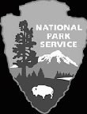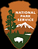
Martin Van Buren
National Park Service
U.S. Department of the Interior
National Historic Site New York

Wayside Loop Trail
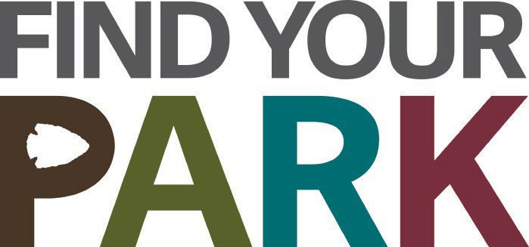
The MVB NHS Wayside Trail is a three-quarter-mile loop trail which is a mix of gravel and grass. There are eleven outdoor interpretive markers - waysides - which contain information about Martin Van Buren and his farm.
The Wayside Trail can be used from dawn to dusk throughout the year. While walking the trail you can connect to more of the stories of Lindenwald using the convenience of your own cell phone.
Here's how: If using a smartphone enter the link mava.oncell.com into your phone's browser to enjoy additional photos, audio, and links at each wayside.
To listen to audio only as you visit each of the stops, call 518-660-0600.
Enter the number of the wayside exhibit to enjoy a short narration (3-10 minutes) expanding the information on the exhibit.
Begin in the parking lot and follow the directions in this bulletin for an introduction to the nation’s eighth president as well as an enjoyable walk.

A Walk in the Park 1. Welcome! If you haven’t already
been to the wayside in the parking lot begin here for an introduction to our 8th president and his beloved Lindenwald. From the parking lot proceed left down Old Post Road to the next stop on the right.
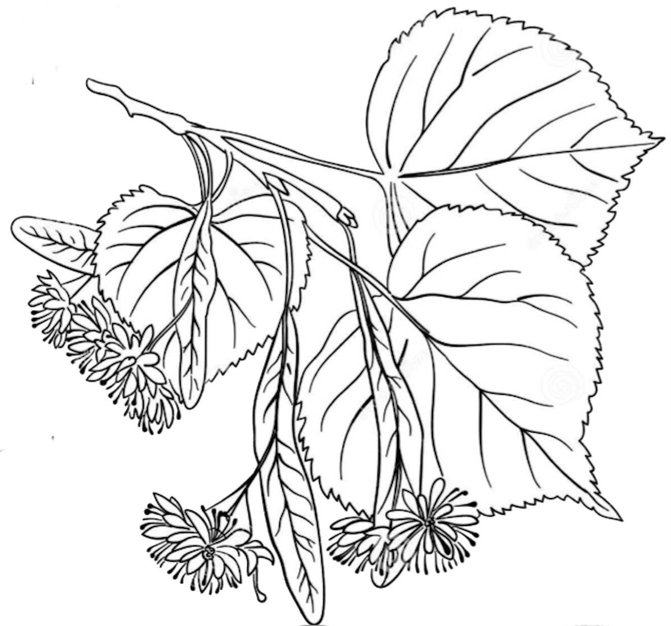
- Uncovering the Past - Researching the past often involves many disciplines including archeology. Here you can learn what was discovered about Lindenwald at the old north gatehouse site. Continue to the left down the road to the third wayside.
- Lindenwald and Old Post Road - See the route of Old Post Road through Columbia County when Martin Van Buren lived here and
learn what a linden leaf looks like. Go across the lawn toward the house to see the next wayside.
- A House Transformed - In 1849, Martin Van Buren commissioned Richard Upjohn to redesign and expand the house. The result was the quirky 36-room house we see today. Walk back to Old Post Road and continue south to the gatehouse for the fifth wayside.
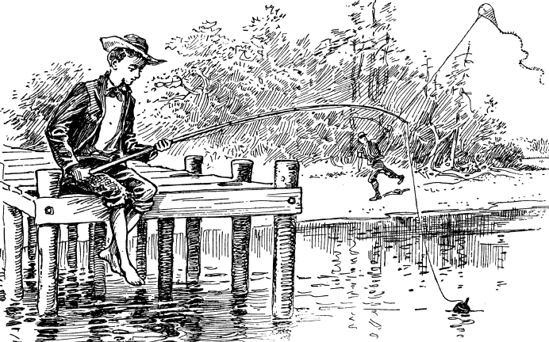
- Farmhands and Fishing - Lindenwald was a large farm of 230 acres. A great deal of farm work occurred here, but there was still time for leisure. Continue up the carriage path to the hop poles and look for the wayside.
- Farm Operations - Discover one of the agricultural experiments conducted at Lindenwald while Martin Van Buren lived here and try to figure out why the farm office had as many doors as it did. The next wayside is ahead of you to the right.
- An Agrarian Lifestyle - Much of what was grown at Lindenwald found its way to market in New York City. The fields of Lindenwald are still productive to this day. Turn around and walk over to the rear of the mansion for the next wayside.
- Bustling Household - This wayside describes the community of people who lived and worked at Lindenwald. To the left, on the other side of the house is the ninth wayside.
- Fertile Political Ground - Van Buren purchased this property while he was president and he remained politically active for many years after moving here. Follow the path behind you through the field for 75 yards to the tenth wayside. Careful - uneven ground.
- Soil Improvers - In the early years of the republic Van Buren and others constituted a group known as soil improvers, who hoped to reverse the common practice of moving west to new lands. Their goal was to create a more sustainable agricultural system while also preventing the loss of political power that would result from the depopulation of the northeast.
- A farmer in my native town - Although he held many prestigious offices throughout his life, Martin Van Buren was most happy while a farmer at home in the beautiful Hudson River Valley.
Due to the historic nature of the site, pathways and grounds may be uneven. Ticks are common thru the area. After walking through the lawn or around the trails, check for ticks.

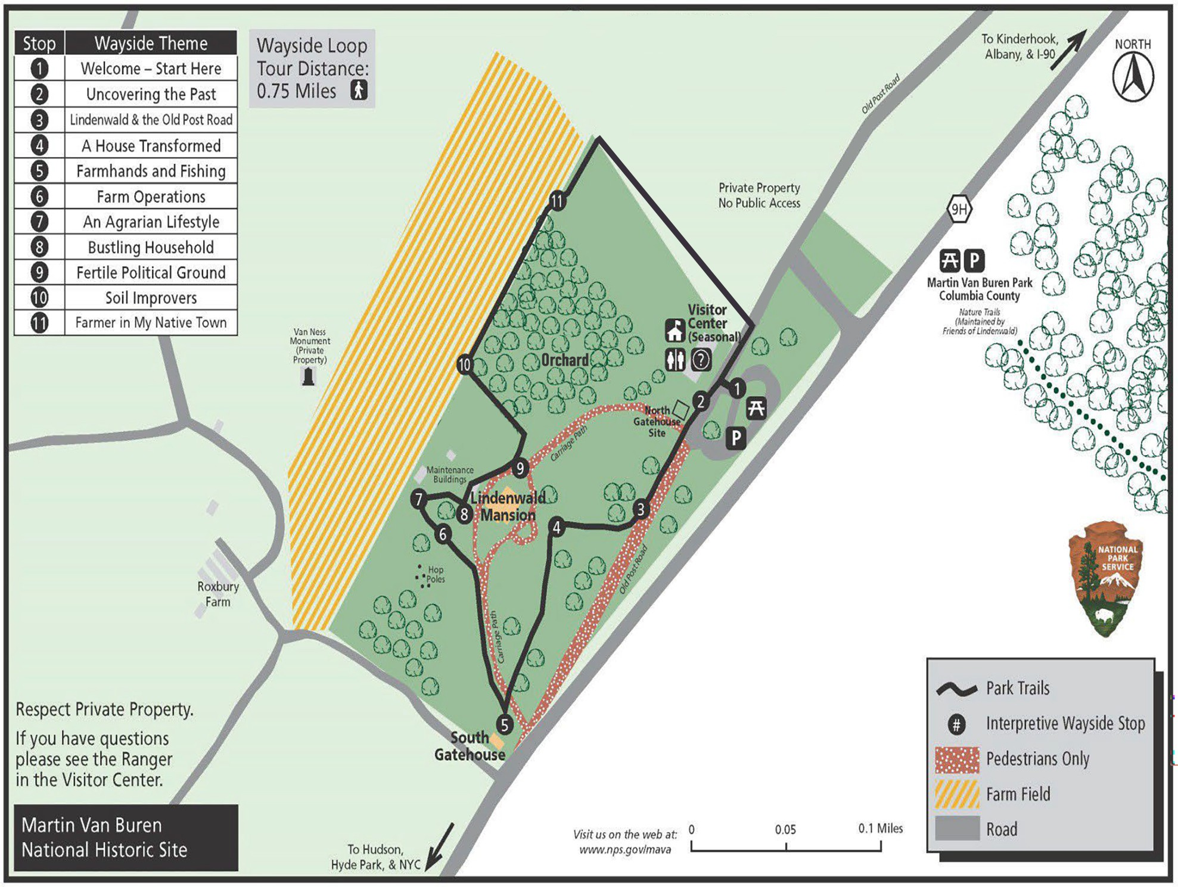

Junior Rangers

Participate in Martin Van Buren National Historic Site's Junior Ranger Program!

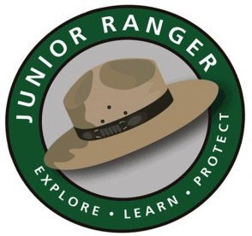
Our Junior Ranger book offers visitors an engaging way to explore Martin Van Buren's house and the grounds.

Junior Rangers are encouraged to:
  - Think about 19th century life
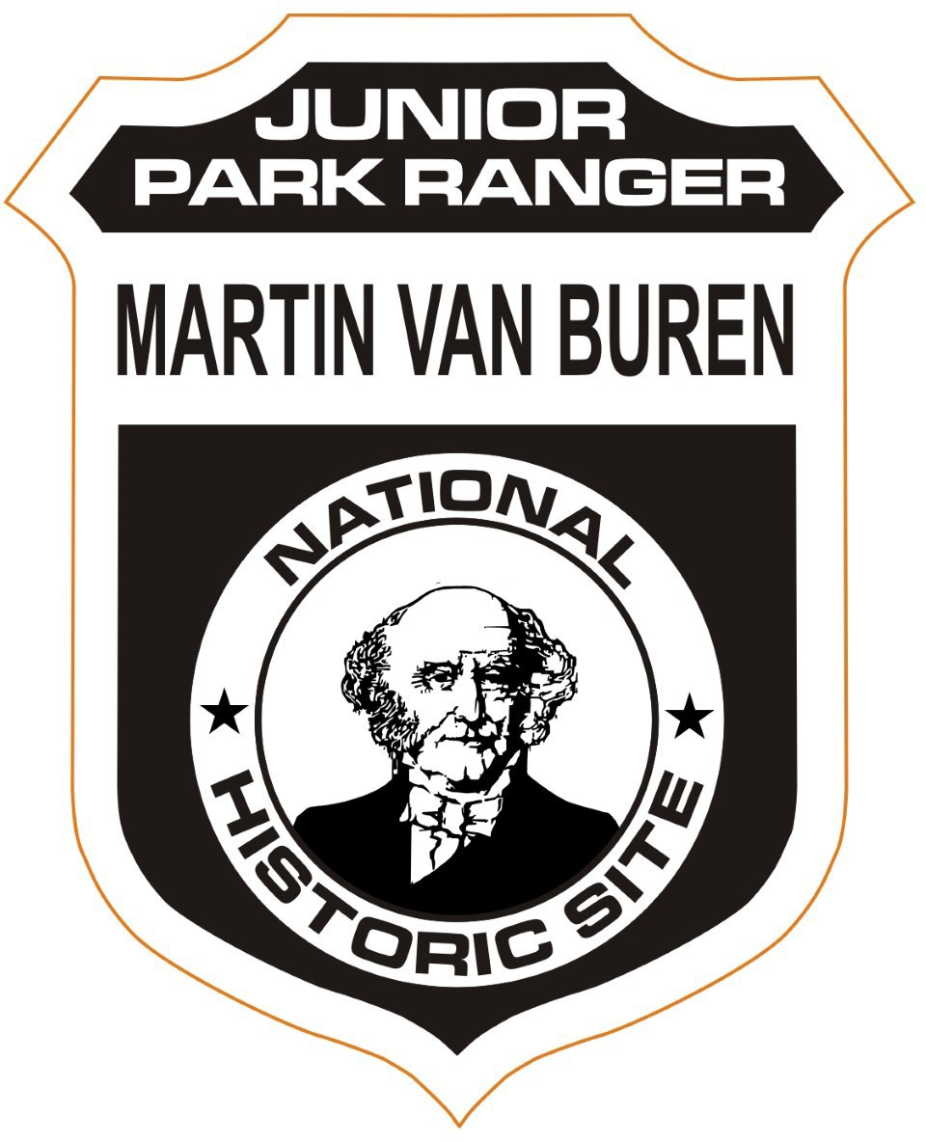
  - Discover the past
  - Learn about major political events
  - Explore the farm and the park
  - Create their own community maps, family trees, and coat of arms

BARK Rangers

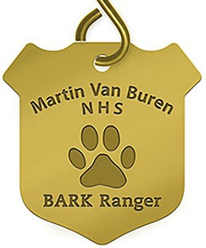
We welcome people of all ages to become a Martin Van Buren Junior Ranger. Check-in at the visitor center to pick up a Junior Ranger book, receive instructions, and earn your badge!

Martin Van Buren NHS wants dogs and their humans to have a “pawsitive” experience in the park while keeping people, pets, and the park safe through its new "BARK Ranger" program.

To get your furry family member BARK Ranger certified, visit the park, and take the BARK Ranger pledge. Dogs who get certified will get a free Martin Van Buren NHS BARK Ranger dog tag. (While supplies last.)

E X P E RI E N CE Y O UR A M E RI CA ™
6/2024

