**Pu‘ukohol**ā **Heiau**

**National Historic Site**

**Kupuna Ranger**

**Kupuna Adventure**

Aloha! Pu‘ukoholā Heiau National Historic Site is a legendary place with deep significance to Hawaiian culture and history. To learn more about your local National Park Service programs, visit [www.nps.gov](http://www.nps.gov).

**Kupuna** is an elder, grandparent, ancestor, relative or close friend of the grandparent's generation, grandaunt, granduncle. Traditionally, Kupuna’s were teachers and caretakers of their *mo‘opuna* (grandchild) and that bond was especially strong. The term has been stated to be the embodiment of natural respect.

Kupuna Rangers have a knowledge of how to preserve special places and not to destroy them and pledge to share their *mana‘o* (knowledge) with others.

* Read the park brochure, look at displays in the visitor center museum and outdoor lanai area, watch a five and a half minute video, and take a self-guided tour on a half mile paved loop trail.
* Complete this entire booklet.
* Have a Ranger check the completed booklet at the visitor center.
* Say the Kupuna Ranger pledge and receive your badge.

**Congratulations!**

**Have Fun Becoming A Kupuna Ranger!**

**Instructions**

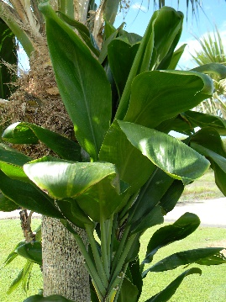

Look for these plants or trees within the park and identify the species by drawing a line from the picture to the name and description of the species. Early Hawaiians used native plants for many things: thatching for houses, food, instruments, clothing, weapons, and medicine.

**Identify Native Species**

**Pua Kala-**

A delicate white flower covered in sharp, stiff pickles on the stalk, leaves, and seed pods. Nickname: thorny flower.

**Ki-**

Long, broad, waxy leaves were utilized in many ways. Stalk cuttings brought over on canoes.

**Hala-**Recognized by its supporting base of aerial roots, leading to its nickname: the walking tree.

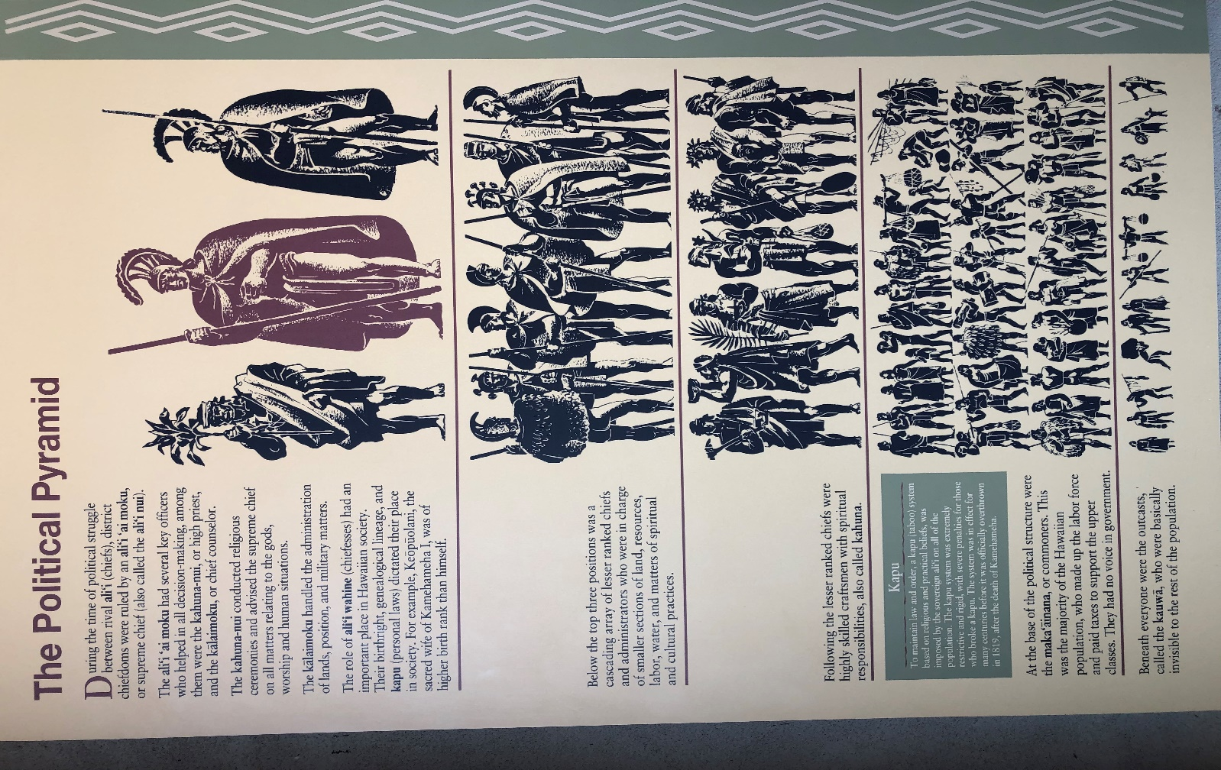

**Word Scramble**

uuPāhoo‘kl uhaie is the last roajm letmet to be built in iHaiw‘a in 1971, and played a jomra erlo in ahKmaeemah the rGta’se ascendancy to weopr.

________________________________________________________________________________________________________________________________________________________________________________________________

* **ali‘i ‘ai moku: _______________________**
* **ali‘i wahine: ________________________**
* **kahuna-nui: ________________________**
* **k**ā**laimoku: _________________________**
* **kapu: ____________________________**
* **kauw**ā**: ____________________________**
* **maka’**ā**inana: _______________________**

**Political Pyramid**

Translate Hawaiian words into English

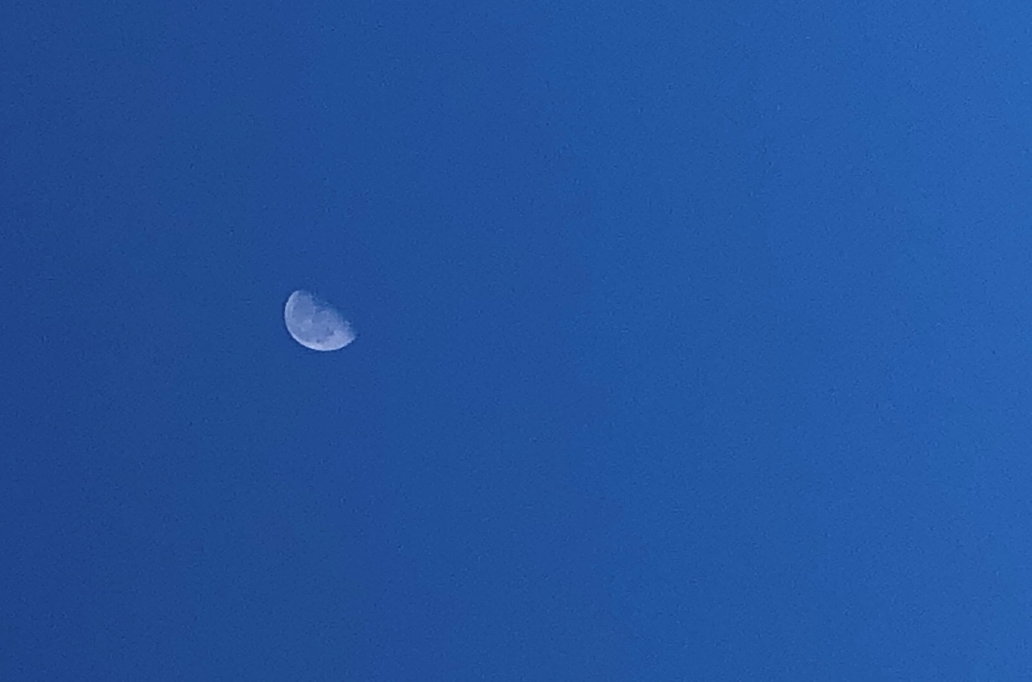

Fill in the **timeline** below by using your **park brochure** and **displays in museum and open lanai area** to find the **correct dates.**

**The first on has been done for you!**

**1758** Birth **of Kamehameha I**

____ Kamehameha I inherits land at uncles death

____ John Young stranded on Hawai‘i Island

____ Kamehameha finished building Pu‘ukoholā Heiau

____ Kamehameha retakes Maui, Lana‘i, and Moloka‘i

____ Kamehameha ends opposition on O‘ahu

____ Kaua‘i joins Kamehameha peacefully

____ Death of Kamehameha I

____ The Hawaiian Monarchy ends

____ The stone leaning post is accidentally broken

____ Your visit to Pu‘ukoholā Heiau

**Sailing Through Time**

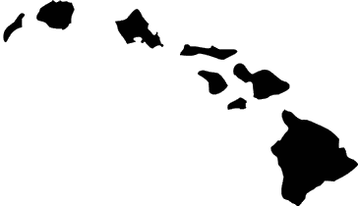

“I pledge to help protect

**Pu‘ukohol**ā **Heiau National Historic Site** and to show respect to all National Park Service units that include Historical and Cultural places, so others may enjoy these places in the future.”

**Kupuna Ranger Pledge**

Kupuna