### Fee Schedule and Payment Information

**Fee Schedule**The ***Application Fee*** has been determined to be $260 per application.

***Management Fees*** were established by Public Law 105-391 Sect 418, and further defined by the National Park Service in September and October 2018. Management Fees are completely tiered, with amounts depending upon the value of in-park gross receipts of the respective vendor. The Management Fee schedule is as follows:

* 3% of in-park gross receipts – businesses and nonprofits with up to $250,000 in in-park gross receipts per year
* 4% of in-park gross receipts – businesses and nonprofits with in-park gross receipts between $250,001 and $500,000 per year
* 5% of in-park gross receipts – businesses and nonprofits with more than $500,001 in in-park gross receipts per year

The Application Fee costs ($260.00) can be credited to the Management Fees, and as such, some businesses may not have to pay Management Fees.

**Payment**Payment will only be accepted by electronic means using Pay.gov. Applicants must follow the steps in the instructions below to process payment; no checks or cash will be accepted by the receiving park[1]. The park will not process Application Fees using Pay.gov on the applicant’s behalf. Application fees must be paid in advance—and the payment confirmation number referenced—of the park receiving the application for applications to be considered.

Pay.gov allows payment via several platforms for your convenience: Amazon, PayPal, Dwolla, direct deposit from your bank account, debit card, and credit card. Processing across two platforms (i.e., PayPal and credit card) is not available.

1. Use an internet browser and type “www.pay.gov” into the address bar. The home page will look like the figure below.

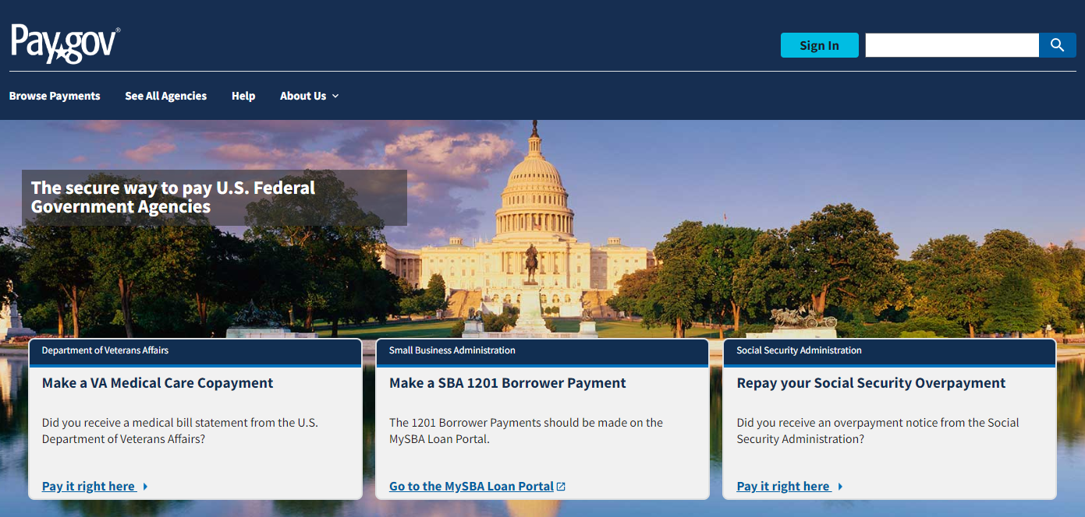

1. Use the Search bar in the main page of Pay.gov to search for “SACN CUA,” and then select the search icon.
2. The first form that populates on the next page, “St Croix NSR Commercial Use Authorization Fees,” is the correct form to use. Select the blue “Continue” to the form button.
3. Review the “Before You Begin” screen and select the “Continue to the Form” button.
4. On the “Complete Agency Form” screen, type in the information as it relates to you.
   1. If you held a CUA permit in the previous year: Please enter the most recent permit number you had in the “Commercial Use Authorization Permit #” field. New permit holders should enter the number “9999.”
   2. Complete the business name and Permittee Information section as it relates to your organization.
   3. Select the payment box that applies to you. You can select more than one at a time, thus consolidating the number of transactions in to one.
      1. If you select “Application Fee,” “$260.00” will be entered.
      2. If you select “Additional Monitoring Fee,” please enter the amount indicated on your outstanding Management Fee Memo.
   4. Enter any comments you may have, and then select “Continue” at the bottom.
5. Enter the appropriate information for your payment preference method in the “Enter Payment Info” screen. Select “Continue” at the bottom.
6. Review all the information you have entered on the “Review and Submit” screen and select “Continue” to finish payment. If you have made an error, you can use the back arrow to correct any screen.
7. The “Confirmation” screen will display a payment confirmation number.

Example:

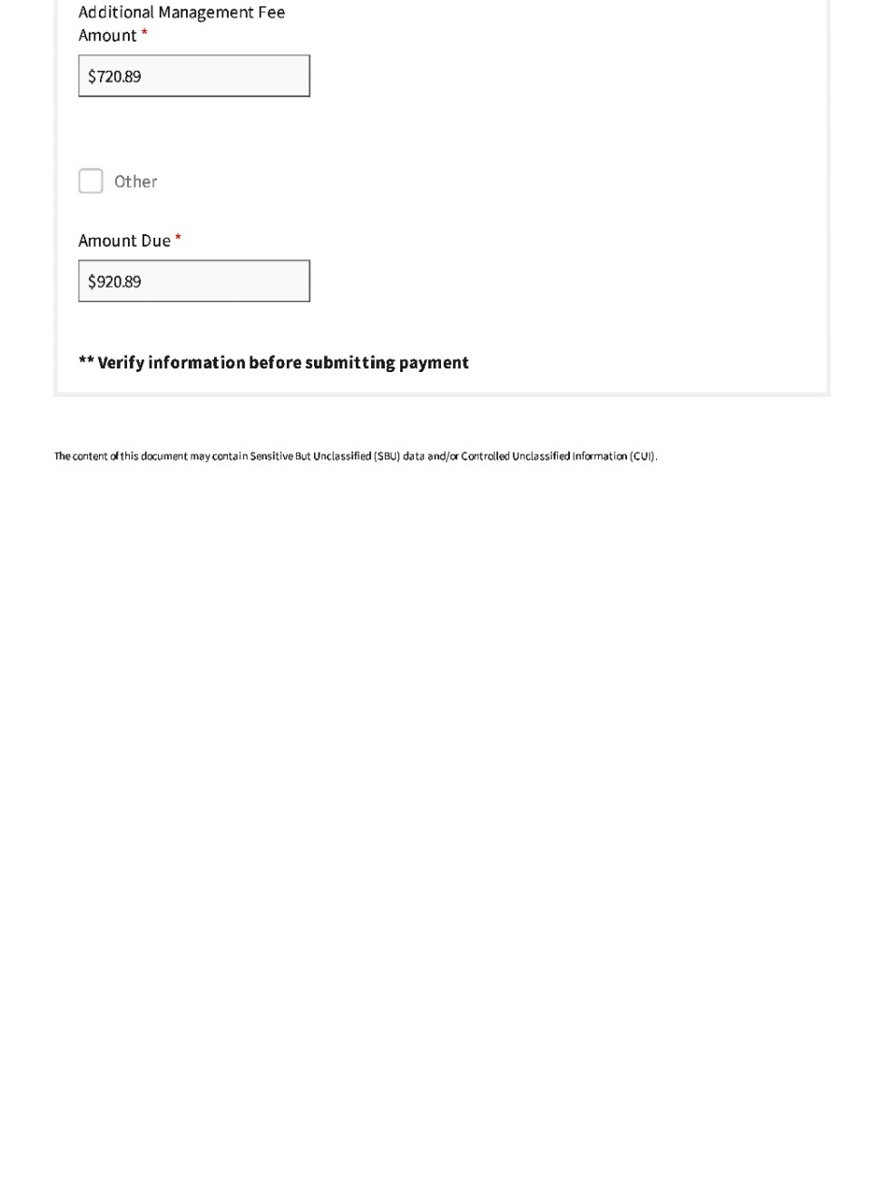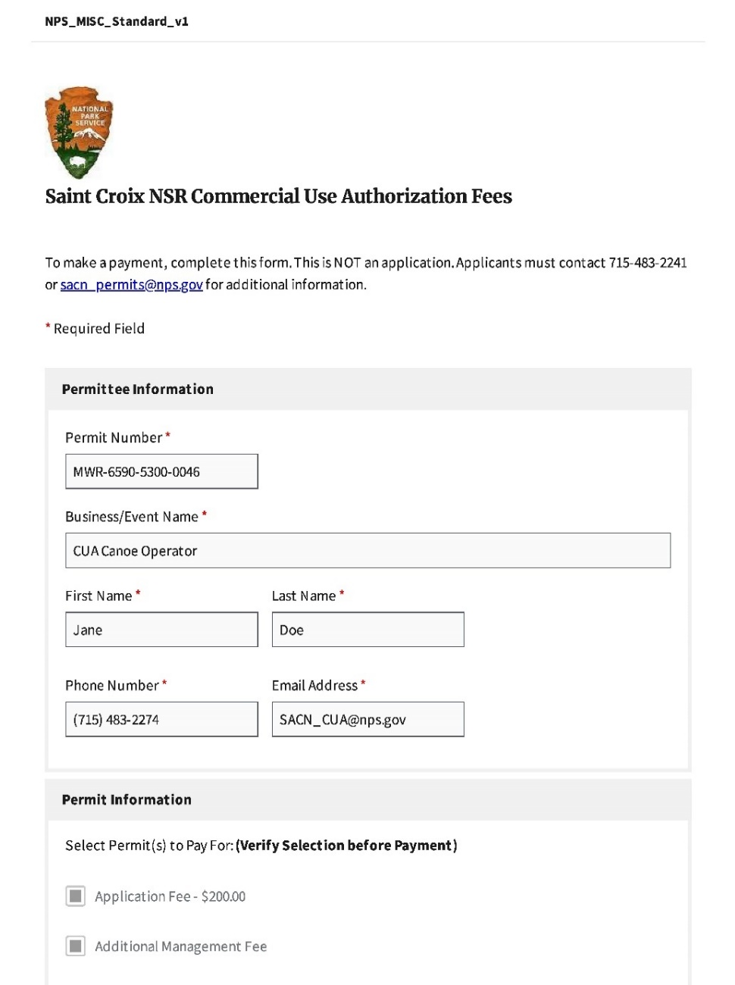

1. The purpose of the online payment module is to reduce costs for processing applications in future years.