Measuring the height of Saguaros using a clinometer
Normally, the height of an object such as a saguaro is found by multiplying the distance from the object to the person taking the height by the degree of the angle (tan, or θ) that can be determined by a special instrument known as a clinometer. From there, the height of the observer’s eye is added to get the total height of the object.
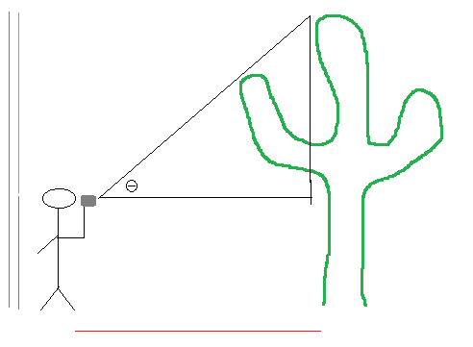
Formula
H = D • tan θ + HI
Where,
H = height
θ = degree of the angle
HI = height of the instrument (height of the observer’s eye)

However, an alternative method is that instead of taking just one angle, the person with the clinometer takes two angles expressed in percentages. One angle is from the person’s eye to the top of the saguaro, and the other is from the eye to the bottom of the saguaro. This eliminates the need to measure the height of the instrument or the height of the observer’s eye. From here, the observer can just add the two measurements together and divide it by the distance to get the height of a saguaro. Figure 3 shows what the angle percentage looks like when viewed through the clinometer.
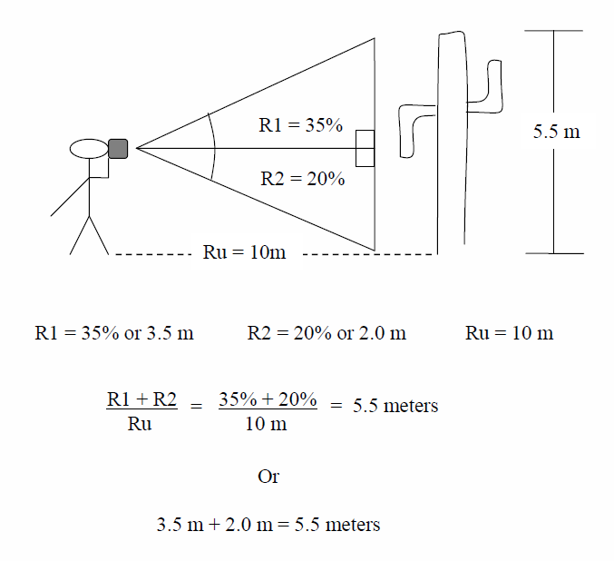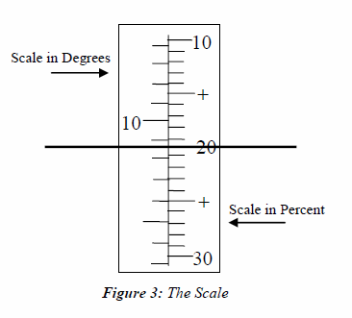
Top angle (x) = tanθ • D
Bottom angle (y) = tanθ • D
Height = x + y

