Lithic Tools
The Native Americans had to use the natural resources available in the area around them to make helpful tools. They had to look at the materials available to them and design tools to help do different jobs and then make the tools by hand. Gather some materials and see what you can come up with!

You will need:
- Scissors
- Pencil
- Markers
- Paper
- Newspaper
- No bake sculpting clay
- String (twine, leather, yarn, etc.)
- Beads
- Pebble sized rocks
- Sea shells
(Don’t worry if you cannot gather all these things. Part of the game is seeing what you can make with what you can find!)
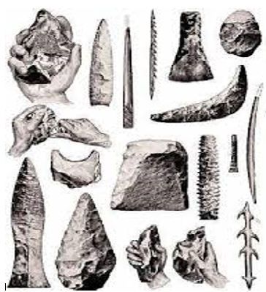

Instructions
In the southwest region of the United States, the Utes (who inhabited the Florissant Valley) heavily depended on the tools and weapons they created for everyday activities. The tools they created were necessary for many parts of their daily life such as gathering and preparing food or making clothing and shelter. Weapons such as bows were needed for both protection and hunting animals for meat and other resources.
Step One: Once you have your materials gathered, look at what you have. Use your imagination to come up with a design for a tool you could make. Think of a task that a tool could make easier for you or your family. It could help with preparing or gathering food, cleaning, personal hygiene, anything you can think of! Use your pencil and paper to sketch your design. Make notes on what it will be used for and what it will be made of.

Note: You are making a tool, not a weapon. Otherwise someone, including you, could get hurt.
Both men and women made and used the different tools and weapons important to the Utes. Women would weave baskets to gather food, nets of natural fibers for catching fish and rabbits, and made pottery from natural minerals to store food, water, and other goods. The men would also use natural materials to make grinding stones, bows and arrow, knives, and shields for hunting food and defending their families. The Utes would use materials such as clay, stones, and plants to craft the things they needed.
A lithic tool from the Utes has actually been found in Florissant Fossil Beds National Monument. It was most likely a scraper for preparing hides made from a piece of Wall Mountain Tuff.
Step Two: When you have a design in mind, start making your tool using the materials you have. If something isn’t working, you don’t have to strictly follow your initial design. You can make changes to make it better.
People who study ancient human artifacts and remains, such as lithic tools, are called archeologists. Paleontologists are scientists who study fossils. While both groups study ancient remains and use careful collecting techniques, their focuses are very different. Through archeology, scientists work to understand ancient civilizations and peoples. In paleontology, scientists work to understand life on Earth and how environments have changed over time.
Step Three: Once you have your tool made, you can use your markers or other items to decorate it.
Now that you have made a tool, what else could you make? Are there natural resources in the area you live in that could be useful in making tools? If there were certain materials you think would have been better or you needed but didn’t have, how would you go about getting them?

Vocabulary:
- Lithic: adjective; of the nature of or related to rock
- Archaeology: noun; the science that deals with past human life as shown by fossil relics and the monuments and tools left by ancient peoples
- Paleontology: noun; a science dealing with the life of past geological periods as know especially from fossil remains

Alt Text:
- A black and white picture showing a number of stone tools including a barbed spear, points for spears or arrows, and hide scrapers. A couple of examples are shown of how such tools are made by chipping away small pieces to shape the stone into the desired piece.

