Haleakalā National Park: Birds, Not Mosquitoes Curriculum

By: Kaitlyn Scheib

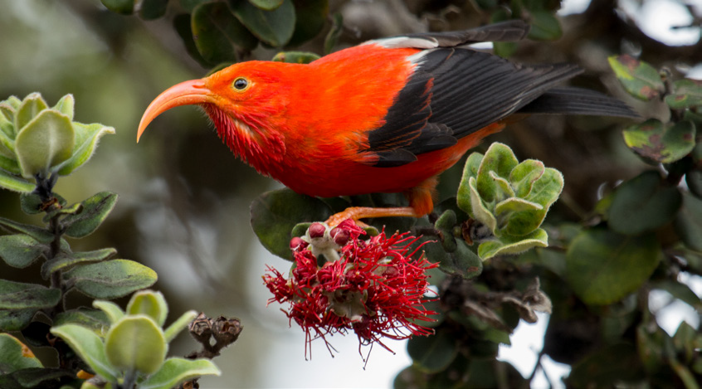

Table of Contents
Table of Contents 1
Background Information 2
Lesson Plan 1: Maui Forest Birds Introduction 4
Objective 4
Grade Level 4
NGSS Alignment 4
Time 5
Materials 5
Teacher Notes 5
Essential Questions 5
Direct Instruction 5
Guided Practice 8
Conclusion 8
Lesson Plan 2: Maui’s Hawaiian Honeycreepers and Adaptive Radiation 9
Objective 9
Grade Level 9
NGSS Alignment 9
Time 9
Materials 9
Teacher Notes 9
Essential Questions 10
Direct Instruction 10
Guided Practice 10
Conclusion 11
Natural Selection Activity: Bunny Blitz! 12
Getting Started: 12
Mission 1 13
Mission 2 13
Discussion Questions 14
Lesson Plan 3: Mosquito Population Control 15
Objective 15
Grade Level 15
NGSS Alignment 15
Time 15
Materials 16
Teacher Notes 16
Essential Questions 16
Direct Instruction 16
Guided Practice 17
Conclusion 17
Lab Activity: Mosquito Habitat 18
Objective 19
Materials 19
Set up 19
Procedure 19
Observations 19
Questions 20
Lab Activity: Mosquito Repellants 21
Summary: 21
Grade Level: 21
NGSS Alignment: 21
Objective: 21
Materials: 21
Procedure: 22
Data 22
Analysis 23

Background Information

Mosquitoes were introduced to Hawaiʻi in the 1800s from whaling ships coming to Maui. One species of mosquito, the southern house mosquito (Culex quinquefasciatus), is the biggest threat to Hawaiian honeycreepers. Hawaiian honeycreepers are Hawaiʻi’s only native forest birds. In these lessons, this family of birds is sometimes generally referred to by the term “forest birds”.
Southern house mosquitoes carry diseases that Hawaiian honeycreepers are highly susceptible to; avian malaria and avian pox. These mosquitoes, and other mosquito species found in Hawaiʻi, can also carry diseases that are harmful humans. One bite from a southern house mosquito carrying avian malaria has a 90% chance of killing an ʻiʻiwi (ee-ee-vee). The ʻiʻiwi is one of the 17 remaining species of Hawaiian honeycreepers! Factors such as climate change have caused mosquitoes to migrate farther and farther into these birds’ high-elevation habitat in the forests of Haleakalā, increasing the spread of avian malaria and avian pox.
To protect the Hawaiian honeycreepers from mosquito-borne illnesses, Haleakalā National Park is extending the use of a mosquito population control method that has previously only been used to protect human health. This method is called the Incompatible Insect Technique, or IIT, for short! IIT has been effective in other parts of the world, helping to reduce the spread of other mosquito-borne diseases such as dengue fever. Unlike other commonly used mosquito population control techniques, IIT doesn’t use any dangerous chemicals. Instead, IIT uses a bacteria called Wolbachia. Wolbachia is a commonly found, naturally occurring, bacteria in insects. In certain cases, Wolbachia has been found to interrupt the mosquito reproduction cycle. When female mosquitoes mate with male mosquitoes that carry a different, incompatible form of the bacteria, the eggs laid by the female are not viable and will not hatch. IIT relies on this natural incompatibility in mosquito reproduction. In an effort to decrease the overall population of the southern house mosquito, incompatible male mosquitoes are released into wild, pre-existing populations. With continuous releases, southern house mosquito populations and transmission rates of avian malaria should decrease. In this curriculum, students will learn how they can help control the mosquito population and be a part of saving the Hawaiian honeycreepers!

Lesson Plan 1: Maui Forest Birds Introduction

Objective
Students will learn about the history of the endemic Hawaiian honeycreepers, Hawaiʻi’s only native forest birds. They will learn how to identify the six different species of Hawaiian honeycreepers found on Maui and what these birds meant to Hawaiians in the past. Students will also consider the future of these birds and what impact their decline is having on Hawaiʻi. In this lesson, students also have the opportunity to learn some words in ʻŌlelo Hawaiʻi (Hawaiian language).

Grade Level
High School (9-12)

NGSS Alignment
HS-LS2-6: Evaluate claims, evidence, and reasoning that the complex interactions in ecosystems maintain relatively consistent numbers and types of organisms in stable conditions, but changing conditions may result in a new ecosystem.

HS-LS2-7: Design, evaluate, and refine a solution for reducing the impacts of human activities on the environment and biodiversity.

Time
Teacher Preparation: 30 minutes
Lesson: 1-2 class periods, 60 minutes each

Materials
- Paper
- Coloring supplies (markers, colored pencils, etc.)
- Pictures and videos of Hawaiian honeycreepers found on Maui

Teacher Notes

Essential Questions
1) What are the past and current threats to the native forest birds of Hawaiʻi?
2) What role do the forest birds play in Hawaiian culture past and present?
3) How can you contribute to the efforts to save the forest birds?

Direct Instruction
- Introduction: In Hawaiian mythology, the demigod Māui loved the forest birds and painted them bright colors for all to see and enjoy. The native Hawaiians loved to use the feathers of these forest birds to create lei kāmoe (feathered lei), mahiole (feathered helmets), kāhili (feathered standards), and ʻahu ʻula (feathered cloaks). These birds’ populations have been steadily declining since European settlers came in the 19th century bringing non-native plants and animals.
- Listen to an audio sample from Hosmer Grove, a special forest found in Haleakalā National Park. Do you hear the different bird calls? What birds do you hear near your home?
- Link to Hosmer Grove recording: https://youtu.be/MZr_nylWTI4
- Show pictures/videos of the different Hawaiian honeycreepers found on Maui. What differences do you notice? What factors can help distinguish each species?
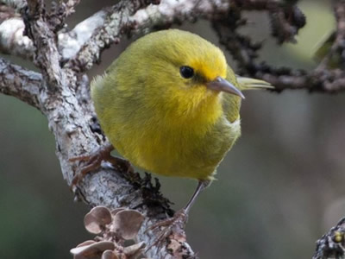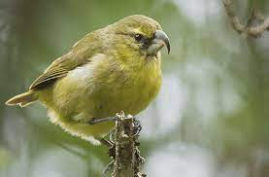
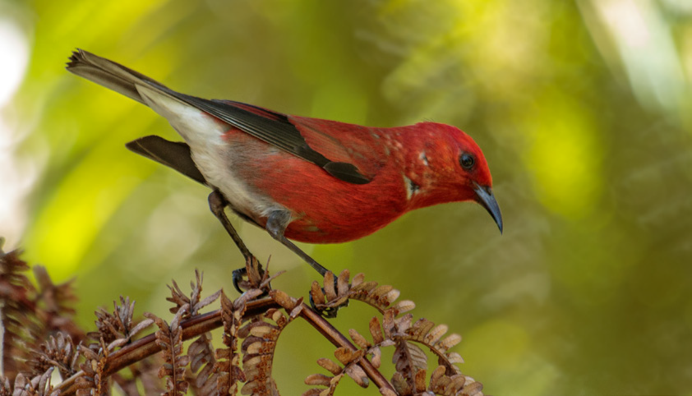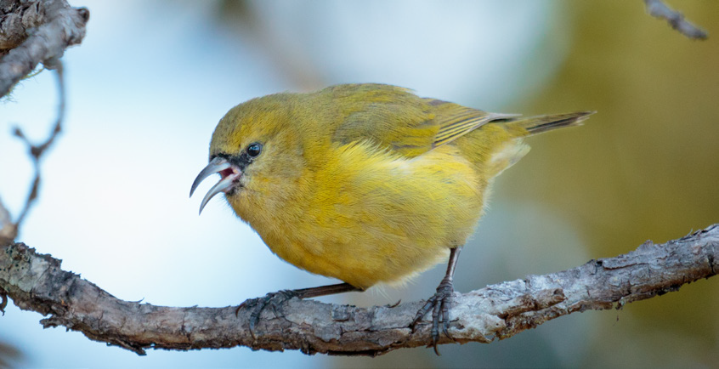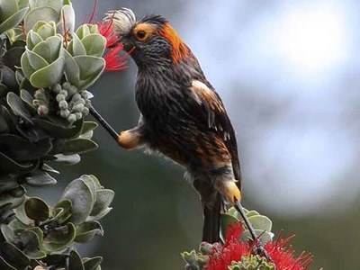
- History of the Hawaiian honeycreepers:
  - The ʻiʻiwi (ee-ee-vee) was an especially prized bird among Hawaiians for its bright red feathers. This bright red color was considered sacred and was only worn by those of high rank during special ceremonies.
  - There were designated bird catchers who collected the feathers for ʻahu ʻula (feathered cloaks) and such. Those bird catchers were called “kia manu”. These bird catchers used decoy branches or flowers covered in sticky paste that the birds would get stuck to. Most kia manu would only collect a few feathers from a bird and then release it back into the wild.
  - When the Europeans colonized Hawaiʻi, they brought new plants and animals with them. These animals included predators that the birds had not experienced before like mongooses, cats, and rats.
  - With colonization, the Hawaiian honeycreepers’ habitat was also diminished. The sandalwood tree, or ʻiliahi (ee-lee-ah-hee), was prized by the Europeans and nearly wiped out. The settlers then tried to replenish the forests by planting non-native trees such as pines and eucalyptus. Unfortunately, not all of the native forest birds have been able to adapt to these changes in trees.
  - Another important tree to the nectar-eating Hawaiian honeycreepers is the ʻōhiʻa lehua (oh-hee-uh leh-hoo-uh). Unfortunately, these trees across Hawaiʻi are at high risk of a fungal infection called Rapid ʻŌhiʻa Death.
  - The most pressing threat to the forest birds’ population, however, are the mosquitoes. Mosquitoes are not native to Hawaiʻi. They were brought in by whaling ships in the 1800s. These mosquitoes (specifically the southern house mosquito) carry avian malaria which the birds, especially the ‘iʻiwi, are highly susceptible to.

- Share La‘ieikawai’s Story
  - “In the romantic story of La‘ieikawai, as told by S.N. Hale‘ole, La‘ieikawai is a beautiful chiefess who is served upon and resides on the wings of supernatural Hawaiian honeycreepers. La‘ieikawai’s house is thatched with the royal yellow feathers of the ōʻō bird (a now extinct Hawaiian honeycreeper) and she is attended to by i‘iwipolena. While living amongst the honeycreepers, she catches the eye of a handsome Kaua‘i chief, Kauakahialii. He sends a servant to invite her to his dwelling and La‘ieikawai responds, “When rings the note of the ōʻō bird, I am not in that sound, or the ʻalalā (Hawaiian crow), I am not in that sound; when rings the note of the ‘elepaio then am I making ready to descend; when the note of the ‘apapane sounds, then I am without the door of my house; if you hear the note of the i‘iwipolena, then I am without your ward’s house; seek me, you two, and find me without. That is your wards chance to meet me.” La‘ieikawai’s suitor listens to the birdcalls for announcement of the beauty’s arrival. The first night she does not come but on the second night, after the ‘apapane’s song rings at dawn, La‘ieikawai appears at Kauakahialii’s door, resting on the wings of her birds.” – Maui Forest Bird Recovery Project

Guided Practice
What stories do you think might have been told about the colorful honeycreepers of Hawai‘i?

- Split into groups.
- Each group should work together to develop an illustrated short story involving one or more of the Hawaiian honeycreeper species.
- Groups will share their stories and illustrations with the class.

Conclusion
The Hawaiian honeycreepers found across the Hawaiian Islands are not found anywhere else in the world! Because of habitat loss, introduction of predators, and climate change, the Hawaiian honeycreepers are slowly going away. There were once over 50 different species of Hawaiian honeycreeper, but now only 17 remain. In order to preserve Hawai‘i’s past and rich culture, we all need to help protect the unique birds found here.

Discussion: What can you do to help preserve the Hawaiian honeycreepers?

Lesson Plan 2: Maui’s Hawaiian Honeycreepers and Adaptive Radiation

Objective
Students will learn about the evolution and adaptation of Maui’s forest birds. They will be able to describe how endemic species evolve through adaptive radiation. They will identify what environmental factors affect certain traits in the birds and any common ancestors the birds have.

Grade Level
High School (9-12)

NGSS Alignment
HS-LS4-4: Construct an explanation based on evidence for how natural selection leads to adaptation of populations.

HS-LS4-5: Evaluate the evidence supporting claims that changes in environmental conditions may result in (1) increases in the number of individuals of some species, (2) the emergence of new species over time, and (3) the extinction of other species.

Time
Teacher Preparation: 15 minutes
Lesson: 60 minutes

Materials
- Computer access for each student or group
- Student natural selection activity handout

Teacher Notes

Essential Questions
- What roles do different traits have on a species survival?
- What factors have affected the Hawaiian honeycreeper population on Maui?

Direct Instruction
Students should have already been taught about evolution and natural selection
- Introduce the topic by teaching about Darwin’s finches.
  - When British Naturalist, Charles Darwin explored the Galápagos Islands off the coast of Ecuador, he discovered 13 different species of finches. He noticed they were closely related, but each individual bird varied in small ways. This is an example of adaptive radiation which commonly happens on islands. (see https://www.pbs.org/wgbh/evolution/library/01/6/l_016_02.html)
- Teach about adaptive radiation and how it has applied to the Maui forest birds.
  - Similar to the Galápagos finches, many endemic species of birds have evolved on Hawai‘i.
  - Scientists can see common ancestors of the birds through the birds that are alive now and fossil evidence of birds that are now extinct. For instance, 18 species of Hawaiian honeycreepers are known only through their fossil records!
  - We also see examples of coevolution, especially between the birds and the flowers. For example, the ‘i‘iwi’s long, curved bill has evolved to perfectly suck the nectar from the long, curved flowers found on Hawai‘i — such as the Hawai‘i lobelia.
- What are some environmental threats that can lead to extinction of a species?
  - Habitat destruction
  - New species introduced causing competition and predation
  - Introduced diseases
- What factors cause adaptive radiation?
  - Isolation
  - Available food resources
  - Intraspecies food competition

Guided Practice
- Natural Selection Activity: Bunny Blitz!
  - Students will use the simulation to change elements of the environment and possible mutations for a bunny population.
  - Complete various tasks in the simulation:
- Create a population of entirely brown rabbits
- Create a population of white rabbits with long teeth

Conclusion
Maui is home to a diverse range of endemic birds. One special family of birds, the Hawaiian honeycreepers come from a common finch ancestor and have evolved into many distinct species that each fulfill a unique role in Hawaiian forest ecosystems. These species have evolved through the process of adaptive radiation.

It has taken a very long time for the Hawaiian honeycreepers to adapt to the specific environment on Maui and it is challenging for these birds to adapt quickly to the sudden changes in their environment caused by habitat loss, the introduction non-native species, and climate change. These factors have caused the extinction of many species of Hawaiian honeycreepers and left others endangered.

Discussion: What can we do to help minimize the human impact on the Hawaiian honeycreepers?

Natural Selection Activity: Bunny Blitz!

Getting Started:

*Open the simulation at http://bit.ly/2Z6SU1N. Select the “Lab” option.

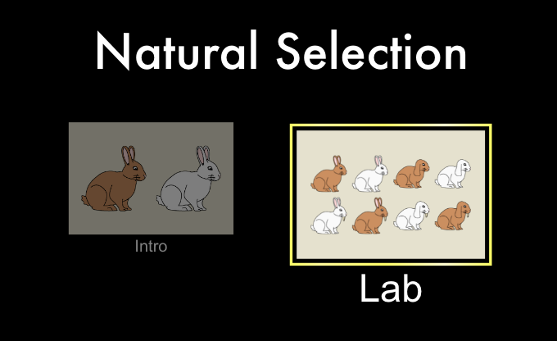

*Take a few minutes to explore the simulation. Learn what the different controls do.

Mission 1
Change the conditions so that you end up with a population of entirely brown rabbits. To accomplish this, you will need to follow these steps:
- Add mate.
- Add brown fur mutation.
- Let a few generations pass.
- Add wolves.
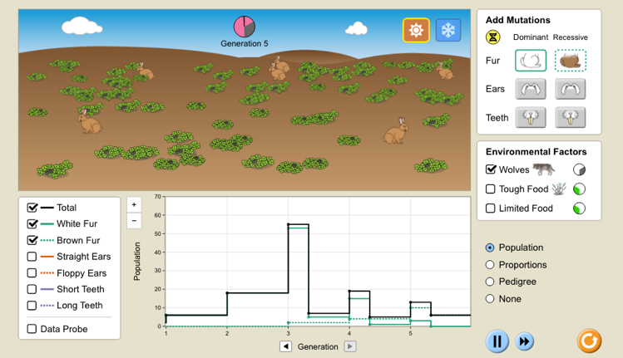

- Once you have accomplished this mission, paste a screenshot of your final bunny population similar to the one above.
- What advantage did rabbits with brown fur have over the white rabbits?
(Ans: They blend in better with the environment; therefore, the wolves kill fewer of them.)

- EXTRA CREDIT: Is it easier to create an environment of entirely brown rabbits with a recessive or dominant mutation? Why?

Mission 2
Change the conditions so that you end up with a population of entirely white rabbits with long teeth. Follow these steps to accomplish this:
- Add mate.
- Add long teeth mutation.
- Let a few generations pass.
- Add tough food to the environment.

- Once you have accomplished this mission, paste a screenshot of your final bunny population.

- What advantage did the rabbits with long teeth have over the rabbits with normal teeth?
(Ans: They can eat the tough food more easily, and therefore are more likely to survive.)

Discussion Questions
- What examples of variation were present in the simulation? What was the cause of this variation?
(Answer - Color: white or brown rabbits
Teeth: Long or short
Ears: Straight or floppy)

- What examples of inheritance were present in the simulation?
(Answer - Rabbits inherit their traits (fur color, tooth length, ear floppiness) from their parents through Mendelian patterns of inheritance. )
[The “Pedigree” option can help students visualize this]
- What examples of adaptation were present in the simulation?
(Answer - When the selective pressure of wolves was added, the allele for brown fur became more common in the population.
When the selective pressure of tough food was added, the allele for long teeth became more common in the population.)

- What examples of variation are present in the Maui forest birds?

(Answer - Beak: Short or long, Feather color: Red, Green, Yellow, Brown)

- What is an example of adaptation that is present in the Hawaiian honeycreepers on Maui?

(Example Answer: Each bird species has adapted to a niche environment on Maui and to a specific type of food. For example, the ‘i‘iwi has developed a long, curved beak to eat the nectar of the long trumpet shaped flowers while the kiwikiu has a parrot like beak to get at larvae in branches.)

Lesson Plan 3: Mosquito Population Control

Objective
Students will research and learn about mosquito life cycle and reproduction. Students will also learn through observations of mosquitoes in a controlled environment. Students will then test different mosquito repellants and be able to identify the most effective methods of mosquito control.

Grade Level
High School

NGSS Alignment
HS-L24-5: Evaluate the evidence supporting claims that changes in environmental conditions may result in (1) increases in the number of individuals of some species, (2) the emergence of new species over time, and (3) the extinction of other species.

Time
Teacher Preparation: 30-60 minutes
Lesson: 2 class periods, 60 minutes each

Materials
- Sand
- Distilled water
- Salt water
- Vinegar
- Baking soda
- Dry leaves
- Vegetable peels
- Mosquito traps (see https://www2.clarku.edu/~tlivdahl/page19/denise.pdf for assembly)
- Coffee filters
- Garlic
- Cinnamon
- Citronella
- Eucalyptus
- Tea tree oil
- Neem oil
- Ulu (breadfruit) flowers
- Sweetgrass

Teacher Notes

Essential Questions
- Why is mosquito population control important?
- What can you do to help control the mosquito population?
- How does understanding the mosquito life cycle help us control the mosquito population?

Direct Instruction
- Ask students if they have noticed where/when they have most noticed mosquitoes around them? What does your experience tell you about the behavior of mosquitoes?
- Teach students why this lesson is important to Maui. Mosquitoes have been a problem for a long time. They have adapted over time to breed quickly and survive in many different environments. Specifically in Hawai’i, when mosquitoes were introduced, they spread disease to the people and native species. We can all play a part in helping to control the mosquito population by finding ways to limit their reproduction.
- In this lesson, we will learn about the life cycle of a mosquito and discover where they thrive and how to repel them.
- Teach students about the life cycle of the southern house mosquito (Culex quinquefasciatus mosquito (See CDC handout)
- Culex mosquito life cycle facts (from CDC, https://www.cdc.gov/mosquitoes/about/life-cycles/culex.html):
  - The females lay eggs on stagnant water.
  - Most eggs hatch within 24 hours.
  - Larvae live in water and develop into pupae within 5 days.
  - The pupae then develop into adults in 2-3 days.
- In the next lesson, review the students’ findings from the activity and compare with their predictions at the beginning of the lesson. List any sources of uncertainty in the findings.

Guided Practice
- Students will perform two experiments testing mosquito habitat and repellants.
- Provide each student with a copy of the two labs:
  - Lab Activity: Mosquito Habitat
  - Lab Activity: Mosquito Repellants
- Before each lab, have students write down their predictions of the experiment results.
- At the end of the lab, have students answer the analysis questions and compare the results with their initial prediction.

Conclusion
Mosquitoes have been a growing threat to the endangered Hawaiian honeycreepers on Maui (and across all of the Hawaiian Islands). On Maui, Haleakalā National Park is working hard to implement solutions to control southern house mosquito populations to protect these birds. However, we can each play a small part in the efforts to save these birds in our own homes and backyards.

Discussion: What will you do to help control the mosquito population in your area?

Lab Activity: Mosquito Habitat

Objective
Identify environments mosquitoes are most attracted to.

Materials
- Sand
- Distilled water
- Salt water
- Vinegar
- Baking soda
- Dry leaves
- Vegetable peels
- Mosquito traps (see https://www2.clarku.edu/~tlivdahl/page19/denise.pdf for assembly)
- Coffee filters

Set up
- Divide class into small groups.
- Provide each group with 6 mosquito traps and coffee filters.
- Cover the bottom of each trap with different materials in each trap.
- Label each coffee filter and place on the traps.
- Leave the traps in a secluded place outside for about 1 week.

Procedure
- After leaving the traps outside for 1 week, close each trap with a lid and bring into the lab.
- Count the number of mosquitoes on the coffee filter in each trap and record in the table below.
- Test the pH level of the solution in each jar and record in the table below.
- Look at a couple of mosquitoes under a microscope and identify the differences between the males and females.

Observations

Jar # | Material | pH | # mosquitoes | # larvae
1 | Sand
2 | Distilled water
3 | Vinegar and water
4 | Baking soda and water
5 | Dry leaves
6 | Vegetable peelings

Questions
- Which material attracted the MOST mosquitoes?

- Which material attracted the LEAST mosquitoes?

- Do you think there is a connection to pH and the number of mosquitoes in the area? Why or why not?

- Did you find more male or female mosquitoes? How did you tell the difference?

- How can knowing the mosquitoes’ preferred environment help save the forest birds?

Lab Activity: Mosquito Repellants

Summary:
In the lab, students will test a variety of natural mosquito repellants and determine which are the most effective. Students will practice good lab skills including setting up an experiment, collecting and analyzing data, and determining possible sources of error.

Grade Level:
High School (9-12)

NGSS Alignment:
This lab will help prepare your students to meet the performance expectations in the following standards:
- Scientific and Engineering Practices:
  - Engaging in Argument from Evidence

Objective:
By the end of this lab, students will be able to:
- Set up an experiment testing multiple variables and comparing with a control.
- Identify the different stages of the mosquito life-cycle.
- Analyze the results of their experiment and determine the best sources of mosquito repellant.

Materials:
- Garlic
- Cinnamon
- Citronella
- Eucalyptus
- Tea tree oil
- Neem oil
- Ulu flowers
- Sweetgrass
- Coffee filters
- 6-8 mosquito traps per group

Procedure:
- Assemble mosquito traps.
- Add 12 oz. water to each trap.
- Add one repellant to each trap. Make sure to label each trap!
- Leave traps in a shady spot for 7-14 days.
*Important: have students add water to these traps every 2-3 days, as they will dry out in less than a week. Have them bring the water level up to within a half inch of the top of the black plastic. Once the traps dry out, they’re not attractive to mosquitoes and much more likely to blow away.
- Collect traps and remove lids.
- Carefully transport filter papers to the lab.
- Do your best to identify and count the number of male mosquitoes, female mosquitoes, and eggs on each filter paper.
- Record your observations in the data table below.
- Complete post-lab questions.

Data

Repellant | # Male | # Female | # Eggs

Analysis
- How could you tell the difference between the male and female mosquitoes?

- Did you see a correlation between the number of eggs and the type of repellant?

- Which repellant that you tested was the most effective?

- Which repellant that you tested was the least effective?

- What possible sources of error occurred during the experiment that could affect the accuracy of your results?

References
1 Mark Kimora, Haleakala National Park, https://www.nps.gov/hale/learn/nature/native-hawaiian-forest-birds.htm

2 These photos are found on the Haleakala NPS website and the Maui Forest Bird Recovery Project. https://www.nps.gov/hale/learn/nature/native-hawaiian-forest-birds.htm

Mark Kimora, Haleakala National Park, https://www.nps.gov/hale/learn/nature/native-hawaiian-forest-birds.htm
These photos are found on the Haleakala NPS website and the Maui Forest Bird Recovery Project. https://www.nps.gov/hale/learn/nature/native-hawaiian-forest-birds.htm

