Six Major Insect Orders
Orders: Coleoptera, Lepidoptera, Hymenoptera, Diptera, Hemiptera, and Orthoptera

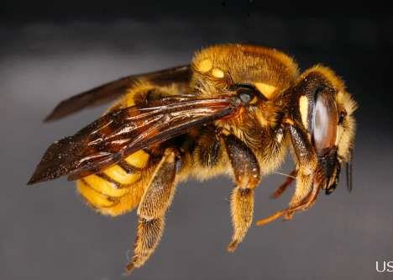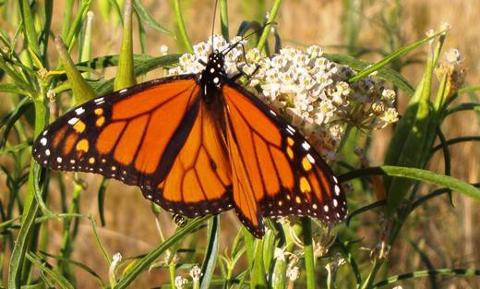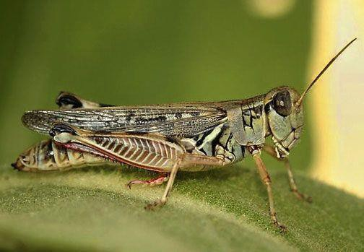Six Major Insect Orders

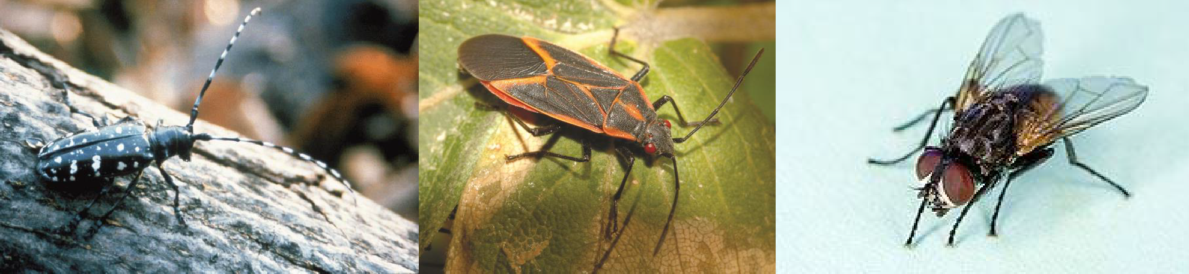

- Butterfly: http://www.nrcs.usda.gov/Internet/FSE_MEDIA/stelprdb11195 06.jpg
- Boxelder Bug:
- http://www.fs.usda.gov/Internet/FSE_MEDIA/stelprdb517641 4_tn.jpg
- Asian Long-Horned Beetle:
- http://www.nasa.gov/images/content/103564main_beetle.gif
- Grasshopper:
- http://www.blm.gov/pgdata/etc/medialib/blm/wy/programs/pes ts/gr-hoppers.Par.73488.Image.-1.-1.1.gif
- Leafcutter Bee:
- http://gallery.usgs.gov/photos/06_20_2011_rvm8PCb55J_06
_20_2011_1#.U-KHEqMXJvV
- House Fly:
- http://www.ars.usda.gov/is/graphics/photos/apr13/d1058-
1i.jpg

